NOMBRE: XOCHILT PAOLA BALDIZON DIAZ

GRADO Y GRUPO:1”A”

Hello everyone!

Today, I'm excited to introduce you to Osita, a sweet and playful young bear from the forest.
Spelling Osita's name: O-S-I-T-A
Contact Information: If you want to learn more about Osita, you can reach out to us at 555-987-6543.
Meet Osita: Osita is a fictional character who loves playing with flowers and exploring the woods. She's a curious and adventurous bear, and her best friends are a rabbit named Rosie and a squirrel named Squeaky.
Two notable names: Rosie and Squeaky
Two common nouns: Forest and Flowers
Osita's Story: Osita lives in a cozy little den in the forest, surrounded by tall trees and colorful flowers. She loves to play hide-and-seek with her friends and go on treasure hunts. One day, she discovers a hidden clearing filled with the most beautiful flowers she's ever seen.
Osita's Kindness: Osita is a kind and gentle bear who always puts others before herself. She shares her flowers with her friends and helps those in need. With the help of Rosie and Squeaky, she learns the value of friendship and community.
Conclusion: Osita is a lovable character who shows us the importance of kindness, friendship, and exploration. I hope you've enjoyed learning about her story!

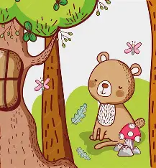
Thank you for listening!

