STUDY PROJECT – HOUSEHOLD CHORES

Full Name: Melany Rosmary Noriega Morales
Group: 3° semester
School: Universidad del Sureste (UDS)
Date: October 9th, 2025



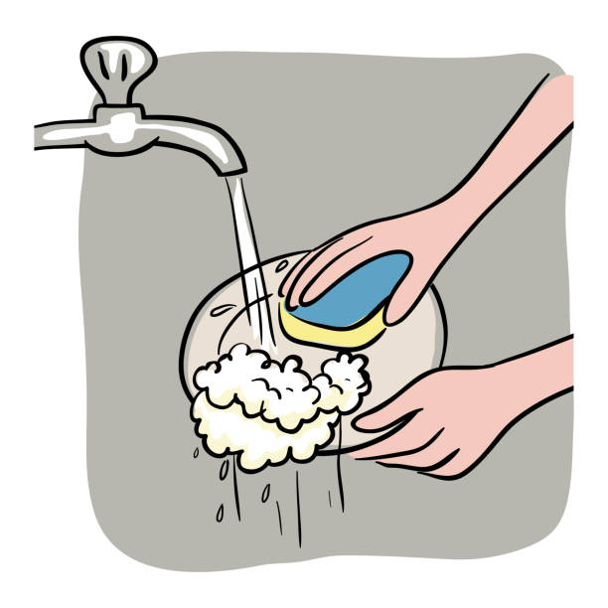

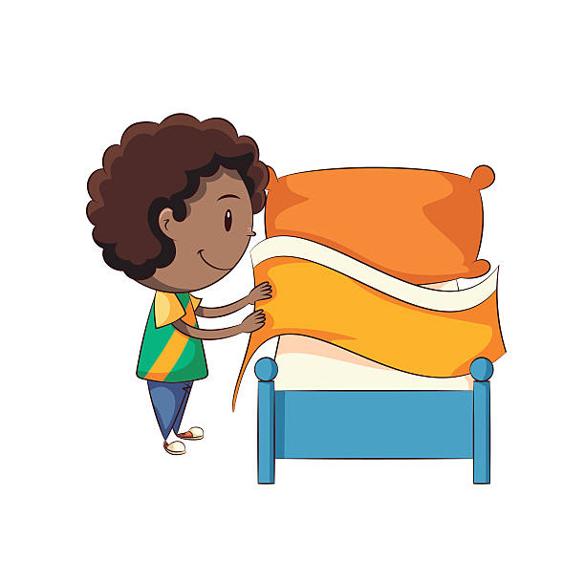
1. Household Chores List
Chore
1. Wash the dishes
2. Make the bed
3. Sweep the floor
4. Mop the floor
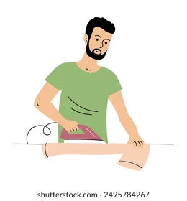
5. Cook dinner
6. Do the laundry
7. Water the plants
8. Take out the trash | 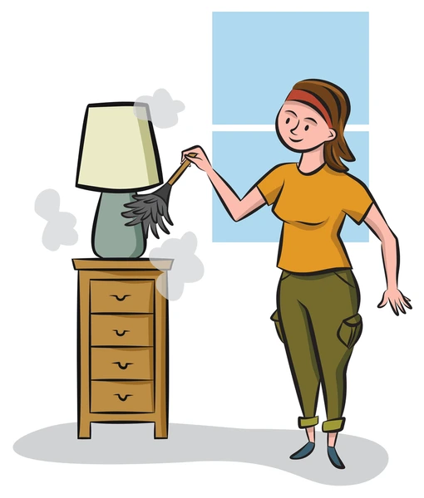
9. Clean the bathroom
10. Feed the pets
11. Iron the clothes
12. Dust the furniture
13. Vacuum the carpet | 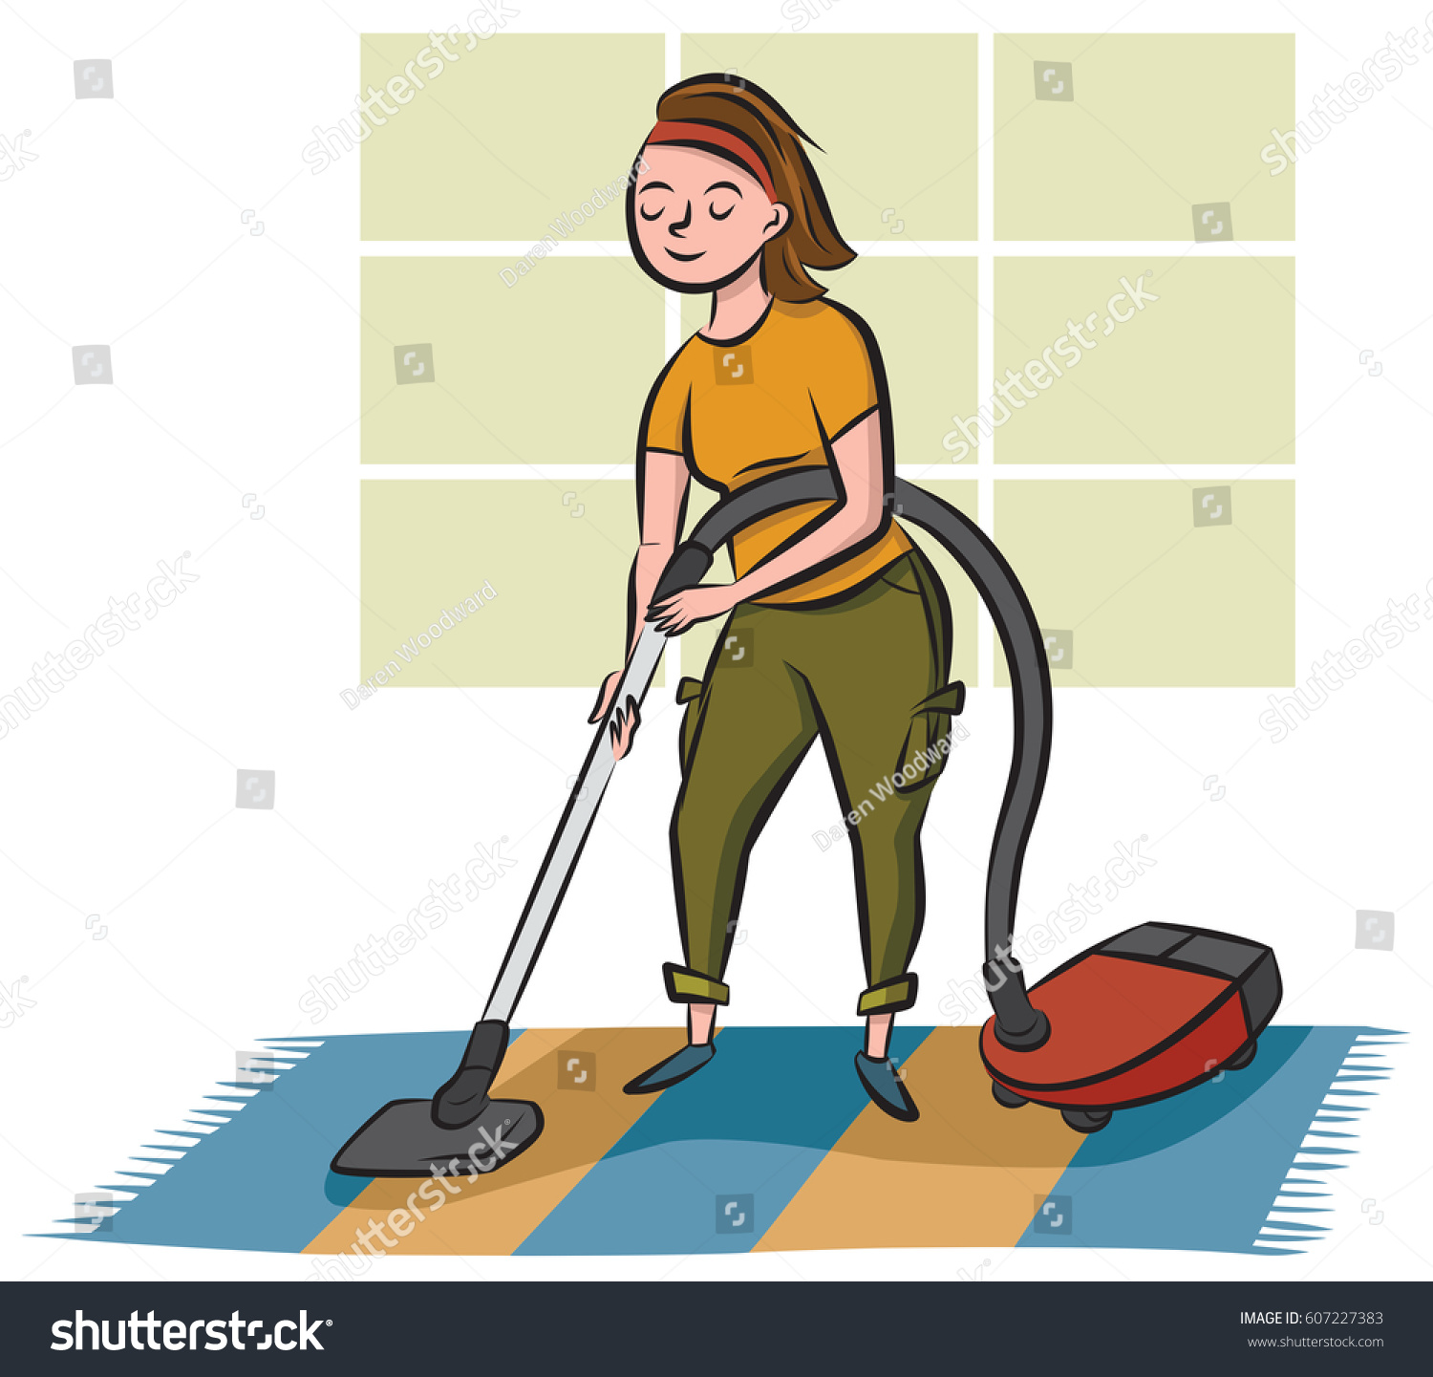
14. Set the table
15. Wash the windows


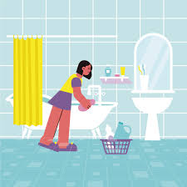
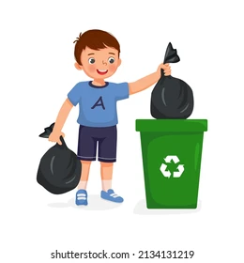
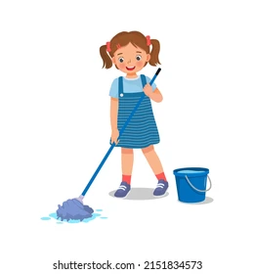
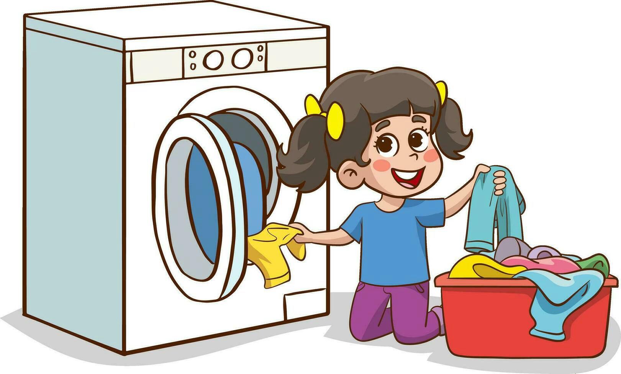

2. WH Questions
How often:
- How often do you wash the dishes?
- How often do you clean your room?
- How often do you water the plants?
- How often do you take out the trash?
- How often do you cook dinner?
Who:
- Who makes the bed every morning?
- Who washes the clothes at home?
- Who takes care of the pets?
- Who cleans the bathroom?
- Who sweeps the floor?
Where:
- Where do you keep the cleaning products?
- Where do you fold the clothes?
- Where do you eat breakfast?
- Where do you wash the dishes?
- Where do you store the trash bin?

3. Answers
- How often:
- I wash the dishes every day.
- I clean my room twice a week.
- I water the plants every morning.
- I take out the trash at night.
- I cook dinner three times a week.
- Who:
- My mom makes the bed every morning.
- My sister washes the clothes at home.
- My brother takes care of the pets.
- My dad cleans the bathroom on weekends.
- I sweep the floor after school.
- Where:
- I keep the cleaning products in the laundry room.
- I fold the clothes on my bed.
- I eat breakfast in the kitchen.
- I wash the dishes in the sink.
- I store the trash bin outside the house.

