Rutina diaria

I wake up at seven o’clock every day.


I brush my teeth and wash my face in the morning.
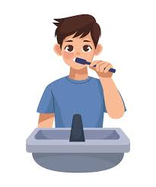

I go to school at eight o’clock.


I do my homework in the afternoon.


I watch TV and play video games in the evening.
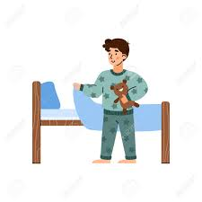

Rutina de tiempo libre

I listen to music in my free time.

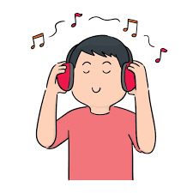

I play soccer with my friends on weekends.



I read books in the afternoon.



I watch movies with my family.



I use my phone and chat with my friends.


