

**ROSSAINE YUDITH MORALES PEREZ**

**MARIA FERNANDA MONTSERRATH CAMPOS**



COMITÁN DE DOMÍNGUEZ CHIAPAS A 15 DE JULIO 2025

**ORACIONES EN PAST SIMPLE, PAST CONTINUOS, PRESENT PERFECT Y FUTURE.**

**GRADO Y GRUPO : 3 B**

**INGLES III**

 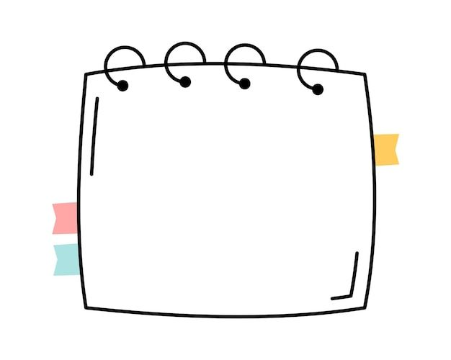

THIS WEEK I DID HAVE ENGLISH CLASSES

AND I'VE FINISHED MY WORK AND SCHOOL ASSIGNMENTS, THANK GOD

I'VE ALSO BEEN STUDYING A BIT FOR THE EXAM

TWO WEEKS AGO, ON MY DAY OFF I WAS STUDYING WHEN I GOT A CALL FROM WORK TO SEE IF I COULD HELP FOR A FEW HOURS.

BUT I DID NOT ACCEPT BECAUSE A WEEK AGO I WAS WORKING OVERTIME AND THEY DID NOT REPLACE THE HOURS I WORKED.

SO I WAS STUDYING ALL AFTERNOON

FUTURO “WILL” O “GOING TO”

**PAST SIMPLE, PAST CONTINUOS**

PRESENT PERFECT

TODAY IT DAWNED CLOUDY I THINK IT WILL RAIN AT NIGHT

I WILL HAVE TO RETURN HOME ON TIME.

TOMORROW I'M GOING TO WORK EARLY