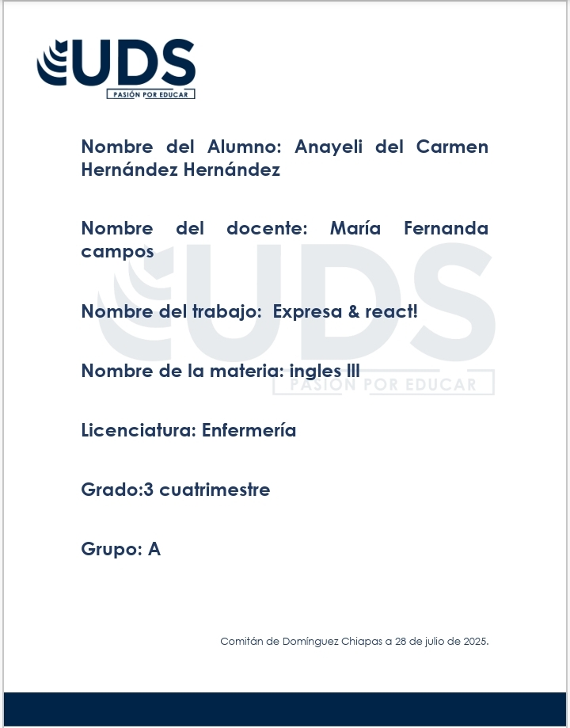

1. **Describe a commen or persona problem**

I get distracted easily when I try to study at home. There are too many noises and interruptions, especially from my younger siblings. Because of this, I take longer to finish my homework and sometimes I don’t study well for exams.

You should look for a quiet place to study, maybe the library or your room with the door closed.

You must talk to your family and ask them not to interrupt you during study time.

1. **Real situation using First Conditional**

If I wake up early tomorrow, I will finish all my homework before lunch.

1. **Opinion on a simple topic**

Topic: Social Media

In my opinion, social media has both advantages and disadvantages.I think that it helps people stay connected, especially with family and friends who live far away.However, I believe that spending too much time on social media can be bad for mental health.It’s important to use it with balance and not let it affect your sleep or productivity.