

NAME OF THE: henry caleb sanchez calvo

NAME THEACHER: LIC. DEICY FABIOLA LOPEZ AGUILAR

SUBJECT: INGLISH 2

FOUR-MONTH PERIOD: 2

TITLE OF THE WORK: "DISCOVER MY CITY OR A SPECIAL PLACE"

COURSE NAME: BACHELOR'S DEGREE IN NURSING

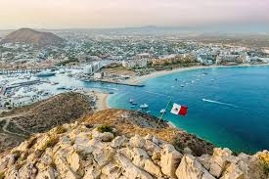THIS CITY THAT I WILL PRESENT IS CALLED LOS CABOS SAN LUCA MEXICO. THIS CITY IS CHARACTERIZED BY ITS BEAUTIFUL BEACHES AND GEOLOGICAL FORMATIONS.

¡/THE CITY IS A TOURIST AREA DUE TO ITS BLUE SEA AND ROCK FORMATIONS, THE CITY IS A PLACE WITH A LOT OF POPULATION

ºSome of its important places are El Arco de Cabo San Lucas, a natural rock formation located on Lover's Beach.

ºIn the months of January you can see humpback whales in the arch of Cabo San Lucas

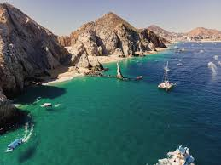ºSanta Maria beach is popular for swimming, diving and snorkeling. It is located in the Cabo San Lucas tourist corridor.

In Los Cabos they use buses or cars for transportation. For sea trips they use boats.



How can you get from the hike to Cabo Aventuras?

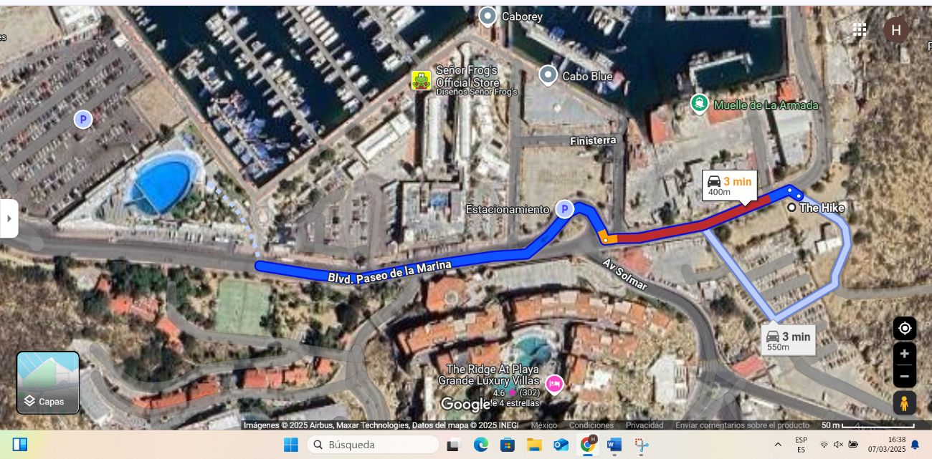

To get to the hike we must take the path of Blvd. Paseo de la Marina passing Tres Esquinas, we pass through Finisterra and three hundred meters away we find the Navy Pier and, gladly, there is the hike, so we walk 500 meters.

why visit los cabos?

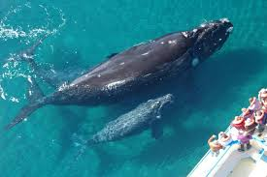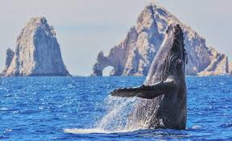Besides being a city with a lot of history, its natural wealth is great, as it has beautiful beaches and is one of the most visited places, with magnificent natural rocks such as the rock arch and beaches for snorkeling and swimming. In the months of January to March, humpback whales can be seen from the beaches and you can get close to them from boats. It is for these attractions that I recommend visiting Los Cabos San Lucas.