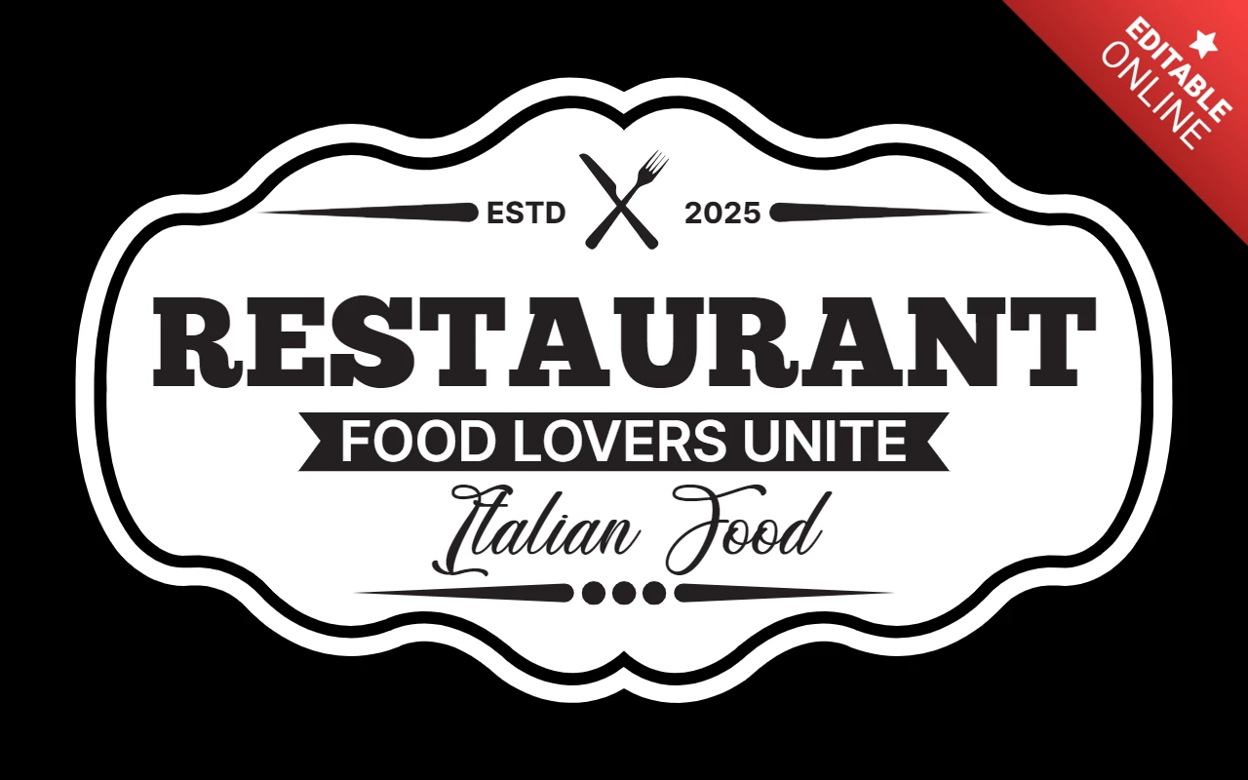 ***CIBO DIVINO***

***DIVINE FOOD***

FOOD

* PIZZA

It is a baked flatbread, usually round in shape, made with wheat flour, salt, water and yeast, topped with tomato sauce and cheese.

* PASTA

Pasta is made from a special type of grain, durum wheat, which is different from the soft grain used for common bread. The ground grain is made into flour or semolina, which is kneaded and shaped into different shapes.

* RIBOLLITA

The dish usually contains beans called cannellini beans and various vegetables such as carrots, zucchini, tomatoes, black cabbage or chard and red onions.

* CACIO E PEPE

Cheese and pepper are traditionally the only ingredients in this classic Roman dish. Combined with spaghetti, they create a delight famous for its creaminess, cheese and pepper. For such a seemingly simple dish, it can be a challenge to make the sauce without the cheese getting sticky and clumping together.

* Caponata

Caponata is a mixture of vegetables enriched with fresh tomato sauce, walnuts and olives.

DRINKS:

* CAFÉ
* BEER
* CAME
* WATER
* CAPUCHINO
* SODA
* JUICE

DESSERTS:

* Panna Cotta. ...
* Cannoli. ...
* Gelato. ...
* Sfogliatelle. ...
* Zuccotto. ...
* Panforte. ...
* Panettone.