

UDS

MY UNIVERSITY

DEGREE IN PSYCHOLOGY

2ST QUARTER

SUBJECT: ENGLISH 1

LIC. ALEJANDRA VIDAL ESCANDON

STUDENT: LETICIA DEL ROSARIO DE LA CRUZ TORRES

ACTIVITY:

SUPER NOTE

DELIVERY DATE: APRIL 18th 2025

PICHUCALCO CHIAPAS

FOOD

COUNTABLES AND COUNTABLES

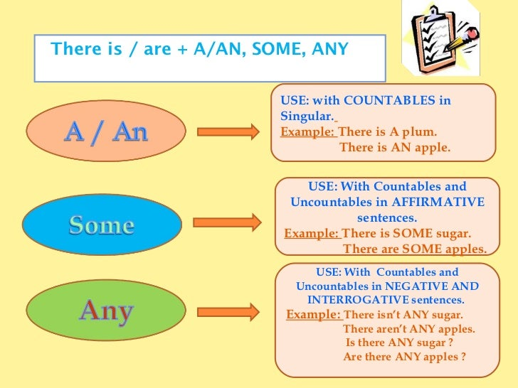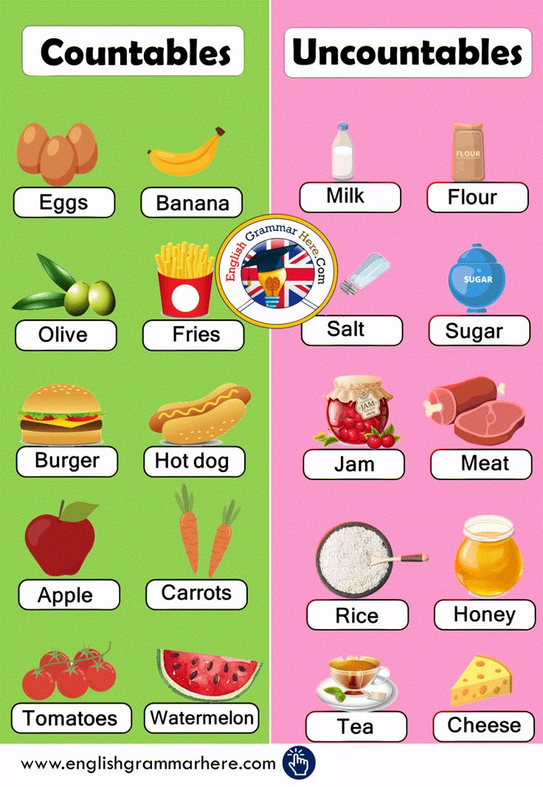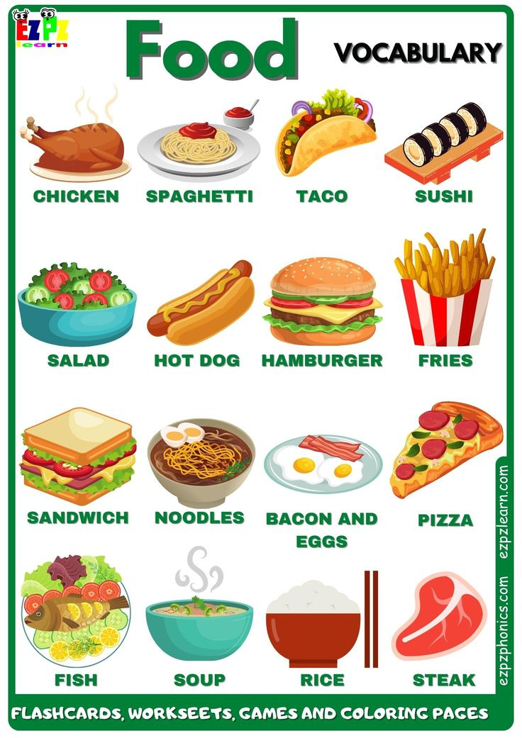

SOME/

ANY

Countable nouns are those elements that can be counted one by one using numbers. Uncountable nouns are those elements that we cannot count using numbers but can use quantifiers.

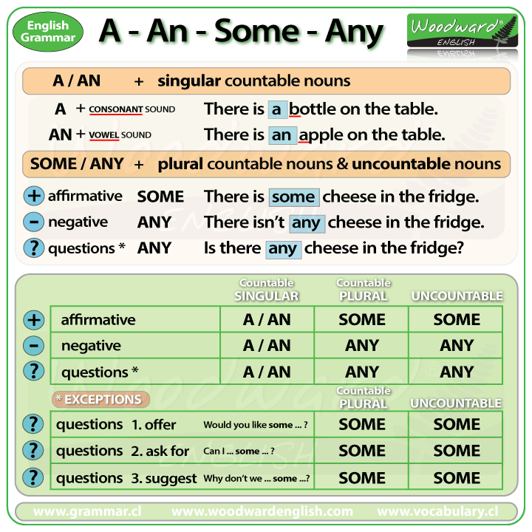

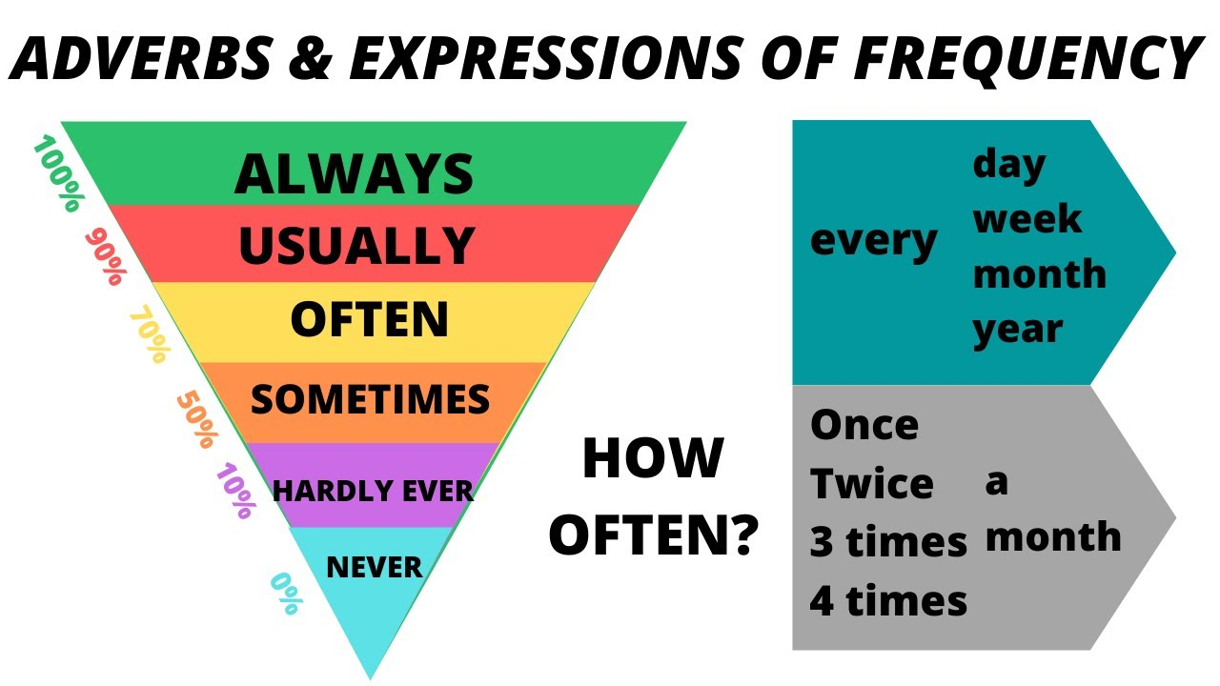

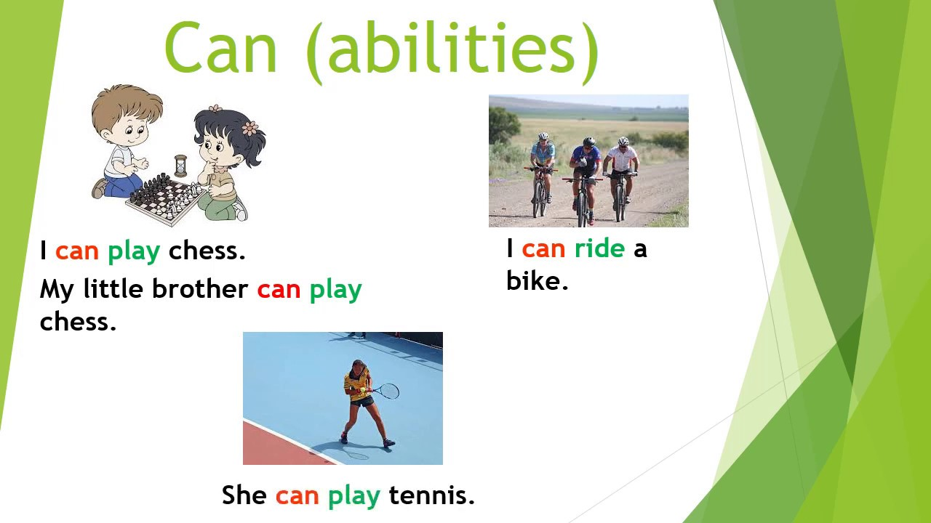

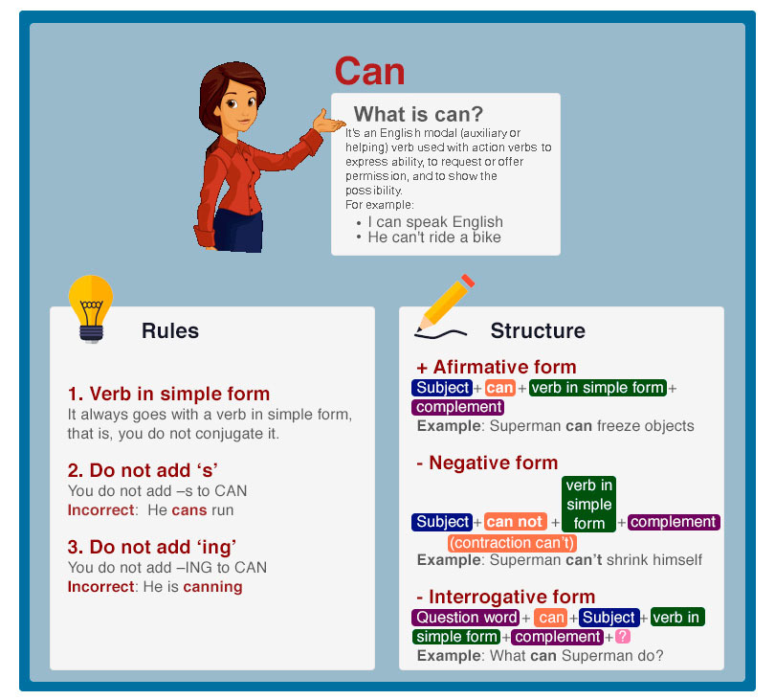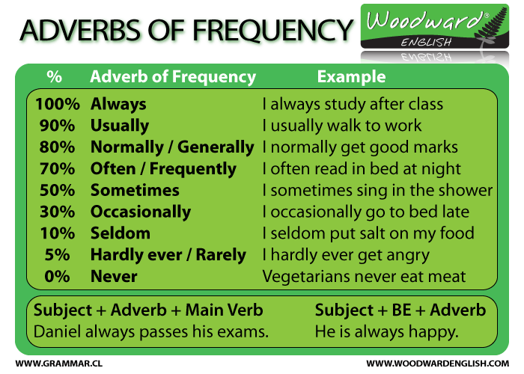

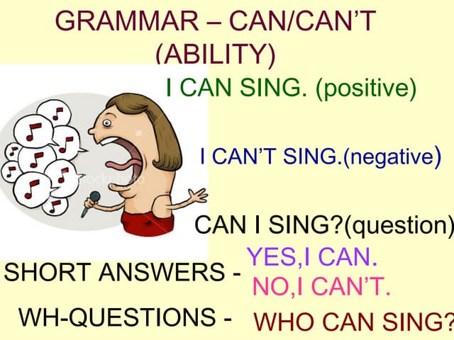

CAN´T

