**Super note**

***Student’s Name: Lizbeth Alessandra Santiago Velazco***

***Topic: Super note***

***Parcial: I***

***Subject: english 2***

***Teacher’s name: Lic. Alejandra Vidal***

***Quarter 2st Grade.***

***Pichucalco Chiapas: january 18, 2025.***

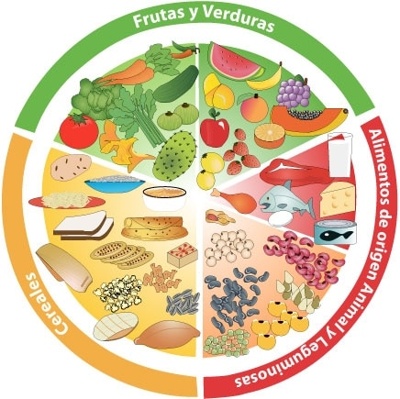

***I like: i dont like:***

***Potato Onion***

***Pasta Bread***

***Orange Apple***

***Cucumber Milk***

***Meat Cereal***

**FOOD**

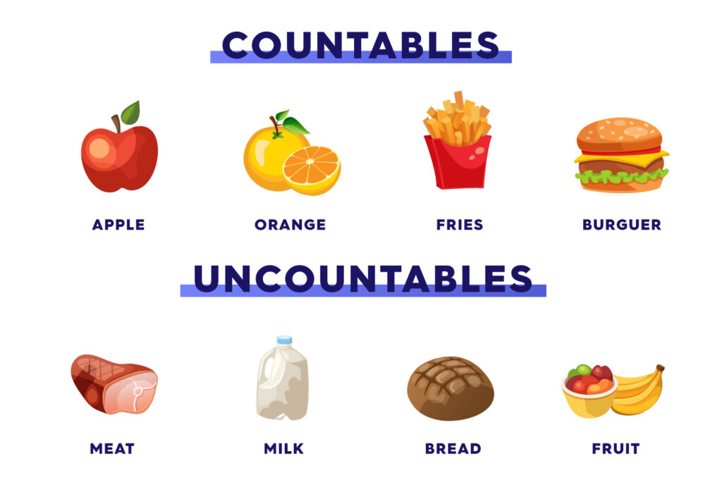

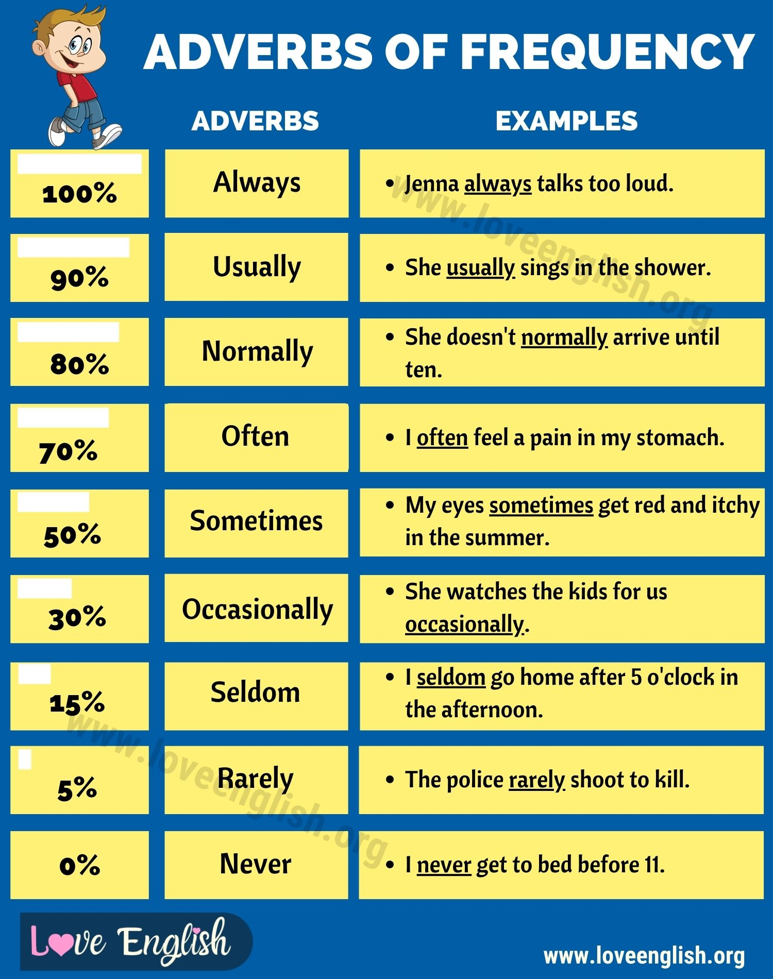

I need to buy some books

There are some apples here

We watched some fun videos

SOME

ANY

I dont have any money

Do you have any questions

I dont have any plans tonight

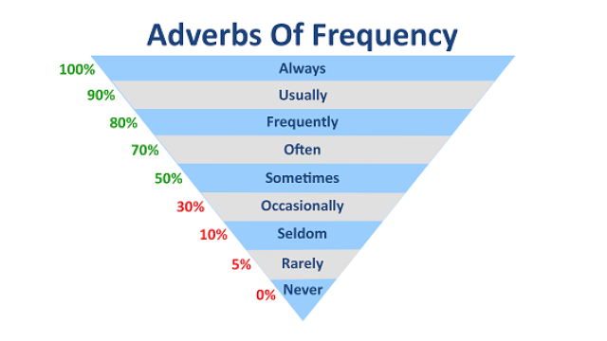

**AF IN VERB TO-BE**

Is peter usually sick

complement

adverb of frequency

subject

Verb to be

INTERROGATIVE

Nick is not usually in mexico

complement

adverbo of frequency

not

verb to be

subject

NEGATIVE

AFFIRMATIVE

subject

verb to be

Adverb of frequency

complement

Susan is always happy