**Unit Activity #1 – U1**

*Nombre del Alumno: Mauricio Sánchez Rivera*

*Nombre del tema: Unit 1*

*Parcial: Firts*

*Nombre de la Materia: English II*

*Nombre del profesor: Juan Manuel Jaime Díaz*

*Nombre de la Licenciatura: Psicología*

*Cuatrimestre: Second*

*Lugar y Fecha de elaboración*

Comitán de Domínguez Chiapas a 20 de enero de 2025.

**DOES IT HAVE A VIEW?**

**Exercise 1.** Write the parts of the house (Escribe las partes de la casa)

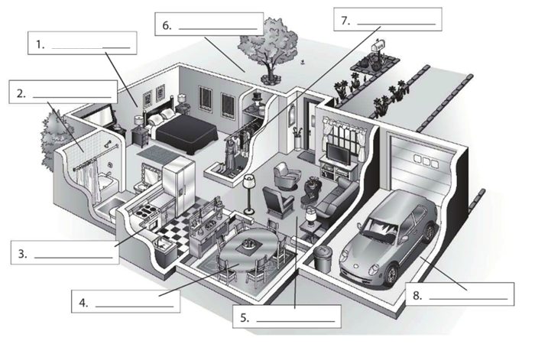

**Living room**

**Dinning room**

**bathroom**

**Garage**

**kitchen**

**closet**

**yard**

**bedroom**

**Exercise 2.** Complete the conversation. Use the sentences in the box (Completa la conversación usa las oraciones de la caja)

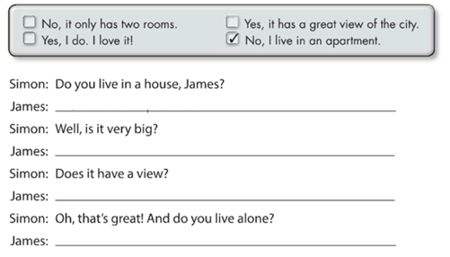

**Yes, it has a great view of the city**

**NO. It only has two rooms**

**Yes I do . I love it**

**No, I live in an apartment**

**Exercise 3.** Complete the conversation with the correct words in parenthese (Completa la conversación con las palabras correctas en parentesis)

**live**

**Do**

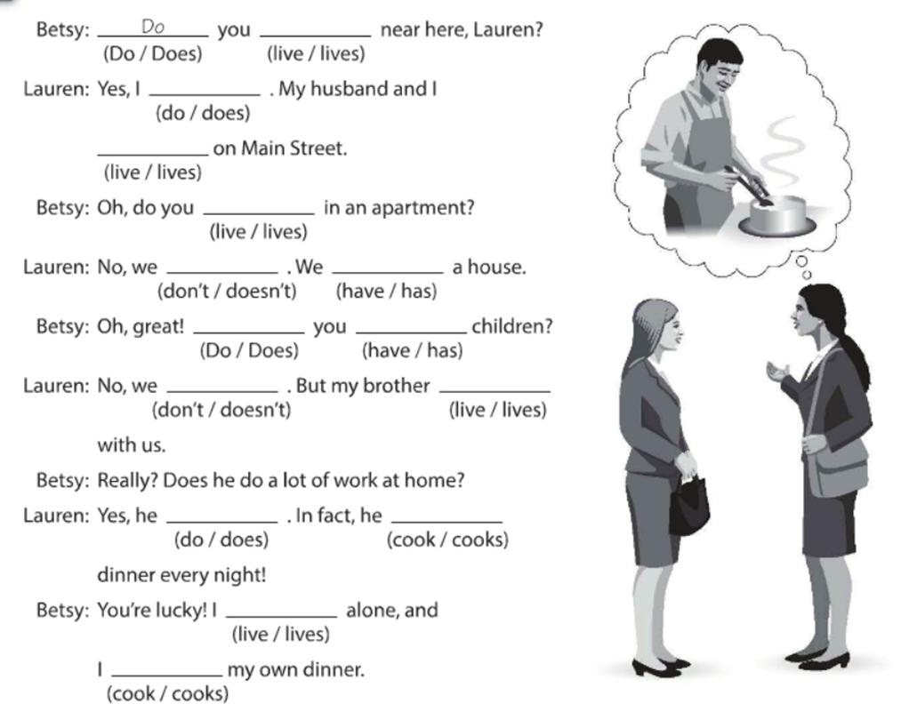

**cooks**

**Don´t**

**Don´t**

**cook**

**live**

**does**

**lives**

**have**

**do**

**have**

**live**

**live**

**do**

**Exercise 4.** Answer these questions with your personal information Use short answers (Completa estas preguntas con tu información personal, usa respuestas cortas)

**No, I don´t**

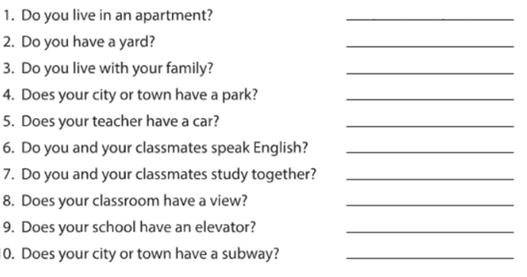

**No, it doesn´t**

**No, it doesn´t**

**Yes , it does**

**No we don´t**

**Yes we do**

**Yes , he does**

**Yes it does**

**Yes I do**

**No I don´t**

**Exercise 5.** Answer these questions about the pictures. (Responde las preguntas de acuerdo a la imagen)

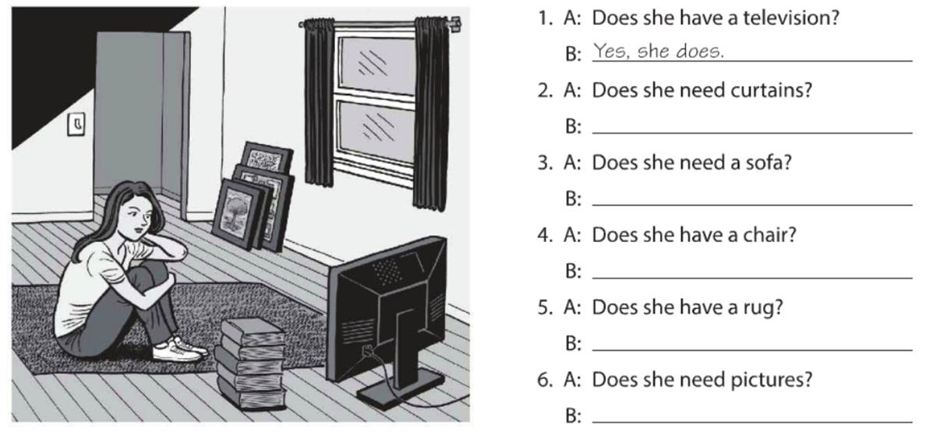

**No, she doesn´t**

**Yes,she does**

**No she doesn´t**

**Yes, she does**

**No , she doesn´t**

**Yes, she does**

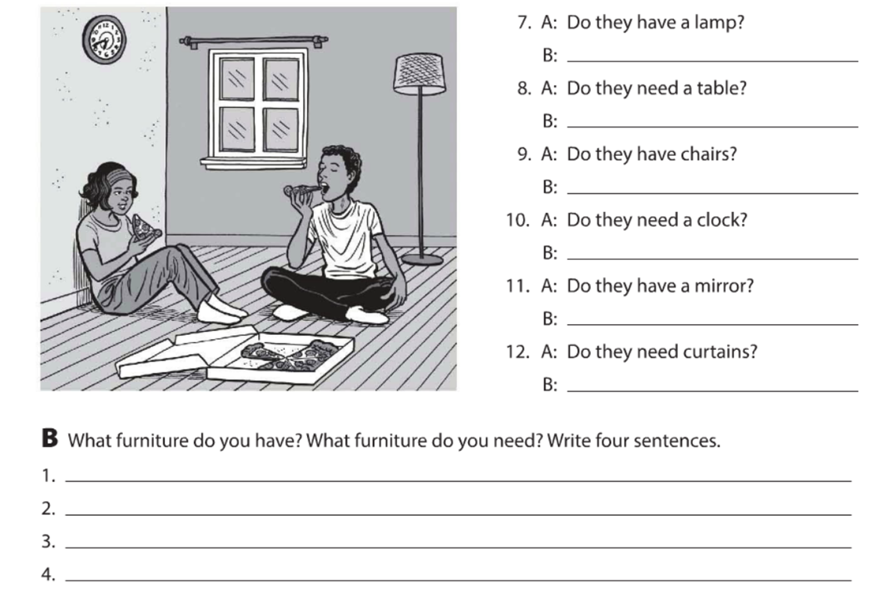

**I have a closet**

**I have a desk**

**I need a new mirror**

**I need a window**

**Yes, they do**

**No, they don´t**

**No, they don´t**

**No , they don´t**

**Yes, they do**

**Yes, they do**

**Exercise 6.** Complete the description with “ ´s, are or aren´t ”. (Completa la descripción con “ ´s, are or aren´t ”)

**‘s**

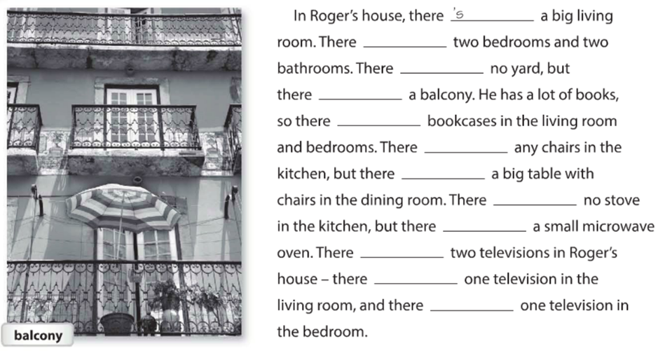

**´s**

**´s**

**´s**

**´s**

**aren´t**

**´s**

**Aren´t**

**´s**

**´s**

**Aren´t**

**´s**

**Exercise 7.** Answer these questions with information about your home. Use the phases in the box. (Responde las preguntas con información acerca de tu casa, usa la información de la caja).

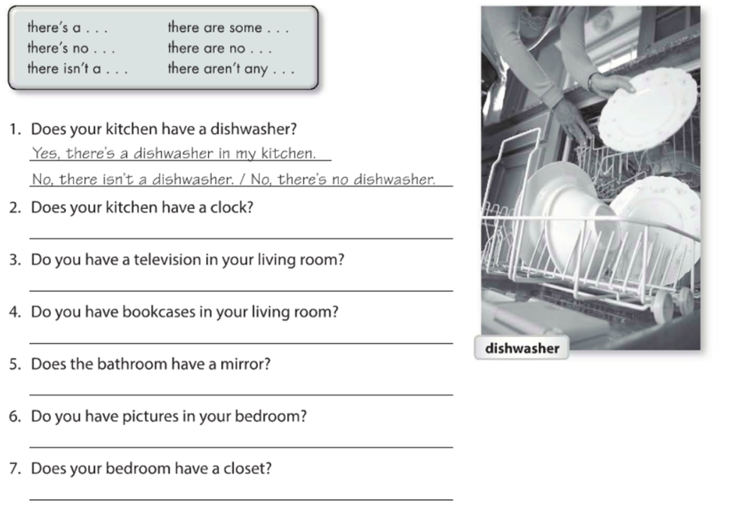

**Yes there´s a closet**

**no. there aren´t any pictures in my bedroom**

**Yes, there´s a mirror**

**No. There aren´t any bookcases**

**Yes. There´s a Television in my living room**

**No. there´s no clock**

**Exercise 8.** Write sentences about the house. Use “**there”** and the words in parentheses. (Escribe acerca de la casa, usa **“there”** y las palabras en parentesis).

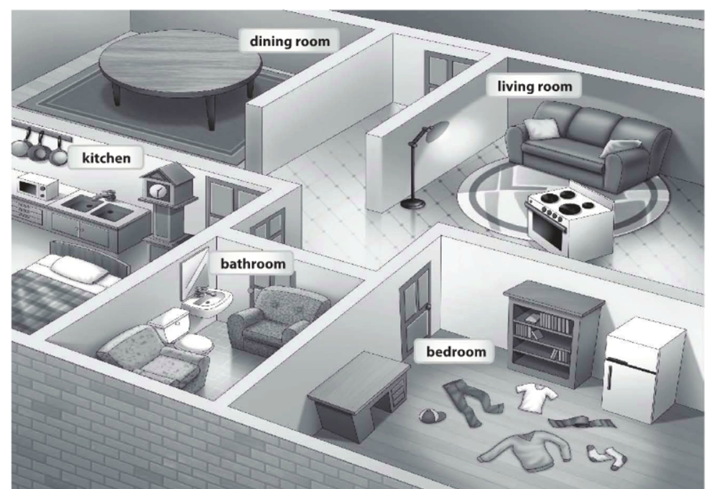

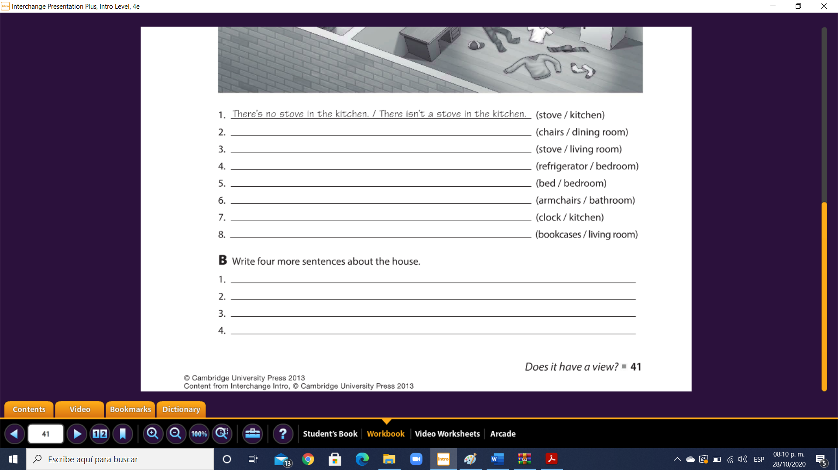

**There aren´t any chairs in the living room**

**There is a dresser in the bedroom**

**There isn´t a cupboard in the kitchen**

**There are some clothes in the bedroom**

**There aren´t any bookcases in the living room**

**There is a clock in the kitchen**

**There is a bed in the bathroom**

**There is not a bed in the bedroom**

**There is a refrigerator in the bedroom**

**There is a stove in the living room**

**There aren´t any chairs in the dining room**

**Exercise 9.** Chose the correct responses. (Escoge las respuestas correctas).

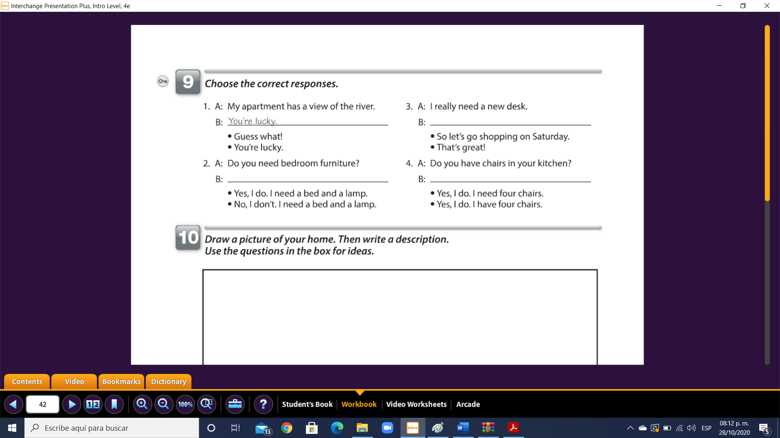

**Yes, I do . I need a bed and a lamp**

**Yes,I do . I have four chairs.**

**So let´s go shopping on saturday**

**Exercise 10.** Reading comprehension (Lectura de comprensión).

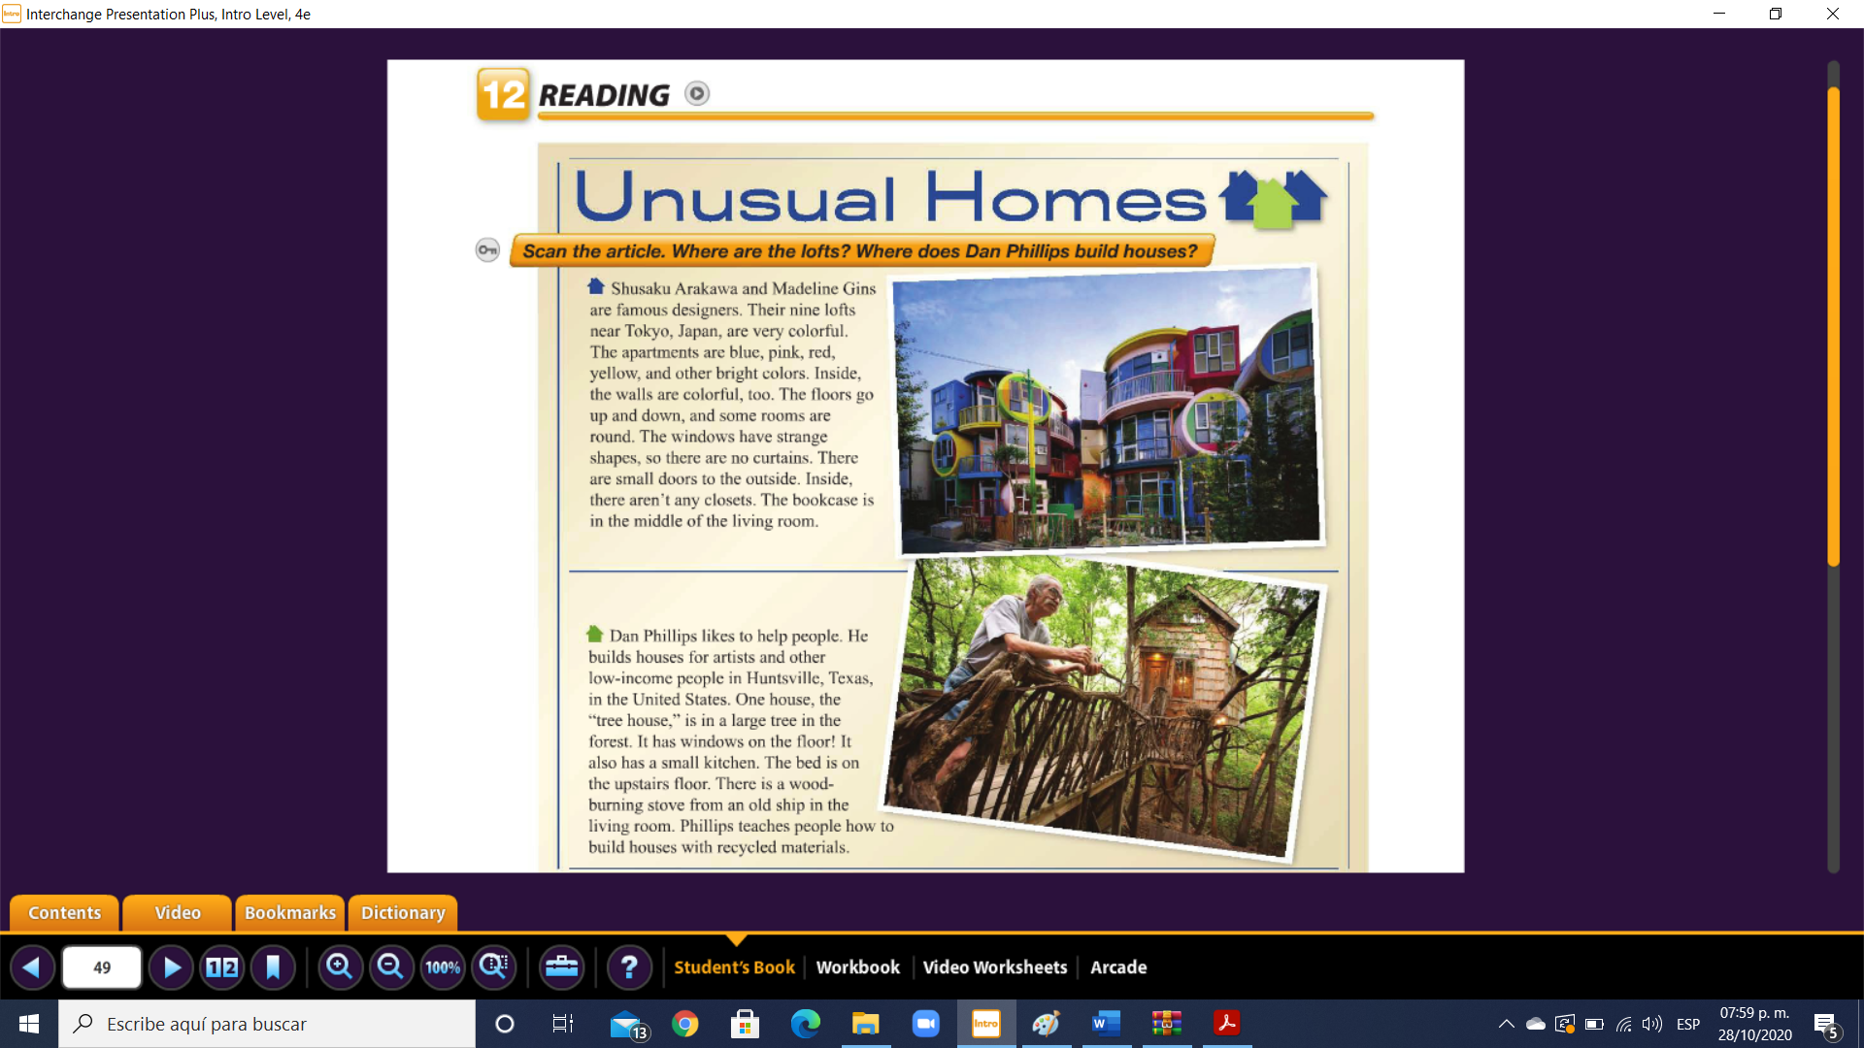

Complete the chart. (Completa la tabla).

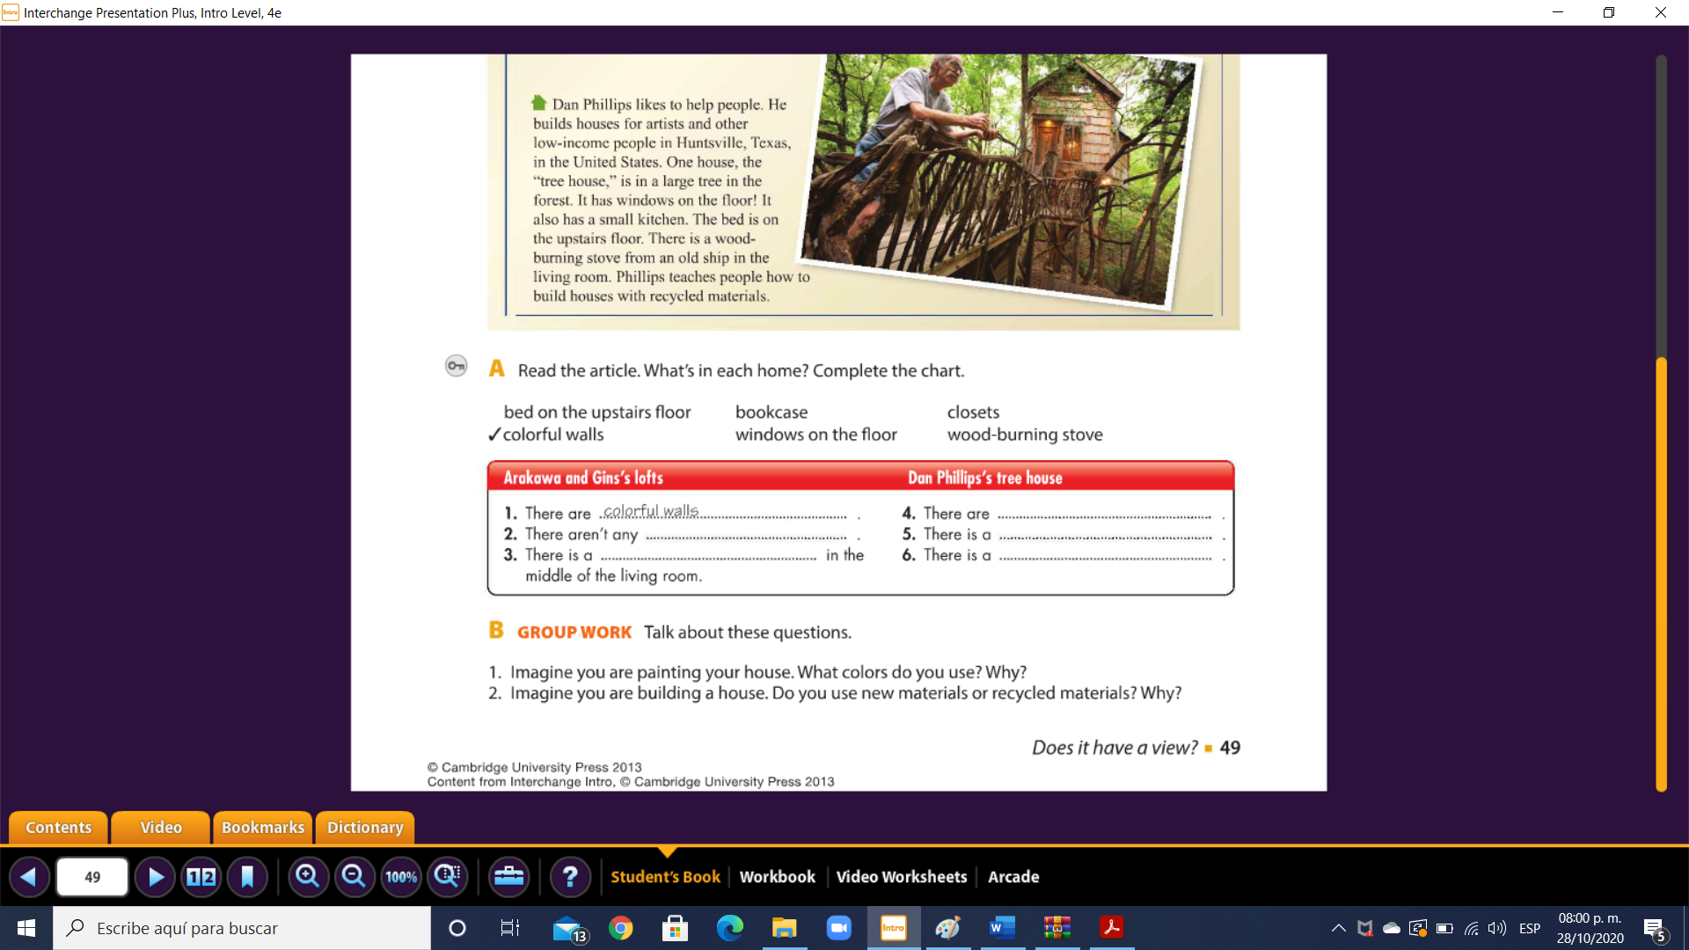

**Bed on the upstairs floor**

**Windows on the floor**

**Wood-burning stove**

**bookcase**

**closets**