**Unit Activity #1 – U1**

Comitán de Domínguez Chiapas a 20 de enero de 2025.

**DOES IT HAVE A VIEW?**

**Exercise 1.** Write the parts of the house (Escribe las partes de la casa)

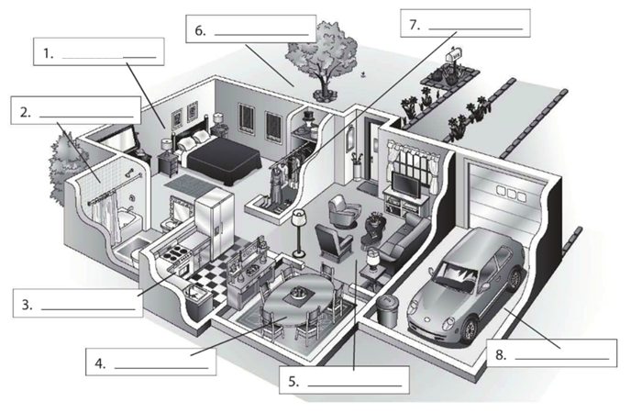

**Dining room**

**bathroom**

**Living room**

**garage**

**Kitchen**

**closet**

**yard**

**bedroom**

**Exercise 2.** Complete the conversation. Use the sentences in the box (Completa la conversación usa las oraciones de la caja)

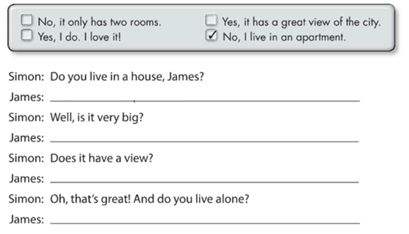

**Ansyes, it has a great view of the city**

**No, it only has two rooms**

**Yes, I do. I love it**

**No, I live in an apartment**

**Exercise 3.** Complete the conversation with the correct words in parenthese (Completa la conversación con las palabras correctas en parentesis)

**live**

**Do**

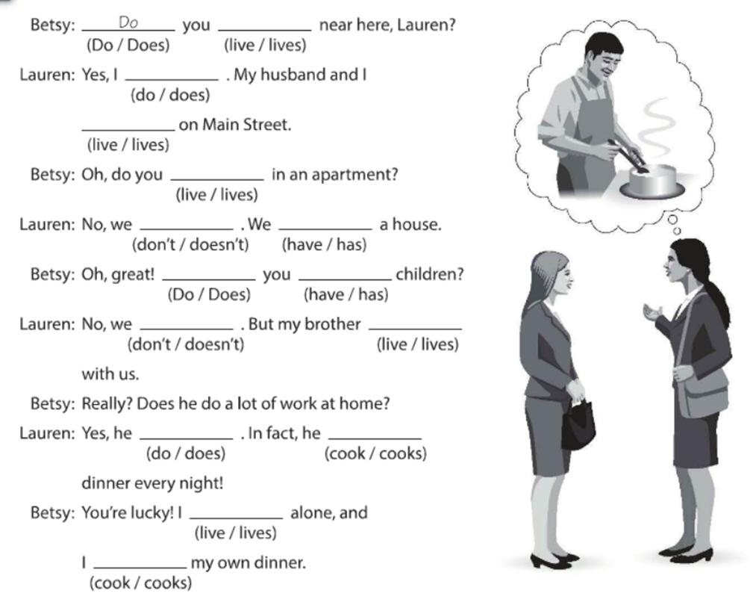

**cooks**

**Don´t**

**Don´t**

**cook**

**Anslivce**

**does**

**lives**

**have**

**Do**

**have**

**Live**

**live**

**do**

**Exercise 4.** Answer these questions with your personal information Use short answers (Completa estas preguntas con tu información personal, usa respuestas cortas)

**Yes, I do or No, I don´t**

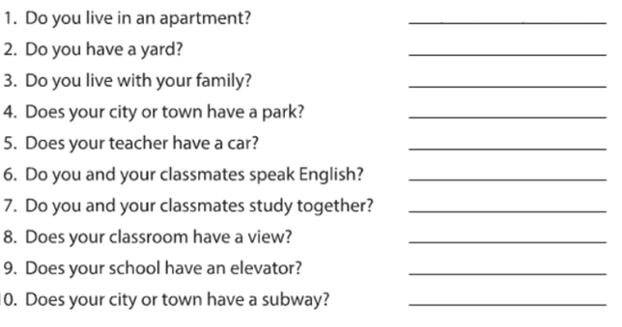

**No, it doesn´t**

**No, it doesn´t**

**Yes, It does**

**Yes, we do**

**Yes, we do**

**Yes, he does**

**Yes, it does**

**Yes, I do**

**nswer**

**Yes, I do**

**Exercise 5.** Answer these questions about the pictures. (Responde las preguntas de acuerdo a la imagen)

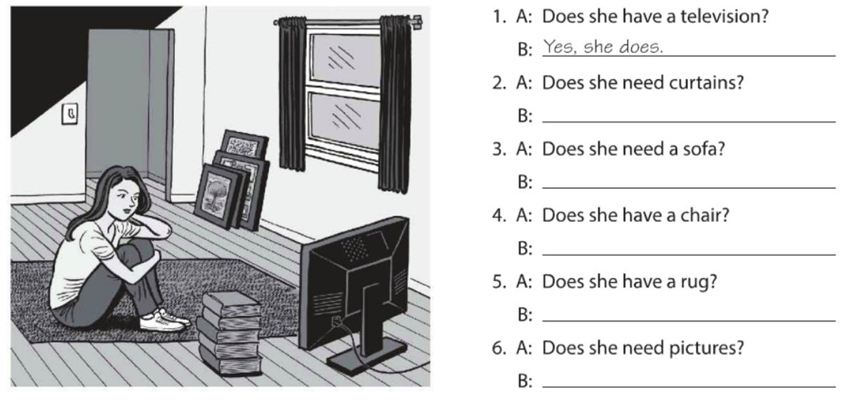

**Yes, she does**

**No, she doesn´t**

**No, she doesn´t**

**Yes, she does**

**No, she doesn´t**

**Yes, she does**

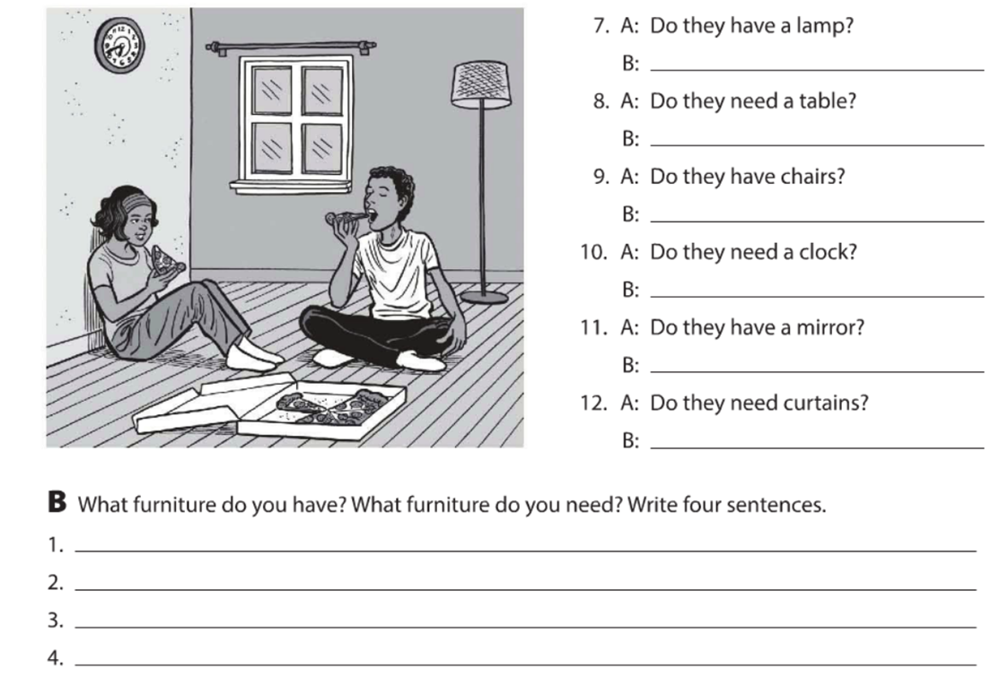

**I want buy a new vanity for my room**

**I want a new bed because what I have now is so short.**

**I have a closed and it is a full of clothes.**

**I have a bed in my room.**

**Yes, they do**

**No, they don´t**

**No, they don´t**

**No, they don´t**

**Yes, they do**

**Yes, they do**

**Exercise 6.** Complete the description with “ ´s, are or aren´t ”. (Completa la descripción con “ ´s, are or aren´t ”)

**‘s**

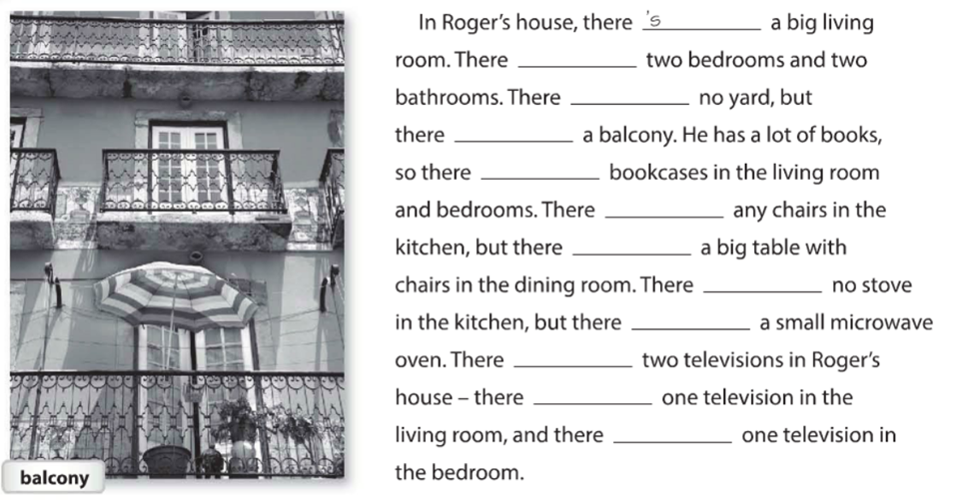

**´s**

**´s**

**´s**

**´s**

**´s**

**´s**

**Aren´t**

**´s**

**´s**

**Aren´t**

**´s**

**Exercise 7.** Answer these questions with information about your home. Use the phases in the box. (Responde las preguntas con información acerca de tu casa, usa la información de la caja).

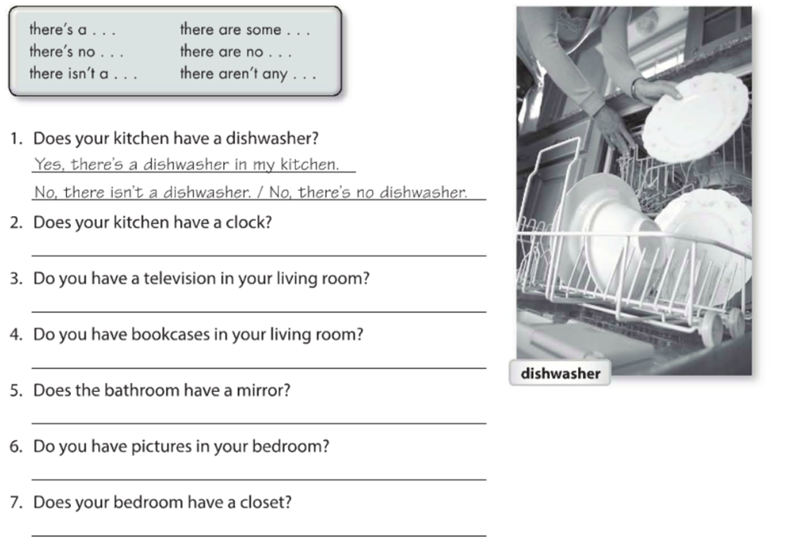

**Yes, there´s a closet in my bedroom**

**No, there isn´t pictures in my bedroom**

**Yes, there´s a mirror in my bathroom**

**No, there´s a bookcases in my living room**

**Yes, there´s a television in my living room**

**Yes, there´s a clock in my kitchen**

**Exercise 8.** Write sentences about the house. Use “**there”** and the words in parentheses. (Escribe acerca de la casa, usa **“there”** y las palabras en parentesis).

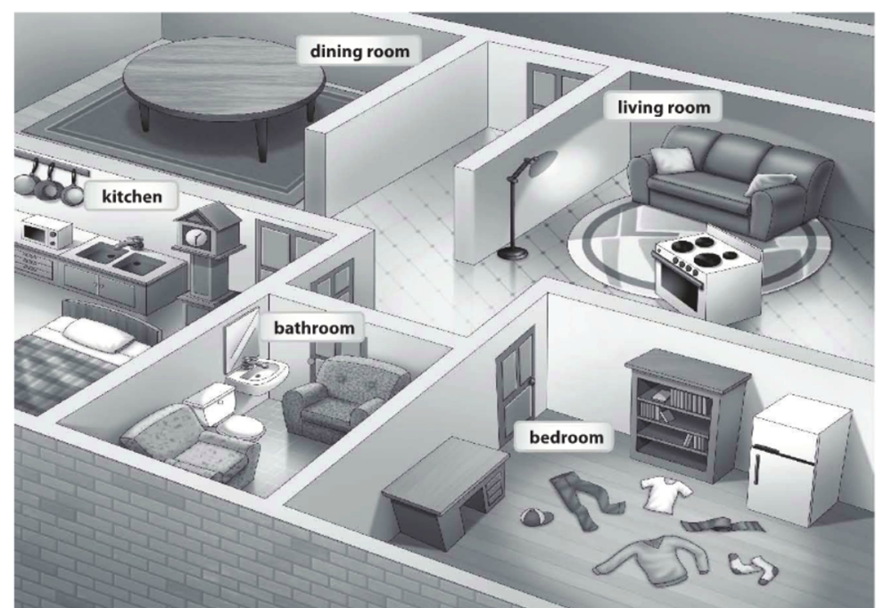

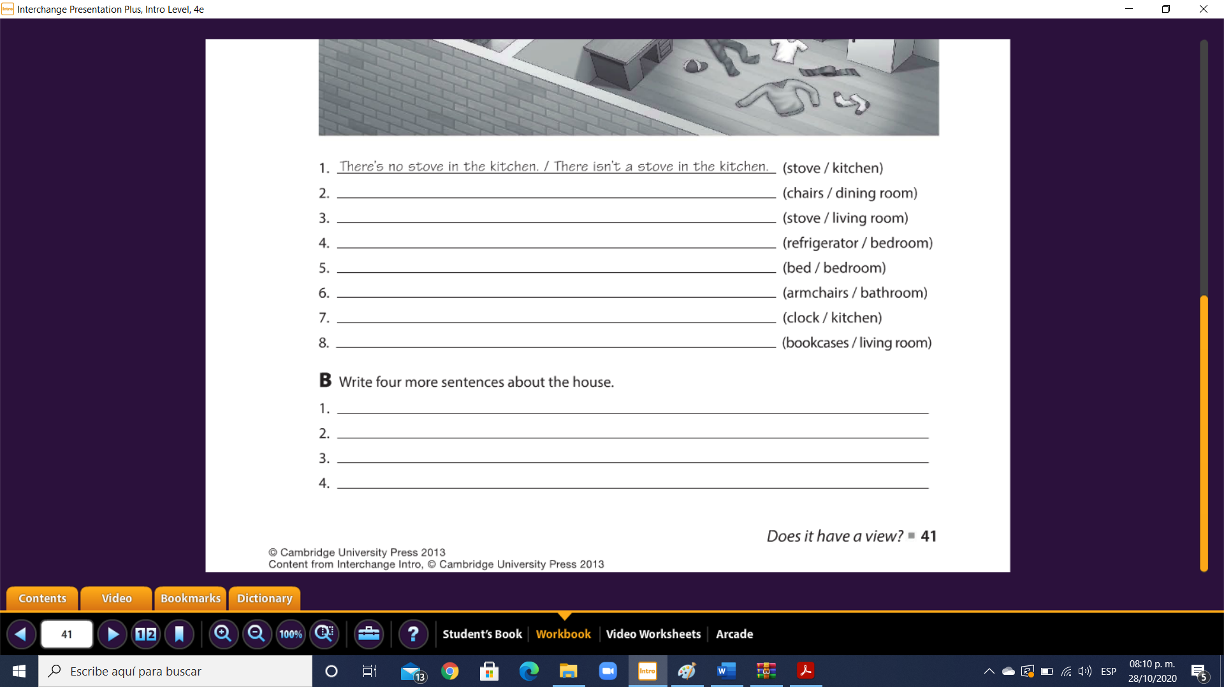

**In the dining room isn´t there chairs… where I get sit…**

**In the house the refrigerator are in the bedroom… I don´t know why if it need to be in the kitchen**

**The bed is in the kitchen but it doesn´t have to be there**

**In the house all the clothes are in the floor because isn´t a closet in the bedroom**

**There´s not a bookcases in the living room**

**There´s a clock in the kitchen**

**There´s armchairs in the badroom**

**There´s no a bed in the bedroom**

**There´s a refrigerator in the bedroom**

**There´s a stove in the living room**

**There´s no chairs in the dining room**

**Exercise 9.** Chose the correct responses. (Escoge las respuestas correctas).

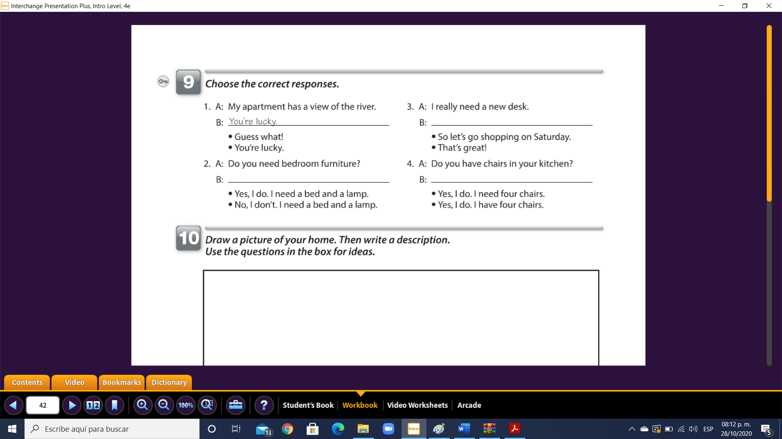

**Yes, I do. I have four chairs**

**Yes, I do. I need a bed and a lamp**

**So let´s go shopping on saturday**

**Exercise 10.** Reading comprehension (Lectura de comprensión).

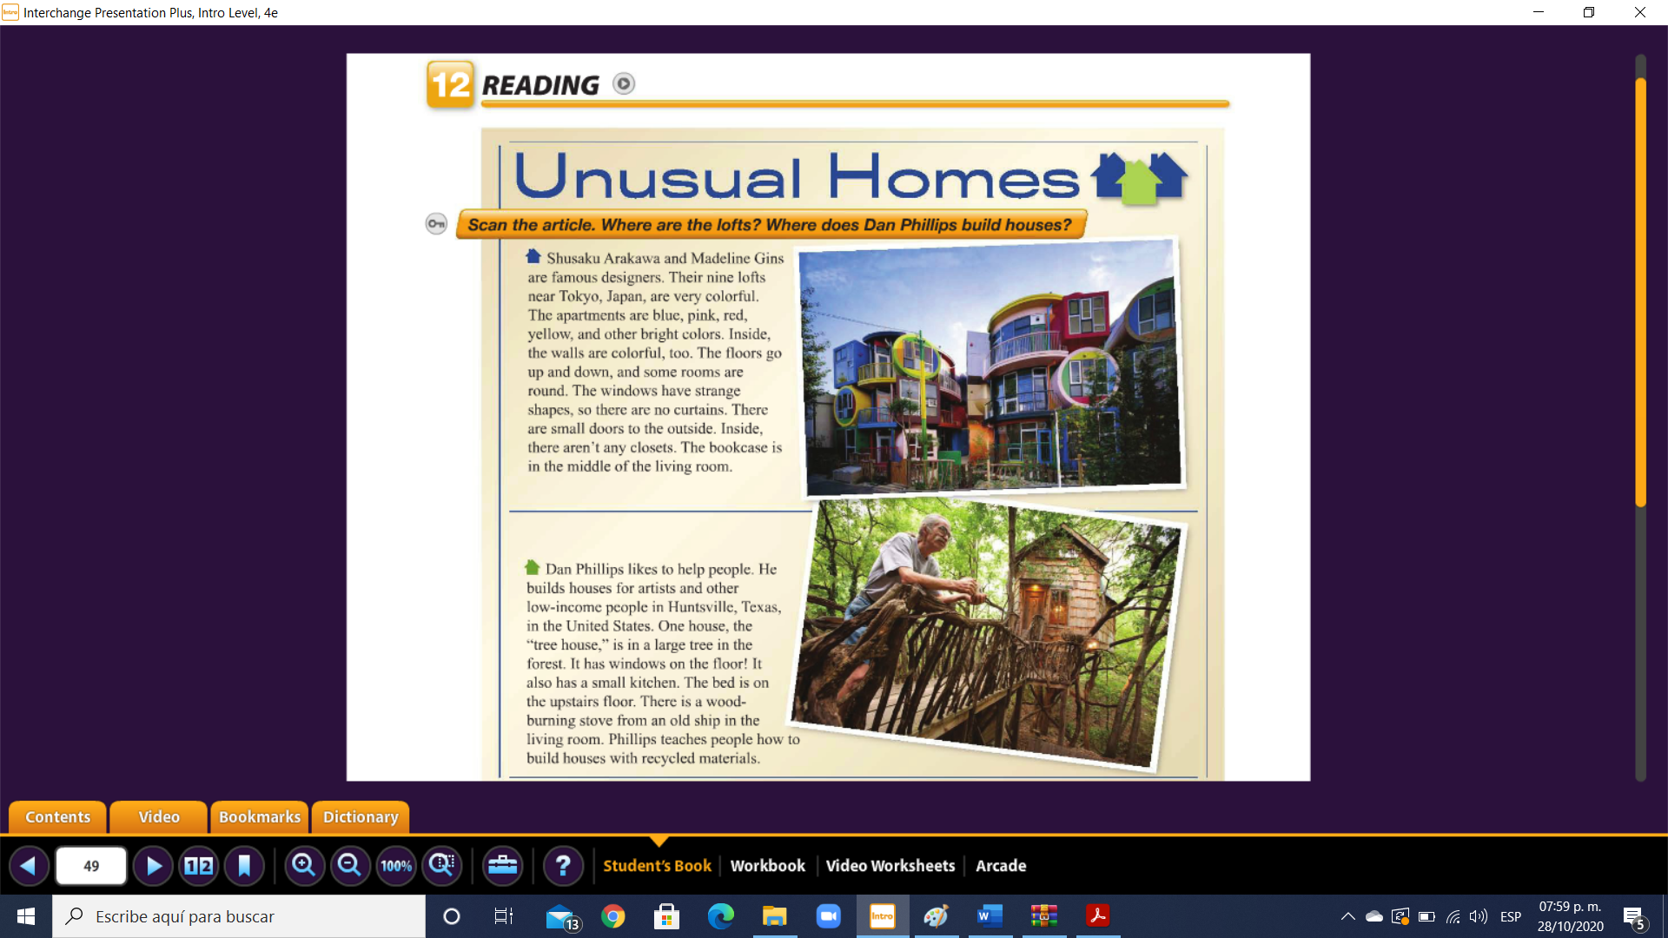

Complete the chart. (Completa la tabla).

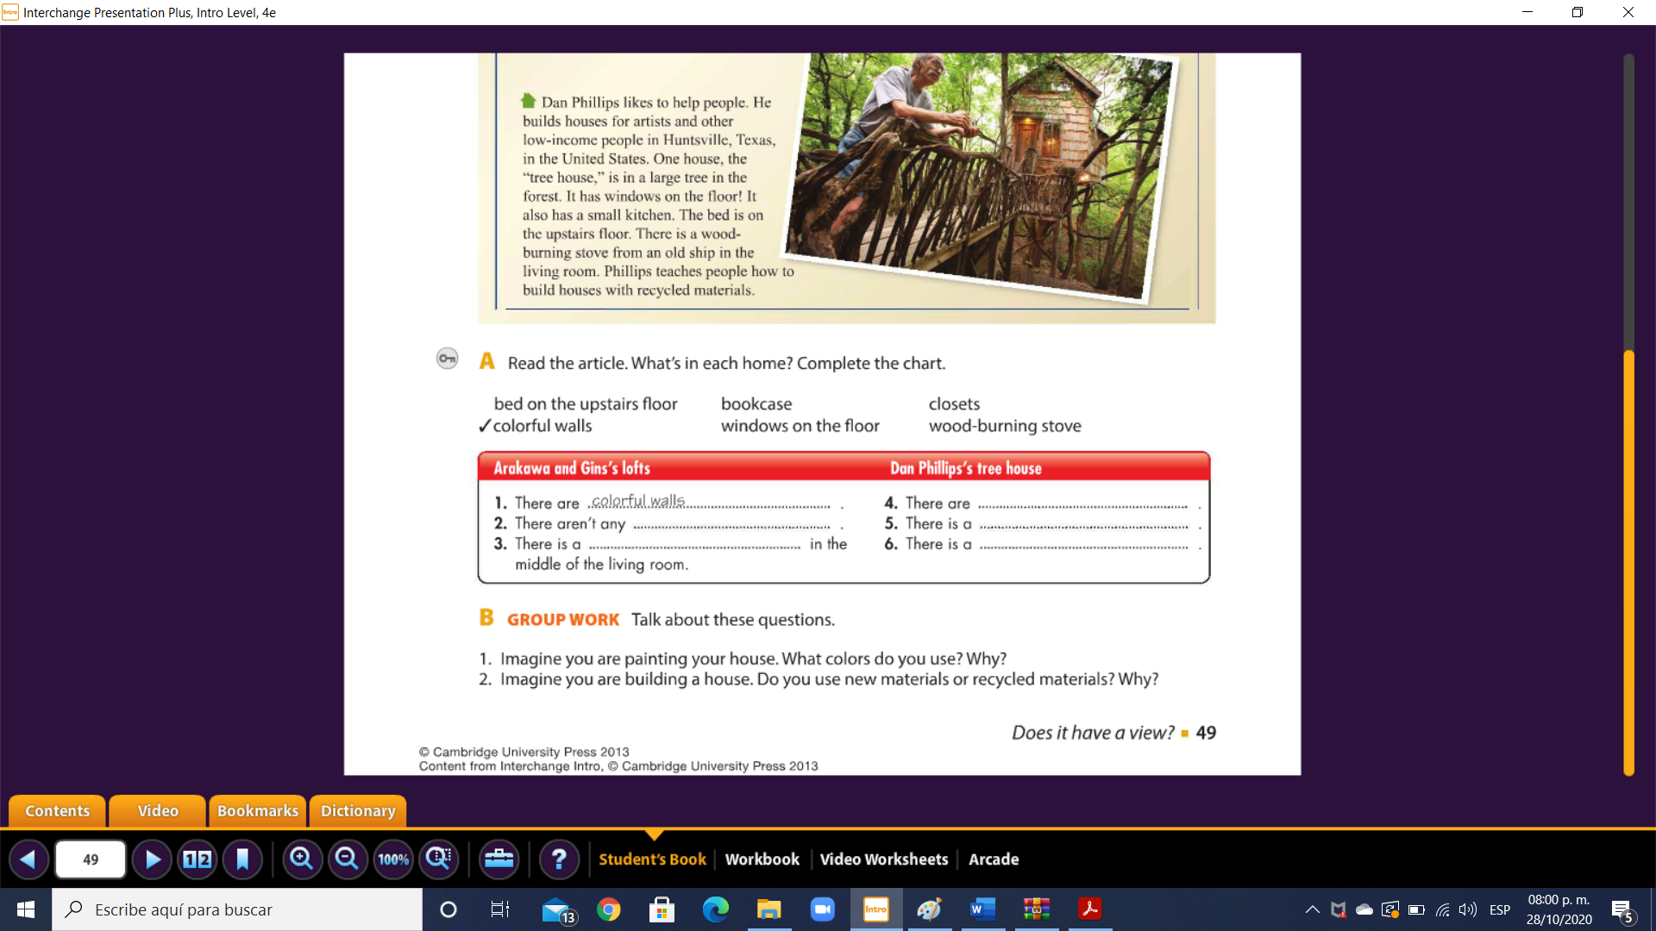

**bookcase**

**Wood-burning stove**

**Bed on the upstairs floor**

**Windows on the floor**

**closets**