

Nombre del alumno: Cinthia jackeline Villatoro Gómez

Nombre del tema: Conversation Jobs

Parcial: 2

Nombre de la materia: Ingles 2

Nombre del catedrático: Rafael Ivan Guillen Alcala

Nombre de la licenciatura: Medicina Veterinaria y Zootecnia

Cuatrimestre: 2

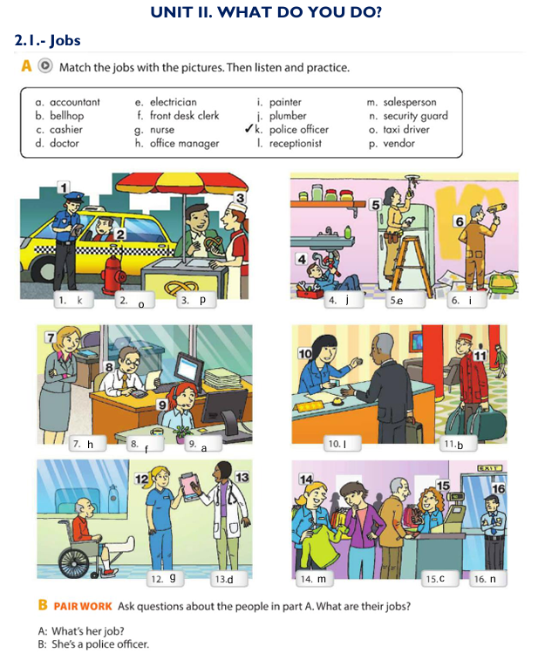

Receptionist: Good morning! Welcome to Sunshine Hotel. How can I assist you today?

\*Client: Hi, I have a reservation under the name Johnson.

\*Receptionist: Let me check that for you. Could you please provide me with your ID?

\*Client: Sure, here it is.

\*Receptionist: Thank you, Mr. Johnson. I see your reservation for a double room for three nights. Would you like any assistance with your luggage?

\*Client: Yes, please. That would be great.

\*Receptionist: Perfect! I'll have someone bring your bags to your room. Here’s your room key. You're in room 204, and breakfast is served in the dining area from 7 to 10 AM.

\*Client: Thank you! Is there a gym in the hotel?

\*Receptionist: Yes, we have a gym on the second floor, open 24 hours for guests.

\*Client: Awesome! Thank you for your help.

\*Receptionist: You're welcome! Enjoy your stay with us!

---