**Unit Activity #1 – U1**

*Nombre del Alumno: Cesar Antonio Franco Cordova*

*Nombre del tema: Unit 1*

*Parcial: Firts*

*Nombre de la Materia: English II*

*Nombre del profesor: Juan Manuel Jaime Díaz*

*Nombre de la Licenciatura: Arquitectura*

*Cuatrimestre: Second*

*Lugar y Fecha de elaboración*

Comitán de Domínguez Chiapas a 25 de enero de 2025.

**DOES IT HAVE A VIEW?**

**Exercise 1.** Write the parts of the house (Escribe las partes de la casa)

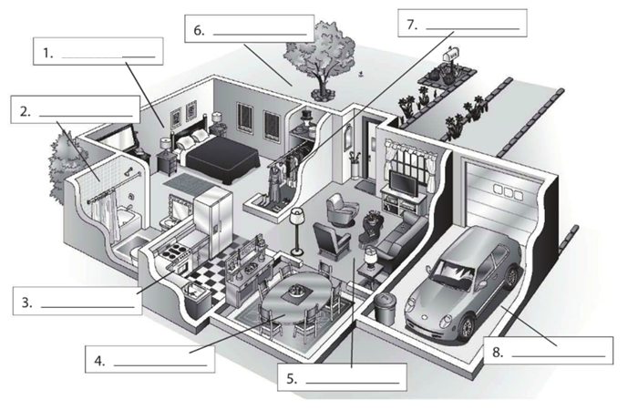

**Bathroom**

**Dining room**

**Living room**

**Garage**

**Kitchen**

**closet**

**Garden**

**bedroom**

**Exercise 2.** Complete the conversation. Use the sentences in the box (Completa la conversación usa las oraciones de la caja)

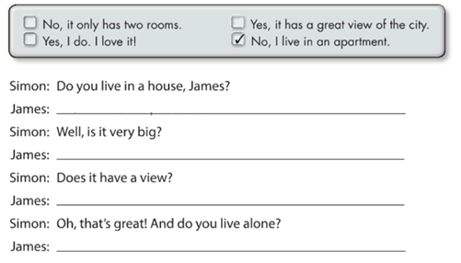

**Yes, it has a great view of the city**

**No , it only has two rooms**

**Yes , I do . I love it**

**No, I live in an apartment**

**Exercise 3.** Complete the conversation with the correct words in parenthese (Completa la conversación con las palabras correctas en parentesis)

**Live**

**Do**

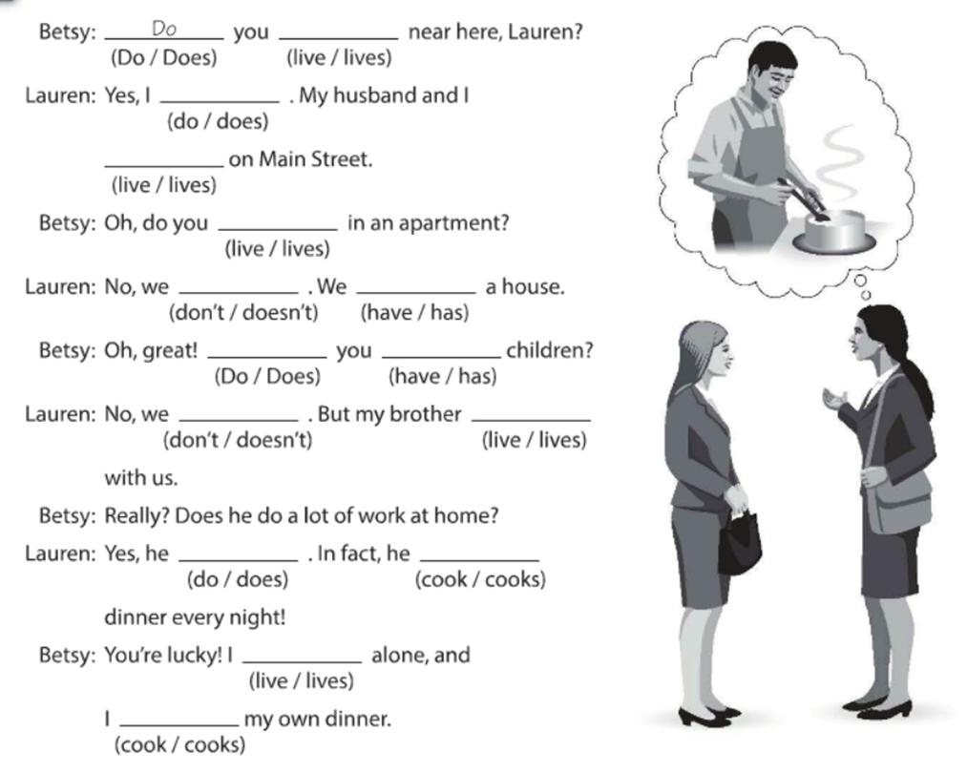

**cooks**

**cook**

**live**

**does**

**lives**

**dont**

**have**

**do**

**dont**

**have**

**live**

**live**

**do**

**Exercise 4.** Answer these questions with your personal information Use short answers (Completa estas preguntas con tu información personal, usa respuestas cortas)

**Yes, I do or No, I don´t**

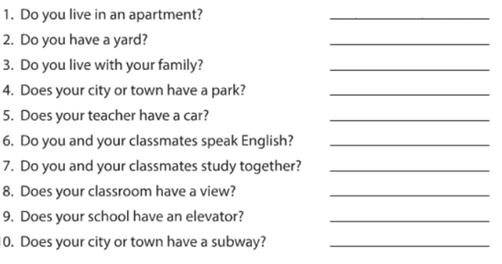

**No I dont**

**No it isnt**

**Yes it does**

**No we dont**

**Yes I do**

**Yes he does**

**No I dont**

**Yes I do**

**YES I DO**

**Exercise 5.** Answer these questions about the pictures. (Responde las preguntas de acuerdo a la imagen)

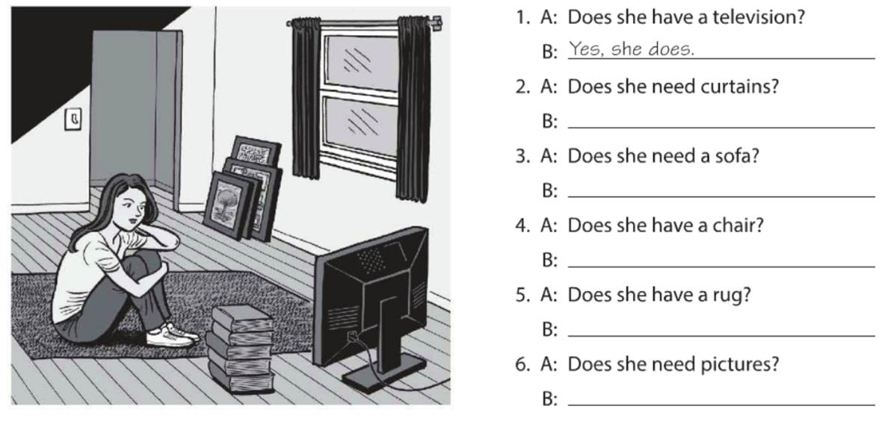

**Yes she does**

**No she doesnt**

**No she dont**

**No she doesnt**

**Yes she does**

**Yes, she does**

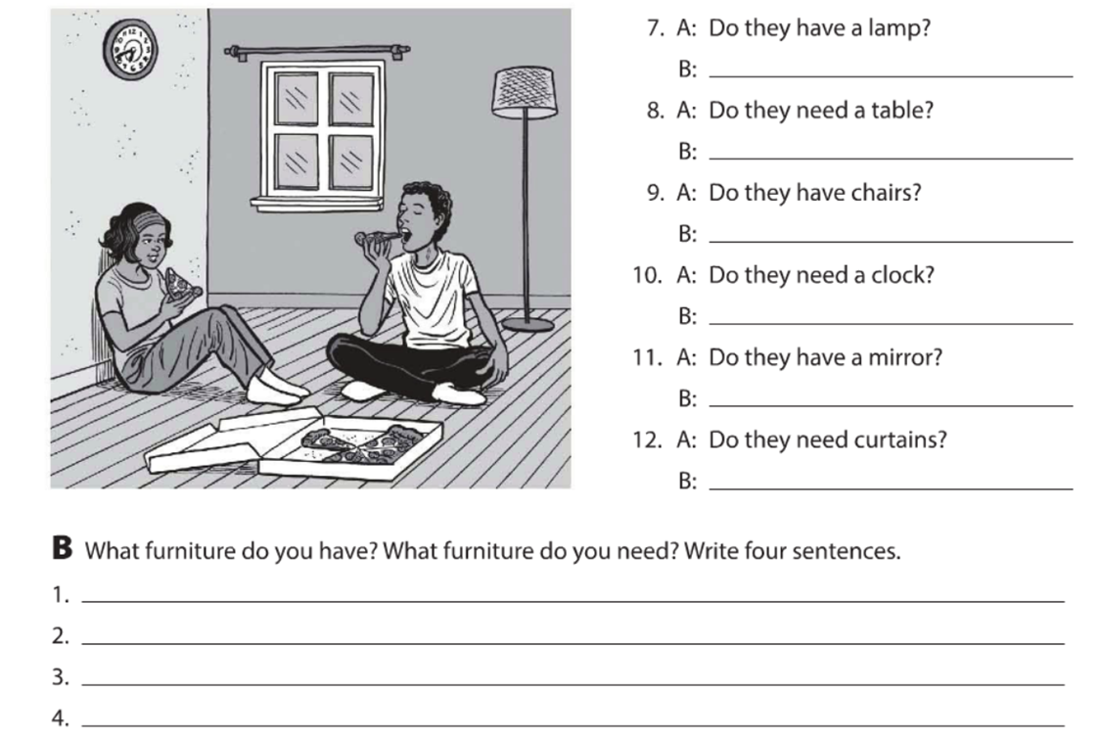

**answer**

**answer**

**answer**

**answer**

**answer**

**answer**

**answer**

**answer**

**answer**

**answer**

**Exercise 6.** Complete the description with “ ´s, are or aren´t ”. (Completa la descripción con “ ´s, are or aren´t ”)

**‘s**

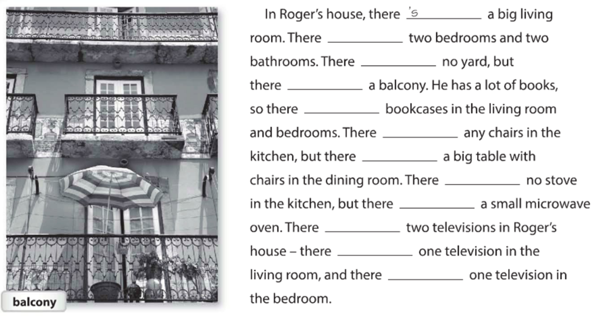

**answer**

**answer**

**answer**

**answer**

**answer**

**answer**

**answer**

**answer**

**answer**

**answer**

**answer**

**Exercise 7.** Answer these questions with information about your home. Use the phases in the box. (Responde las preguntas con información acerca de tu casa, usa la información de la caja).

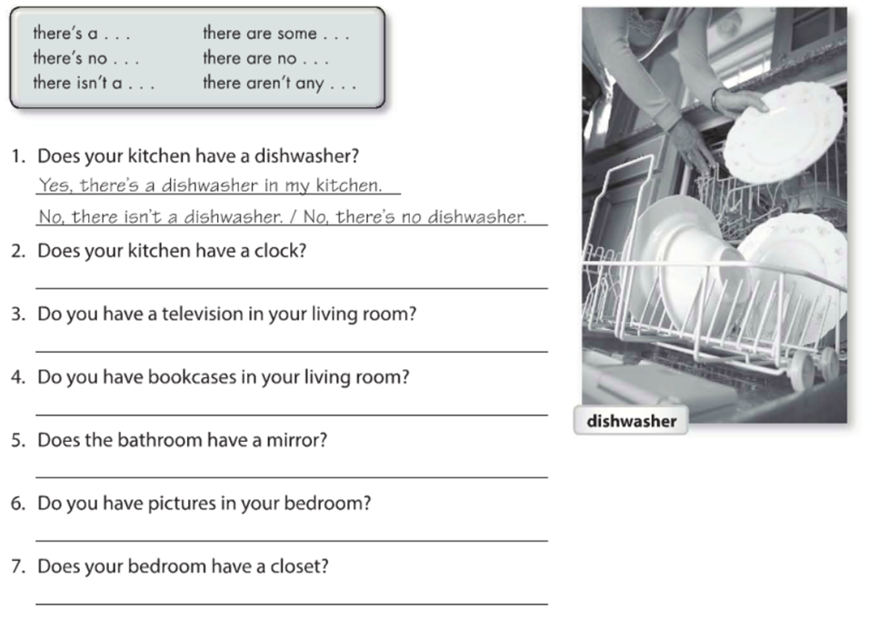

**answer**

**answer**

**answer**

**answer**

**answer**

**answer**

**Exercise 8.** Write sentences about the house. Use “**there”** and the words in parentheses. (Escribe acerca de la casa, usa **“there”** y las palabras en parentesis).

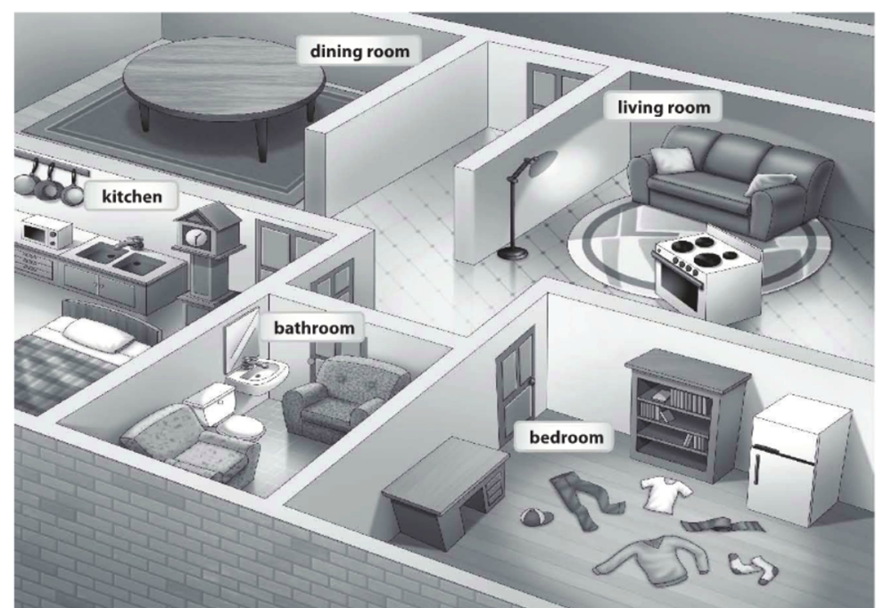

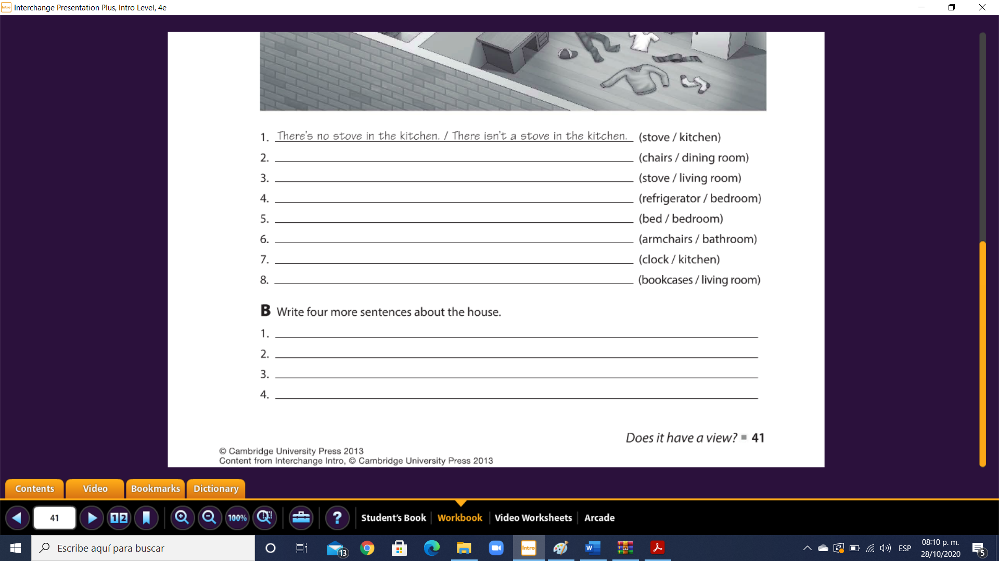

**answer**

**answer**

**answer**

**answer**

**answer**

**answer**

**answer**

**answer**

**answer**

**answer**

**answer**

**Exercise 9.** Chose the correct responses. (Escoge las respuestas correctas).

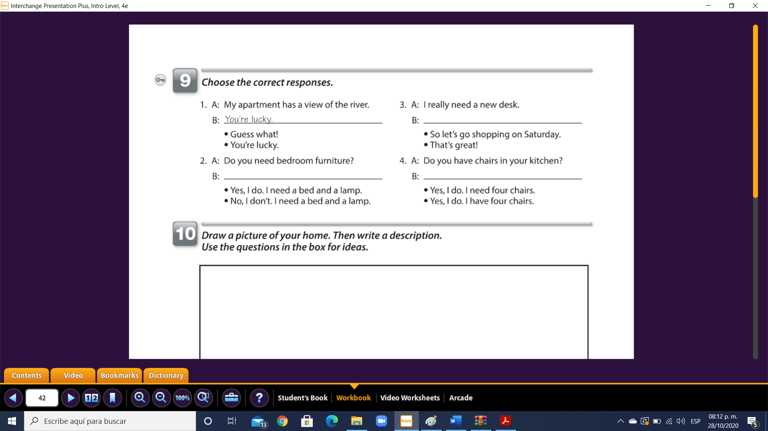

**answer**

**answer**

**answer**

**Exercise 10.** Reading comprehension (Lectura de comprensión).

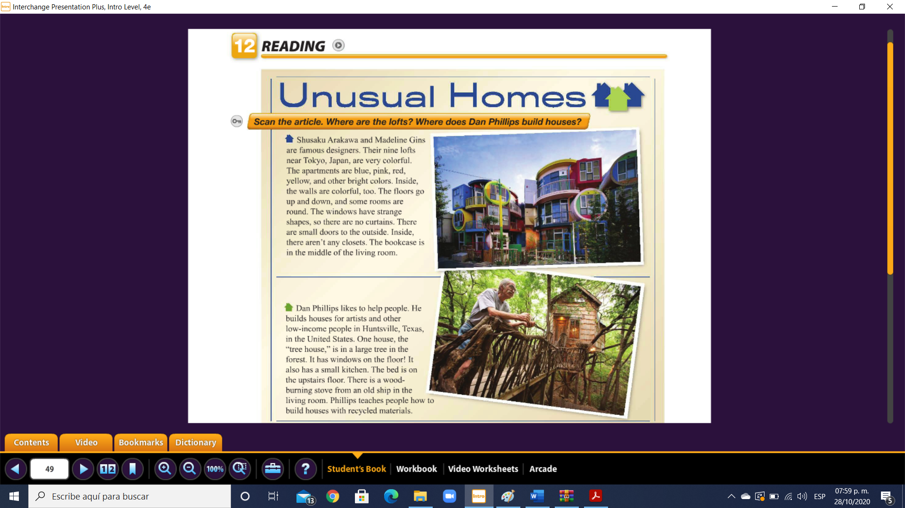

Complete the chart. (Completa la tabla).

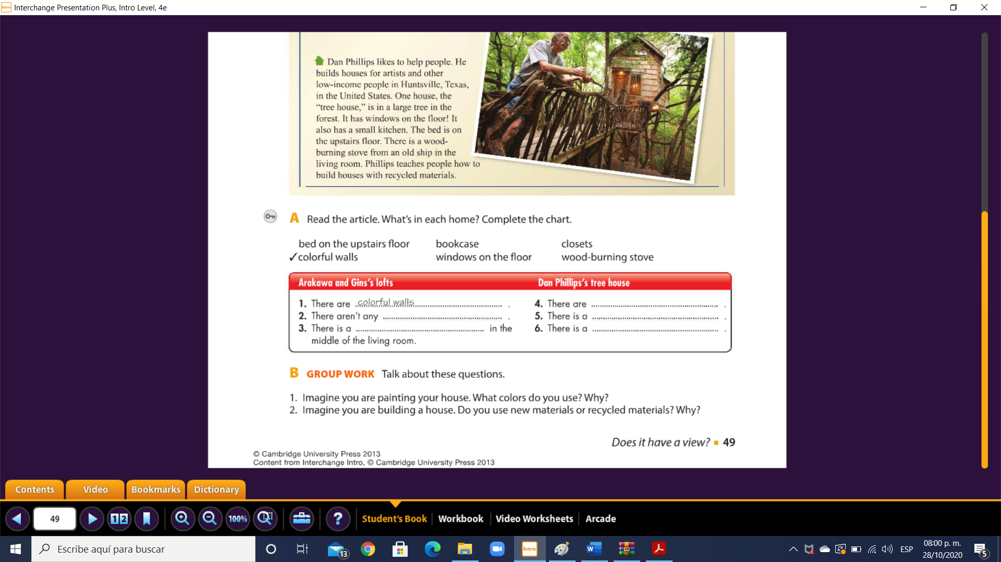

**answer**

**answer**

**answer**

**answer**

**answer**