



Unit Activity #1 – U1

*Nombre del Alumno: Sergio jhony López Dilma Nombre del tema: Unit 1*

*Parcial: Firts*

*Nombre de la Materia: English II*

*Nombre del profesor:Juan Manuel Jaime Díaz Nombre de la Licenciatura: arquitectura Cuatrimestre: Second*

Comitán de Domínguez Chiapas a 20 de enero de 2025.

**DOES IT HAVE A VIEW?**

**Exercise 1.** Write the parts of the house (Escribe las partes de la casa)

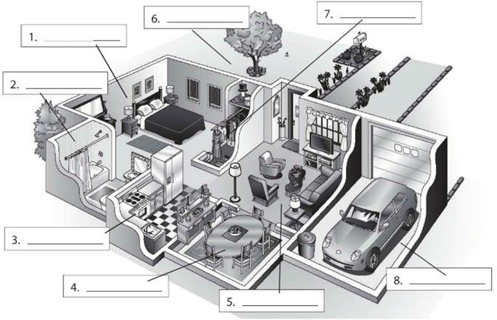

**Yard**

**Closet**

**bedroom**

**Bathdroom**

**kitchen**

**Dining room**

**Garage**

**Living room**

**Exercise 2.** Complete the conversation. Use the sentences in the box (Completa la conversación usa las oraciones de la caja)

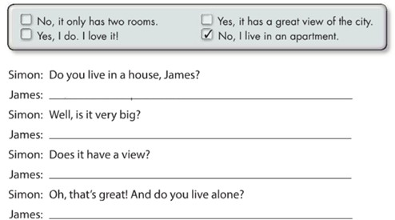

**No, I live in an apartment**

**No, it only has two rooms**

**Yes, it has a great view of the city**

**Yes, I do, I love it**

**Exercise 3.** Complete the conversation with the correct words in parenthese (Completa la conversación con las palabras correctas en parentesis)

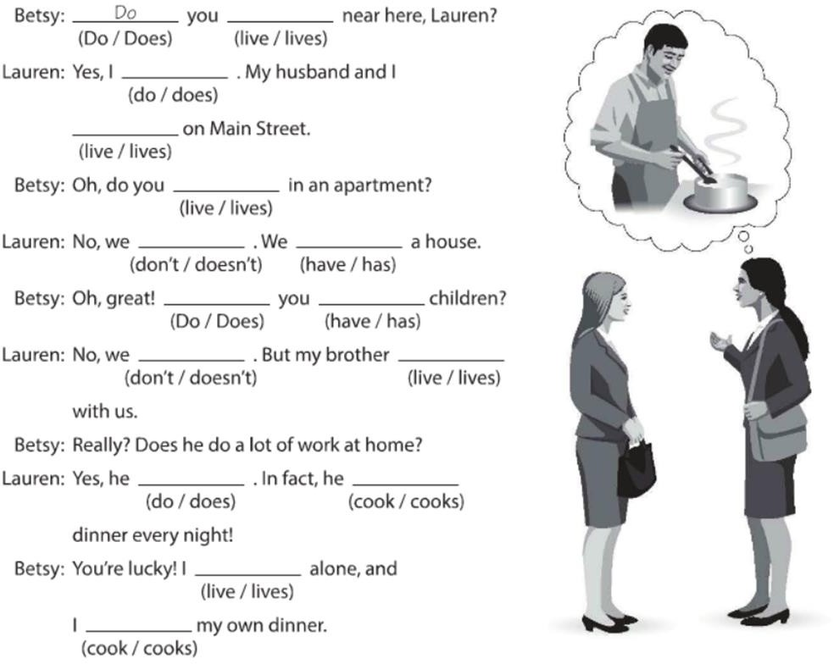

**Do**

**Live**

**Does**

**Lives**

**Live**

**Don´t**

**Have**

**Do**

**Have**

**Don´t**

**Live**

**Does**

**Cooks**

**Live**

**Cook**

**Exercise 4.** Answer these questions with your personal information Use short answers (Completa estas preguntas con tu información personal, usa respuestas cortas)

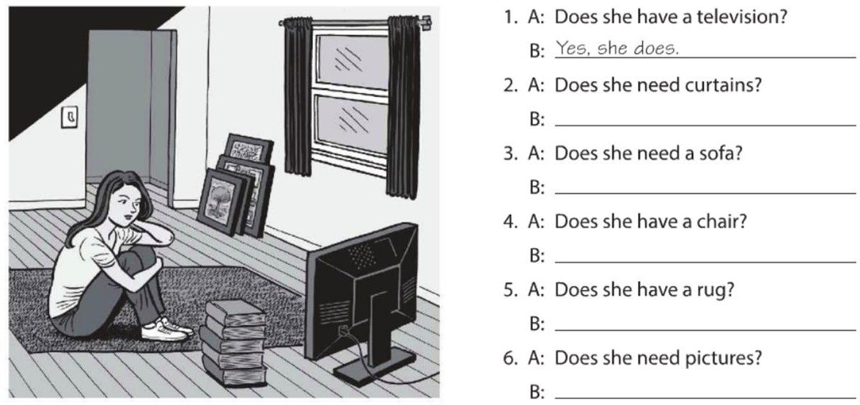

**Yes, she does**

**No, she doesn´t**

**Yes, she does**

**No, she do**

**Yes, she do**

**No, she doesn´t**

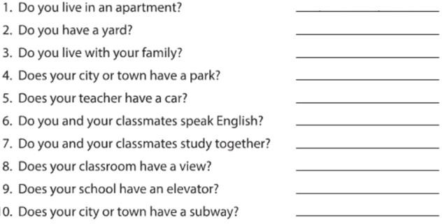

**Yes, I do or No, I don´t**

**No, I don´t Yes, I do**

**Yes, it does Yes, he does No, we don´t**

**Yes, we do Yes, it does**

**No, it doesn´t No, it doesn´t**

**Exercise 5.** Answer these questions about the pictures. (Responde las preguntas de acuerdo a la imagen)

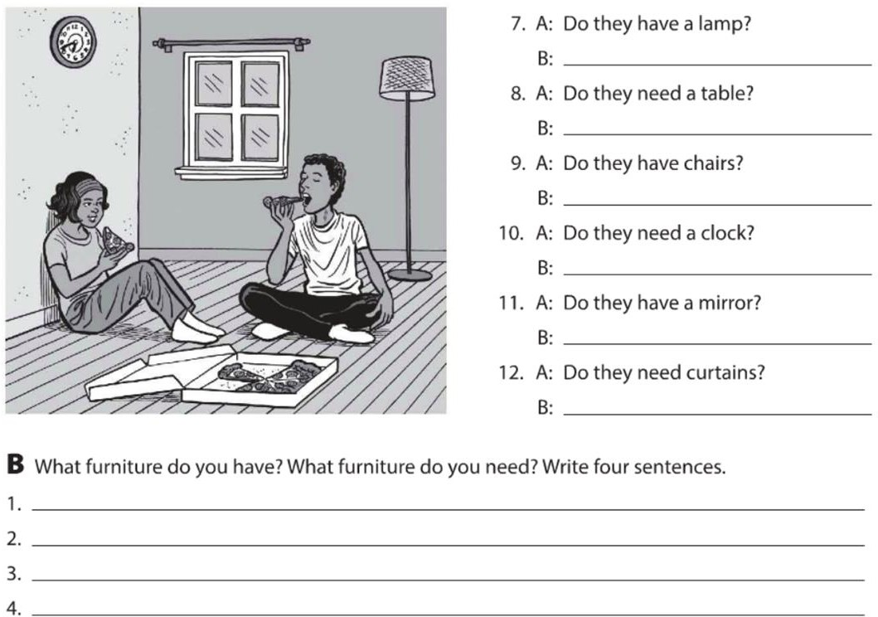

**Yes, they do**

**Yes, they do**

**No, they doesn´t**

**No, they don’t**

**No, they don’t**

**Yes, they does**

**Do, I have a coffee table**

**Does, I have a mirrors Do, I need a bookcase**

**Does, I need a pictures**

**Exercise 6.** Complete the description with “ ´s, are or aren´t ”. (Completa la descripción con “ ´s, are or aren´t ”)

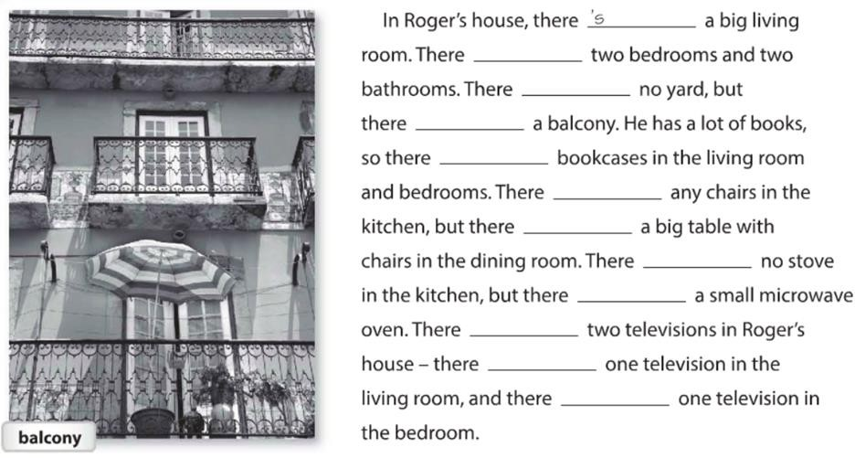

**‘s**

**Are**

**Aren´t**

**Are**

**´s**

**Aren´t**

**Are**

**Aren´t**

**Are**

**´s**

**Are**

**Are**

**Exercise 7.** Answer these questions with information about your home. Use the phases in the box. (Responde las preguntas con información acerca de tu casa, usa la información de la caja).

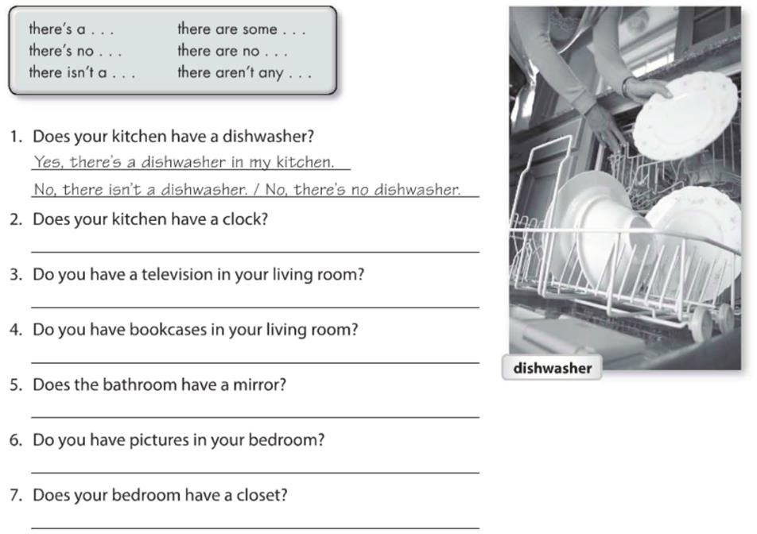

**No, there isn´t a clock**

**Yes, there´s a television in my kitchen**

**No, there´s no bookcases**

**Yes, there´s a mirror in my bathroom**

**Yes, there´s a picture in my bedroom**

**Yes, there´s a closet in my bedroom**

**Exercise 8.** Write sentences about the house. Use “**there”** and the words in parentheses. (Escribe acerca de la casa, usa **“there”** y las palabras en parentesis).

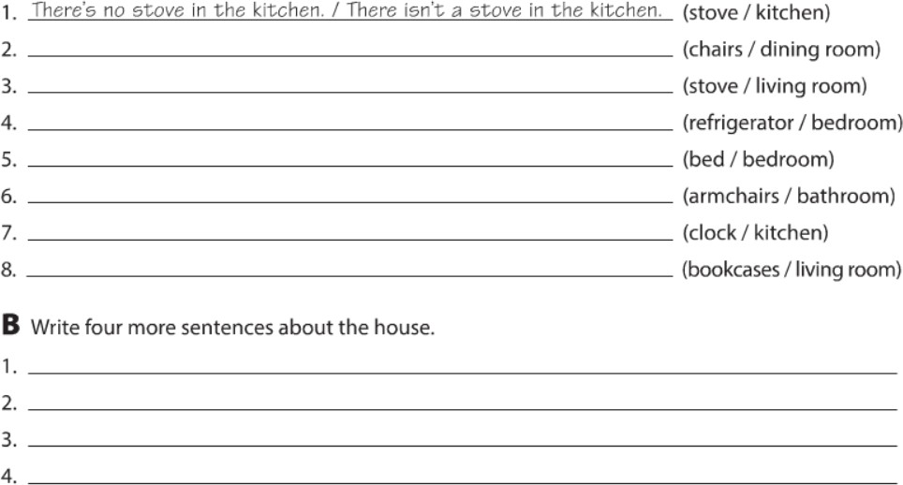

**There´s no chairs in the dining room**

**There isn´t a stove in the living room There isn´t a refrigerator in the bedroom There isn´t a bed in the bedroom**

**There isn´t an armchair in the bathroom There isn´t a clock in the kitchen**

**There isn´t a bookcase in the living room**

**There is a table in the dining room**

**There is a lamp in the living room There is a rug in the dining room**

**There is a bookcase in the bedroom**

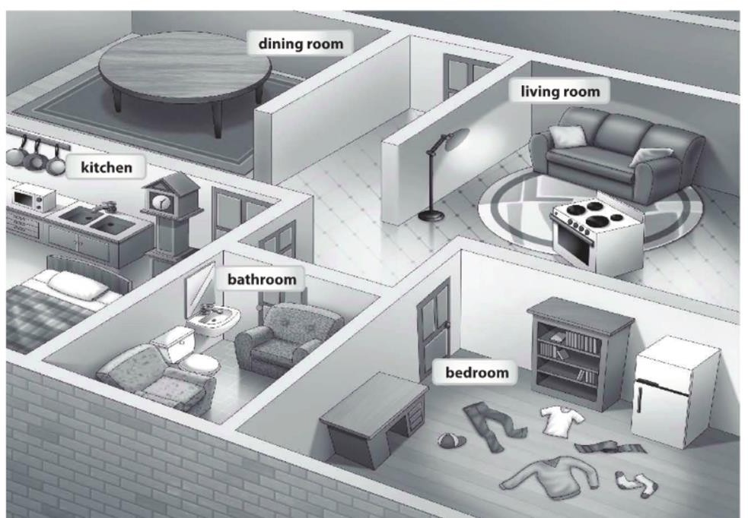

**Exercise 9.** Chose the correct responses. (Escoge las respuestas correctas).

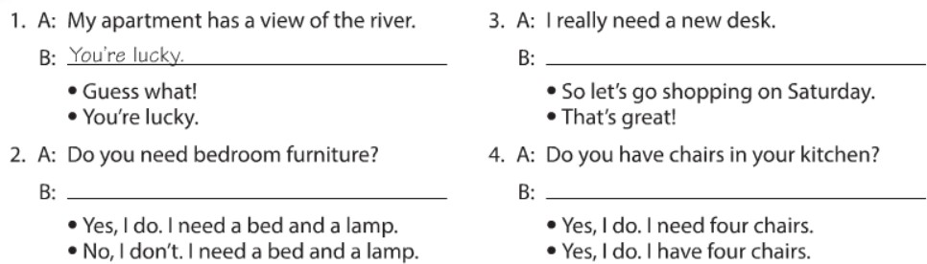

**That´s great**

**Yes, I do. I need a bed and a lamp**

**Yes, I do. I have four chairs**

**Exercise 10.** Reading comprehension (Lectura de comprensión).

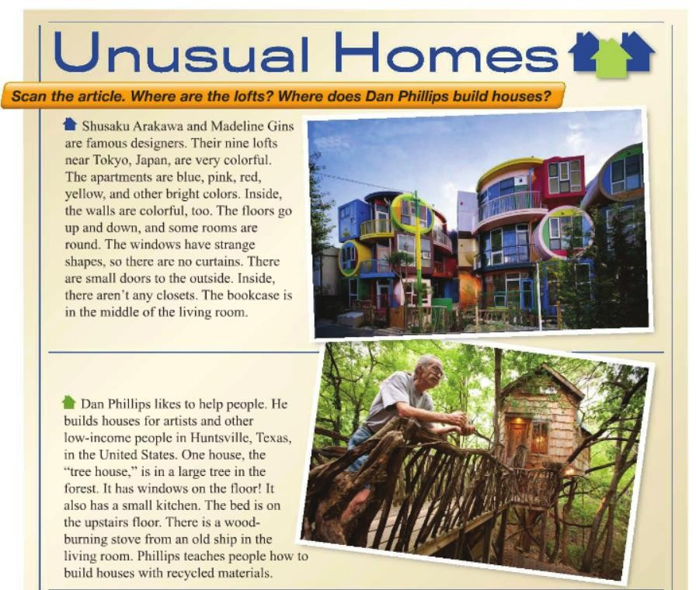

Complete the chart. (Completa la tabla).

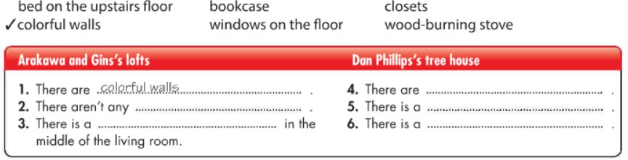

**Closets**

**Bookcase**

**Windows on the floor**

**Wood-burning stove Bed on the upstairs floor**