**Student Name: Danna Fernanda García Hernández**

**LINCENCIATURA: Psicología**

**Teacher`s name: Alejandra Vidal Escandón**

**Module: Inglish**

SUPER NOTE OF CLASS ONE AND TWO:

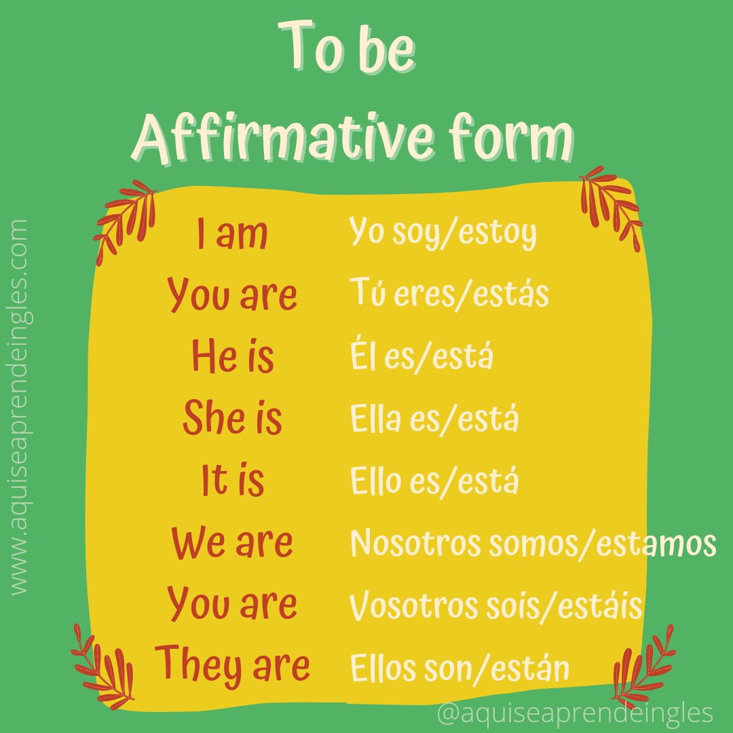

THE VERB BE:

**This verb is used to express the verbs ser or estar in Spanish.**

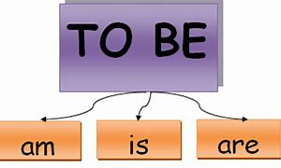

NEGATIVE FORM:

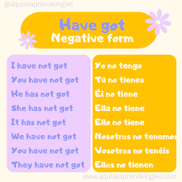

**AFIRMATIVE FORM:**

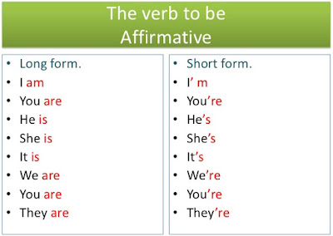

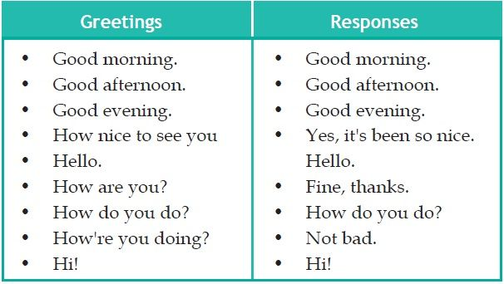

FORMAL GREETINGS:

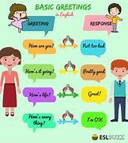

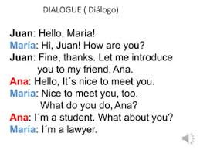



**INTRODUCE YOURSELF:**

CLASS TWO:

SOME EXAMPLES OF THESE, THOSE, THIS, THIS LIKE WHAT I SAW IN CLASS TWO.





**-AN ANIMAL**

**-AN OCEAN**

**WE USE AN WITH NOUNS THAT BEGIN WITH A VOWEL SOUND.**





**-A RACE CAR**

**-A BIG HORSE**

**WE USE A WITH NOUNS THAT BEGIN WITH A CONSONANT SOUND EXAMPLE:**





**THAT'S MY TRUCK**



**THIS IS MY BAG**

-My sister is a nurse





**THOSE ARE SHOES**



**THESE ARE MID HEADPHONES**

-it's an elephant



ARTICLE a/an :

SINGULAR , PLURAL :