**U□S**

***Answer these questions.***

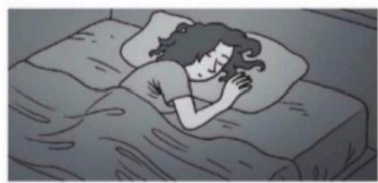

**1.Is Debbie getting up?**

No,she's not.She's

sleeping

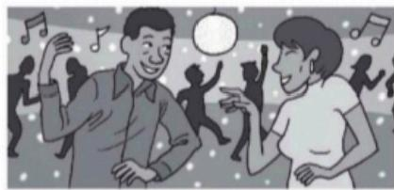

3.Are Dan and Megan studying?

No,They're not'They 're at parts

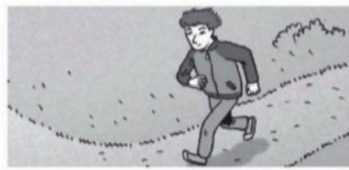

5.Is Bill playing tennis?

No.He's not.he Is runnig

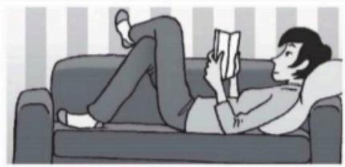

7.Is Claire watching television?

No,She's not she's reading book

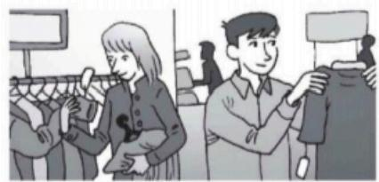

**2.Are Kelly and Tony taking a walk?**

No,they're not.They're shopping

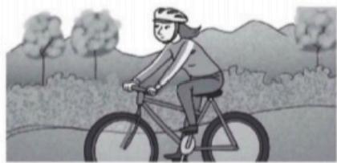

4.Is Carmen driving a car?

**No,She's not She's fide Biking**

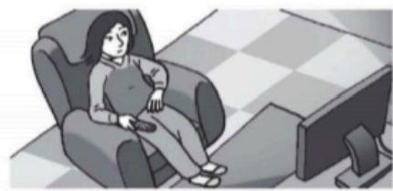

6.Is Michiko checking her email?

Na.She's not.She Ir watching TV

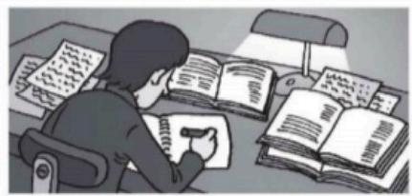

8.What about you?Are you sleeping?

No,I am not.i'm studing





***Write questions about these people.Use the words in parentheses.***

**Then answer the questions.**

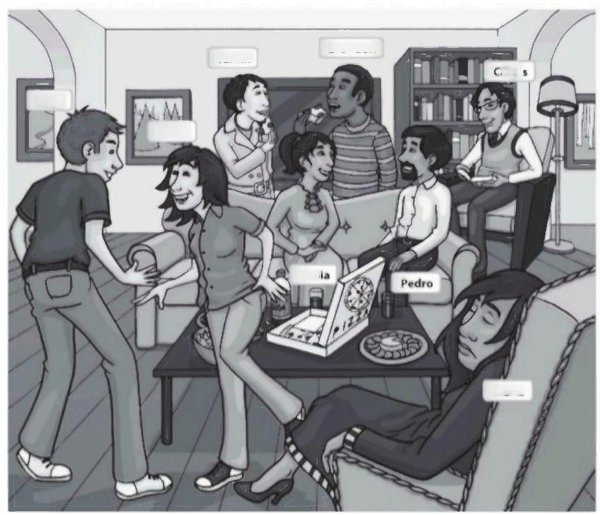**Brandon**

Tai-lin

ardo

Terry

Helen

Son

Maria

1.A:

**B:**

2.A:

B:

3.A:

B:

4.A:

B:

wearing shorts?

Terry

Is

|  |
| --- |
| (Terry /wear shorts)  No he's not.Hes wearing jeans |
| Is tai-lin wearing a raincoat |
| (Tai-lin /wear a raincoat) |

|  |
| --- |
| (Maria /talk on the phone) |
| Are terry and helen eating |
| (Terry and Helen/eat) |

5.A: Are Pedro and Sonia wathing television

(Pedro and Sonia/watch television)

B:

6.A: Are ta-lin and Brandon eating pizza (Tai-lin and Brandon /eat pizza)

B:

7.A: **Is Carlos chating online** (Carlos/chat online)

B:

8.A: Is mana wearing boots (Maria/wear boots)

B:

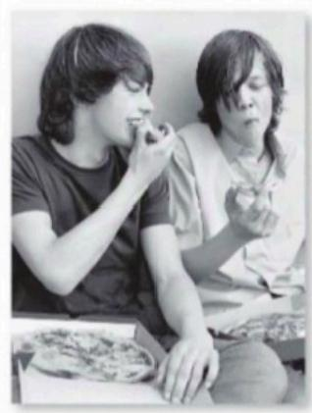**Write questions and answers . Use What + doing and the words in parentheses.**

**1.A: What are you and Ricky doina?**

**B: We're eating pizza.**

**2.A: What's Michaeldoing?**

**B: He's cooking dinner**

**3. A: What's are ronand Lucy**

B: They're toking a walk

4.A: What's Julisdoing

B: She 's setting up

5.A: WhafsMarydoing?

B: She's shapping

6.A: What are balle and hank

B: They re Watching a movie

7.A: What's steven doing?

B: Im studyng math

8.A: What areyou doing?

B: Im studyingenglish

9.A: What are you and emma doing?

B: We'rehavinglunch

10.A: What are you doing?

B: I'm finishing This exercise

( you and Ricky)

_( eat pizza)

_( Michael)

_( cook dinner)

_( Ron and Lucy)

( take a walk)

Julie)

( get up)

( Mary)

( shop)

( Belleand Hank)

_( watch a movie)

.( Steven)

_( study math)

( you)

_( study English)

_( you and Emma)

( have lunch)

.(1)

( finish this exercise)

**What are you doing ? What are your friends doing ? Write sentences.**

1. Iam reading a book

2. My frend Is Watching TV

**3. Iam estudyng english**

4. My frends are playing soccer

5. Iam cooking dinnei

**6. Im Is doing homework**

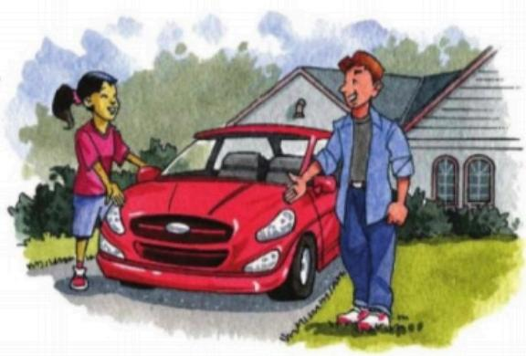**UOS**

**UNIT IV.MY SISTER WORKS DOWNTOWN**

**4.1.-Transportation**

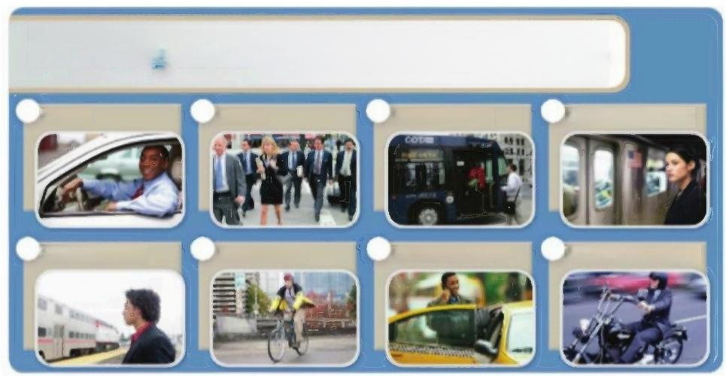

***Transportation in the U.S.***

**The Top Eight Ways to Get to Work**

1.drive 2.walk 3.take the bus 4.take the subwoy

5.toke the train 6.ride a bike 7.take a taxi/cab 8.ride a molorcycle

SoreUS.(ms Srem

Check (√)the kinds of ransportalion you use.

*What are some other kinds of transportation?*

***CONVERSATION*** *Nice car!*

OListen and practice.

Ashley:Nice car,Jason!Is it yours?

Jason:No,it's my sister's.She has a new

job,and she drives to work.

Ashley:Is her job here in the suburbs?

Jason:No,it's downtown.

Ashley:My parents work downtown,

but they don't drive to work.

They use public transportation.

Jason:The bus or the train?

Ashley:The train doesn't stop near our

house,so they take the bus.

UOS

**son daughter**

**(children)**

**4.2.-Family Tree**

***WORD POWER Family***

A ◎ **PAIR WORK** Complete the sentences about

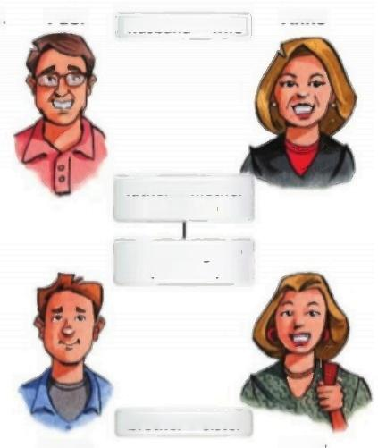the Carter family.Then listen and check your answers.

1.Anne is Paul's …Vife … …

2.Jason and Emily are their …………

3.Paul is Anne's … ….

4.Jason is Anne's ………………

5.Emily is Paul's …………

6.Jason is Emily's … … … … . … …

7.Emily is Jason's … … … … … . … ... …

8.Paul and Anne are Jason's

**Paul**

husband wife

**father** **mother** **(parents)**

Anne

|  |
| --- |
| **kids a children**  **mom =mother**  **dad** **father** |

**B PAIRWORK** Who are the people in your family?

What are their names?

"My mother's name is Angela.My brothers'names

**brother** **sister**

**Jason**

**Emily**

are David and Daniel.”

**U□S**

**4.3.-Simple present**

|  |  |  |  |  |  |  |
| --- | --- | --- | --- | --- | --- | --- |
|  | **Simple** **present** **statements** O | | |  | | d**on't**=do nof  does**n't**-does not |
| I **walk** to school.  You **ride** your bike to school He **works** near here  She **takes** the bus to work | | I **don't** **live** far from here You **don't** **live** near here  He **doesn't** **work** downtown. She **doesn't** **drive** to work | | |
| We **live** They **use** | with our parents We **don't** **live**  public transportationThey **don't** **need** | | | alone.  a car. |  |
|  |

A Paul Carter is talking about his family.Complete the sentences

with the correct verb forms.Then compare with a partner.

1.My family and l …!ye….(live /lives)in the suburbs.My wife and l

(work/works)near here,so we ………………(walk/walks)

to work.Our daughter Emily (work /works)downtown,

so she (drive/drives)to work.Our son ………………

(don't/doesn't)drive.He ………(ride /rides)his bike to school.

2.My parents ……………(live /lives)in the city.My mother

……(take /takes)a train to work.My father is retired,

so he… (don't/doesn't)work now.He also

(use/uses)public transportation,so they………(don't /doesn't)

need a car.

**verb**

walk

ride

study

watch

**endings:he,she,it**

→walks

→rides

→stud**ies**

→walches

1 **Simple present statements**

**irregular verbs**

**and Simple present statements with**



▶In affirmative statements,verbs with he/she/it end in -s:He/She **walks** to school.Bur l/You/We/They **walk** to school.

In negative statements,use doesn't with he/she/it and don't with all the others: He/She/It **doesn't** live here.I/You/We/They **don't** live here.

▶Don't add -sto the verb:She **doesn't live** here.(Nor:She doesn'tlives here.)

Elena is talking about her family.Complete the sentences with the correct form of the verbs in parentheses.

My family and l … !!y … (live)in the city.We … (have)

an apartment on First Avenue.My sister ………………………(go)to school

near our apartment,so she … (walk)to school.My father

… …………(work)in the suburbs,so he ……………(drive)to his job.

My mother ……… (use)public transportation -she …………………(take)

the bus to her office downtown.She ……… ………(have)a new job,but she

……………………(not like)it very much.And me?Well,I … … (not work)

far from our apartment,so l …… (not need)a car or public

transportation.I … … (ride)my bike to work!

**U□S**

**4.4.-Simple present with irregular verbs**

|  |
| --- |
| **Simple** **present** **stotements** **with** **irregular** **verbs** **O** |

|  |  |  |
| --- | --- | --- |
| **l/you/we/they**  I **have** a bike.  We **do** our homework every day My parents **go** to work by bus. | **he/she/it**  My father **has** a car. My mother **does** a lot of The bus **goes** downtown. | work at home |

**B** Ashley is talking about her family and her friend Jason.

Complete the sentences.Then compare with a partner.

1.My parents …haY…(have /has)a house in the suburbs.My mom

and dad …………………(go/goes)downtown to work.My parents are very

busy,so l ……… .(do /does)a lot of work at home.

2.My brother doesn't live with us.He ……… …(have /has)an apartment in

the city.He ……… (go /goes)to school all day,and he ……… …(do/does)

his homework at night.

3.I…………………(have /has)a new friend.His name is Jason.We … … … … …

(go/goes)to the same school,and sometimes we ………….(do /does)

our homework together.

C **PAIRWORK** Tell your partner about your family.

"I have one brother and two sisters.My brother is a teacher.

He has a car,so he drives to work."

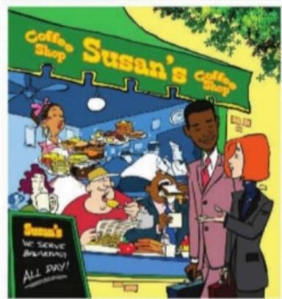**U□S**

**CONVERSATION** Iget up at noon.

O)Listen and practice.

Jack:Let's go to the park on Sunday.

Amy:OK,but let's go in the afternoon.

I sleeplate on weekends.

Jack:What time do you get up on Sundays?

Amy:At ten o'clock.

Jack:Oh,that's early.On Sundays,

I get up at noon.

Amy:Really?Do you eat breakfast then?

Jack:Sure.I have breakfast every day.

Amy:Then let's meet at this restaurant at

one o'clock.They serve breakfast all day!

**4.5.-Simple present questions**

***Simple present questions O***

**Do** you **get up** early?

No,I **get up** late.

**Does** he **eat** lunch at noon?

No,he **eats** lunch at one o'clock. **Do** they **take** the bus to class?

No,they **take** the subway.

**What time do** you **get up?**

At ten o'clock.

**What time does** he **have** dinner?

At eight o'clock.

**When do** they **take** the subway?

On Tuesdays and Thursdays.

A Complete the questions with do or does.

1.……P…….you get up early on weekdays?

|  |  |
| --- | --- |
| **tlime** **expressions** | |
| early  late  every day  **at** 9:00  **at** noon /midnight **at** night | **in** the morning **in** the afternoon **in** the evening **on** Sundays  **on** weekdays  **on** weekends |

2. **What time** …… you go home on Fridays?

3.………………your father work on weekends?

**4.** …………………………your mother cook everyday?

**5.**…………………your parents read in the evening?

6. **When** ……… your parents shop?

7.………………………you check your email at night?

8.What time ………………you have dinner?

9.When ……… you study?

10.………………your best friend drive to class?

11. **What time** ……… your father get up?

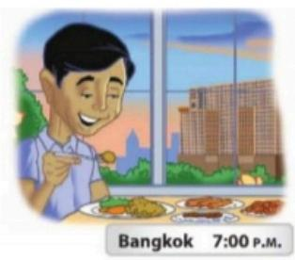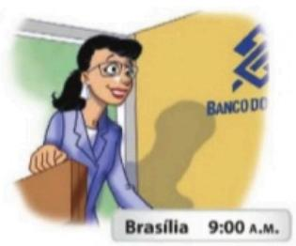

**3.7.-Present continuous Wh-questions**

*GRAMMAR FOCUS Present continuous Wh-questions ◎*

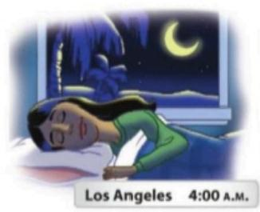

**What's** Victoria **doing?**

She's **sleeping** right now.

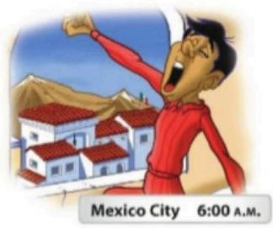

**What's** Marcos **doing?**

If's 6:00 A.M.,so he's **getting up.**

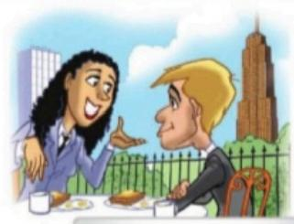

**New York City 7:00 A.M.**

**What are** Sue and Tom **doing?** They'**re having** breakfast.

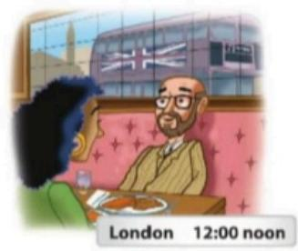

**What are** Jim and Ann **doing?** If's noon,so they**'re eating** lunch.

**What's** Celia **doing?** She's **going** to work.

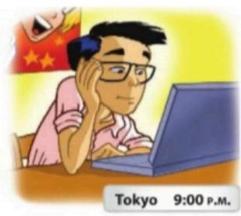

**What's** Permsak **doing?**

**What's** Hiroshi **doing?** He's **checking** his email.

He'**s eating** dinner right now.

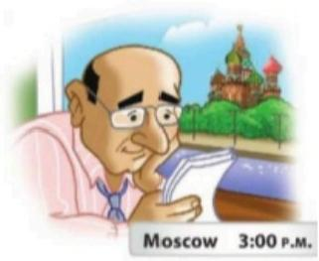

**What's** Andrei **doing?**

He's working.

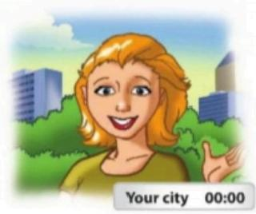

What are you **doing?**

It's ...l**'m …**



**A PAIRWORK Ask and answer the questions about the pictures.**

|  |  |
| --- | --- |
| 1. Who's sleeping now?  2. Who ' s having breakfast?  3. Where ' s Andrei working? 4. Where's Hiroshi checking  his email? | 5. What'sCelia wearing?  6. What's Marcos wearing? 7. Why is Marcos getting up? 8. Why are Jim and Ann  having lunch? |

**spelling**

sleep → sleeping

get →gelting(+f) have → having (-e

**B GROUPWORK Writefive more questions about the pictures.**

Then ask and answer your questions in groups.

**2 Present continuous Wh-questions**

Use the present continuous totalk about actions that are happening right now:

**What are you doing ? I' m talking to you!**

**In questions, the be verbcomes before the subject: What are you doing?**

To form the continuous of verbs ending in -e , drop the e and add -ing:

have →having.

→ For verbs ending in vowel+ consonant, double the consonant and add -ing: get →getting.

What are the people doing? Write conversations . Use the words in parentheses.

………………………

…………………………

…………………………

…………………………………

……………………………

………………………

……………………………

………………………

……………………

……………………………………

……………………………

………………………………

…………………

……………………

………………………

…………………………

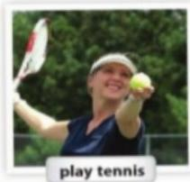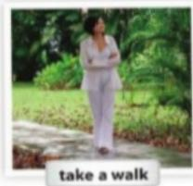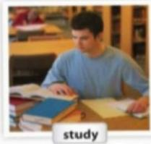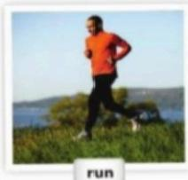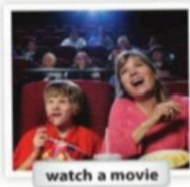UOS

**3.8.-Verbs activities**

 ***WORD POWER*** *Activities*

A◎Listen and practice."She's playing tennis."

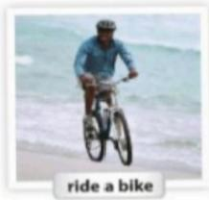

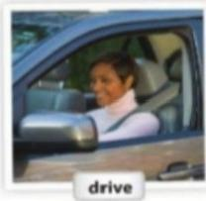



B **PAIRWORK** Ask and answer questions about the pictures in part A.

A:Is she playing soccer?

B:No,she's not.

A:What's she doing?

B:She's playing tennis.

C ◎ What's Mary doing?Listen to the sounds and number the actions from 1 to 8.

|  |  |  |  |  |
| --- | --- | --- | --- | --- |
| dancing  1 ] driving | 7 ealing dinner (2)playing tennis | 3]riding a bike 5shopping | 6]swimming 8]watching | television |

**UOS**

*MErchange5* ***WHAT'S WRONG WITH THIS PICTURE?*** *5*

GROUP WORK What'S wrong with this picture?Tell your classmates,

"Ellen is swimming,but she's wearing high heels and a hat!"

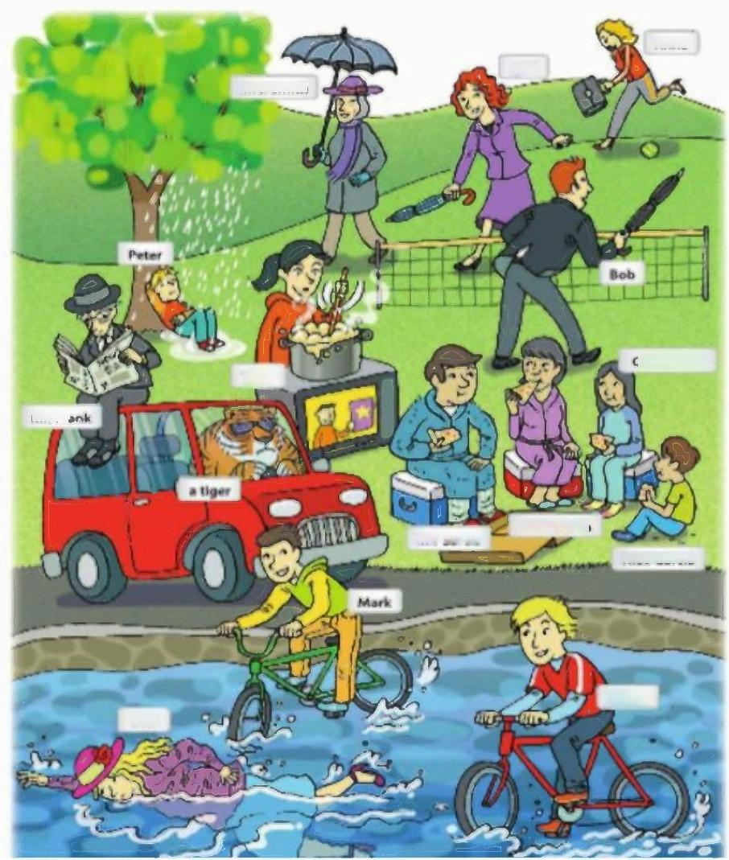Anna

tynn

Mrs.Smith

Gina Garcia

Tracy

Me.Fn

Mrs.Garcia

Me.Garda

Alex Garcia

Randy

Ellen

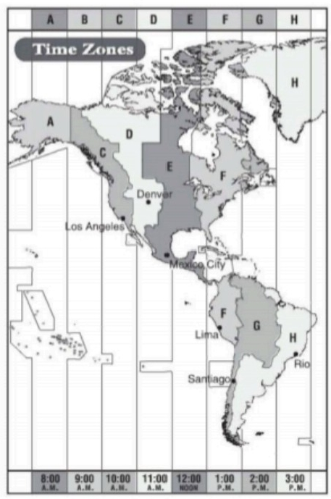

**UNIT II.-WHOSE JEANS ARE THESE?**

**WORKBOOK**

***Write each sentence a different way.***

1.It's midnight

2.It's 4:00 P.M.

3.It's 9:15 A.M.

4.It's 8:00 P,M.

5.It's 10:45 P.M.

6.It's 3:30 P.M.

7.It's 6:00 p.M.

8.It's 12:00 P.M.

It's twelve oclock at night.

|  |
| --- |
| It's four o'clock in the afterngon |
| It's quarter past nine in the momig |
| It's eight o'clock in the evening |
| It's quarter to eleven ay night |
| **It's half past theree in the afternoon**  It's six o'clock inthe evening |
| It's twetve o'clock noon |

***What time is it in each city?Write the time in two different ways.***

1.It's 10:00 a.m,in Los Angeles

t's ten oclock in the mornina.

2. It's11.00am in Donvet

It's o'clouck in the morning

3.. It's 11:00 am in Mexico city

It's a'clock in the moming

4. lt's 1.00pm in lima

It's ope a'clock in the atternoon

5. It's 1.00pm in Santiago

It's ope a'clock in the aftemoon

6.Its3:00 pmin rio

It's There o'clock in the aftemoon

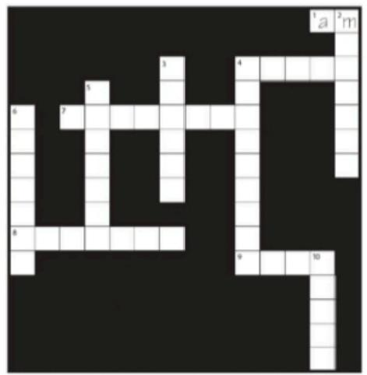UOS

***What time is it?Use the sentences in the box.***

☑ It's twenty after nine Ir's eight after six

Ii's ten to eight.

I1's a quarter to three

□ It's five-oh-five

I's a quarter afher one.



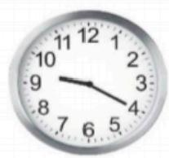

1.It's twenty after nine

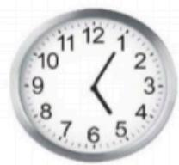

4. t's fiye o five

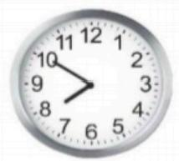

2. It's ten to eight

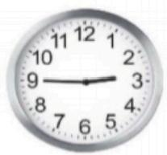

5. It's quarter to three

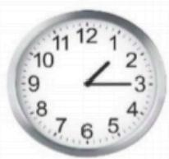

3. It's a quarter after one

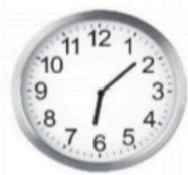

6.it's eight atter six.

***Complete the crossword puzzle. Write each time a different way.***

**Across(→)**

**1** It's five in the morning.It's five

**4** It's 4:15.It's a quarter four.

**7** It's twelve AM.It's .

**8** It's 8:00 p.m.It's eight in the —— .

**9** It's twelve p.M.It's .

**Down(1)**

**2** It's 7:00 AM.It's seven in the

**3.**It's 3:30.It's three- .

**4** It's 4:00 p.M.It's four in the —_.

**5** It's 1:15.It's one-

.

**6** It's 3:45.It's a to four.

**10** It's 11:00 pM.It's eleven at

**U□S**

***What are these people doing?Write sentences.Use the words in the box****.*

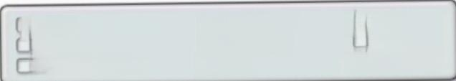

dance

drive

play a video gome

read a book ride a bike shop

sleep

swim

toke a wolk



☑



1. She's sleeping

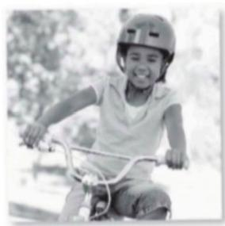

4.H e's ride bikieng

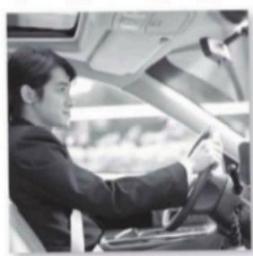

7.H e's driving

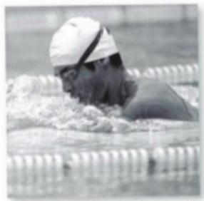

2. He ls swiming

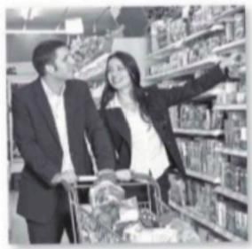

5.

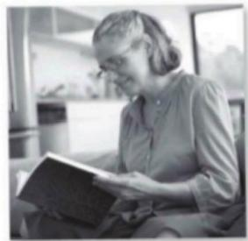

8. She's seas a booking

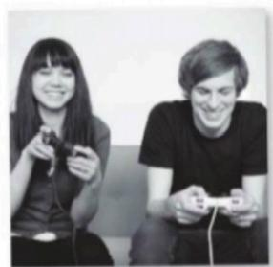

3. They re play video game

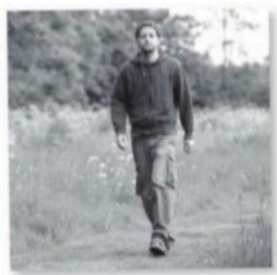

6.He!

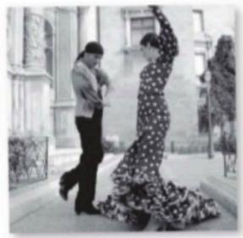

9. The

**UOS**



***Waiting for the bus***

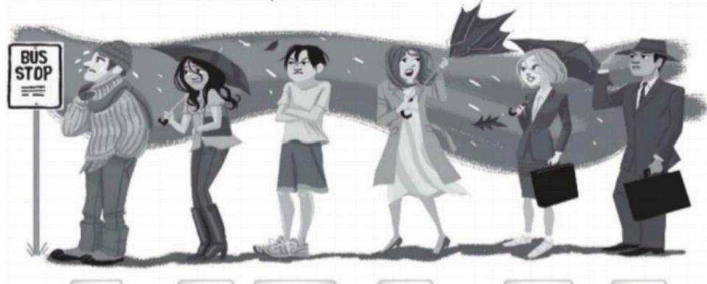

**A** Write sentences.Use the words in parentheses.

***Todd* Alicia Chul-woo Maya Maggie Hugo**

|  |  |
| --- | --- |
| 1. Huao is wearing a tie. | (tie) |
| 2. Tadd and Alicla are wearing boots | (boots) |
| 3.  **Chulwoo only has a shirt** | (T-shirt) |
| 4. **Maya Is wearing skirt** | (skirt) |
| 5.  **Maggie ls wearing dress** | (dress) |
| 6.  **Maya Is wearing sneakers** | (sneakers) |
| 7. Todos ls wearing scarf | (scarf) |
| 8.  **Hugo ls wearing hats** | (hats) |

**B** Correct the false sentences.

1.Chul-woo is wearing jeans.

No,he isn't./No,he's not.He's wearina shorts.

2.Maggie and Hugo are wearing raincoats.

**No.he isn'v They are wearing clothes**

3.Alicia is wearing a skirt.

No she ins't she Is wearing pants

4.Maya is wearing pajamas.

No,she ins't /she Is wearing dress

5.Alicia and Maggie are wearing T-shirts.

No,she ins't

6.Todd and Hugo are wearing shorts.

No.he Is n't/They are wearing pants

**UOS**

|  |  |
| --- | --- |
| ***Complete the sentences.***    1.My name's Jane.I m wearing  a T-shirt and shorts.I Am  sneakers,too.It Is raining, butlAm a raincoat | 2.It Is snowing,but Amy  Wearing boots -she s high heels.She is gloves,and she Har a hat. |
|  | |
| 3.It's very hot.Tom and Sue **Araniwoaring**  sweaters today.They **Are waadt** pants.  It's sunny,so Sue Is wearing a hat, and Toml**s wearing** sunglasses. | 4.Roger lswearing a suit.  He Is woaring a belt,but  he Isntwearing a tie.  He Is wearing shoes and socks.  It's very windy. |

***Complete these sentences with and,but,or so.***

1.He's wearing jeans and sneakers, and he's wearing a T-shirt.

2.It's very cold outside, **But** .I'm not wearing a coat.

3.Her skirt is blue. **And** .her blouse is blue,too.

4.It's raining, And .I need an umbrella.

5.He's wearing an expensive suit, But _he's wearing sneakers.

6.It's summer and it's very sunny, So _it's hot.

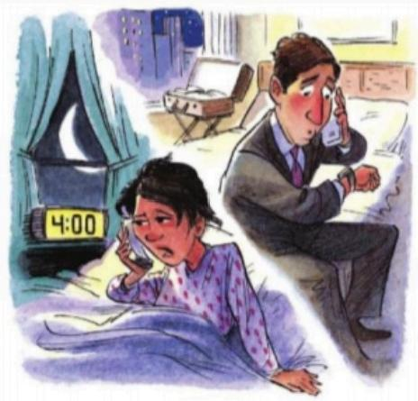**U□S**

**3.6.-Telling the time**

(O)Listen and practice.

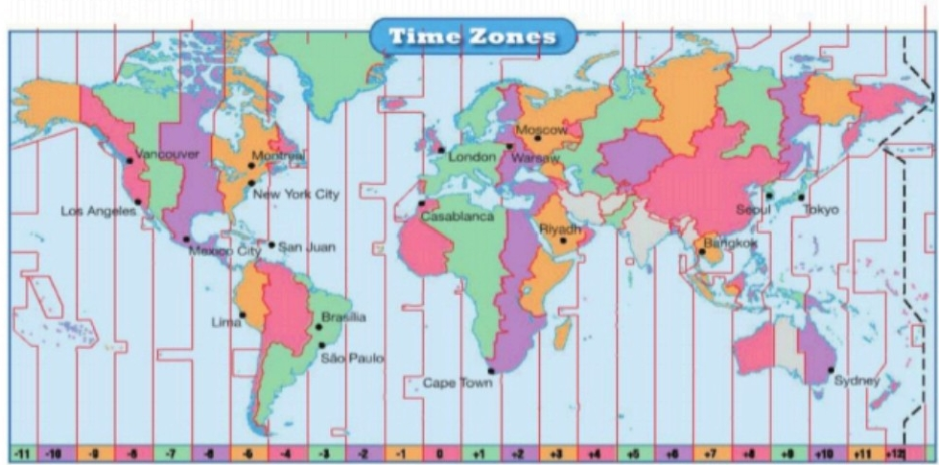

Soace:Time Serwe Deyormert,.S.Morl Obarotey

Which cities are in the same timezones?

*Which cities are in your timezone?*

**CONVERSATION** What time is it there?

Listen and practice.

Debbie:Hello?

John:Hi,Debbie.This is John.

I'm calling from Australia.

Debbie:Australia?

John:I'm at a conference in Sydney.

Remember?

Debbie:Oh,right.What time is it there?

John:It's 10:00 p.M.And it's four o'clock

there in Los Angeles.Right?

Debbie:Yes-four oclock in the morning!

John:4:00 A.M.?Oh,I'm really sorry.

Debbie:That's OK.I'm awake..now.

**UOS**

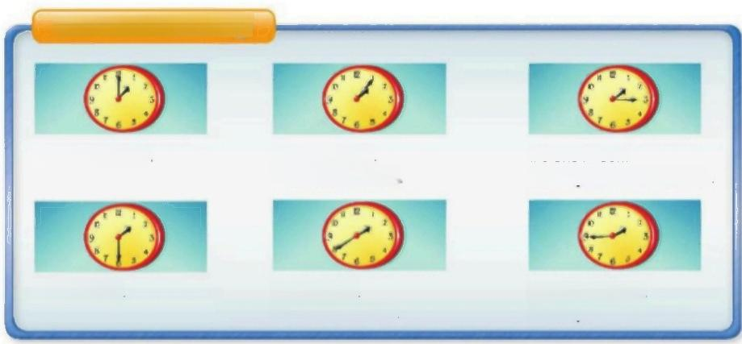

***What time is it?O***

It's one fifeen.

If's **a quarter after** one.

It's one-thirty If's one forty If's one forty five.

Ir's twenty **to** two It's **a quarter to** wo.

If's one-oh-five

It's five **after** one

It's one **o'clock**

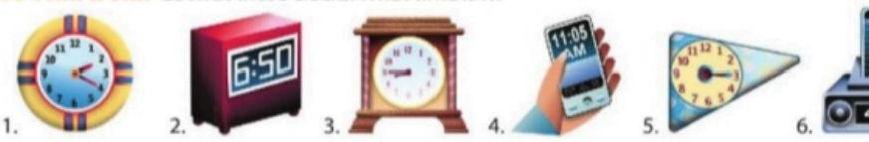A **PAIR WORK** Look at these clocks.What time is it?



A:What time is it?

B:It's twenty after two.on It's two-twenty.



Is it A.M.or PM.?O



If's seven (o'clock)

**in the morning**

Ir's 7:00 **A.M.**

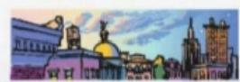

If's seven (o'clock)

**in the evening**

It's 7:00 P.M.



It's twelve (o'clock)

It's 12:00 P.M,

It's **noon.**

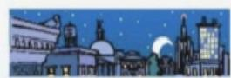

If's ten (o'clock) **at night.** Ir's 10:00 **P.M.**



lf's four (o'clock)

in the afternoon

Ir's 4:00 P,M.



t's twelve (o'clock) **at night.** It's 12:00 A.M.

t's **midnight.**



1**What time is it?/Is it A.M.Or P.M.?**

▶Remember:you can say times different ways:1:15 =one-ffteen or a quarter

*after one.*

Write each sentence in a different way.

1.It's a quarter to four.ltis.three.fartx:five. … … … … …

2.It's 12:00 p.M.ItnQQn……… ……

3.It's six-fifteen.It's aquarter.atter.six

4.It's ten oclock at night.1M9.1090 p …

6.It's twenty-five to eleven..Mstten.hirty:Ave … … …

5.It's three-oh-five..It's **five.atter theree**…

7.It's one oclock in the morning.Its 1.00am .

8.It's midnight.It's.12:00.am … …

**B PAIR WORK** Say each time a different way.

1.It's nine o'clock in the evening.“It's 9:00 p.M.” 2.It's eight oclock in the morning.

3.It's twelve o'clock at night.

4.It's three in the afternoon.

5.It's 3:00 A.M.

6.It's 6:00 P.M.

7.It's 4:00 P.M.

8.It's 12:00 P.M.

**LISTENING** It's 4:00 P.M.in Vancouver.

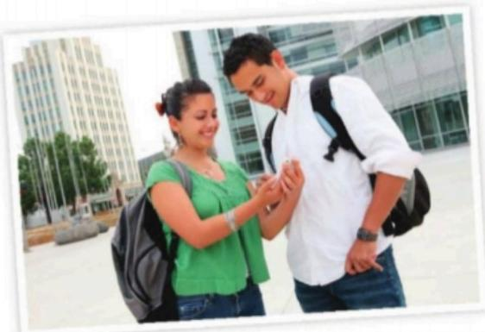

◎Tracy and Eric are calling friends in different parts of the world.Listen. What time is it in these cities?

|  |
| --- |
| **City** **Time** |
| **Vancouver** **4:00.pm………………**  **Bangkok** **6.00** **am………** **…………**  **London** **12:00** **am…** **………**  **Tokyo** **8.00.am** **……**  **Sāo** **Paulo** **8-00** **pm…** **……** **…** |

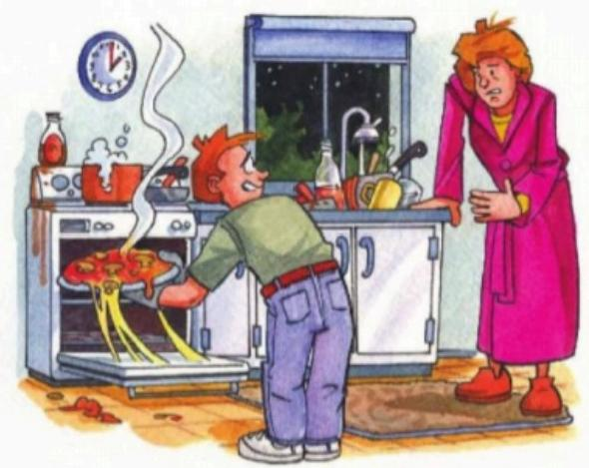**U□S**

***CONVERSATION*** *I'm really hungry!*

◎Listen and practice.

Steve:Hi,Mom.

Mom:What are you doing,Steve?

Steve:I'm cooking.

Mom:Why are you cooking now?

It's two o'clock in the morning!

Steve:Well,I'm really hungry!

Mom:What are you making?

Steve:Pizza.

Mom:Oh?What kind?

Steve:Cheese and mushroom.

Mom:That's my favorite!Nowl'm

getting hungry.Let's eat!

***PRONUNCIATION*** *Rising and falling intonation*



A ◎ Lsten and practice.Notice the intonation of the yes/no and

Wh-questions.

Is she getting up?

Are they sleeping?

What's she doing?

What are they doing?

B◎Listen to the questions.Draw a rising arrow()for

rising intonation and a falling arrow ()for falling intonation.

1.… 2..………… 3.: · 4. 5.…… 6.

**U□S**

A Complete these sentences.Then compare with a partner

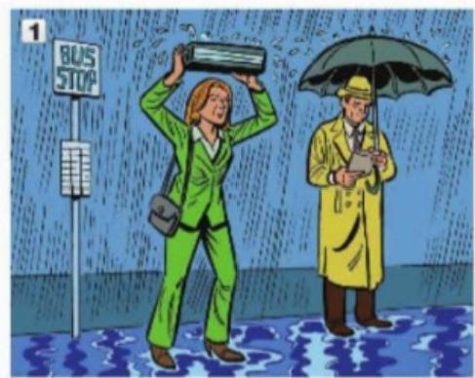

My name is Claire.I.m.wearing……a green

suit today.I .Finowlts…… .high heels,too.

It's raining,but l.Hae … a raincoat.

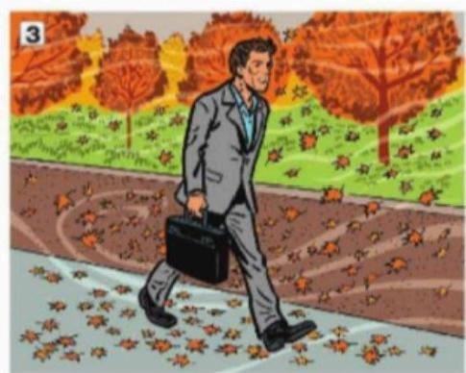

Phil Is not weating…………a suit today -he

ls.weanng… pants and a jacket.

He ….a light blue shirt,but

he Dogs n …a tie.

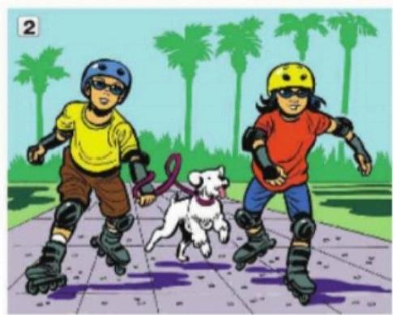

It's very hot today.Toshi and Noriko

Are wearing………shorts and T-shirts.It's really

sunny,so theyAe sunglasses.

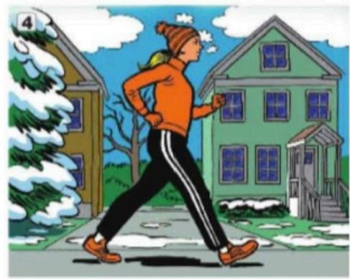

It's cold today,but Kathy .Waaing … … a

coat.She iswaaing…… …gloves and a hat.

She.ls nat …boots.She

…Nat… sneakers.

**U□S**

**3.5.-Present continuous yes/no questions**

***Present conlinuous yes/no questions*** *O*

**Are** you **wearing** gloves?

Yes,I **am.**

Yes,she **is.**

**Is** she **wearing** bools?

Are they wearing sunglasses?Yes,they

No,I**'m not.**

No,she' **s not**./No,she **isn't.**

are.No,they're not./No,they aren't.

**B PAIRWORK** Ask and answer these questions about the people in part A.◎

1.Is Claire wearing a green suit?

2.Is she wearing a raincoat?

3.Is she wearing high heels?

4.Are Toshi and Noriko wearing swimsuits?

5.Are they wearing jackets?

6.Are they wearing sunglasses?

A:Is Claire wearing a green suit?

B:Yes,she is.Is she wearing a raincoat?

A:No,she's not.oR No,she isn't.

C Write four more questions about the people in part A.Then ask a partner the questions.

7.Is Phil wearing brown pants?

8.Is he wearing a blue shirt?

9.Is he wearing a tie?

10.Is Kathy wearing boots?

11.Is she wearing a coat?

12.Is she wearing a hat and gloves?

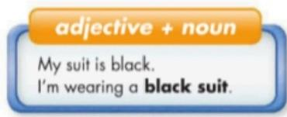

3 **Present continuous yes/no questions;adjective +noun**

▶In questions,the present continuous is be+subject+verb+-ing: **Is** it **raining? Are** you **wearing** brown shoes?

▶Adjectives can come before nouns or after the verb be:He's wearing a **blue hat.**

His hat **is blue.**

▶Adjectives don't have a plural form:a**green hat;** two **green hats**

Write questions using the words in parentheses.Then complete the responses.

1.A:lshe.wearina.a.aray.sult?(wear,gray suit) 3.A:.Isheweaing………………(wear,sunglasses)

B:No,he … B:Yes.I Am sunglassesing… …………… 

2.A:.Is he.wearing……………………(wear,brown boots) 4.A:.Is herain………………(rain)

B:No,we.Is browning boots … … B:Yes,it.is raing … … … …

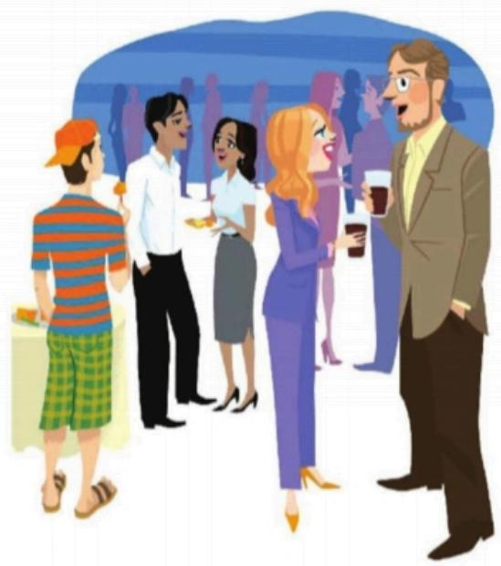**UOS**

***LISTENING*** *He's wearing a T-shirt!*

A ◎ Listen.Write the names **Bruce,**

|  |  |  |
| --- | --- | --- |
| **Nick** |  | Jon |

|  |  |  |  |  |
| --- | --- | --- | --- | --- |
| **Beth** |  | **Anita** |  | Bruce |

**Beth,Jon,Anita,** and **Nick** in the

correct boxes.

**B GROUP WORK** Ask questions about

the people in the picture.

A:Is Bruce wearing a light brown jacket?

B:Yes,he is.

C:Is he wearing a tie?

**C GROUP WORK** Write five questions

about your classmates.Then ask and

answer the questions.



Are Sonia and Paulo wearing jeans? Is Paulo wearing a redshirt?



**UOS**

**WORKBOOK**

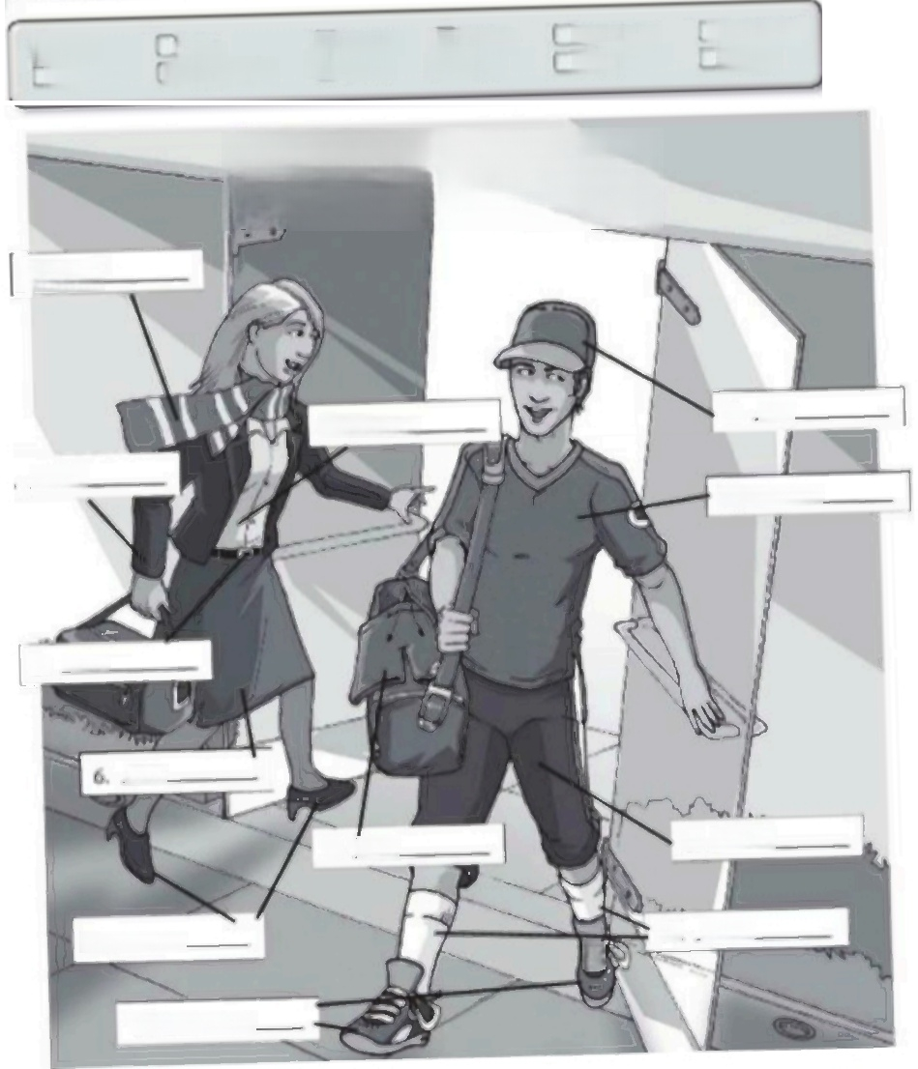 **Label the clothes.Use the words in the box.**

□ bek cap jocket

blouse ] high heels ☑ carf

shors

skirt

sneokers

socks

)swimswt

Tshirt

SPORTS CLU B

*1.scar!*

9. Cap

5.Blouse

Sack

10.T-shin

3. Belt

Skit

8. Short

7. Skirt

11. Socks

4.Swimsuit.

三

12. Sneacker

UOS

What clothes don't belong?Check(√)the things.

|  |  |  |  |
| --- | --- | --- | --- |
| For work | For leisure | For cold weather | For warm weather |
| □shirt | T-shirt | boots | swimsuit |
| shorts | shorts | scarf | T-shirt |
| tie | suit | shorts | boots |
| belt | sneakers | pants | sneakers |
| swimsuit | jeans | sweater | shorts |
| shoes | gloves | gloves | sweoter |
| □ jacket | high heels | T-shirt | cap |

***What things in your classroom are these colors?Write sentences****.*

ight blue dark blue

black

gray

green

orange

pink

purple

red

white

yellow

brown

1. My desk is brown. 2. Celia's bag is purple. 3. **The wals are ight bl** 4.  **The capet ingray**

5.  **The curtains are dark blue**

6. **The whiteboart Is white**

7. The Pencil case Is green

8. The marker Is Orange

9. The Chair Is red

10. The notebook is yellow

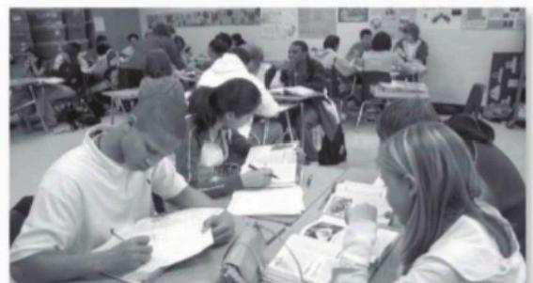





***Whose clothes are these?***

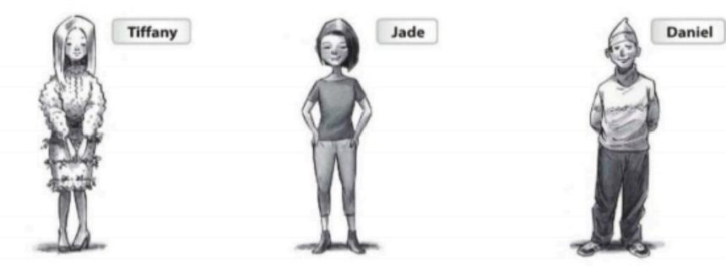

**A** Complete the conversations.

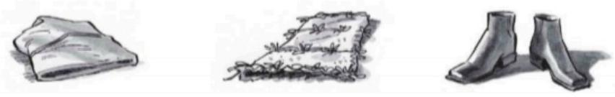

1. **A:Whose** hat is this ?2.A:Whose Hatls i ? 3.A:Whose Hat ls thon __?

**B:** It's Daniel's B: It's tiffanys B:Ther jade's

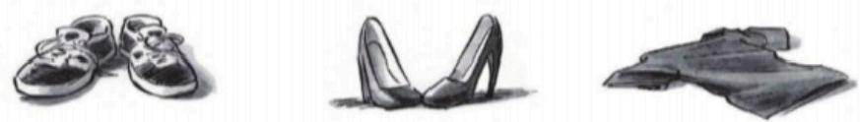

4.A:Whose Hatls Ther ?5.A:Whose Hat ir ther ? 6.A: Whose Hat ls This .?

B:  **Ther's daniel B:** Ther's tiffany's B: it's jade's

**B** Complete the conversations with the correct words in parentheses.

1.A: Whose (Whose/His)T-shirt is this?Is it Lisa's?

B:No,it's not **Hers** (her /hers).It's My (my /mine).

2.A:Are these **Yours** (your /yours)jeans?

B:No,they aren't  **Mine** (my/mine)jeans.Let's ask Keith.

I think they're **He's** .(his/he's).

3.A:Are these Annie's and Jennifer's socks?

B:No,they aren't Their (their /theirs).They're Your (your /yours).

A:I don't think so.These socks are white.and Mi (my/mine)are blue.

**UOS**



**What season is it?How is the weather?Write two sentences about each picture.**

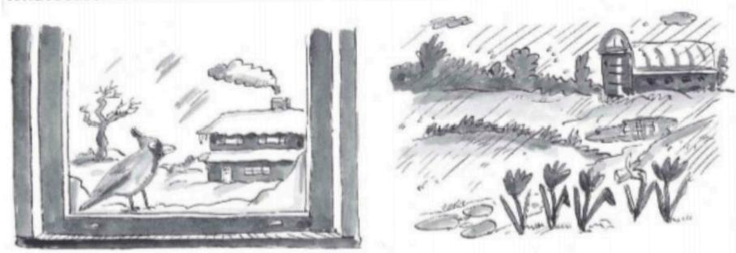

1. It's winter

It's very cold

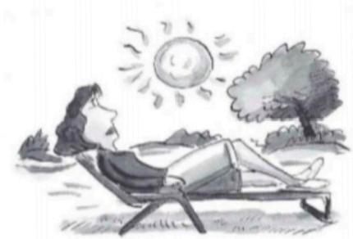

2. It's rainy They're Is mud

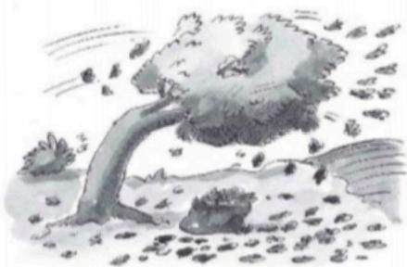

3. it's sunny 4. it's winter

It's hot There Is wind

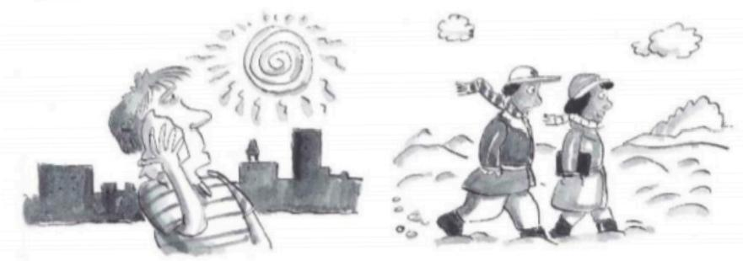

5. 6.

There Is hacer There Is snow

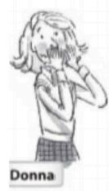UOS

***Descriptions***

**A** Write sentences about the people in the pictures.Use the words in the box.

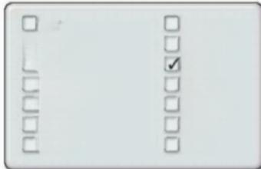

cute

√friendly

)funny

handsome heavy

pretty

quiet

serious short

shy

smart

talkotive tall

thin

1.Donna is shy

Margo is friendly.

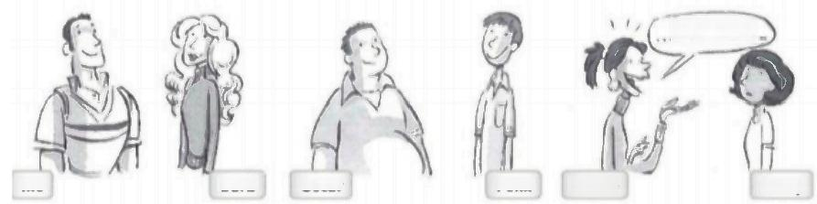

and then I.

**lke Barb Oscar Felix Jackie Cindy**

2.ike is Handsome Barb is Pretty

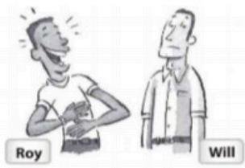

5.Roy is Funny Will is Smart

3.Oscar is Heavy

4.Jackie is Takative

Cindy is Sarous

Felix is Ouet

|  |  |
| --- | --- |
| 6.Jeff is Tall Matt is Short | *cAMg*  Matl  **Peggy Teddy**  7.Peggy is Senous Teddy is Cute |

**B** Answer the questions,

1.ls leff tall? Yes,he is. 2.Is Barb pretty? Yes,she,is 3.Is Oscar thin? No,she 4.Is Margo shy? No.she.nont

5.Are Oscar and Felix male? **Yes.They are** 6.Are Margo and Donna old? No.They,aren't 7.Are you talkative? Yes.she.not 8.Are you serious? **Yes.His**



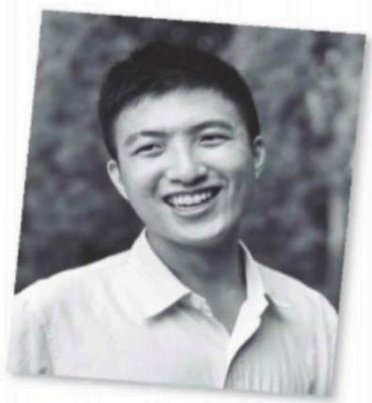**UOS**

***Complete the conversations.Use the words in the boxes.***



□he's □ is √what's

□ his □ not where

1.A:Connie,. what's your boyfriend like?

B: very nice. _name

is Tommy Ho.I call him Tom.

A: **whers** is he from?

he from China?

B:No,he's **Not** .He's from Singapore.



□ are her

we're

what's



2.A:Marco,are you and Rita from Puerto Rico?

B:Yes, are. from San Juan.

A: **wha** your first language?

B: **-Myin** first language is Spanish,but Rita's first

language is English.. parents

**Har** .from New York originally.

***Answer the questions.Use your own information.***

1.Where are you from?

I am from Maxica

|  |
| --- |
| 2.What's your first language?  My first lenguage spanish  3.How are you today?  m fine thankyou- |
| 4.Where is your teacher from?  My teacher is from the united state  5.What is your teacher like?  lt's nice  6.What are you like?  Lam Serious |

**UOS**

**CLOTHES FOR WORK CLOTHES FOR LEISURE**

shirt

belt

skirt

it

sneakes

aincoat dres pajamas wimsuits

sweater

tie

high

**UNIT II.WHOSE JEANS ARE THESE?**

**3.1.-Clothes**

 ***WORD POWER*** *Clothes*

A (O)Listen and practice

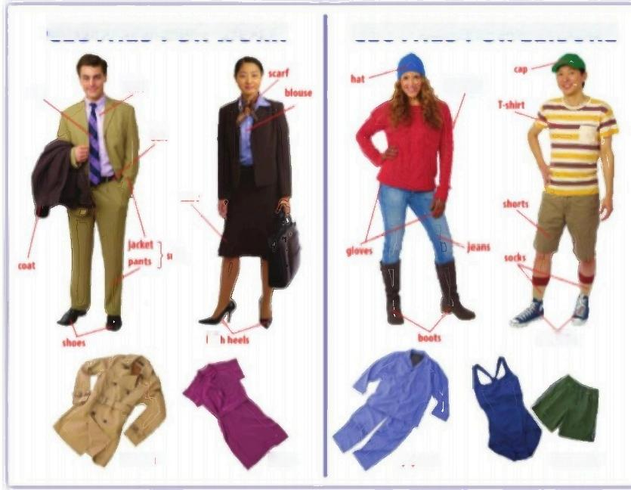

B Complete the chart with words from part A.

|  |  |  |  |  |
| --- | --- | --- | --- | --- |
| **Cothes** **for** **warm** **weother** **Clothes** **for** **cold** **weather** | | | | |
|  | .Y,shirt…  **Shorts** …  **Cao**……  **Swearters** | ……………  ……………  …  ……… | .Cool… .Bouts…  Scarf  Gloues | ……… ………  …………  ………………………… |

C **PAIRWORK** Look around the classroom.What clothes do you see?Tell a partner.

"1 see jeans,a sweater,boots,and."

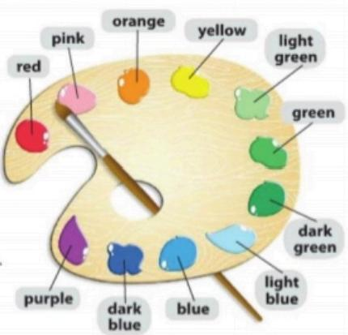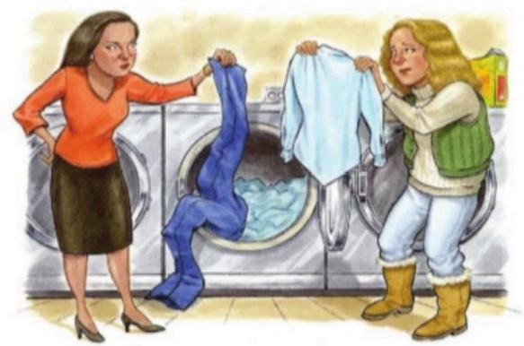**UOS**

**3.2.-Colors**

 **COLORS**

A (O)Listen and practice.

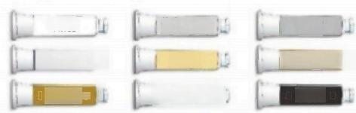

gray

light browm

black

white

**brown**山

**light gray**

**beige**

**kbrown**

**kR**

B **GROUP WORK** Ask about favorite colors.

A:What are your favorite colors?

B:My favorite colors are dark green and purple.

C **GROUP WORK** Describe the clothes in Exercise 1.

A:The suit is beige

B:The pajamas are light blue.

**CONVERSATION** It's a disaster!

(O)Listen and practice.

Pat:Great!Our clothes are dry.

Where is my new blouse?

Julie:What color is it?

Pat:It's white.

Julie:Here's a lightblue blouse.

Is it yours?

Pat:No,it's not mine.…Wait.

It is mine.It's a disaster!

Julie:Oh,no!All our clothes are

Pat: '. problem.It's these

new blue jeans.Whose

jeans are these?

Julie:Uh,they're mine.Sorry.

***PRONUNCIATION*** *The letters s and sh*

A ◎Listen and practice.Notice the pronunciation of s and sh.

1.suit socks scarf

2.shirt shorts shoes

B Read the sentences.Pay attention to the pronunciation of s and sh.

1.This is Sandra's new **shi**rt. 3.Where are my **sho**es and socks?

2.These are Sam's purple **sho**es! 4.My **sho**rts and T-**sh**irts are blue!



U□S

**3.3.-Possessive Adjectives and Pronouns**

|  |  |  |
| --- | --- | --- |
| **Possessives** | **o**  **Pronouns**  **mine**  **yours** socks are **his.**  These  **hers**  **ours**  **theirs** | **Names**  **Pat's** blouse /s/  **Julie's** jeans /z/  **Rex's** T-shirt /z/  **Whose** blouse is this?If's **Pat's**  **Whose** jeans are these?They're **Julie's** |
| **Adjectives**  **my**  **your**  These gre **his** socks  **her**  **our**  **their** |

A Complete the conversations with the correct words in parentheses.

Then practice with a partner.

1.A:Hey!These aren't gu…(our /ours)clothes!

B:You're right..**Ous**… (Our/Ours)are over there.

2.A:These aren't.**My**……….(my /mine)gloves.Are

they…Youie……(your /yours)?

B:No,they're not.**Mne**………(my /mine).Ask Sally.Maybe

they're Hars… (her /hers).

3.A:.Whose………(Whose /Yours)T-shirts are these?Are they

Julie's and Pat's?

B:No,they're not hel………(their /theirs)T-shirts.But

these socks are .Thairs………(their /theirs).And these

shorts are You………(your /yours).

1 **Possessives**

▶The noun comes after a possessive adjective:This is **my** T-shirt.

Don't include the noun after a possessive pronoun:This T-shirt is **mine.**

Whose can be used with singular and plural nouns: **Whose** bag is this? **Whose** keys are these?

Complete the conversations.Use the words in the boxes.There are two extra words in each box.

|  |
| --- |
| his mine my your yours √whose |

1.A:…Whaa….jacket is this?Is it .Yours…………,Phil?

B:No,it's not .Mne………….Ask Nick.I think it's ……………

|  |
| --- |
| her our ours your yours |

2.A:These aren't.My … … … books.Are they Yours……………?

B:No,they're not ours………….Maybe they're Young-min's.

|  |
| --- |
| her hers their theirs whose |

3.A:.Whose……..sweaters are these?Are they Julie's?

B:No,they're not .He………sweaters.But these shorts are …………………



**UOS**

见 发 寒 急 心 思 的 意 言

重

院

年富

)Listen and practice.

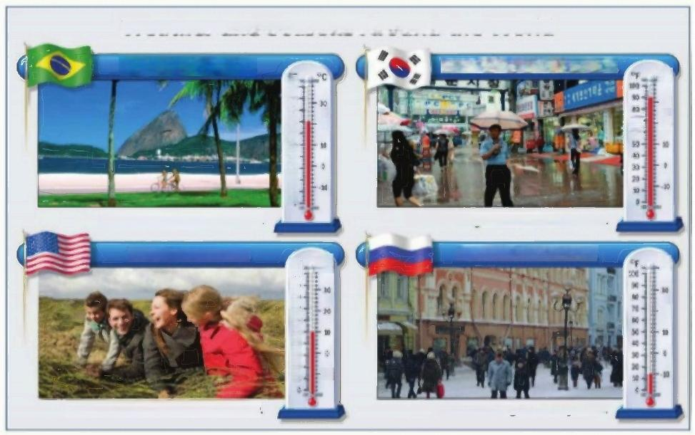**Weather and Seasons Around the World**

**it's spring in Brazil.** Its summer in South Korea.

_c



- n+ -0 0

it's warm.It's very sunny.

it's fall in the U.S.

it's cool.It's doudy and windy.

It's raining.It's hot and humid.

It's winter in Russia.

+



It's snowing.It's very cold.

c



Soe:Mitoof kwe/

*What season is it now?*

What's the weather like today?

*Whats your favorite season?*

***CONVERSATION*** *It's really cold!*

(O)Listen and practice

Pat:Oh,no!

Julie:What's the matter?

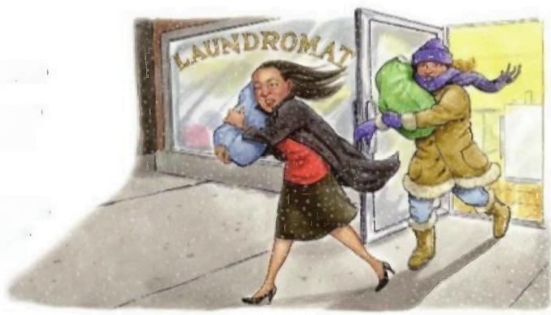Pat:It's snowing!And it's windy,so

it's really cold,

Julie:Are you wearing your gloves?

Pat:No,I'm not.They're at home.

Julie:What about your scarf?

Pat:It's at home,too.

Julie:Well,you're wearing your coat.

Pat:But my coat isn't very warm.

And I'm not wearing boots!

Julie:Let's take a taxi.

Pat:Good idea!

**U□S**

T

**3.4.- Present continuous affirmative and negative**

|  |  |  |  |
| --- | --- | --- | --- |
|  | |  | |
| **Present** **continuous** **stotements;** **con** **Unctions** O | | . | **Conjunctions**  If's snowing  **and** it's windy If's sunny,  **but** it's cold. If's windy  **so** it's very cold |
| **l'm** I**'m** **not**  You'**re** You**'re** **not**  She'**s** **wearing** shoes. She'**s** **not**  We**'re** We'**re** **not**  hey'**re** They**'re** **not** | OR;  You **aren't**  She **isn't** **wearing** boots We **aren't**  They **aren't** |
| It'**s** **snowing** It'**s** **not** It **isn't** **raining** | |

**2 Present continuous statements; conjunctions**

**▶The present continuous is the present of be+ verb+-ing:It's raining.**

**She's wearing shoes.**

**The two negative contractions mean the same: He's not/He isn't wearing a coat. We' re not /We aren' t wearing gloves.**

Change theaffirmative sentences to negativesentences.Change the negative

sentences to affirmative sentences.

1. Mr. and Mrs .Lee are wearing hats. Mr and.MrsLes .arent .wearina.hat ………

2. It isn' t raining. uis aining……………………………………………

**3.** **I'm** **wearingsunglasses.…Im not weating sunglasses**………………………… 

4. You' re wearing a new suit ……**Youarent.weatinga.new.sui…** …

**5.** **Michiko isn' t wearing gloves. Michiko.ls.weating gloves** …… 



2 **Wh-questions with be**

>[Use what to ask about things.Use where to ask about places.Use Who to ask about people.Use What.like?to ask for a description.

Use how to ask for a description: **How are** you today?Use How old to ask about age: **How old** is he?

In answers about age,you can use only the number or the number +years old: He's **18.**oR He's **18 years old.**

Complete the questions with how,what,where,or who.Then match the questions

with the answers.

1.……Who…is that?

2..What…...is her name?.C … …

3..Mis………..is she like?E … …

4..Years……..old is she?.**B …**

5..They……...is your family from?.A … .

6..You………....is Bangkok like?E … …

***WORD POWER*** *Descriptions*

a.We're from Thailand -from Bangkok.

b.She's 16.

c.Her name is Nittaya.

d.She's my sister.

e.It's really beautiful.

f.She's a little shy.

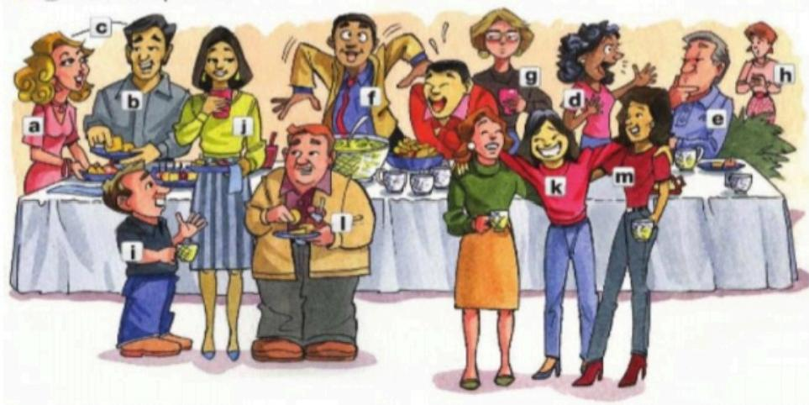

◎ Listen and practice.

a.pretty

b.handsome

c.good-looking

j.tall

k.friendly 1.heavy

g.serious

h.shy i.short

d.talkative

e.quiet

f.funny

m.thin

UOS

B **PAIRWORK** Complete the chart with words from part A.Add two more

words to each list.Then describe your personality and appearance to a partner.

|  |  |
| --- | --- |
| **Persondit** **APPearentc** | |
| talkative **Funny** **Shy**  …… …… … …… | .pnetty .**Short** **.Friendly**………  … …… …… …  .  …………………… ……………………… ……………………… |

T'm funny,smart,and very handsome.

 ***LISTENING*** *Who's that?*

Listen to three descriptions.Check(√)the two correct words for each description.

|  |  |  |  |  |
| --- | --- | --- | --- | --- |
| 1.Elena  2.Marco  3.Andrew | is.  is.  is … | □ short  tall  □ tolkafive | prelty  nice  funny | ·friendly  hy  3my  □ friendly |

**UOS**



Is Min-ho friendly? Is Ryan tall?



**Progress check**

**INTERVIEW**



Match the questions with the answers.Then ask and answer the

questions with a partner.Answer with your own information.

|  |  |
| --- | --- |
| 1.Are you from Malaysia? h | a.It's very beautiful. |
| 2.Where are you and your family from?G … … … … | b.Yes,she is. |
| 3.What is your hometown like?A … | c.We're from Mexico. |
| 4.Is English your first language?..G … … | d.My best friend is Kevin. |
| 5.Who is your best friend?.D. … … … … | e.Yes,they are. |
| 6.Are your classmates Brazilian?E … … … | f.No,it's not.It's Spanish. |
| 7.How old is your best friend?.a … … | g.He's nineteen. |
| 8.Is our teacher from the U.S.?.B … … . | h.No,I'm not.I'm from Thailand. |

**LISTENING** Who's that?

A◎Listen to four conversations.Check(√)the correct description

for each person.You will check more than one adjective.

|  |  |  |  |  |  |  |
| --- | --- | --- | --- | --- | --- | --- |
| 1.Min-ho | tall | short | funny | friendly | talkative | quiet |
| 2.Ryan | tall | .short | funny | serious | friendly | shy |
| 3.Angela | thin | ) heavy | pretty | shy | nice | friendly |
| 4.Helen | thin | heavy | quiet | shy | .serious | funny |

B Write five yes/no questions about the people in part A.

Then ask a partner the questions.

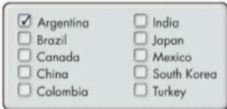**U□S**

**UNIT II.WHERE ARE YOU FROM?**

**WORKBOOK**



***Cities and countries***

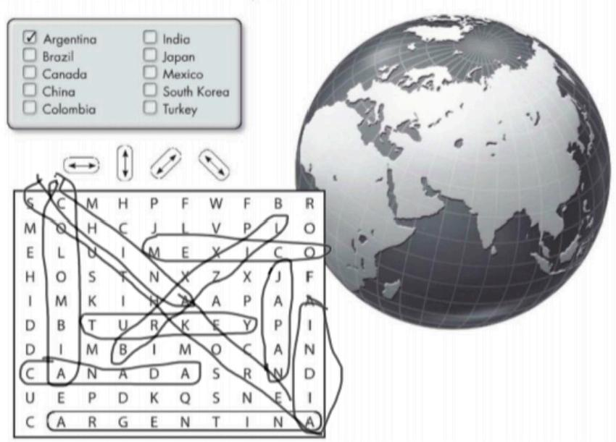**A** Find and circle these countries in the puzzle.

**B** Where are these cities?Complete the sentences with the countries in part A.

1.Delhi and Mumbai are in India.

2.Shanghai Is in china 3.Tokyo Tokio isin Japon 4.Sao Paulo and Rio Are in brazil 5.Seoul and Daejeon Are in south korea 6.Buenos Aires Is in argentina 7.Vancouver and Ottawa Are in Canada. 8.Istanbul Is in turkey

**UOS**

***Complete the conversations with am,'m,are,'re,is,or's.***

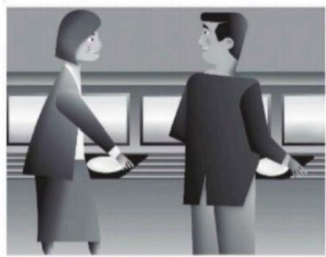

1.A: Are you and your family from

South Korea?

B:No.we Are .not.

We Be .from China.

A:Oh,so you _ Re _from China.

B:Yes.I Am 1 Am from Shanghai.

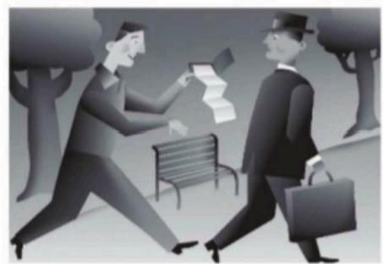

3.A: Is _this your wallet?

B:Yes.it 1s .Thanks.

A:And Are these your pictures? B:Yes.they Are ..

A:Well,they Re very nice pictures. B:Thank you!

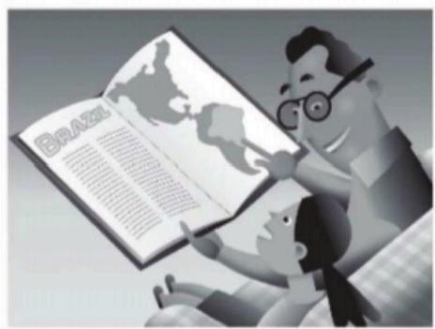

2.A: Is .Brazil in Central America,Dad? B:No,it Is not.It Is .in

South America.

A:Oh. Are we from Brazil,Dad?

B:Yes,we Ar We Re .from Brazil originally,but we Re

here in the U.S.now.

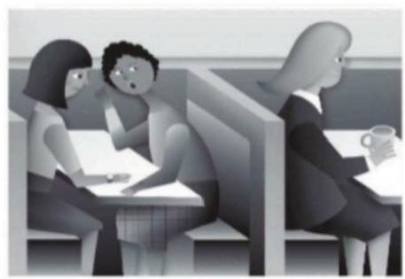

4.A: Is your English teacher from

the U.S.?

B:No,she Is not.She ls from Canada.Montreal,Canada.

A: Is _English her first language?

B:No.it ls not.Her first language Is French.

**U□S**



***Answer the questions.***

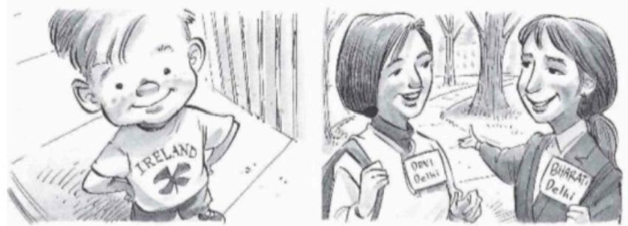

1.A:Is he from Brazil? 2.A:Are they from India?

B: No,he's not.He's from Ireland B: Yes Thay are

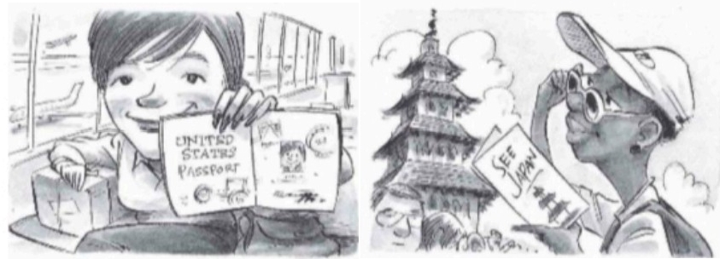

3.A:Is she from Canada? 4.A:Is she in Mexico?

B: Yes,She's Is B: No.She's'not she in japar

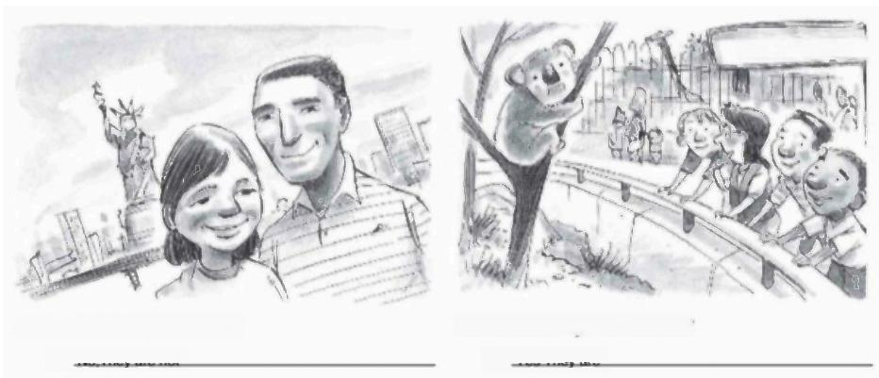

PERTH ZoC

5.A:Are they in Jakarta?

B:No They are not

6.A:Are they B:Yes They

in Australia?

are

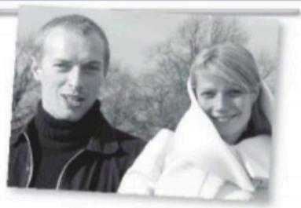***Spell the numbers.***

1.11 eleven

2.15. Eitteen

3.50 Eifty

4.101 One hundred one

5.24 Twenty fout.

6.13 Thirteen

7.70 Seventy

8.30 Thirty

9.19 Nineteen

10.90 Nines

 ***Complete the conversations with the correct***

***responses.***

1.A:Where are they from?

**B:** She's from the US,and heis from the UK

hUPl,rtin.

2.A:Is your first language English?

B: **No,It's japonese**

·No,it's Japan

·No,it's Japanese

3.A:What are they like?

B: They're yery nice

·They're very nice.

·They're in London.

4.A:Who's that?

B:  **Me the new math teacher**

·He's the new math teacher.

·It's my new cellphone.

5.A:Where are Tony and his family?

B: **They're from Sao Paulo**

·They're in the U.S.now.

·They're from Sao Paulo.

6.A:How old is he now?

B: **He's twenty-eight**

·It's twenty-eight.

·He's twenty-eight.

7.A:What's Marrakech like?

B: It's very interesting

·It's in Morocco.

·It's very interesting.

**UOS**



***Complete the sentences.Use the prepositions in the box.***

□ behind ☑ in in front ol □ next to □ on under



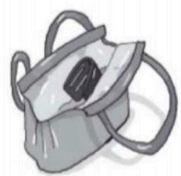

1.The wallet is . n the purse.

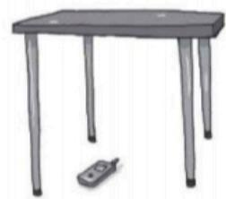

4.The cell phone is Under the table.

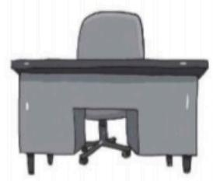

2.The chair is Behind

the desk.

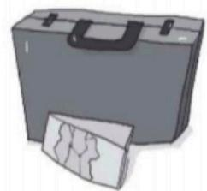

5.The map is Unfrontol

the briefcase

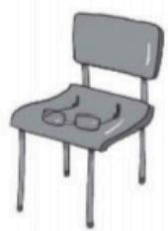

3.The glasses are No the chair.

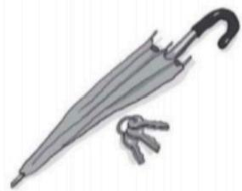

6.The keys are Nextto

the umbrella.

**U□S**

***Where are these things?***

**A** Look at the picture.Wite questions and answers about the things in parentheses

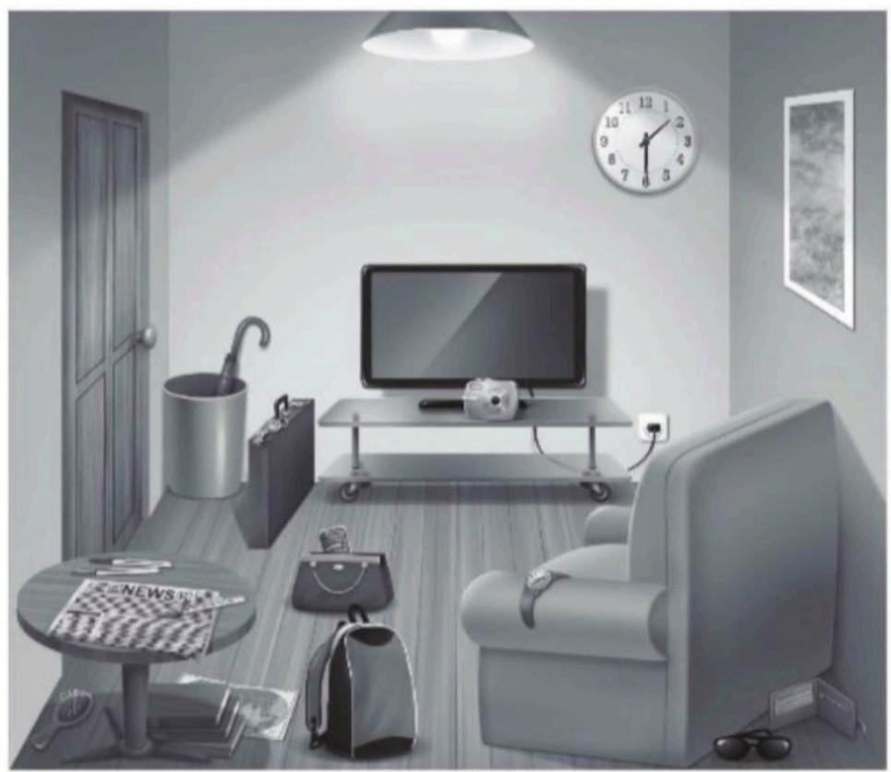

1.A: Where ls the briefcase? (briefcase)

B: It's next to the televislon

2.A:  **Where are the books?** __(books)

B: **They** **are** **no** **the** **flor**

3.A:  **Where is the cell phone** (cell phone)

B:  **It's in the bag**

4.A:Where are the keys .(keys

R ·

5.A: Where is the Camara ? (camera)

B: It's on the furniture

6.A: Where are the sunglasses .(sunglasses)

B: They are behind the sofa

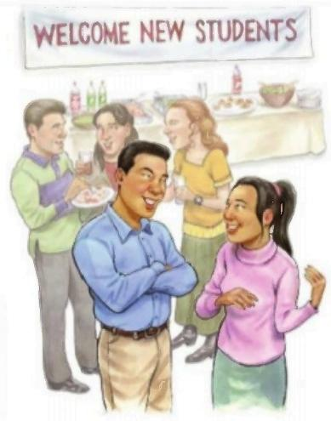**UOS**

**UNIT I.WHERE ARE YOU FROM?**

**2.1.-Cities and Countries**

***SNAPSHOT***

◎Listen and practice.

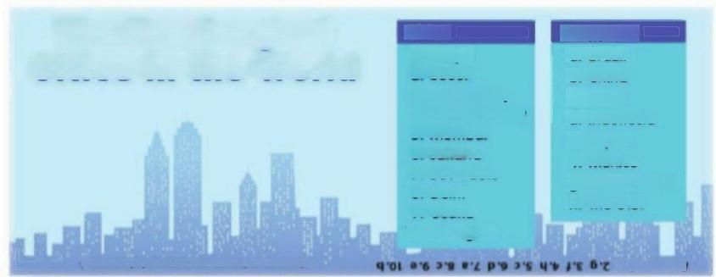

**The Ten Largest**

**Cities in the World**

3.Mexico City 4.New York Cit

**5.Mumbai 6.Jakarta**

**7.Sao Paulo 8.Delhi**

**9.Osaka**

**10.Shanghal**

(hasod on populelon ia the metropoitan aree)

**Countries**

**a.Brazil**

**b.China**

**c.India**

**d.Indonesia e.Japan**

**f.Mexico**

**g.South Korea h.the U.S.**

Cities

1.Tokyo

2.Seoul

● KMSUV

Sun ww wurdhn.om

Match the cifies with the countries.Then check your answers at the botlom of the Snapshot. What other large cihes are in eoch country?What large cihies are in your country?

**CONVERSATION** Are you from Seoul?

A◎ Listen and practice

Tim:Are you from California,Jessica?

Jessica:Well,my family is in California now,

but we're from South Korea originally.

Tim:Oh,my mother is Korean -from Seoull

Are you from Seoul?

Jessica:No,we're not.We'e from Daejeon.

Tim:So is your first language Korean?

Jessica:Yes,it is.

0m B◎LUsten to Jessica and Tim talk to Tony,

Natasha,and Monique.Check (√)True or False.

|  |  |  |
| --- | --- | --- |
|  | True | False |
| 1.Tony is from Italy  **2.**Natasha is from New York.  3.Monique's first language is | C  1  English. | ……… |

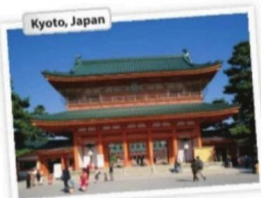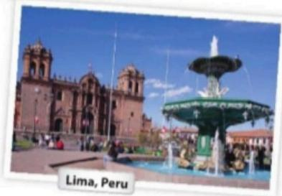**U□S**

**2.2.-Negative and Questions with be**

|  |  |  |
| --- | --- | --- |
| **Negative** **stotements** **and** **yes/no** **questions** **with** **be** **O** | |  |
| **I'm** **not** from New York.  **You're** **not** late  **She's** **not** from Russia **He's** **not** from Italy **It's** **not** English.  **We're** **not** from Japan  **You're** **not** early  **They're** **not** in Mexico  Wo're -We are | **Are** **you** from California?  I'm  you're she's  **l** **am.**  **you** **are** **she** **is**  not not not. not. not. not.  **Am** **l** early?  **Is** **she** from Brazil?   |  |  | | --- | --- | | **Is** **he** from Chile? | Yes,**he** **is** No,he's | | **Is** **it** Korean? | **it** **is** it's | | **Are** **you** from China? | **we** **are.** we're |   **Are** **we** late? **you** **are** you're not  **Are** **they** in Canada? **they** **are** they're not | |



(0m

**A Complete the conversations.Then practice**

with a partner.

1.A:Hiroshi, ….you and Maiko from Japan?

B:Yes,we **Are**

A:Oh? **Are**………you from Tokyo?

B:No,…nie………not..am … from Kyoto.

2.A:..Thi…………Laura from the U.S.?

B:No, ………………not.She's from the U.K.

A:………………….she from London?

B:Yes,she His…… .But her parents are from

Italy..You………not from the U.K.originally.

A:He………Laura's first language Italian?

B:No,Yo………not. … English.

3.A:Mis………...Selina and Carlos from Mexico?

B:No, not.Yau.are…from Brazil.

A:.**A袋**……… you from Brazil,too?

B:No,.Is…………………not.I'm from Peru.

A:So,His………………your first language Spanish?

B:Yes,it …

B Match the questions with the answers.Then practice with a partner.

|  |  |
| --- | --- |
| 1.Are you and your family from Canada? … … . …  2.Is your first language English?.c … … …  3.Are you Japanese?E … …  4.Is Mr.Ho from Hong Kong?.D … …  5.Is your mother from the U.S.? … … | a.No,hes not.He's from Singapore.  b.Yes,she is.She's from California.  c.No,it's not.It's Japanese.  d.No,we're not.We're from Australia. e.Yes,we are.We're from Kyoto. |

C **PAIRWORK** Write five questionslike the ones in part B.Then ask and answer

your questions with a partner.



**1 Negative statements andyes/no questionswith be**

**▶Use be+ not to form negative statements: Ana isn't a student.( wor: Anais ne a student .)**

**▶You is asingular and a plural pronoun: Are you from Rio? Yes, I am./Yes, we are.**

**A Unscramble the words to write negative statements.**

1. in Califonia/ not / New York City /is

New. York City is.notin Califormia……

2. London / not / from /we 're

Not. we're from. london.

3. not/ you and Tim / in myclass / are

Tim .and you not are .in .my class ………………………

4. is/ my first language / Spanish / not



5. from / my mother / not / is / Seoul

My mother not is from seoul ………………………

6. my keys/ not / are/ they

They not are mykeys…………………………

**B Complete the conversations.**

1. A: A …… youandyourfamilyfromMexico?

**B: No,. We're ………… not.. We.re**……………fromGuatemala.

2.A: Is ……………yourfirstlanguageEnglish?

B: Yes, it .Js ……………… MyparentsThey……fromAustralia.

3. A: Are……………KenjiandhisfriendJapanese?

B: Yes, They… are. But. They're……… intheU.S.now.

4.A: Are ……………mymotherandllate?

B: No, Youre ………… not.Youre……………early!

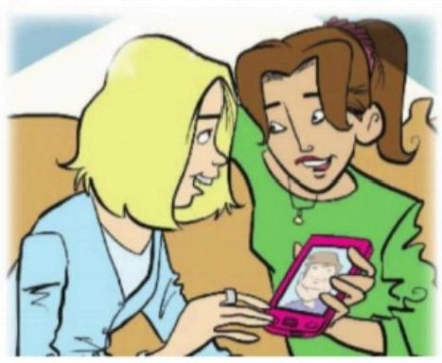

**2.2.-Where are they from?**

**WHERE ARE THEY FROM?**

A Where are these people from?Check(√)your guesses.

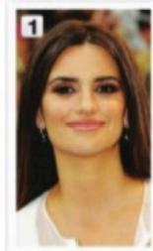

**Penelope Cruz**

Mexico

France

.Spain

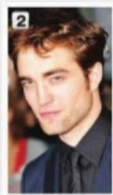

**Robert Pattinson**

the U.S.

the U.K.

Canada

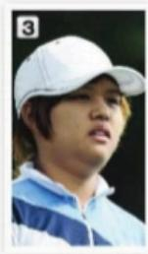

**Haru Nomura**

South Korea Japan

China

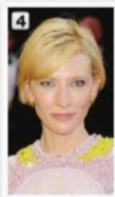

**Cate Blanchett**

Australia

□New Zealand

South Africa

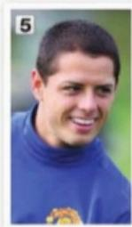

**Javier Hernandez**

Brazil

Mexico

□Chile

**B PAIRWORK** Compare your guesses.Then check your answers at the bottom of the page.

A:Is Penelope Cruz from Mexico?

B:No,she's not

A:Is she from France?

oopxaw s epensny vueder e xn ag zueds t Sansuy

***CONVERSATION*** *He's cute.*

( Listen and practice

Emma:Who's that?

Jill:He's my brother.

Emma:Wow!He's cute.What's his name?

Jill:James.We call him Jim.

Emma:Oh,how old is he?

Ji:He's twenty-one years old.

Emma:What's he like?Is he nice?

Jil:Yes,he is-and he's very smart,too!

Emma:And who's that?

Ji:My sister Tammy.She's only twelve.

She's the baby of the family.

**UOS**

**2.3.-Numbers and Ages**

**NUMBERS AND AGES**

**A** ◎Listen and practice.

**11**

**12**

**13**

**14**

**15**

**16**

**17**

**18**

**19**

**20**

eleven

twelve

thirteen

fourteen

fifteen

sixteen

seventeen

eighteen

nineteen

twenty

**21** twenty-one

**22** twenty-two

**23** twenty-three

**24** twenty-four

**25** twenty-five

**26** twenty-six

**27** twenty-seven

**28** twenty-eight

**29** twenty-nine

**30** thirty

**40**

**50**

**60**

**70**

**80**

**90**

**100**

**101**

**102**

**103**

forty

ffty

sixty

seventy

eighty

ninety

one hundred

one hundred (and)one

one hundred (and)two

one hundred (and)three

**B◎Listen and practice.Notice the word stress.**

thirteen-thirty

○ ◎

①

fourteen -forty

〇

fifteen-ffty sixteen -sixty

C **PAIR WORK** Look at the people in Jll's family for one minute

Then close your books.How old are they?Tell your partner.

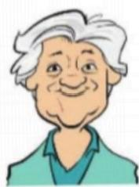

A.Helen-76



B.Howard-52

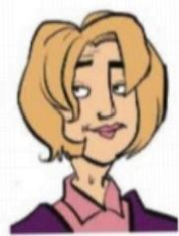

C.Jackie-49



D.Megan-23



E.Tim and Tom-14

**UOS**

**2.4.-Wh-questions with be**

|  |  |  |  |  |
| --- | --- | --- | --- | --- |
|  | **Wh** **-questions** **with** **be** **O** | |  | |
|  | |
| **What's** **your** **name?**  My name is Jill  **Where** **are** **you** **from?**  I'm from Canada.  **How** **are** **you** **today?**  I'm just fine. | **Who's** **that?**  He's my brother.  **How** **old** **is** **he?**  He's twenty-one  **What's** **he** **like?**  He's very nice  Who's=Who is | | **Who** **are** **they?**  They're my classmates.  **Where** **are** **they** **from?**  They're from Rio.  **What's** **Rio** **like?**  lf's very beoutiful |

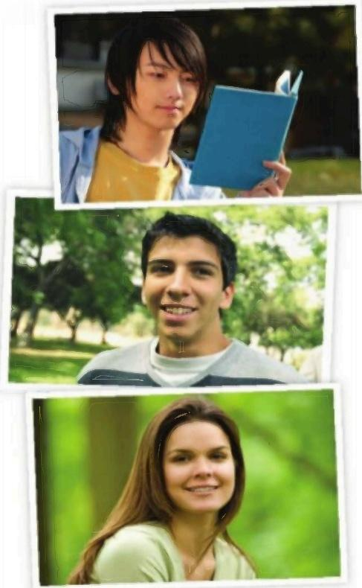**A** Complete the conversations with Wh-questions.

Then practice with a partner.

1.A:Look!Whe.a.that………………………………?

B:Oh,he's a new student.

A:.Whats t calod… …………………?

B:I think his name is Ming.

A:Ming?Wharo ls t trom… …………?

B:He's from China.

2.A:Serhat,Where.are you.trom…………………?

B:I'm from Turkey-from Istanbul.

A:.What Is istanbullike… ………?

B:Istanbul is very old and beautiful.

A:.What.ls.Your last aame………… …?

B:My last name is Erdogan.

3.A:Hi,John.How are you…… ………………?

B:I'm just fine.My friend Teresa is here

this week-from Argentina.

A:Oh,cool.How.is she …

…?

B:She's really friendly.

A:.How and are you…………………?

B:She's twenty-eight years old.

**U□S**

**Progress check**

**HOWARE YOU?**

A Complete the conversation.Use the sentences and questions in the box.

Matt:.Hi.Haw.ane.xau? …

Nicki:I'm fine,thanks.Hoy about you 7 … … … .

Matt:Pretty good,thanks..**My nameis matt Cartos**………

Nicki:And I'm Nicki White.

Matt:It's niceto meet you,nicki … … …

Nicki:Nice to meet you,too..**.Oh,ara you in my anglah dlass?**………

Matt:Yes,I am.

Nicki:Woll,have a good day … … … …

Matt:See you in class.

My name is Matt Carlson.

Oh,are you in my English class? How about you?

**√** Hi.How are you?

It's nice to meet you,Nicki.

Well,have a good day.

**B PAIRWORK** Practice the conversation from part A.Use your

own information.Then introduce your partner to a classmate.

"Malena,this is my friend.His name is Tetsu. …"

***LISTENING*** *What's this?What are these?*

◎Listen to the conversations.Number the pictures from 1 to 6.

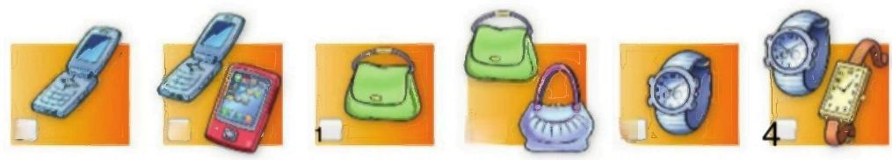

5 6 2 **3.**

**U□S**

***WHAT'S WRONG WITH THIS ROOM?***

A What's wrong with this room?Make a list.Find 10 things.

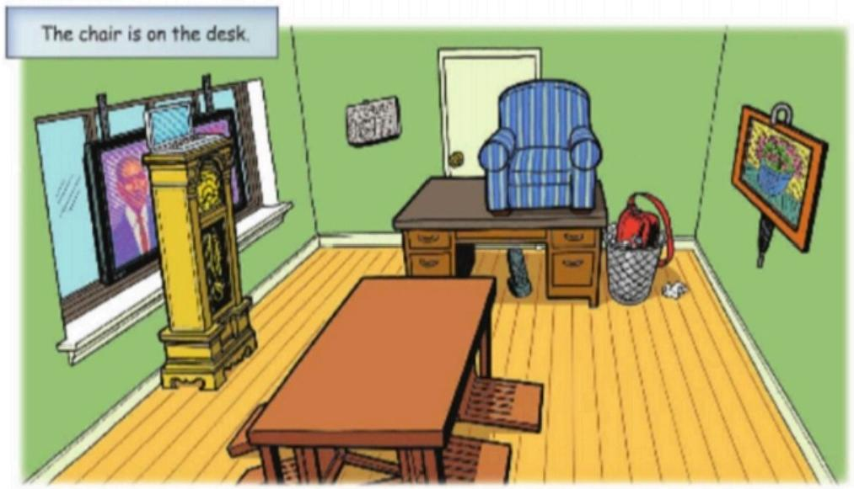

**B PAIRWORK** Ask and answer Where about the picture

questions

A:Where's the chair?

B:It's on the desk.

**YES OR NO GAME**



Write five yes/no questions about the picture in Exercise f Three have

"yes"answers,and two have"no"answers.Then ask a partner the questions.

A:Is the chair behind the clock?

B:No,it isn't.

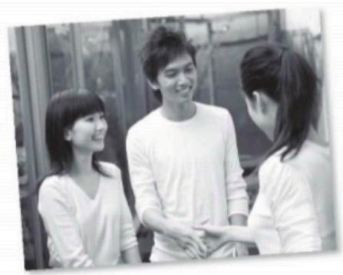

**UNIT I.INTRODUCTION-IT'S NICE TO MEET YOU**

**WORKBOOK**

*Complete the conversations.Use my,your,his,or her.*

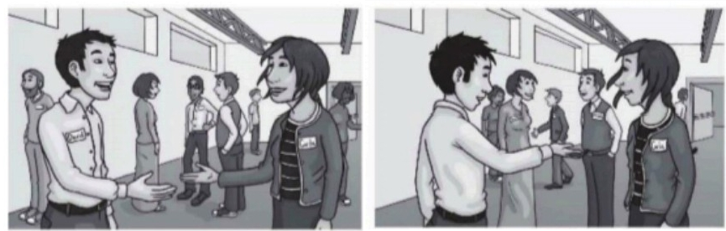

1.A:Hi.What's. your .name?

B: My .name is Carla.And what's

Her name?

A: My .name is David.

2.A:What's Your .name?

B: His name is Michael.

A:And what's Your .name?

*B: My* name is Sarah.

***Choose the correct responses.***

1.A:Hi,Daniel.

B: Hella

·Hello.

·It's nice to meet you

2.A:My name is Pam Walker.

B:I **m jake Wiliams**

·It's Williams.

●I'm Jake Williams.

3.A:Hello,Yuko.How's it going?

B: Fne,thanks

·Fine,thanks.

·Nice to meet you,too.

4.A:How do you spell your last name?

B: R-O-G-E-R

·R-O-G-E-R-S.

·It's Rogers.

5.A:I'm Bill Delgado.

B: Nice to meet you,too

·Nice to meet you,too.

·It's nice to meet you.

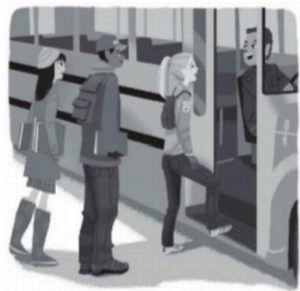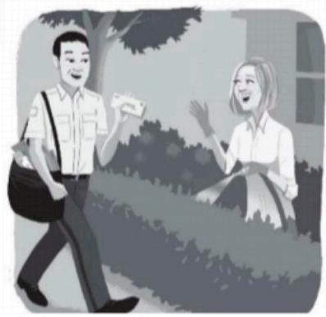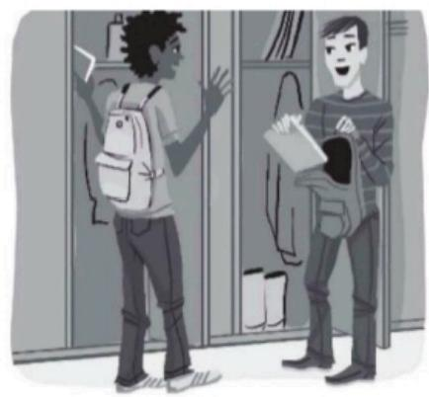UOS

***Complete the conversations.***

1.A:Hello, Me .Jones.

B:Good—morning,Susan.

How _are you?

A:Fne OK,thank you.

2.A:Hi.How are You ,Mrs.Stein?

B:I'm just Fu .,thank you.

How about This

,

Smith?

A:Pretty Fina ,thanks.

3.A:How's it Sc ,Tim?

B:Great are you doing? A:Pretty good.

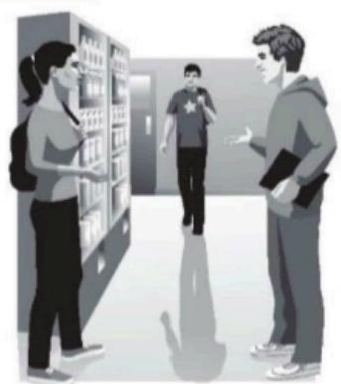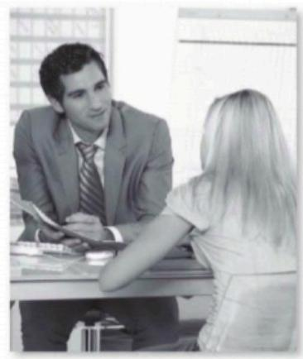UOS



***Complete the conversations.Use the words in the box.***

am

are

□ he's

□I'm

I'm not



is

□ it's

☑ me

you

you're

1.Debra:Excuse me .Are You're

James Lawson?

Kevin:No, I'am not It's over there.

Debra:Oh. Its -sorry.

2.Debra Ecuse me **A re**

 you James Lawson?

James:Yes.I Am _.

Debra:Hi,James.My name Is

Debra Marks.

James:Oh. You're in my English class.

Debra:That's right. Im nice to meet you.

James:Nice to meet you,too.

***Complete the conversation.Use the questions in the box.***



Whats your name?

And how do you spell your last name? ☑ Are you Ashley Nevins?

And what's your email oddress?

What's your phone number?

How do you spell your first name?

A:Hi. Are you Ashley Nevins?

B:No,I'm not.

A:Oh,I'm sorry. **Whats your name**

B:Kerry Moore

A: And how do you spell your last name?

B:K-E-R-R-Y.

A:  **How do you spell your first name?**

B:M-O-O-R-E.

A: What's your phone Numbers

B:It's 618-555-7120.

A: And What's your email oddress?

B:It's kmoore19@cup.org,



**UOS**

***Hello and good-bye!***

**A** Complete the conversations.Use the words in parentheses.

1.A: Hi.How are you? 3.A: Are you soo-mi kim2

(Hi./Excuse me.)How are you? (Excuse me./Thank you.)Are you Soo-mi Kim?

B:I'm fine,thanks. B:Yes,l am.

2.A: See you tomorrow 4.A: Good niaht

(Hello./Good-bye.) (Good evening./Good night.)

B:See you tomorrow. B:Hello.

***What are these things?***

**A** Whats in the picture?Wite the things.

1. a bag

2. A umbrella

3. Cellphone

4 Book

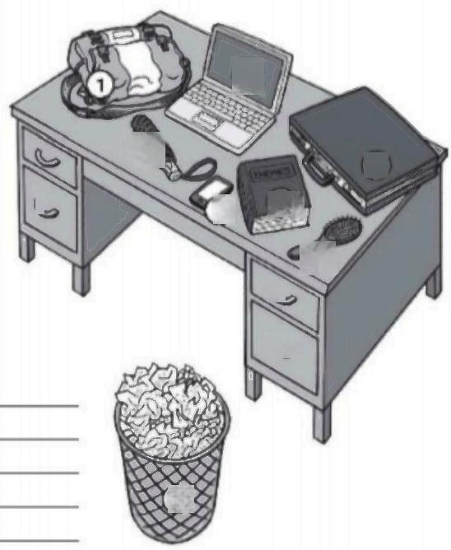5. Umbrella 

6. Portafolio

7.. Como

8. Trash can

**B** What's in the picture?Write sentences.

1. This is a bag 2. This Is a cellphone

3. This Is a comb 4. This Is a laptop 5. This Is a umbrella 6. This ls a book 7. This Is a portafolio

8. This Is a trash can

③

②

④ 5

⑦





8

⑥

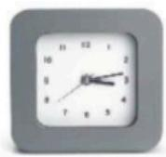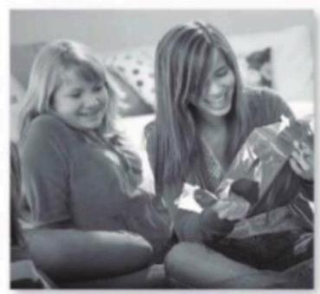



***Complete the questions with this or these. Then answer the questions.***

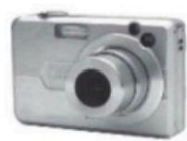

1.A:What's this .? 2.A:What's This .7

B: It's a camera B: An reloj

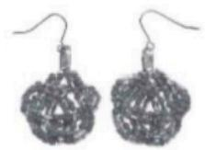

3.A:What are These _?

B: They are apalt aleaing-

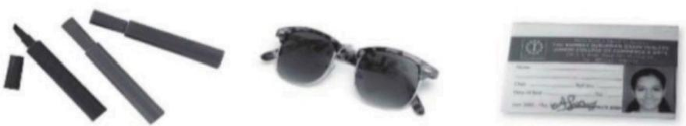

4.A:What are The ?

B:They are dow

5.A:What are These 7 B: They are glasses

6.A:What 's This .? B: It's An ID

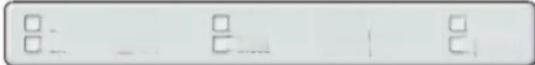

***Complete the conversation.Use the words in the box.***

口they □ they/re

□s

☑ irs

you

you're

this

these

a

an



Dana:Wow!What's this?

Chris: t's .a purse.

Dana:Oh,cool.Thank . You ,Chris.

Chris Yau're welcome.

Eva:Now open These box.

Dana:OK.What Is this?

Eva:It's A scarf.

Dana:Oh,thank you,Eva.And what are They're ?

Eva: They .'re earrings.

Dana:Thanks! This .great!

Amy:Open this,too!

Dana:Oh.it's An umbrella.Thanks,Amy!

**UOS**



***Complete the conversations.***

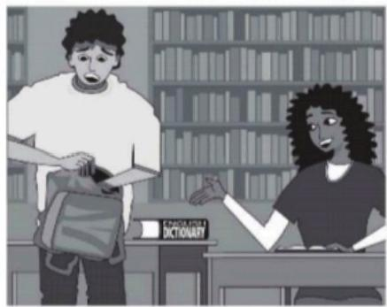

1.A:Where 15 .my English dictionary? B:Is Wha .in your book bag?

A:No.it's No

B:Wait a minute. Is .it on the desk? A:Yes, t _is.Thank you!

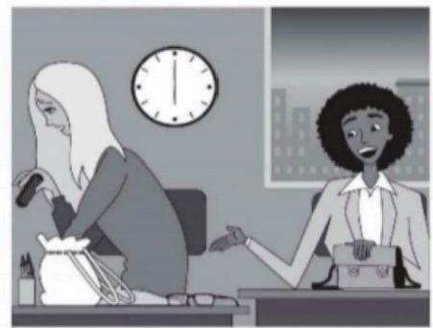

3.A:Where Are my glasses?

B:Are s in your purse?

A:No,they're Nc

B: Are they on your desk?

A:Hmm.Yes.Th ey are.Thanks.

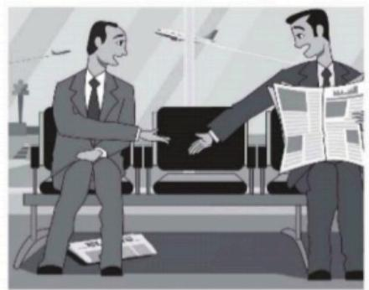

2.A: You this my newspaper?

B:No,. is not.

It's my newspaper

A:Sorry. This .is my newspaper? B:Is under your chair?

A:Oh,yes,it .Thanks.

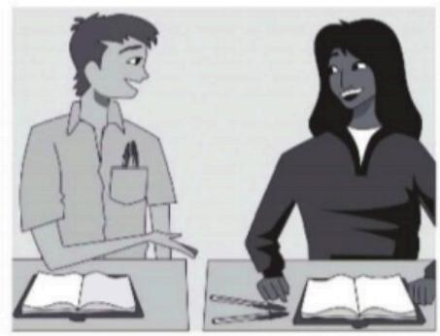

4.A: Yau .my pens on

your desk?

B:No. Is not.Sorry.

A:Hmm. yau _are my pens?

B: Are they in your pocket?

A:Let me see.Yes,they H

Thank you!

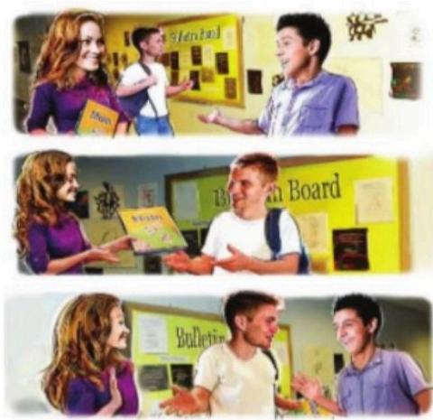U□S

AO )Listen and practice.

Jennifer:Excuse me.Are you

Steven Carson?

David:No,I'm not.He's over there.

Jennifer:Oh,I'm sorry.

Jennifer:Steven?This is your book.

Steven:Oh,thank you.You're in my

class,right?

Jennifer:Yes,I am.I'm Jennifer Miller.

Steven:Hey,David,this is Jennifer.

She's in our math class.

David:Hi,Jennifer.

Jennifer:Hi,David.Nice to meet

you.

**B GROUP WORK** Greet a classmate.Then introduce him or her to

another classmate.

"Hey,Ming,this is.."

B Complete the conversations.Then practice in groups.

Nicole:Excuse me.……Are…you Steven Carson?

David:No,tam … … not.My name . …

David Medina.Steven .……………..over there.

Nicole:Oh,sorry.

Nicole:. **Are**… ………you Steven Carson?

Steven:Yes,I .**Am**……………

Nicole:Hi.l**an** … ..Nicole Johnson.

Steven:Oh,Y **ou**…………….in my math class,right?

Nicole:Yes,I. **Am …**

Steven:'s……….nice to meet you.

**C CLASS ACTIVITY** Write your name on a

piece of paper.Put the papers in a bag.Then

take a different paper.Find the other student.

A:Excuse me.Are you Jin-sook Cho?

B:No,I'm not.She's over there.

A:Hi.Are you Jin-sook Cho?

C:Yes,l am.

**U□S**

**1.3.-Article a,an**

***ARTICLES*** *Classroom objects*



**arlides**(O

**an** +vowel sound a+consonant sound

2.This is …An…..eraser.

3.This is An……English book. 4.This is.A…….marker.

5.This is A.…..notebook. 6.This is A……clock.

A ◎Listen.Complete these sentences with a or an.

1.This is .An….book.

**1.4.-Use of This and These /It and They**

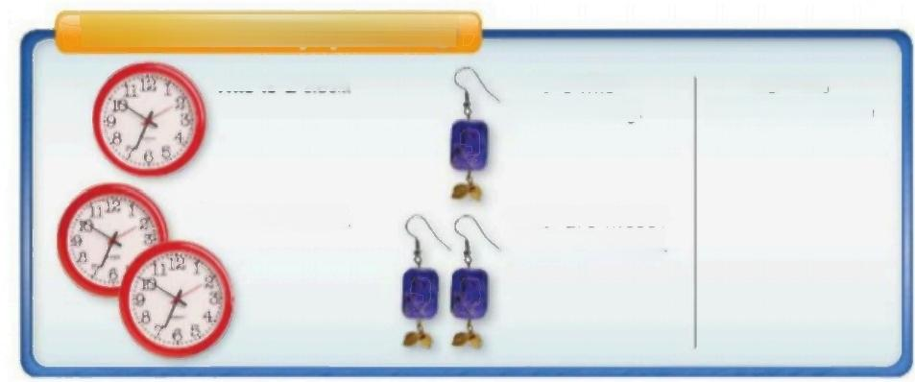**This/these,it/theyr plurals O**

**This is a** clock.

Ir's =It is

What' **s this? It's an** earring

They're -They are

What **are these?**

**These are** clocks

**They're** earrings

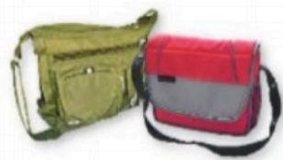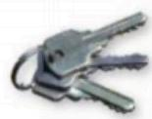**U□S**

Complete these conversations.Then practice with a partner.

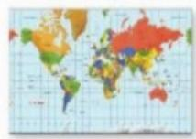

**1.A:What** are.thes… ?

**B:** hayire.keys … … … … … … … .

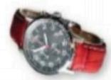

4.A:What.ls this……………………?

B:t's.reloj … … … ….

2.A:What ms… ? 3.A:What Are these………………?

B:..It's map … ……… B:These are.bags … …



5.A:What .Is.this…… …? 6.A:What.Is this……………?

B:Its.umbralla … … … B:It's glassas … …

1 **This/these;it/they;plurals**



Don't use a contraction with What +are:**What are** these?(Nor:**What're these?)** Use this with singular nouns:**This** is a book.Use these with plural nouns: **These**

are earrings.

Circle the correct words.

1.A: **What's /What are** these?

B: **It's/They're** my **earring/earrings.**

2.A: **What's/What are** this?

B: **It's/They're a/an** cellphone.

3.A:What's **this/these?**

B: **It's/They're a/an a**ddress book.

**U□S**

|  |
| --- |
|  |
| **Yes/No** **and** **where** **quesfions** **with** **be** O |
| **Is** **this** your waller? **Where's** your wallet?  Yes,**it** **is.**/No,**it's** **not.** **It's** in my pocket.  **Are** **these** your keys? **Where** **are** my keys?  Yes,**they** **are.**/No,**they're** **not.** **They're** on the table. |

A Complete these conversations.Then practice with a partner.

1.A:…………this your umbrella?

B:No,J **am**………………not.

A:Is… these your keys?

B:Yes,.You…………are.Thanks!

2.A:Where. **Are**……….....my glasses?

B:Are **These…**…your glasses?

A:No,they're. **Not**………………

B:Wait!Are…… they in your pocket?

A:Yes,.You…………are.Thanks!

3.A:Where. **Are …** your sunglasses? B:.They.re…on the table.

A:No,lt's……….not.They're my sunglasses!

B:You're right.My sunglasses dt's … in

my purse.

4.A:.Js……....this my pen?

B:No,They're…………not.It's my pen.

A:Sorry.It……........is my pen?

B:.They're……on your desk.

A:Oh,you're right!

**B GROUP WORK** Put three of your things in a bag.Then choose three

difterent things.Find the owner of each thing.

A:Is this your pen,Yuko?

B:No,it's not

A:Are these your keys,Sergio?

C:Let me see.Yes,they are.



2 **Yes/No and where questions with be**

▶In questions with where,the verb comes after Where: **Where are** my sunglasses? (nor: **Where my sunglasses are?)**

**A** Match the questions with the answers.

|  |  |
| --- | --- |
| 1.Is that your wallet? … … … | a.They're in your purse. |
| 2.Are these your glasses?.**E… … …** | b.No,it's not. |
| 3.Where are my keys? **A…**…… | c.Oh,yes,it is! |
| 4.Is this your pen?,**B………** | d.It's in my pocket. |
| 5.Where's your watch?D … … | e.No,they're not. |

**B** Complete the conversation.Use the words in the box.

|  |  |  |  |
| --- | --- | --- | --- |
| are they  it | it is  it's | they are  this | where √where's |

A:……When…my pen?

B:I don't know.Is.This………………in your book bag?

A:No, **It** **Is**…………… not.

B:ls..This … … …………your pen?

A:Yes, **It-Is** …………….Thanks!Now,They are…………are my keys?

B:.Where……………on your desk?

A:Yes,.Where……………….Thank you!

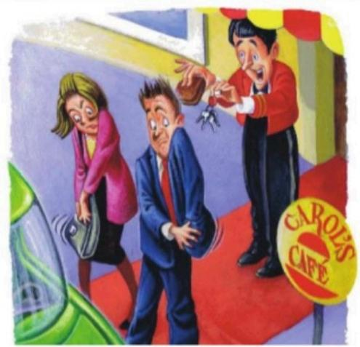UOS

**CONVERSATION** Oh,no!

OListen and practice

Kate:Oh,no!Where are my car keys?

Joe:I don't know.Are they in your purse?

Kate:No,they're not.

Joe:Maybe they're on the table in the

restaurant.

Server:Excuse me.Are these your keys?

Kate:Yes,they are.Thank you!

Server:You're welcome.And is this your

wallet?

Kate:Hmm.No,it's not.Where's your

wallet,Joe?

Joe:It's in my pocket.….Wait a

minute!That is my wallet!

**1.5.-Prepositions of place**

 ***WORD POWER*** *Prepositions;article the*

A◎Listen and practice.

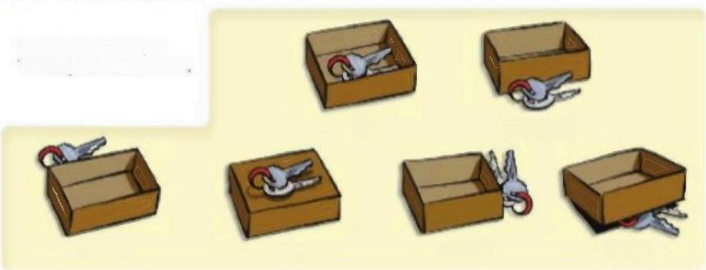

Where are **the** keys?

**The** keys are in **the** box.

in front of

behind on next to under

in

**U□S**

B◎ Complete these sentences.Then listen and check your answers.



1.The books are.in.the … … … 2.The cell phone is Nex. … 3.The map is..Under. …

.kaokkag … **Yo como** .News paper …

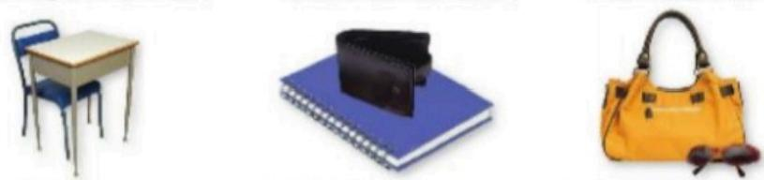4.The chair is.**Behind** ……… 5.The wallet is.on… … 6.The sunglasses are in … … …

Table **Natebook .Front of hag…** ……

C **PAIR WORK** Askand answer questions about the pictures in part B.

A:Where are the books?

B:They're in the book bag.



**WHERE ARE JOE'S THINGS?**

**PAIR WORK** Now help Joe find his things.Ask and answer questions.

briefcase

camera

cell phone

glasses

newspaper

notebook

umbrella

wallet

A:Where's his briefcase?

B:It's on the table.

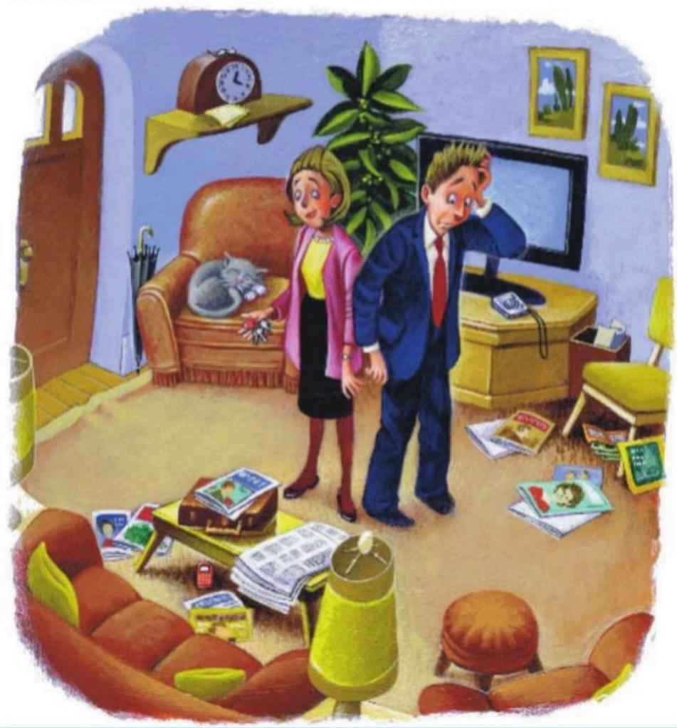



**UNIT I.INTRODUCTION-IT'S NICE TO MEET YOU**

**1.I.-The verb be**

|  |  |  |
| --- | --- | --- |
| **The** **verb** **be** **o**  **I'm** Jennifer Miller.  **You're** in my class.  **She's** in our class.**(Jennifer** **is** in our classI  **He's** over there.**(Steven** **is** over there.) **It's** Miller.**(My** **last** **name** **i**s Miller) | **Are** **you** Steven Carson?  Yes,**I** **am.**  No,**I'm** **not**  How **are** **you?**  **I'm** fine. | I**'m**=lom  You're -You are  He's=He is  She's-She is  Itr's -It is |

A Complete the conversation with the correct words in parentheses.

Then practice with a partner.

David:Hello,Jennifer.How ….!"…(is /are)you?

Jennifer;. **I'm fine,thank**(She's /I'm)fine,thanks.

**rm soryWhat's your rame agan** ?…('m/Its)sorry-whats your name again?

David:,It' **s David.Med**i(He's /It's)David -David Medina.

Jennifer:That's right!David,this ls…………(is /am)Sarah Conner.

**She's in oir match class**…(She's/He's)in our math class.

David:Hi,Sarahis **t nice to maat** y(l'm/It's)nice to meet you.

Sarah:Hi,David.I think Yourein mye (you're /I'm)in my English class,too.

David:Oh,right!Yes,I. **Am** (are /am).

2 **The verb be**

In questions,the be verb comes before the noun or pronoun:**Is he** your

teacher?

Don't use contractions in short answers with Yes:Are you in my class?Yes,**l am**.

(nor:Yes,I'm.)

Complete the conversations.Use the words in the box.

|  |  |  |  |
| --- | --- | --- | --- |
| am  √are | I'm  l am | it's  I'm not | she's  you you're |

1.A:Excuse me.…A……you Patty Wilson?

B:No,.Imnot.s……over there.

A:OK.Thanks.

2.A:Hi.Are.She's…………Patty Wilson?

C:Yes,Im … …

A:Oh,good.IAm…………Sergio Baez..You're……in my English class.

C:Yes,I…Am… …….nice to meet you,Sergio.

U□S

**1.2.-Possessive Adjectives**

**My,your,his,her O**

What's **your** name? What's **his** name? What's **her** name?

**My** name is Taylor. **His** name is Michael. **Her** name is Jennifer.

What's =What is

A Complete the conversations.Use my,your,his,or her.

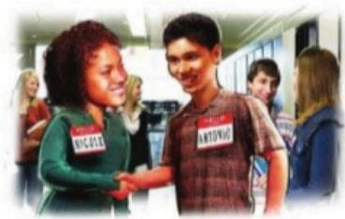

1.A:Hello.What's ……Y?u.….…name?

Mv … … …name is Antonio

B:Hi.

What's .Yout………name?

A:.My……………..name is Nicole.

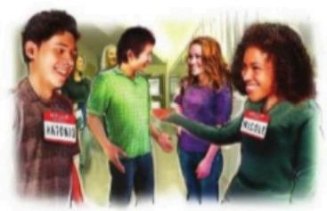

2.A:What's.You……….name?

B:M………………name is Michael.

A:And what's.Her…………..name?

B:H…………name is Jennifer.

*1* ***My,your,his,her***



▶Use his with males and her with females: **His** name is David.(Nor:Her name is Đavid.) **Her** name is Maria.(Nor:His-name is-Maria.)

Complete the conversations with my,your,his,or her.

1.A:Hello.……My…….name is Carlos.

B:Hi,Carlos.What's .You…………last name?

A:It's Gonzales.

B:How do you spell …You…………last name?Is it G-O-N-Z-A-L-E-Z?

A:No,it's G-O-N-Z-A-L-E-S.And what's .Yout………………name?

B:His……………name is Bill Powers.Nice to meet you.

2.A:What's Ms.Robinson's first name?

B:His…… first name is Katherine..With my………nickname is Katie.

A:I'm sorry.What's .You……………first name again?

B:It's Katherine.And what's Mr.Weber's first name?

A:.Her…………first name is Peter.

B:That's right.And.His………...nickname is Pete.