

Family tree

**Student´s name:** Mauricio González Álvarez.

**Topic:**  family tree

**Partial:** 1.

**Subject:** English I.

**Teacher´s name:** Alejandra Vidal Escandón.

**Degree:** Nursing.

**Quarter:** 1st grade.

Pichucalco, Chiapas; seven of september 2024.



ENCANTO

FAMILY MADRIGAL

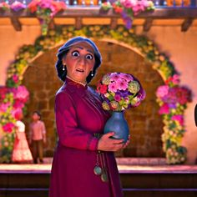

***Pedro Madrigal. Grandfather. Peasant.***

***Alma madrigal. Grandmother. housewife.***





***Agustín Madrigal. father. planner.***

***Félix Madrigal. uncle. family worker.***

***Pepa Madrigal. aunt. Peasant.***



***Julieta Madrigal. mother. nurse.***

***Bruno Madrigal. Uncle. Seer.***

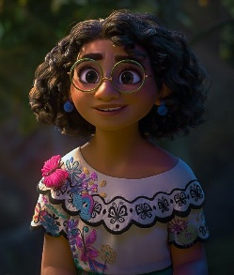



***Isabela Madrigal. sister gardener***

***Mirabel Madrigal. I. to housework.***

***Camilo Madrigal. Cousin. Student.***

***Dolores Madrigal. premium. mentor.***

***Antonio Madriga. cousin.***

***Student.***

***Luisa Madrigal. sister. peasant.***