Inglés 1 Jorge Luis Pérez Espinoza Universidad UDS

PRESENTACIÓN :

I introduce myself my name is Jorge Luis Pérez Espinoza.

ORIGEN :

I Am originally from the state of Chiapas, its the place where I was born,which I am proud to say.

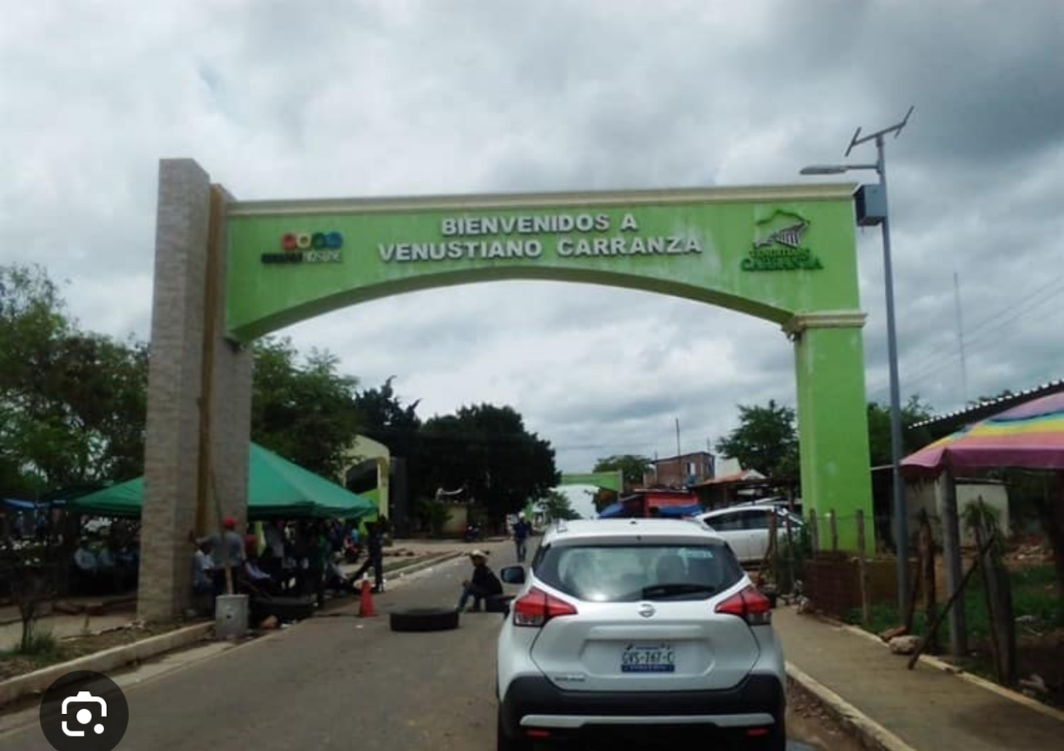

OCUPACIÓN :

My occupation at this time has been roofin



DESCRIPCIÓN FÍSICA :

I am a tall boy ,my eyes are light brown, my hair color is brown, my skin is pearly ,Im thin,my profile is slightly elongated, I have a beard and mustache …



GUSTOS :

I like to spend time with my beautiful wife and kids ,play soccer,I love seeing new places , I like to go swimming , I also love to live with new people, I love to Work and ,more than anything achieve the goals I set my mine to .

