**Unit Activity #1 - U2**

*Nombre del Alumno: Yoshelin Alejandra Perez Lopez*

*Nombre del tema: Unit 1*

*Parcial: Second*

*Nombre de la Materia: English I*

*Nombre del profesor: Juan Manuel Jaime Díaz*

*Nombre de la Licenciatura: Psicologhy*

*Cuatrimestre: First*

*Lugar y Fecha de elaboración*

Comitán de Domínguez Chiapas a 07 de octubre de 2024.

**Grammar - Prepositions of Place**

**Prepositions of place are used to show where something is located and they are always found after the principal verb**, regardless of the verb tense. These prepositions are **most often used with the verb “to be”.**

**Next to (beside)**

**Meaning:** adjacent or by the side of.

**Use:** “Next to” and “beside” can be used interchangeably as the meaning is the same. The use of one over the other depends on the speaker and the context.

**Examples:**

The supermarket is next to the bank or The supermarket is beside the bank

Sit next to me or Sit beside me.

**By**

**Meaning:** in proximity to, near.

**Use:** “by” may be used in the same contexts as “Next to” or “beside”, but the meaning is closer to “near” rather than directly adjacent.

**Examples:**

I sit by the window.

Our house is by the river.

**BETWEEN**

**Meaning:** in the time or space that separates.

**Examples:**

The shop is between the bank and the train station.

She is standing between Peter and John.

**BEHIND**

**Meaning:** in back of, to the rear of.

**Examples:**

The church is behind the school.

He is standing behind you.

**IN FRONT OF**

**Meaning:** the opposite of behind.

**Examples:**

The hotel is in front of the station. Laura is standing in front of you.

**UNDER**

**Meaning:** below or beneath, implying the object is covered by something.

**Examples:**

The ball is under the chair.

The dog is under the tree.

**IN**

**Use (place):** “In” is used to indicate both open and closed spaces. We use this preposition to indicate that something is included within the limits of something, a closed space or the interior of something in a physical sense. As we can see from the following examples “in” can also be used to indicate the geographical location of something.

**Examples:**

The cat is in the box.

I found your address in the phone book.

**Use (time):** is used with months, years, periods of time, seasons and parts of the day.

**Examples:**

I always run in the mornings.

I will see him in a week.

She was born in 1976.

**AT**

**Use (place):** “**At”** is used in front of buildings such as “home”, “the airport”, “university”. It is also used before **”to”, “bottom”, and “the end of”** as well as to indicate events such as meetings, parties, concerts, sports events, etc. **“At”** is also used after the verb **“arrive”** when we are referring to places other than cities or countries.

**Examples:**

He is at home.

I always visit my sister at work

She will see him at the theatre

**Use (time):** We used “At” before the hour or holidays.

**Examples:**

He runs every morning at 6.

I will see them at Christmas.

**ON**

**Use (place):** “On” is used with surfaces, when we are referencing a location within a room, such as the ceiling or the wall, or to indicate that someone is inside a mode of transport or on the floor of a building.

**Examples:**

The pen is on the table.

They have a photograph of Paris on the wall

I am on the bus.

**Use (time): ”ON”** is used with days of the week, dates and holidays.

**Examples:**

They went to Mexico on the first of May.

He runs on Mondays and Fridays.

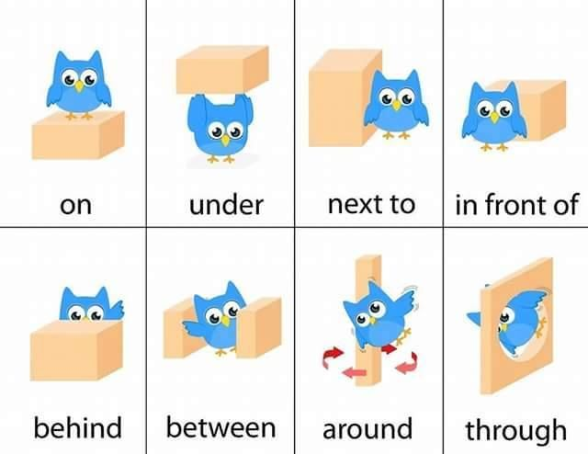

**Encontraras la gramática en español en los siguientes links:**

[**https://www.curso-ingles.com/aprender/cursos/nivel-basico/prepositions/prepositions**](https://www.curso-ingles.com/aprender/cursos/nivel-basico/prepositions/prepositions)

[**https://www.curso-ingles.com/aprender/cursos/nivel-basico/prepositions/prepositions-of-place**](https://www.curso-ingles.com/aprender/cursos/nivel-basico/prepositions/prepositions-of-place)

**Exercise 1**. Complete these sentences – Completa las siguientes oraciones, revisa el ejemplo.

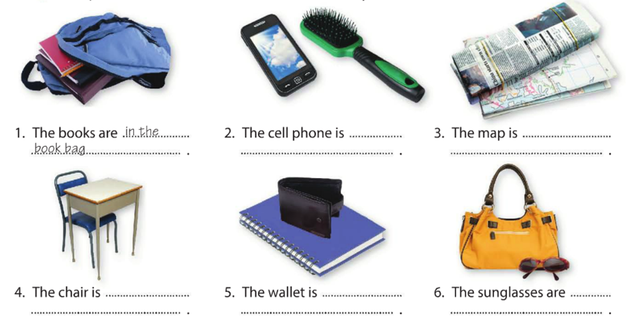

1. The books are in the book bag
2. The cell phone is _next to hair brush_____________________
3. The map is ______under news pape______________________
4. The chair is ____behind the table_________________________
5. The wallet is _____on the note book________________________
6. The sunglasses are _______in front of the purse ________________

**Exercise 2**. Complete these sentences – Completa las siguientes oraciones, revisa el ejemplo.

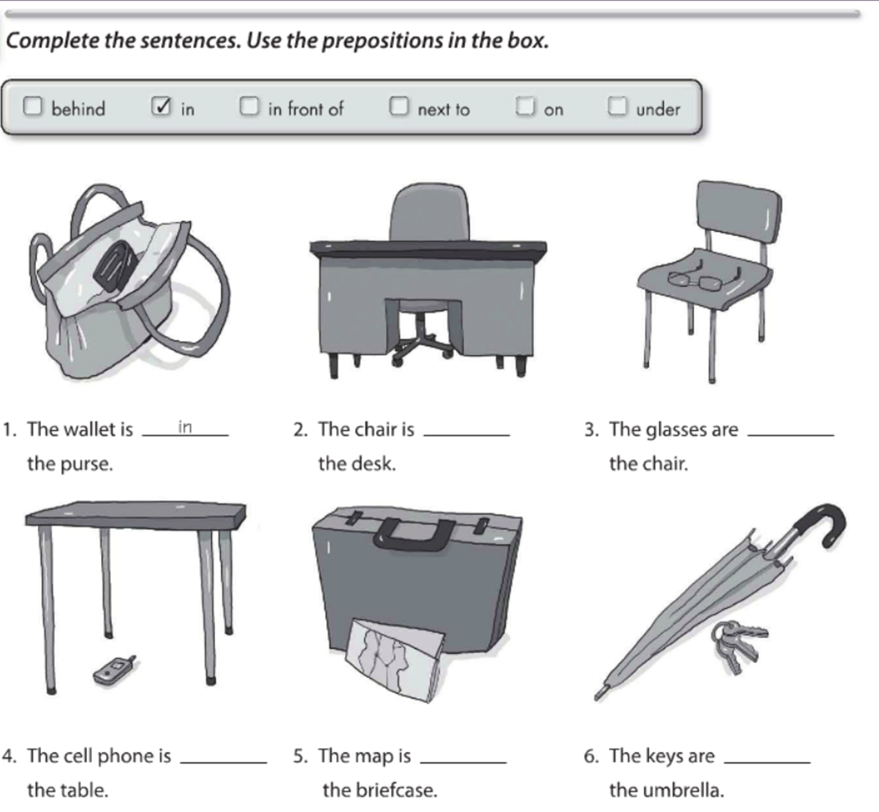

**In front of**

**under**

**Behind**

**in**

**on**

**Exercise 3**. Write questions and answers about the things in the parentheses – escribe preguntas y sus respuestas acerca de las cosas en parentesis.

**Next to**

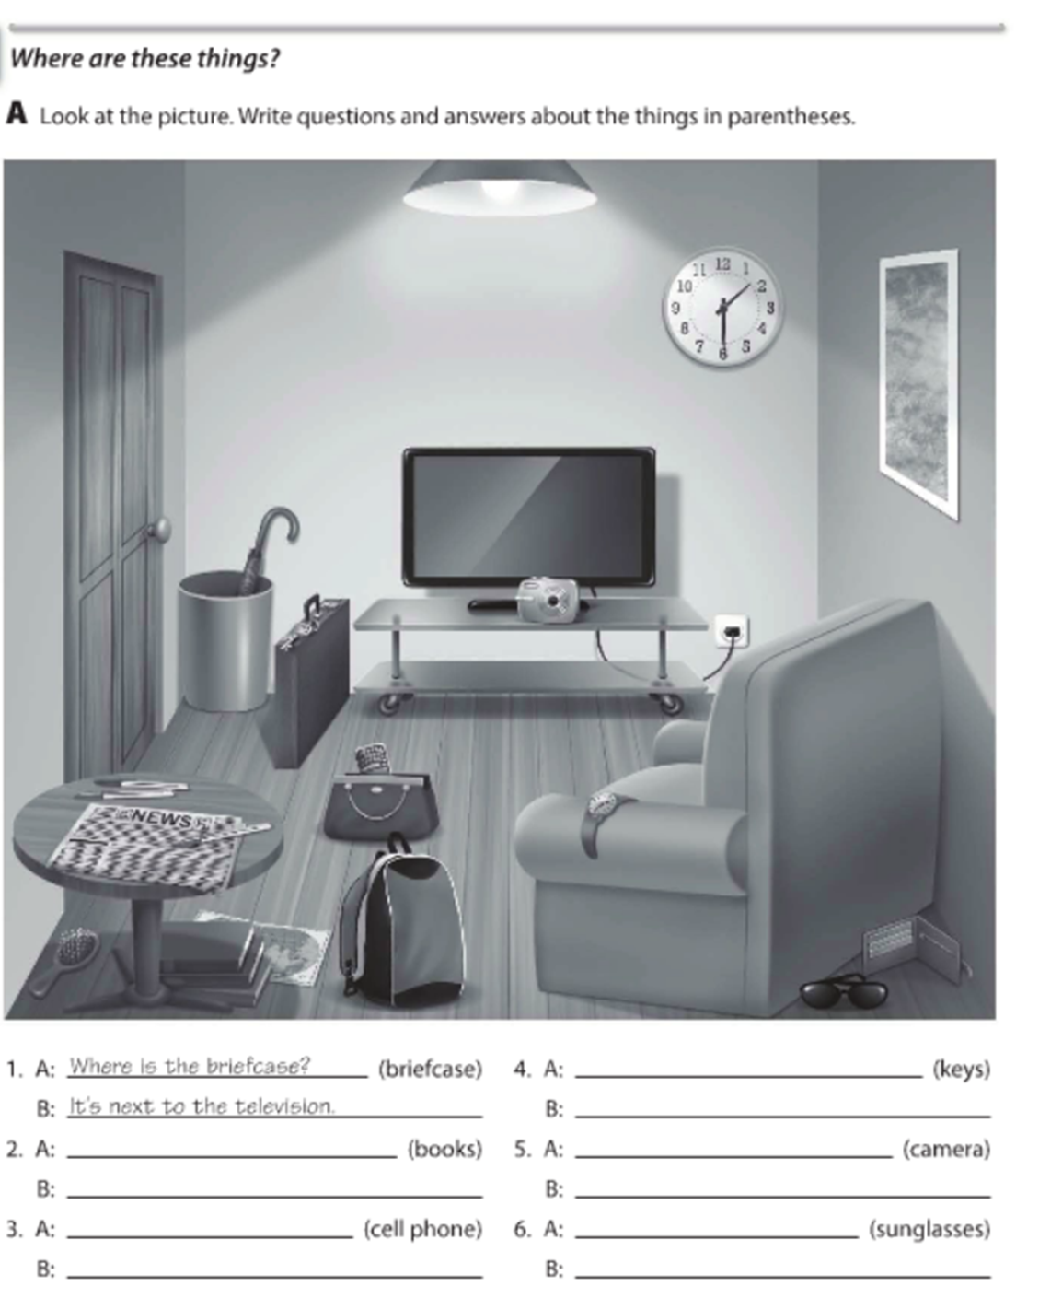

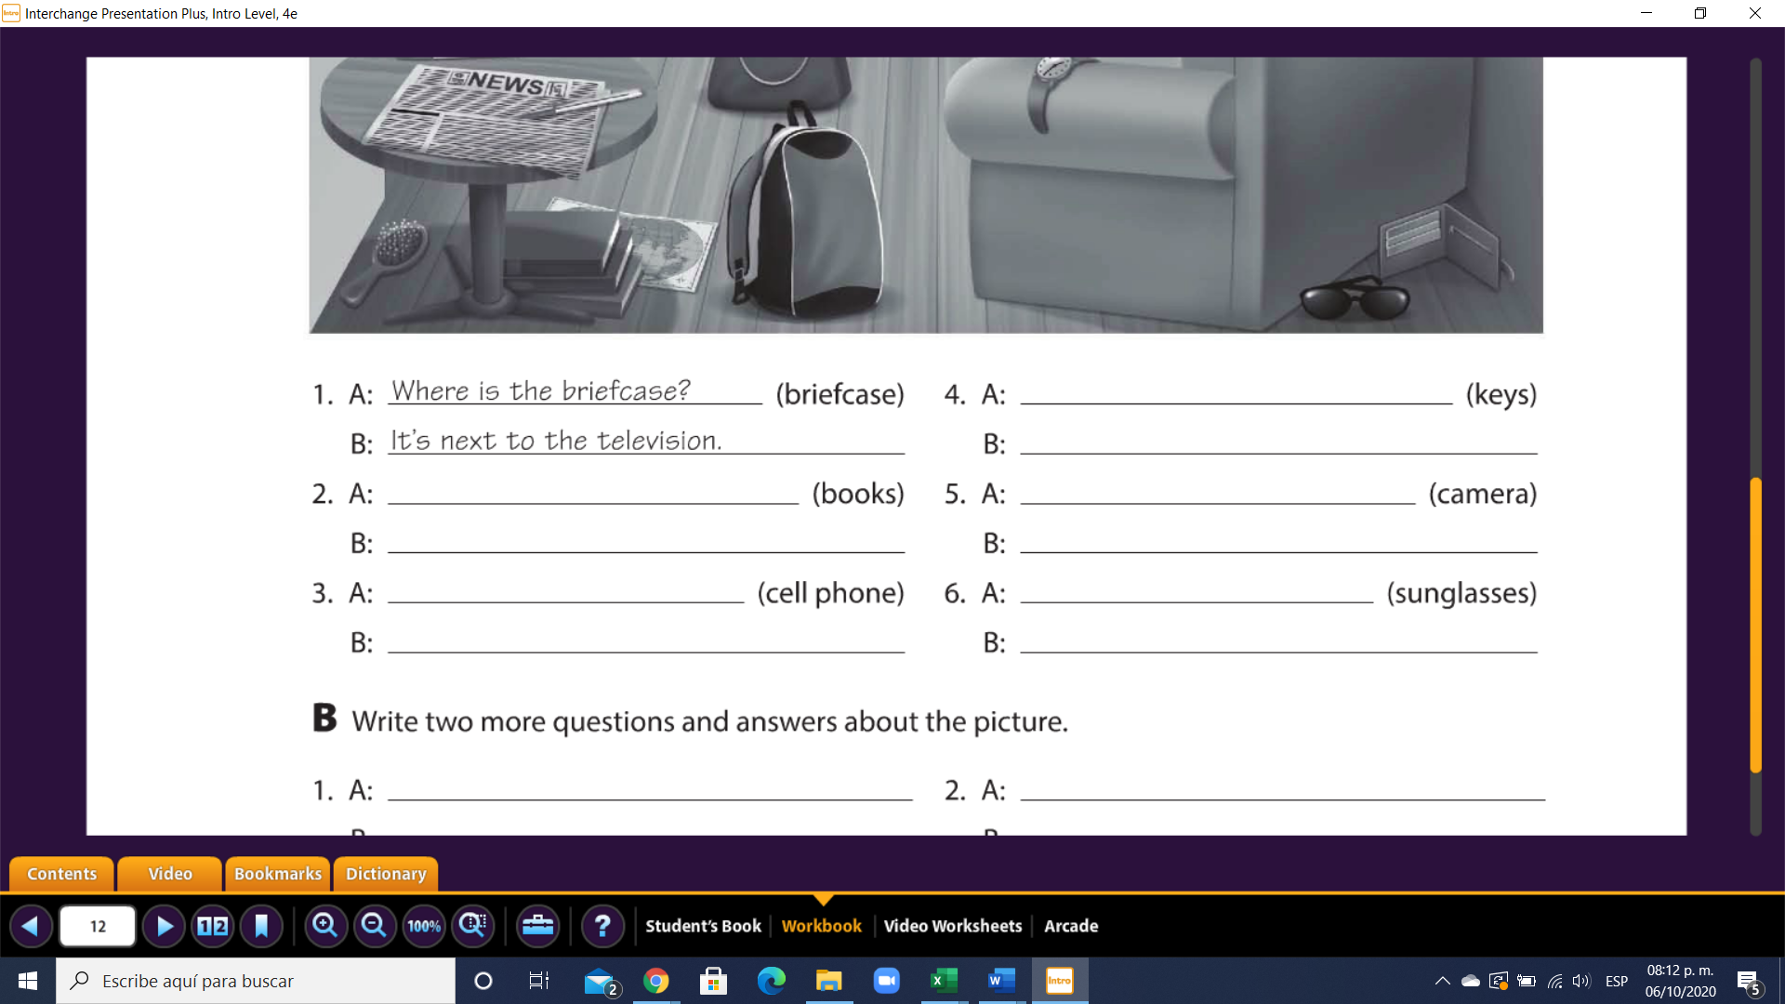

**The´re behind the sofa**

**Where are the sunglasses**

**It´s in front of of the tv**

**Where is the camera**

**They´re on the briefcase**

**Where are the keys**

**It´s in the purse**

**Where is the cell phone**

**They are under the table**

**Where are the books**

**GRAMMAR – Negative statements and yes/no questions with be**

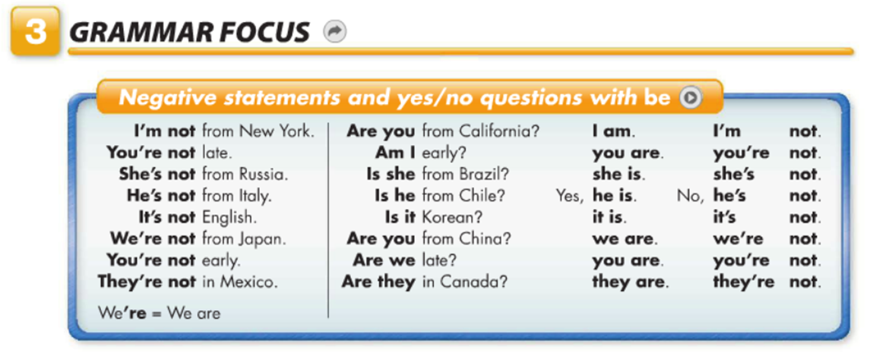

**Exercise 4**. Complete the convertation – completa la siguiente conversaciòn.

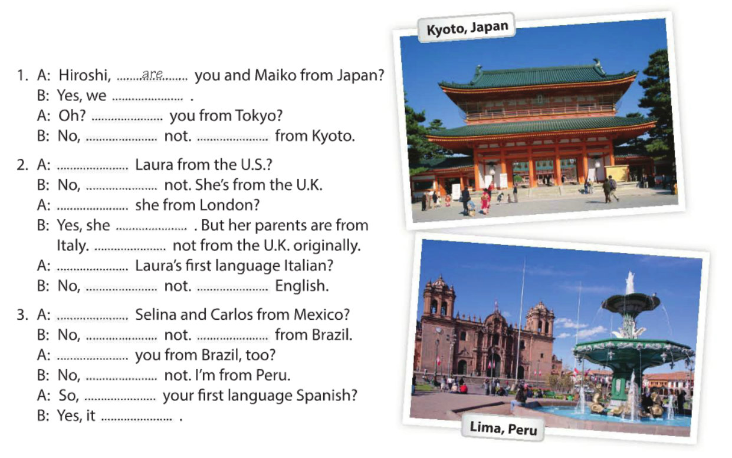

**They are**

**They are**

**They´re**

**We are**

**We are**

**is**

**is**

**I´m**

**are**

**are**

**It´s**

**It´s**

**is**

**is**

**is**

**She´s**

**Is**

**are**

**are**

**are**

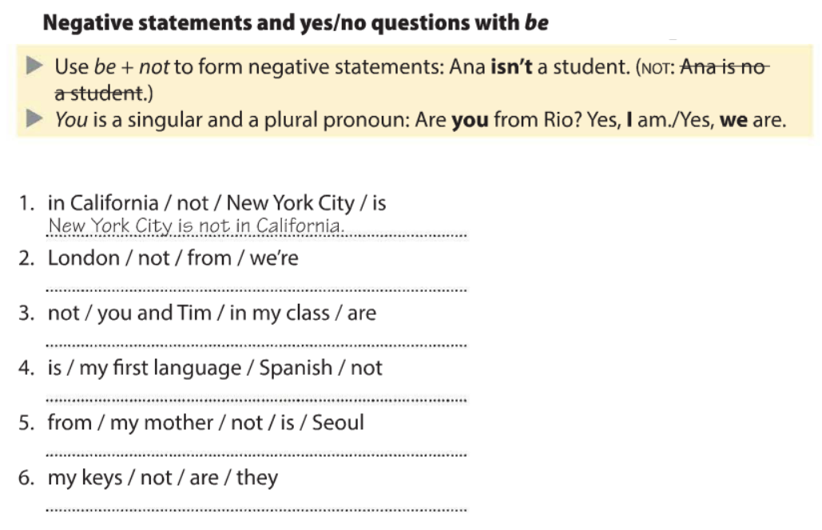

**Exercise 5**. Ordena las siguientes oraciones.



**They are not my keys**

**My mother is not from seoul**

**Spanish is not my first language**

**You and time are not in my class**

**We´re not from London**

**Exercise 6**. Ordena las siguientes oraciones.

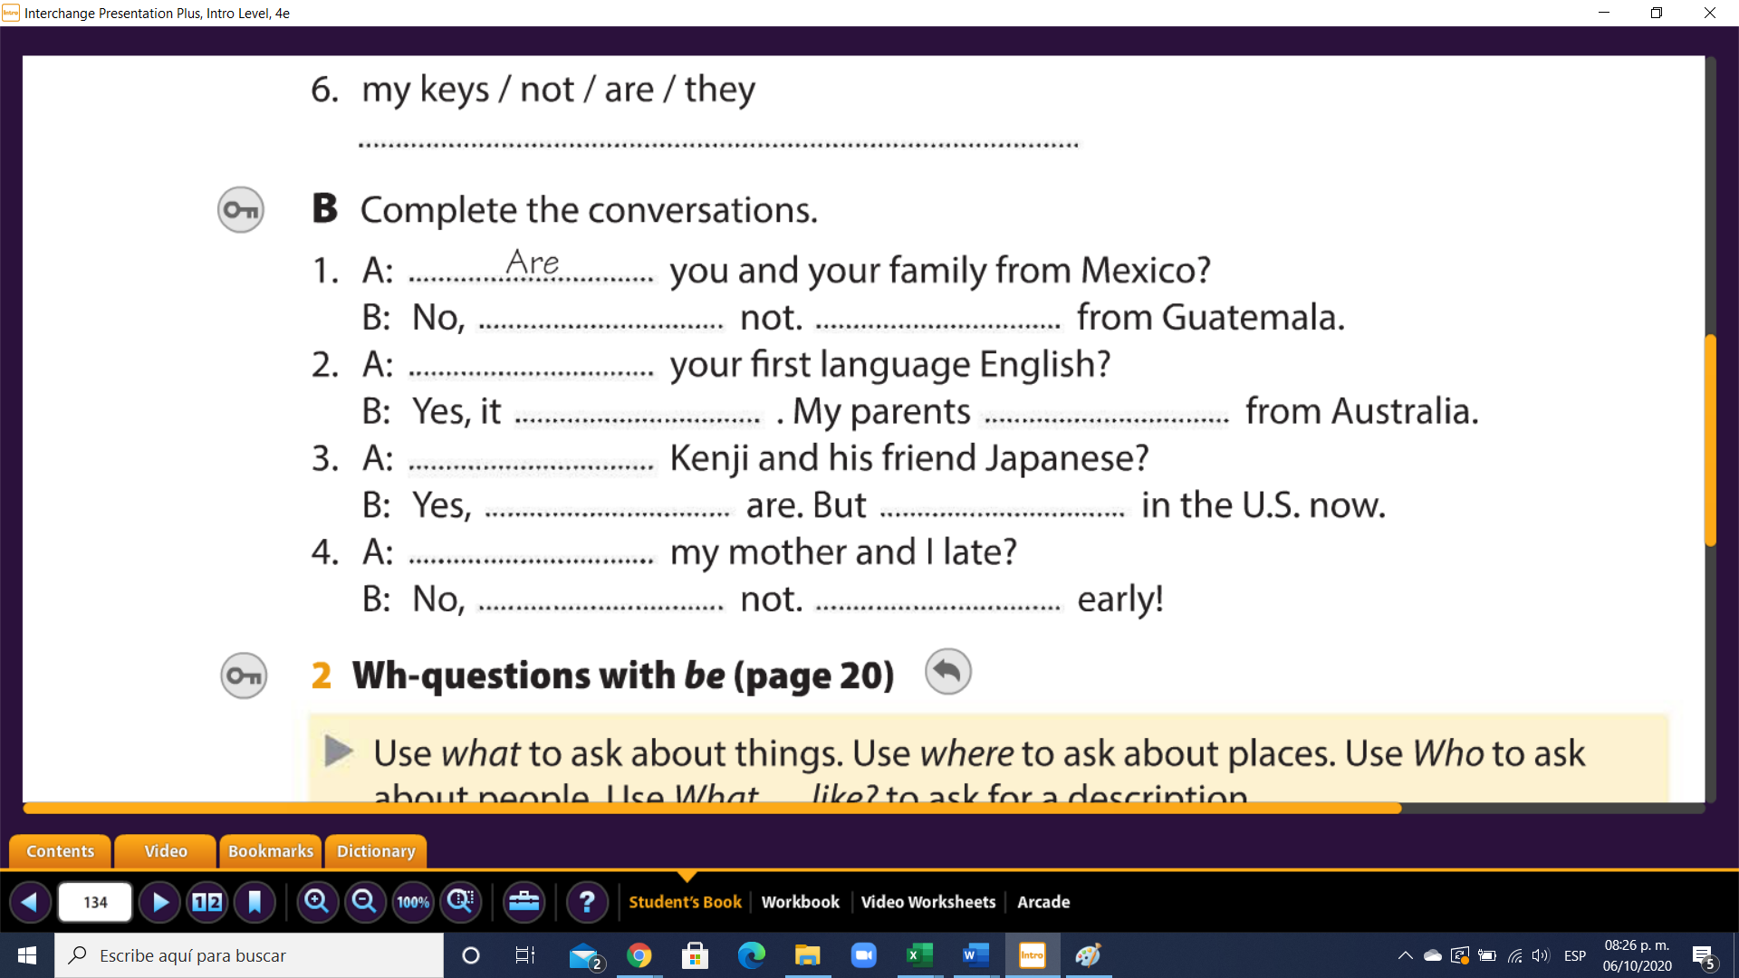

**You are**

**You´re**

**They are**

**We are**

**We´re**

**are**

**they**

**are**

**is**

**are**

**is**