

**INVESTIGACION DE LA IMPORTANCIA DE LA ENFERMERIA(UNIDAD I)**

**ALVARADO HIDALGO SELENA**

**UNIVERSIDAD DEL SURESTE**

**LIC. EN ENFERMERIA**

**INGLES I**

**1ER. CUATRIMESTRE**

**ING.ARREOLA JIMENEZ EDUARDO ENRIQUE**

**TAPACHULA, CHIAPAS A 21 DE SEPTIEMBRE DE 2024**

Tabla de contenido

INTRODUCTION

1.1THE IMPORTANCE OF NURSING …………………………………………………………………………………………..

1.2 BACKGROUND ………………………………………………………………………………………………………………………

1.3 CONCEPT AND DEFINITION……………………………………………………………………………………………….

RELATIONSHIPS WITH OTHER BRANCHES

2.1 RELATIONSHIP WITH OTHER BRANCHES……………………………………………………………………

2.2SPECIALTIES…………………………………………………………………………………………………………………….

CURRENT SITUATION IN THE NURSING …………………………………………………………………………………………..

3.1WHAT IS NURSING LIKE TODAY…………………………………………………………………………………………..

3.2CHARACTERISTICS IN THE IMPORTANCE OF NURSING…………………………………………………………..

CONCLUSION……………………………………………………………………………………………………………………………

LITERATURE …………………………………………………………………………………………………………………………………….

INTRODUCTION

1.1 THE IMPORTANCE OF NURSING

Nursing is a fundamental profession in the health sector that contributes to improving people's health and preventing diseases:

* Disease prevention: Nurses implement measures to control infections in hospitals and care centers.

* Comprehensive care: Nurses provide constant care to patients, administer medications, monitor their progress, and provide emotional support.

* Accompaniment: Nurses support patients and their families, especially in the case of chronic diseases.

* Health education: Nurses educate patients about their health.

* Liaison between patients and doctors: Nurses are the bridge between patients and doctors.

* Physical and emotional well-being: Nursing seeks to improve or maintain people's health status as well as possible.

* Contribution to the well-being of the community: Nurses contribute to the well-being of the community.

The role of nursing, like that of other health professions, should include informing and educating the client about health, so that he or she can choose between the various possible options, once the different risks and benefits of each alternative have been considered.

The history of nursing is perhaps as old as human beings themselves. Whenever there was someone weak enough to need help, there were nurses around, regardless of whether or not it was considered a profession at the time.

It is not known for certain when nursing emerged as a professional option, but many say that this role of medical science has been with humanity since the Middle Ages, through figures such as wet nurses, midwives, nuns and other similar roles in society. Its origins and relationship with the religious world were present since then and then, after the first and second world wars, this profession began to include more and more male personnel.

And transcending its role in history, on this occasion we invite you to learn with us why nursing is essential for life, health and disease prevention.

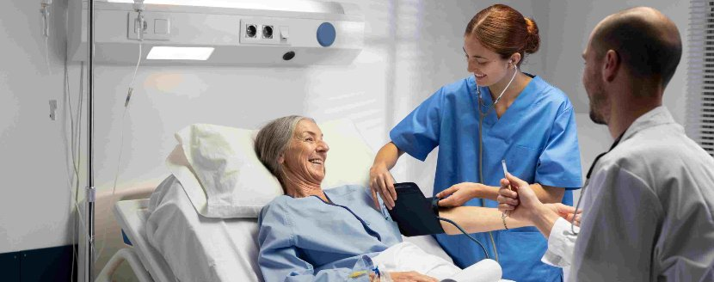

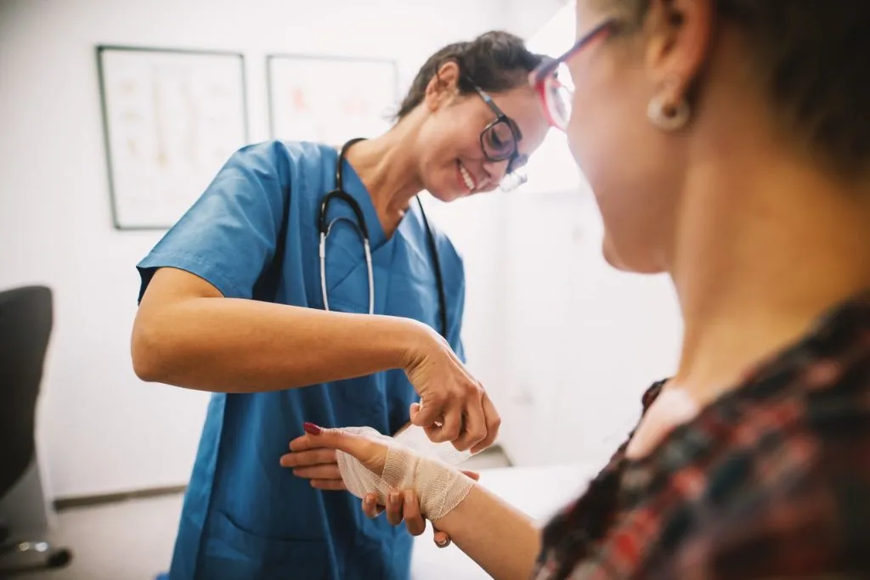

# Nursing occupies a fundamental position in many areas and tasks. From caring for people who need care, as well as medical follow-up. Therefore, nurses have great responsibility in the recovery of the patient. In addition, they must have extensive knowledge and good training. Nurses are the link between medicine, cure and the patient. Nurses can be in all types of centers and are trained to deal with any problem that arises.

 LITERATURE (DEVELOPMENT OF THE TOPIC)

1.2 BACKGROUND

There are various aspects related to Nursing such as the religious background in primitive tribes with shamans, witch doctors, healers... Later, Christianity permeates the philosophy of late Roman and medieval man in the West, and for a long time, health care and care will be motivated by the concept of help and charity. "Nursing care is institutionalized based on a concept of help, which we could call vocational-Christian-charitable (...). Despite everything, Christianity makes this care, restricted in the ancient world to the domestic sphere, emerge in society. The woman as a consecrated nurse"5.

1.3 CONCEPT AND DEFINITION

The concept of health-illness that each culture or people has possessed throughout the centuries has evolved over time, as has the care, carried out mostly by women as preservers of the species: "nurses ensured the continuity of life, helping through their care practices to face illness and death, in contexts of little social and cultural value"6.

Nursing encompasses the autonomous and collaborative care of individuals of all ages, families, groups and communities, sick or well, in all settings, and includes health promotion, disease prevention, and care of the sick, disabled and dying.

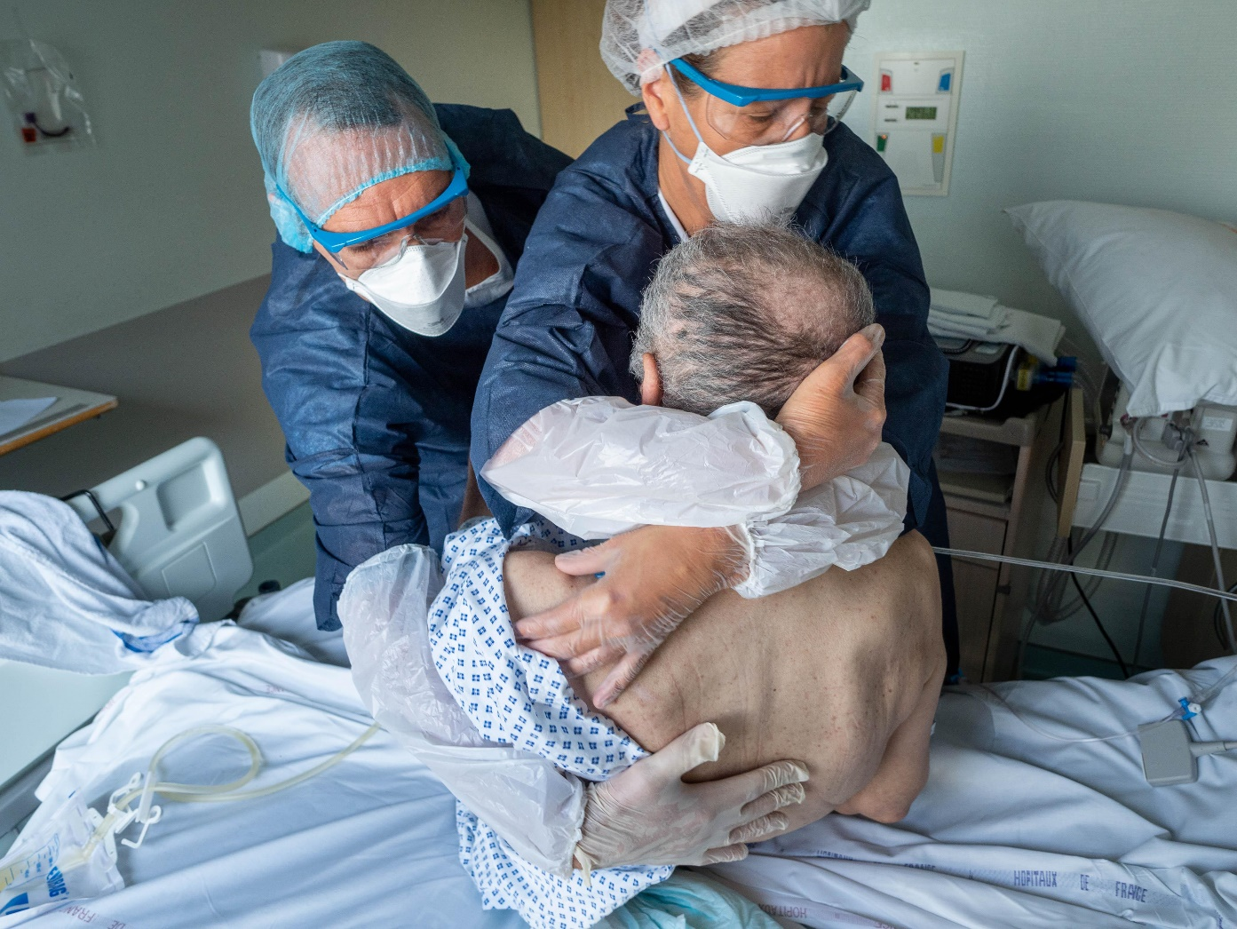

RELATIONSHIPS WITH OTHER BRANCHES

2.1 RELATIONSHIP WITH OTHER BRANCHES

Veterinary nursing is a branch of veterinary medicine that focuses on the care of animals. Veterinary nurses play a vital role in the care and welfare of animals, working closely with veterinarians to provide appropriate care and treatment.

|  |
| --- |
| 2.2 |
| Especialidades | Ginecológica y obstétrica, pediátrica, psiquiátrica y de salud mental, quirúrgica, radiología, del paciente en estado crítico |
| Otras ramas | Cuidados médico-quirúrgicos, geriátrica, del trabajo, comunitaria, práctica avanzada, en anestesiología, militar |

CURRENT SITUATION IN NURSING

3.1 WHAT NURSING IS LIKE TODAY

Nursing is one of the most respected and valued occupations by society in Mexico, considered as such by 33.9 percent of the country's population, according to the Survey on Public Perception of Science and Technology in Mexico 2013, ranking only behind the firefighters, who occupy first place.

Due to the COVID-19 pandemic, doctors and nursing staff are among the most vulnerable sectors, a situation for which they fight every day. We can see the above reflected in the latest analysis of the International Council of Nurses (ICN), which shows that the number of nurses who died after contracting COVID-19 rose to 1,500 at the beginning of 2021, when in August of the same year they were 1097. The figure includes nurses from only 44 of the world's 195 countries; However, this is a underestimate of the actual number of deaths

# “Nurses will have to play an important role in what comes after COVID. “Our experience and data means we have a very powerful and legitimate voice to use to influence the healthcare systems of the future.”

# On the other hand, the World Health Organization designated 2020 as the "Year of the Nurse and the Midwife" in celebration of the 200th anniversary of the birth of Florence Nightingale (1820–1910). Around the world, various professional associations, health care systems and other entities were prepared to commemorate this International Year; However, the coincidence with the great international health crisis was completely unexpected.

# Nurses around the world have taken a big step forward, placing themselves on the front line to combat the spread of COVID-19. This pillar of the health sector has always been at the forefront, working 24 hours a day to protect and maintain the health and well-being of patients and society in general. They are leading response teams, demonstrating professionalism, absolute dedication, and contributing their knowledge, experience and competence.

3.2 CHARACTERISTICS IN THE IMPORTANCE OF NURSING

It is a job that helps physical and emotional well-being. Of course, nursing seeks to ensure that your state of health improves or remains as good as possible, a task that other professions in the world of medicine also do, such as surgical instruments, nutritionists and optometrists, among many others.

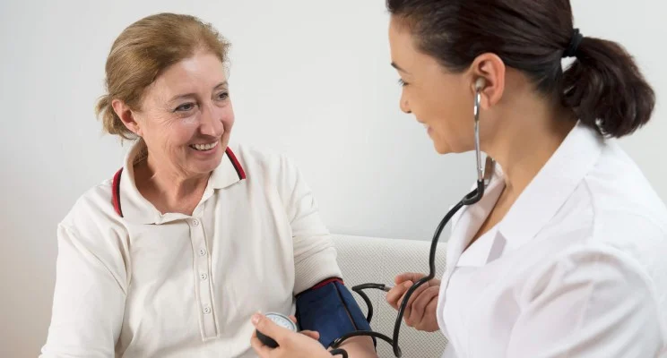

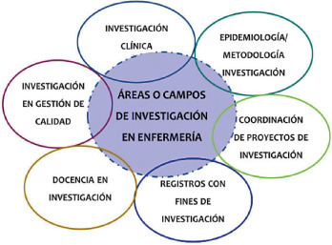

CONCLUSION

Our main objective in this work has been to identify the existence of factors that hinder or favor the appropriation of the aspects linked to health education, as part of the practice inherent to their profession.

For me, this issue of the importance of nursing is to carry out knowledge from its beginning until today, let us remember that in the Middle Ages nurses were in charge of caring for children or grandparents or they were simply used so that they could breastfeed the children of other mothers at that time nursing itself was not a profession because a woman was seen as someone who had to take care of everyone. It was when Florence Nightingale, who was recognized as the lady with the lamp.

It is believed that the figure of the nurse appeared during the Middle Ages. Nurses were mostly untrained women who helped bring children into the world or were wet nurses. On the other hand, caring for the sick was closely associated with nuns, with more training and a religious vow that prevented them from neglecting the weaker.

In 1259, the Alexian Brothers began the ministry of caring for the sick and hungry, which still exists today in many countries, including the United States. The Hospitaller Order of St. John of God was formed in Spain in 1550. From 1550 through 1614, St. Camillus de Lellis cared for the sick and dying at the Hospital of St. James in Rome. It was not until 1633 when St. Vincent de Paul founded the Daughter of Charity, where women began to play a larger role in organized nursing.

Over the years, wars have increased the need for nurses and have had a major influence on the evolution of nursing. Florence Nightingale

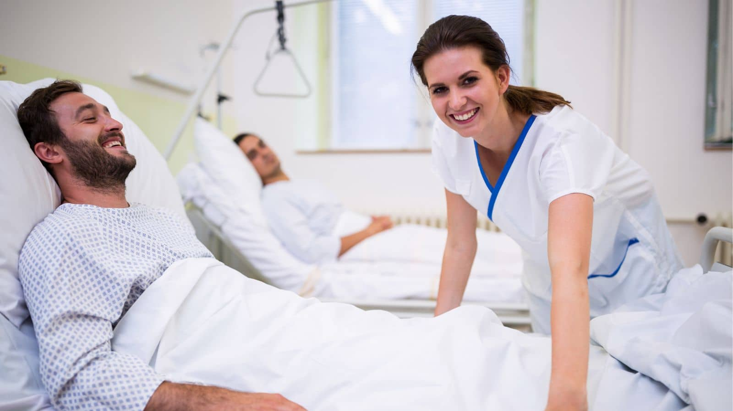

# BIBLIOGRAFIA

CONCLUSIONREShttps://www.teseopress.com/enfermeriayeducacion/back-matter/conclusiones

LITERATURA<https://antoniotuenfermero.com/la-importancia-y-las-funciones-de-la-enfermeria>

CONCEPTOS https://ucmb.edu.py/novedades/la-enfermeria-en-la-historia/