



Nombre del Alumno: GERARDO ALBERTO RAMIREZ DE LA TORRE

Nombre del tema: HOUSE DESCRIPTION

Nombre del profesor: LILIANA RUBI GUTIERREZ PENAGOS

Fecha: 23/01/2023

Nombre de la Materia: INGLES II

Nombre de la Licenciatura: ENFERMERIA

Cuatrimestre: SEGUNDO

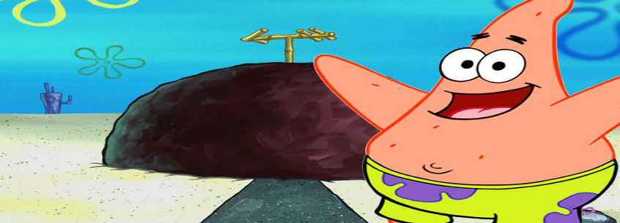

PATRICK STAR HOUSE

Patricio Estrella's house is covered by a stone below it is pure sand inside the house it has many things which areThere is a television in the middle of the room, it also has a sofa where you can watch television, it also has a library where you put your books and where you take them out again to read, there is a pendant where you put your hat from time to time when you go out to watch SpongeBob also has his bed What is sand.

He also has a net to catch jellyfish When he goes out with SpongeBob his house also contains a refrigerator where he has all his food and hamburgers.

He also has what is in his house, pictures hanging from him and his parents also have what is glasses, spoons, plates so that he can eat at ease and watch television in the company of his food.