

NOMBRE DEL ALIMNO:

ZURISADAI SOLIS BONIFA

NOMBRE DEL DOCENTE:

GEORGINA OLIVA VIDAL ALFONZO

NOMBRE DE LA MATERIA:

INGLES

LICENCIATURA: LIC ENFERMERIA

UDS

WORKB00K

|  |  |  |
| --- | --- | --- |
|  |  | Last Saturday |

A WBat dpd these people do SMurdAyi Wt/te sentences.

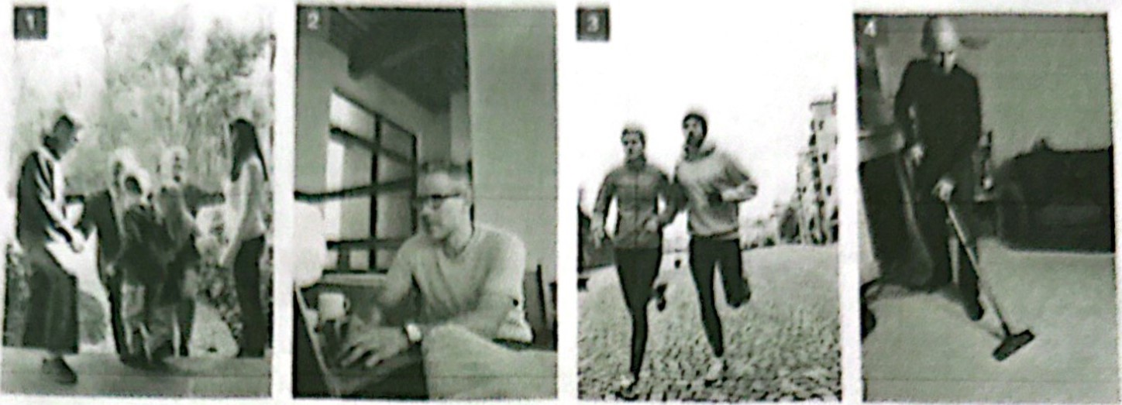

Visit relatives answer email exercise dem the hwse

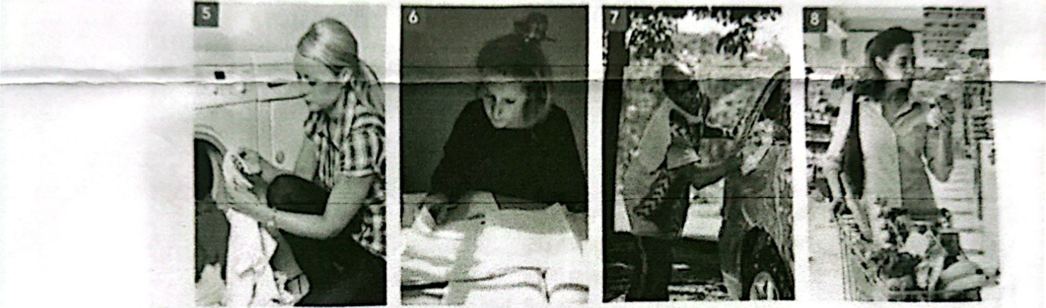

do laundry study wash the car 90 grocery shopping

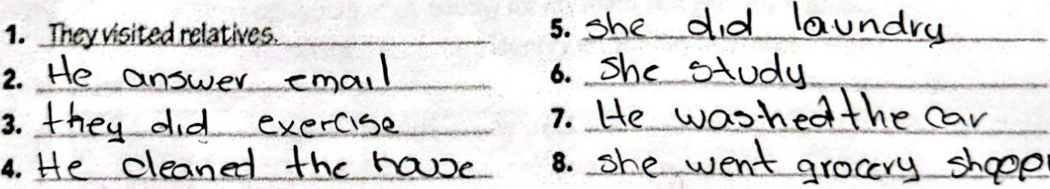

8.-obewen%xoccvb-4eetna

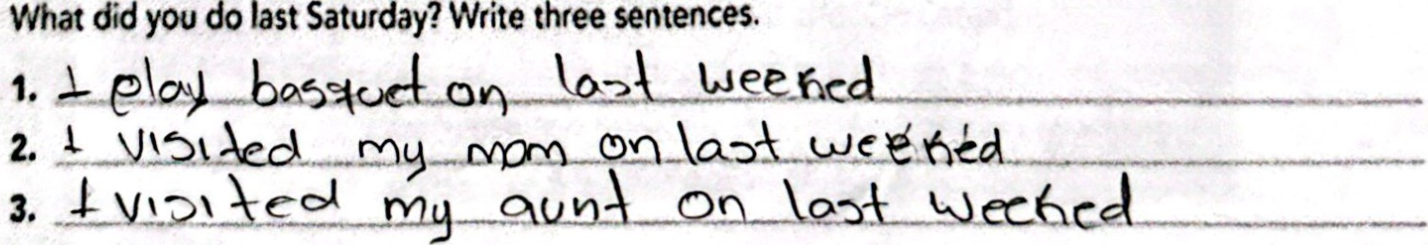

sentences.

B



ANA C. TORRES 52

|  |  |  |
| --- | --- | --- |
|  |  | Kim and AGsha ore sending text messages. Complete the sentences. |
|  |  |

|  |  |  |  |
| --- | --- | --- | --- |
|  | | | |
|  | Messages | | |
| Alisha  it was reaøy busy I (work) Friday, then' friends over after work- I (cook) dnner for them We (listen) to music ard (talk) aban work, but they  (not stay) very Late. drJn*  Alisha  What did you do on Saturday and Sunday? | | |
| Alisha | Kim |  |
|
|
|  |

Use the simple past form of the verbs in parentheses.

(JDS

|  |  |  |
| --- | --- | --- |
|  |  | Claudia and Hiro did different things last weekend. Write sentences about them. |
|  | |

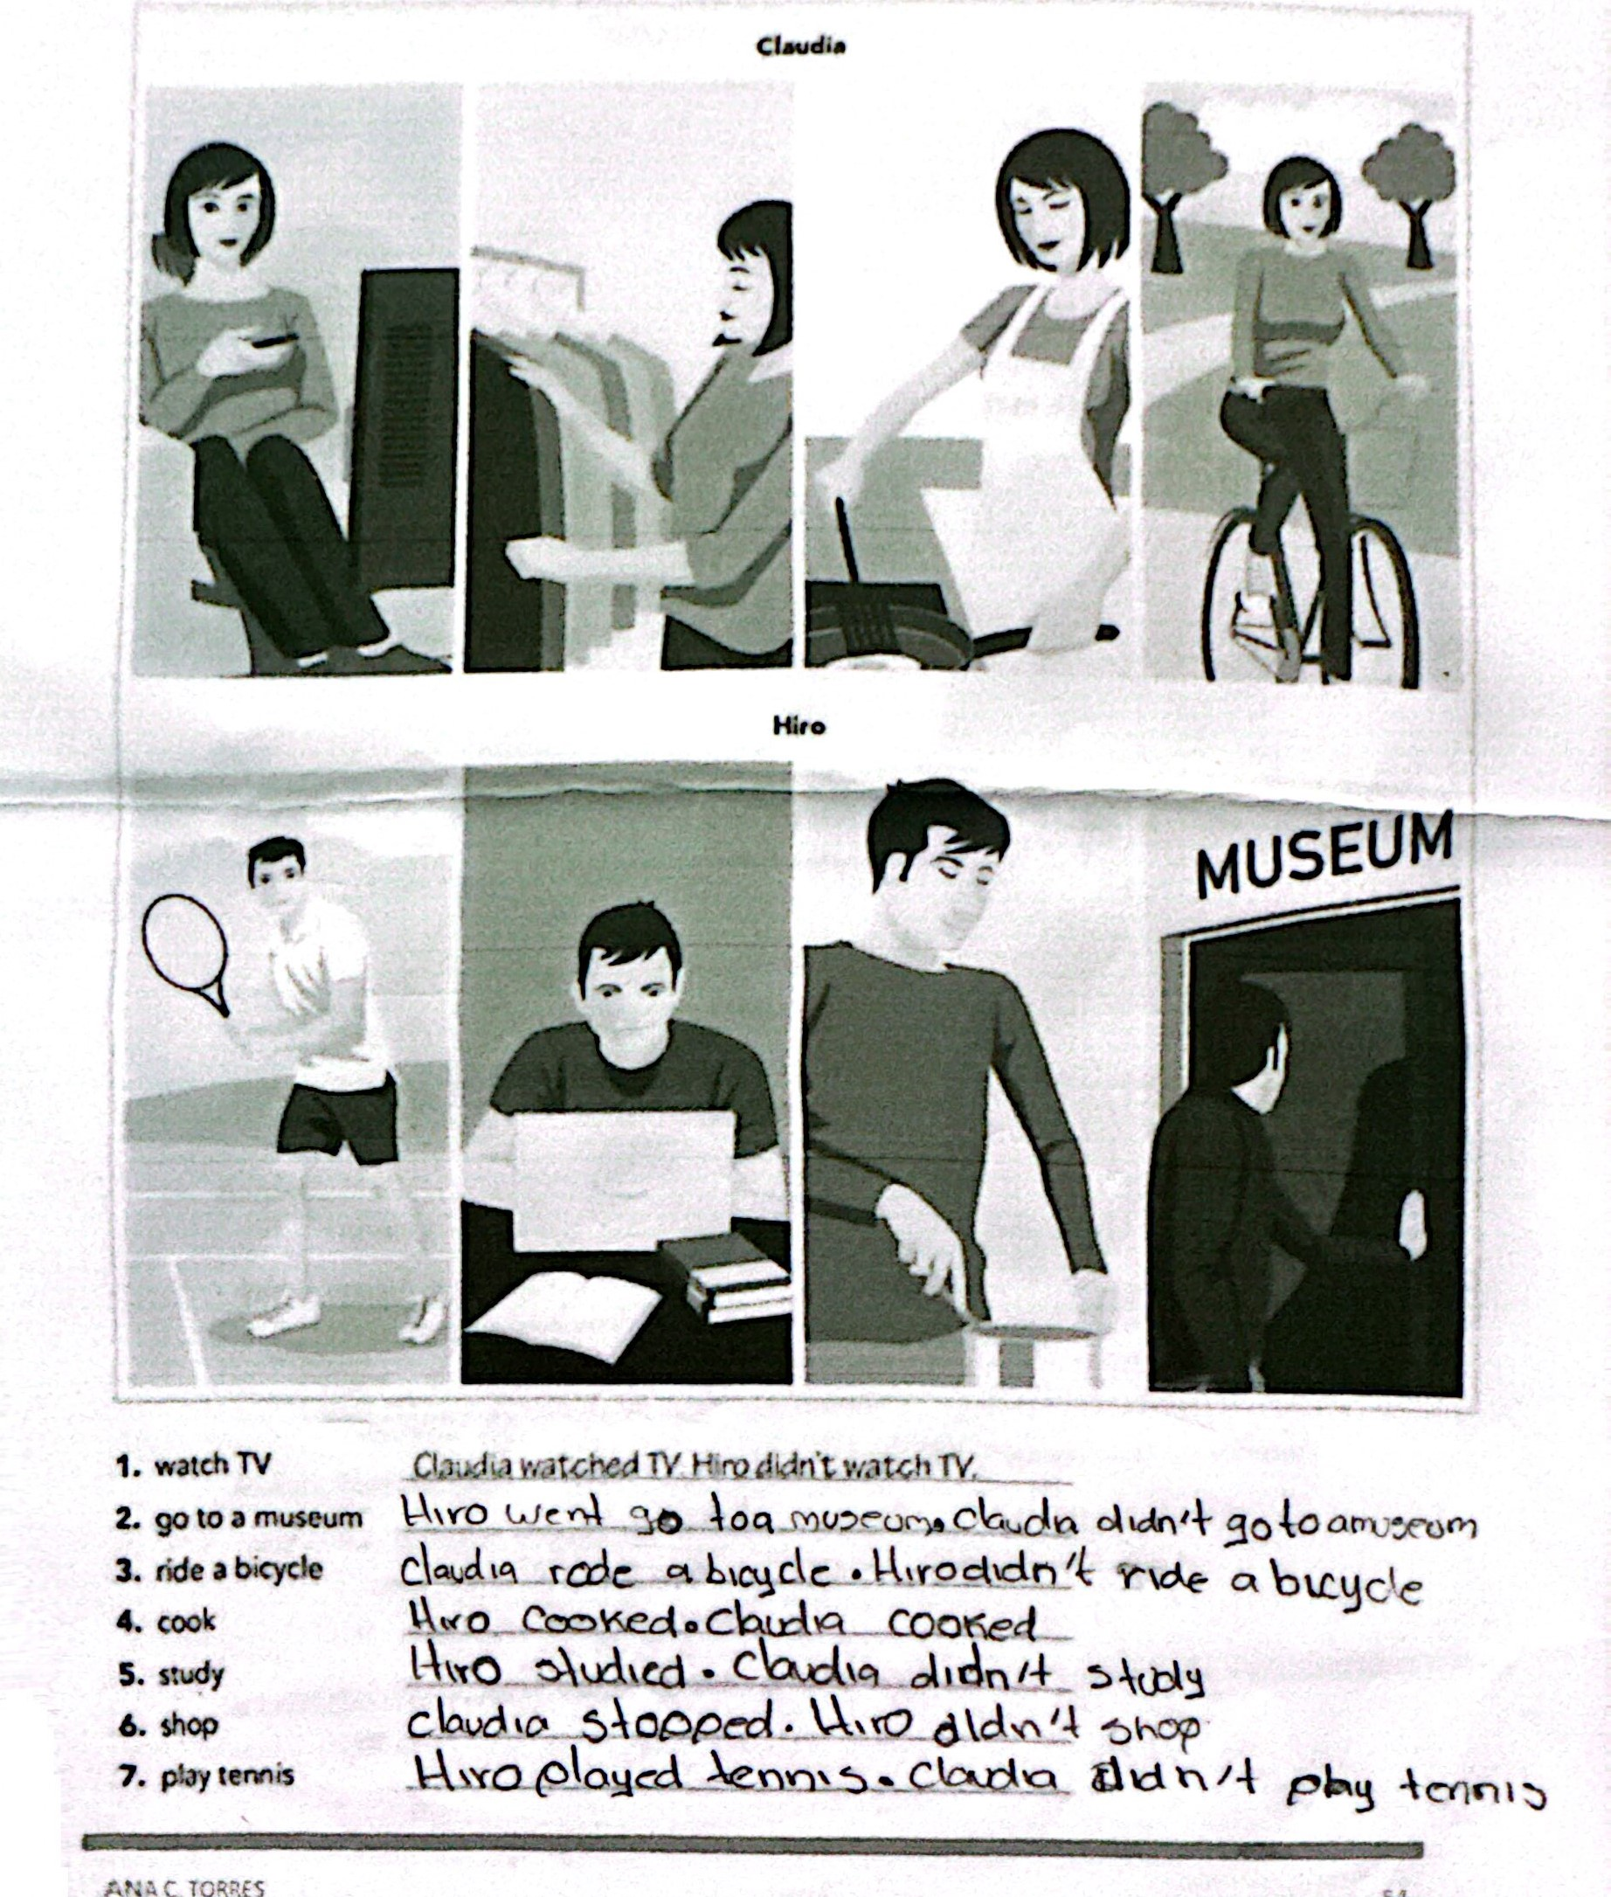

ANA

C

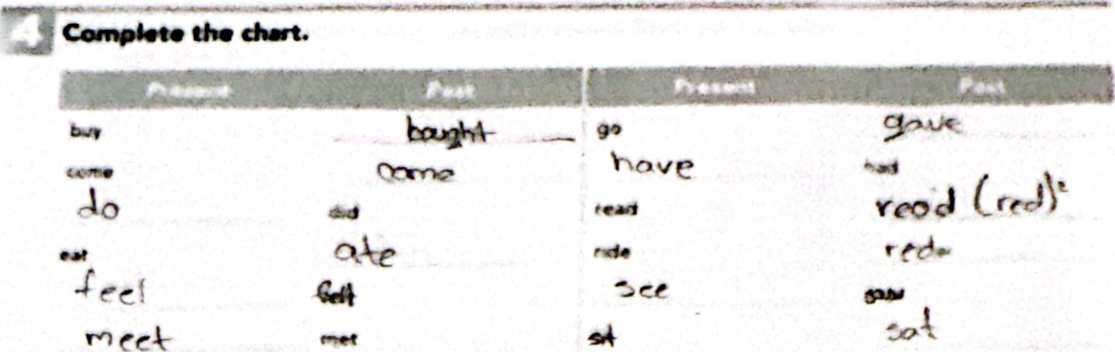

|  |  |  |  |
| --- | --- | --- | --- |
|  | Cmpkte the Use the | pest forms of the verbs | prent.hnes. |
|  |

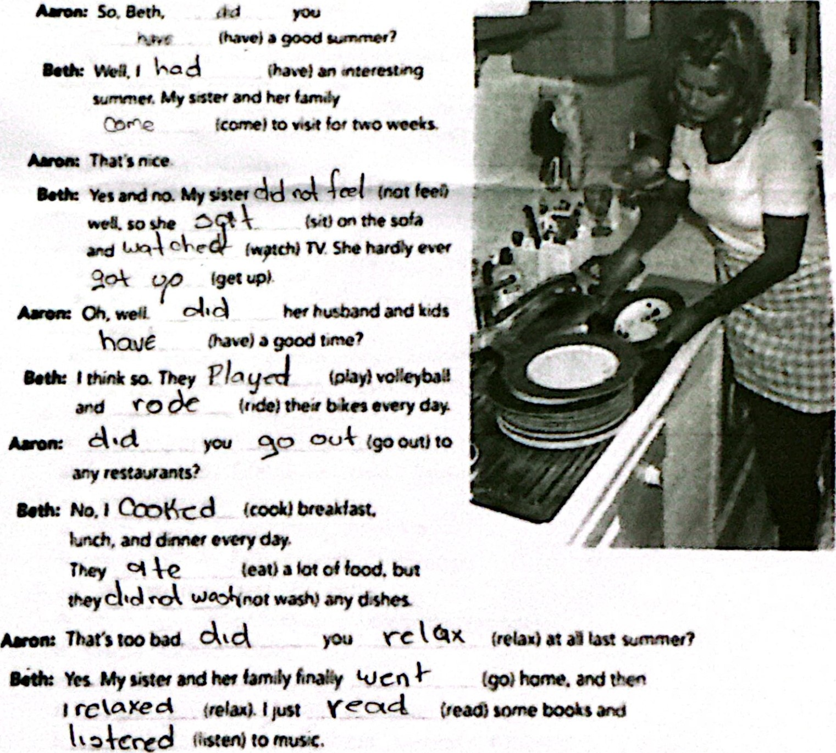



ANA C 70RkES

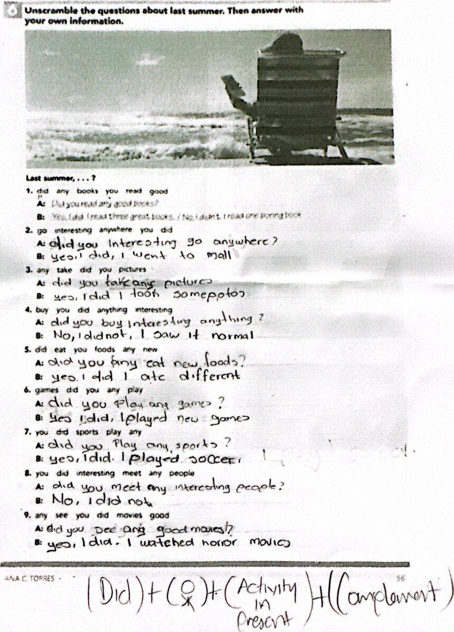



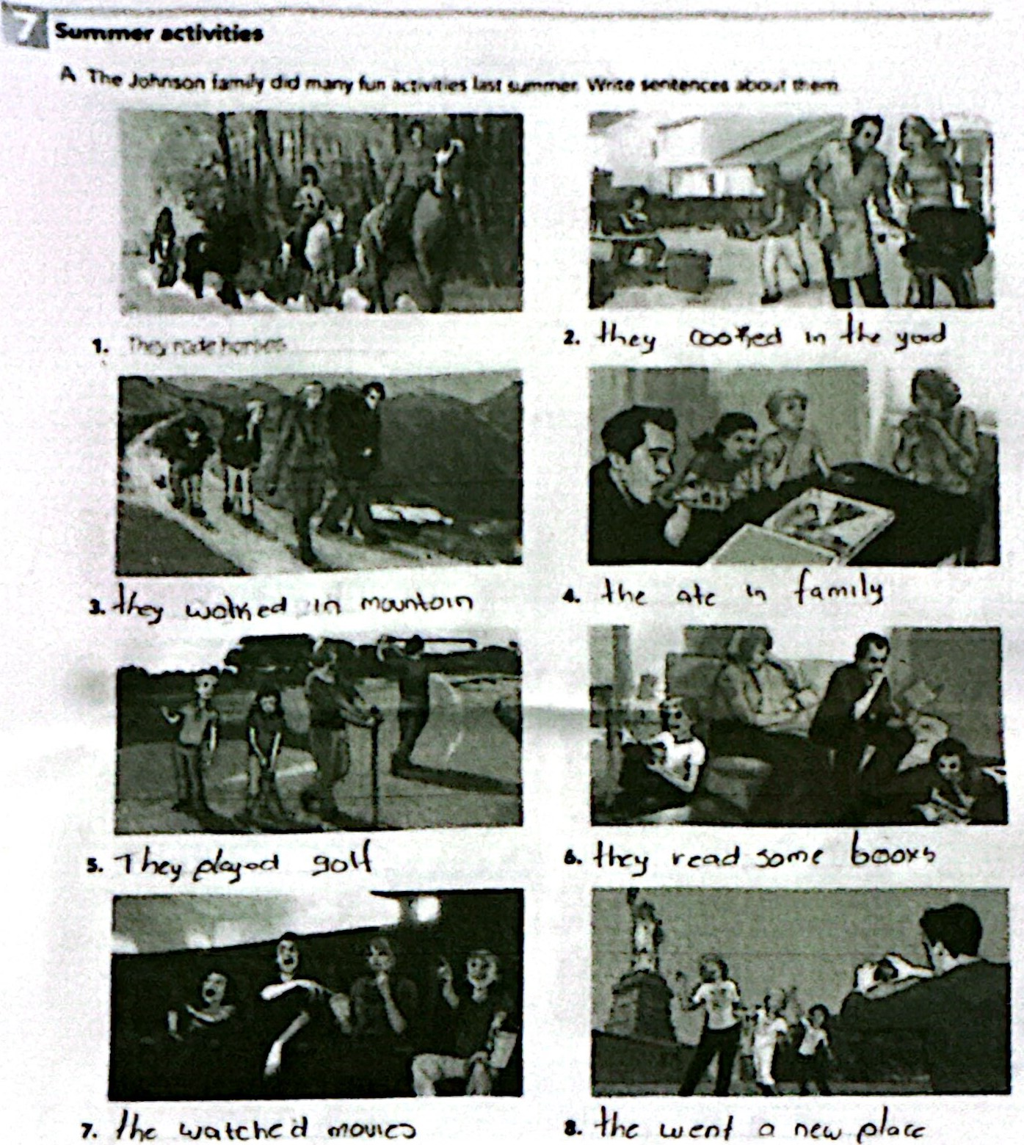

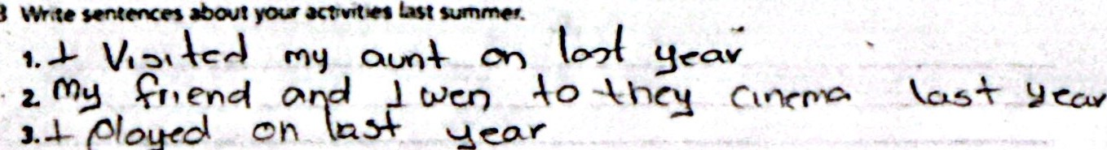

B

-V

Nogecl

