
Unit Activity #1 – U3
Nombre del Alumno: Leo Geovani García García
Nombre del tema: Unit I1I
Parcial: Third
Nombre de la Materia: English II
Nombre del profesor: Juan Manuel Jaime Díaz
Nombre de la Licenciatura:
Cuatrimestre: Second

Lugar y Fecha de elaboración

Comitán de Domínguez Chiapas a 13 de mayo de 2024.

TOURIST INFORMATION - CLOTHES
VOCABULARY
Exercise 1. Match the adjectives to pictures a-h. (Escribe la letra de la figura que concuerda con la palabra)
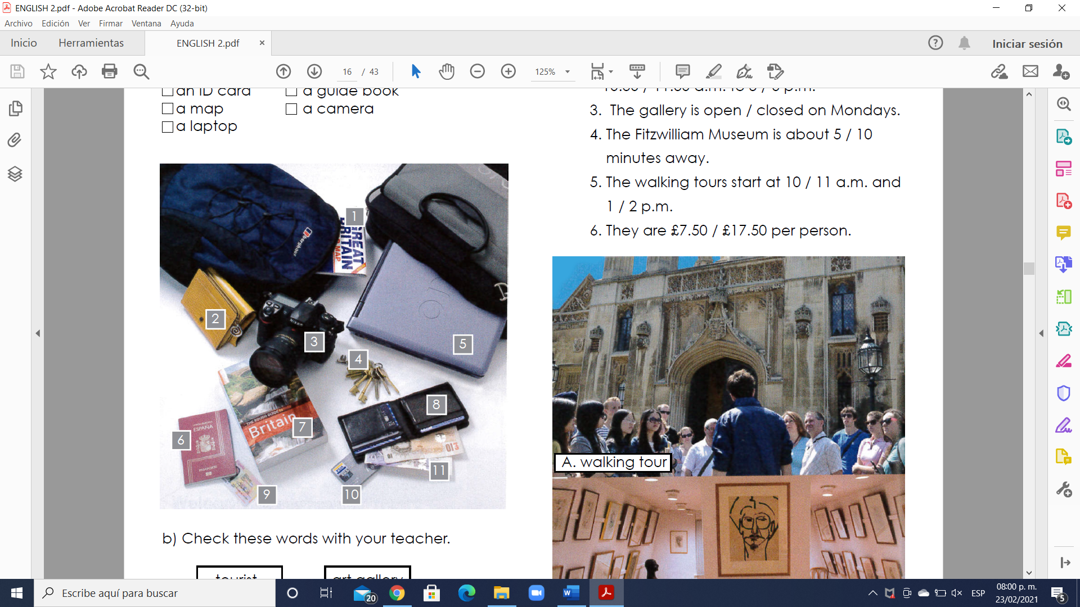
(8 ) - a wallet
(4 ) - keys.
(11 ) - a money
(9 ) - an ID card
(1 ) - a map
(5 ) - a laptop
(2 ) - a purse
(10 ) - a credit card
(6 ) - a passport
(7 ) - a guide book
(3 ) - a camera
Vocabulary - Clothes
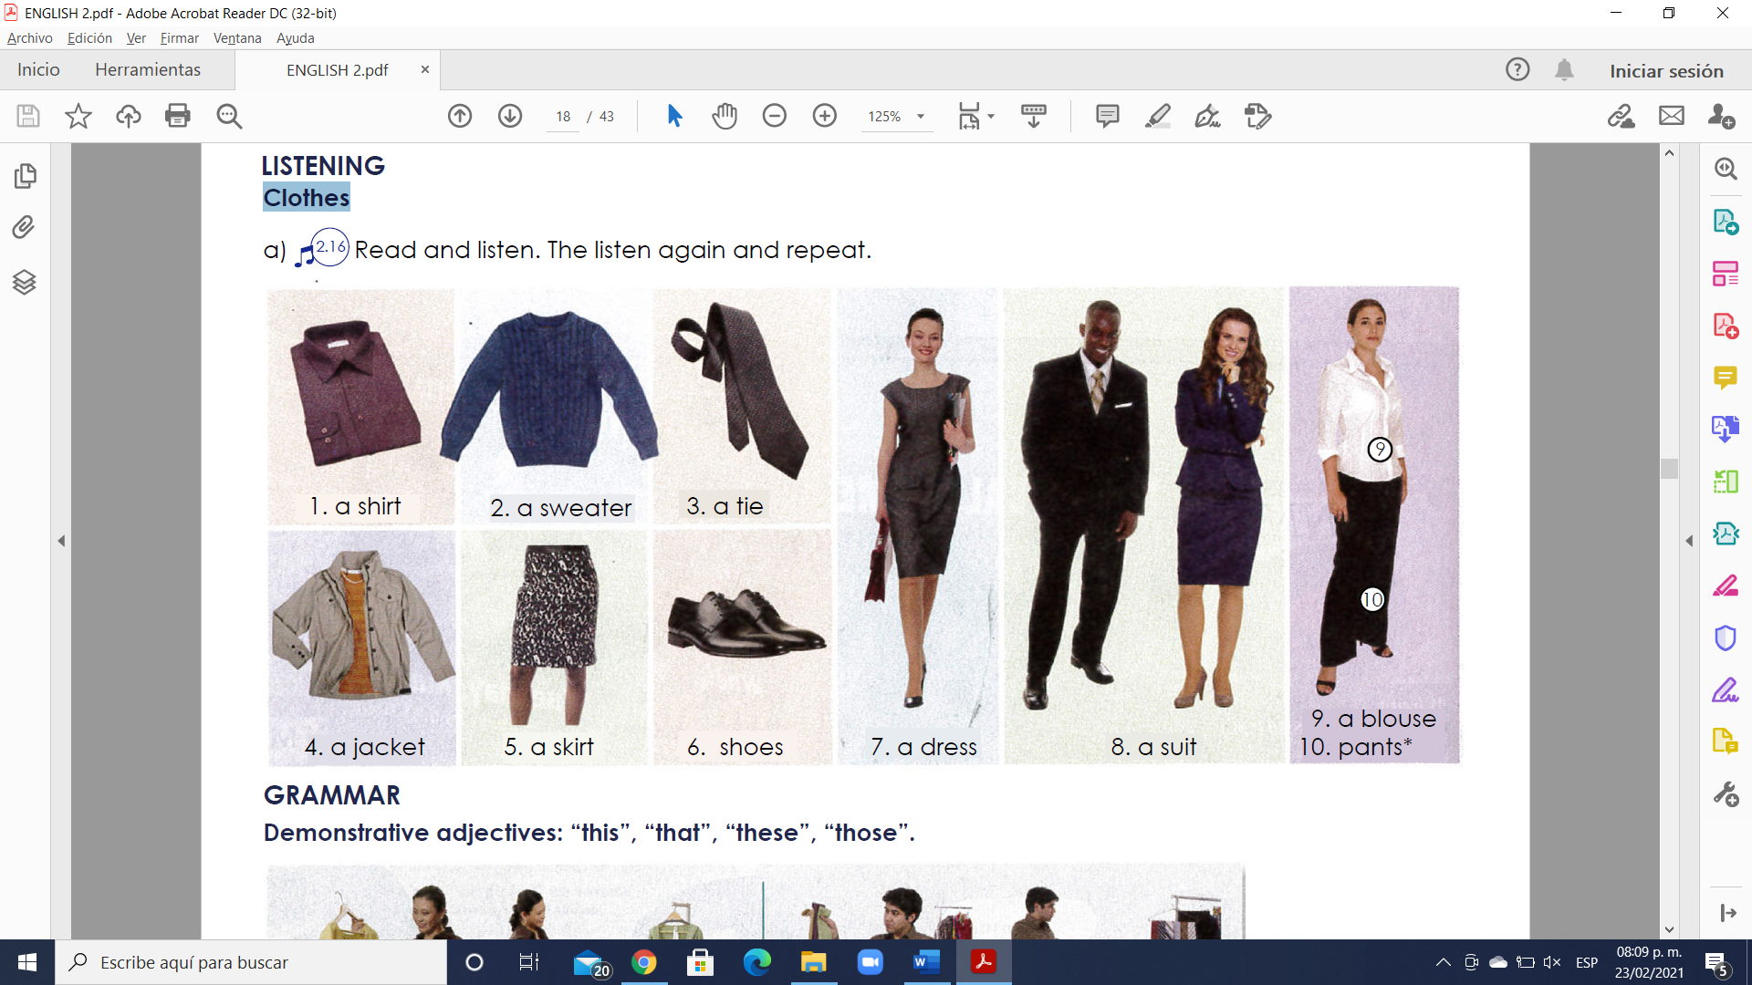
GRAMMAR - Demonstrative adjectives: “this”, “that”, “these”, “those”.
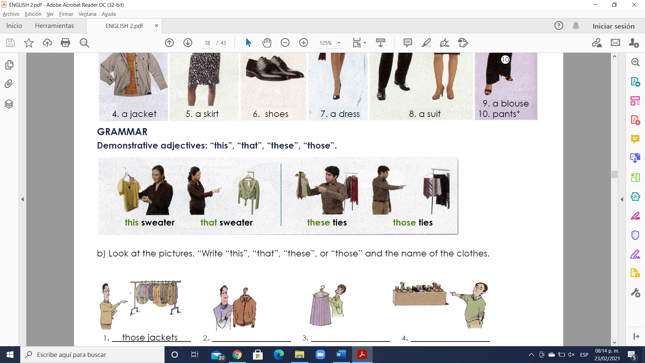
Es importante comenzar señalando que los pronombres pueden estar en singular o plural y que pueden hacer referencia a la distancia.
This (este/a/o)
That (ese/a/o, aquél, aquello/a)
These (estos/as)
Those (esos/as, aquellos/as)
Ejemplos:
Singular and this (singular y aquí):
I like this car.(Me gusta este coche.)
Singular and there (singular y allí):
I like that car.(Me gusta ese coche.)

Plural and here (plural y aquí):
I like these cars.(Me gustan estos coches.)
Plural and there (plural y allí):
I like those cars.(Me gustan aquellos coches.)

Los pronombres demostrativos pueden ir acompañados de un nombre como vemos en los ejemplos anteriores, o pueden ir solos como en los siguientes ejemplos:
This is a good book.(Éste es un buen libro.)
What is that?(¿Qué es eso?)
Other Uses of Demonstrative Pronouns (Otros usos de los demostrativos)
1. Podemos utilizarlos “this” para presentarnos por teléfono.
Hello. This is Alicia.(Hola. Soy Alicia.)
2. Para preguntar quién hay al otro lado de la línea telefónica o en un lugar oscuro, usamos “that”.
Peter, is that you?(¿Eres tú, Peter?)
3. También usamos “this” cuando presentamos personas.
Lucy, this is my friend Jill.(Lucy, ésta es mi amiga Jill.)
4.“That” también lo podemos utilizar para referirnos a algo del pasado.
That pizza was delicious.(Aquella pizza estaba riquísima.)

Exercise 2. Look at the pictures. “Write “this”, “that”, “these”, or “those” and the name of the clothes.
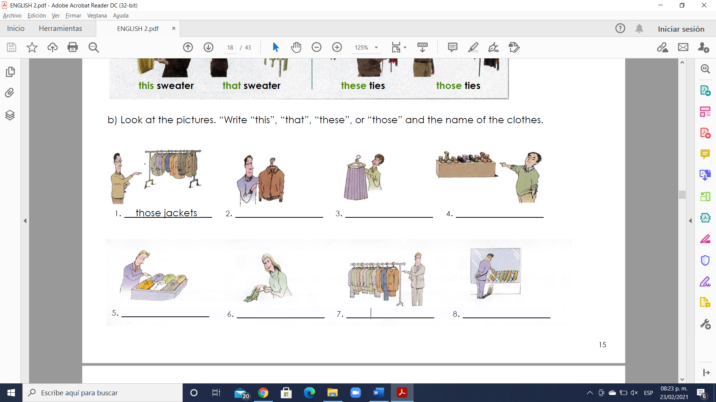
- Those jackets 2. This Jacket 3.This dress 4.Those ties

5. These shirts 6. These high heels 7. These suits 8.those ties

Exercise 3. Escribe 8 oraciones usando “this”, “that”, “these”, and “those”.

1. I like This cap
2. He Needs This suit
3. She likes that skirt
4. Jhoana wants that dress
5. Mario has These shoes
6. Alan has These T-shirts
7. Hanna wants Those blouses
8. Fernanda needs Those pajamas

GRAMMAR - The Present Simple tense: affirmative statements with “like”, “want”, “need” and “have”.
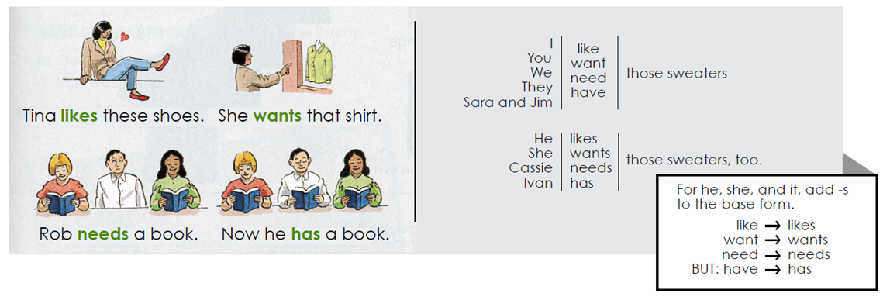

Exercise 3. Complete each statement with the correct form of the verb.
1. I like (like/likes) your tie.
2. My friends want (want/ wants) this suit.
3. Janet needs (need / needs) this skirt.
4. Peter has (have / has) that jacket.
5. We like (like / likes) our dresses.
6. Sue and Tara want (want/ wants) those suits.

VOCABULARY – Colors and Sizes
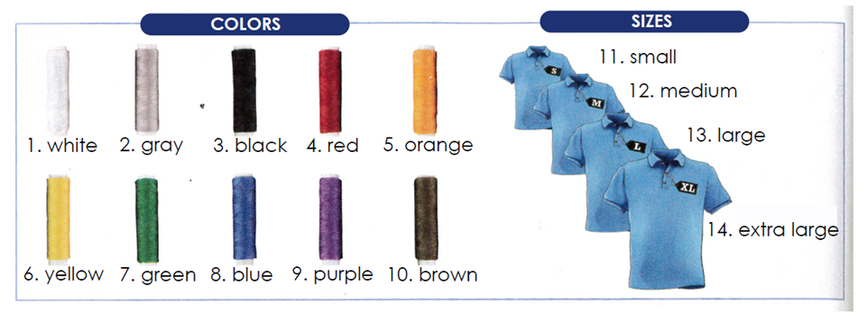
Exercise 4. Complete the sentences with the correct form of the verb. Use contractions.
1. A: Do (Do/Does) your children have (have) sweaters for school?
B: My daughter does (do/does), but my son diesen’ t don´t/doesn´t).
2. A: Does (Do/Does) your husband Need (need) a black tie?
B: No, he doesn’t (don´t/doesn´t). He has (have) two black ties.
3: A: I need (need) a blue suit for work. Do (Do/Does) you need (need) one too?
B: Yes, I do (do/does).
4. A: Do (Do/Does) you like (like) that green shirt?
B: Actually, no, I don’t ( don´t/doesn´t).
5. A: We don’t (not like) the clothes in this store.
B: Really? that`s too bad. We do ( do/does).
6. A: Do (Do/Does) you have (have)this black jacket in size 34?
B: No, I’m sorry. We don’ t (don´t/doesn´t).
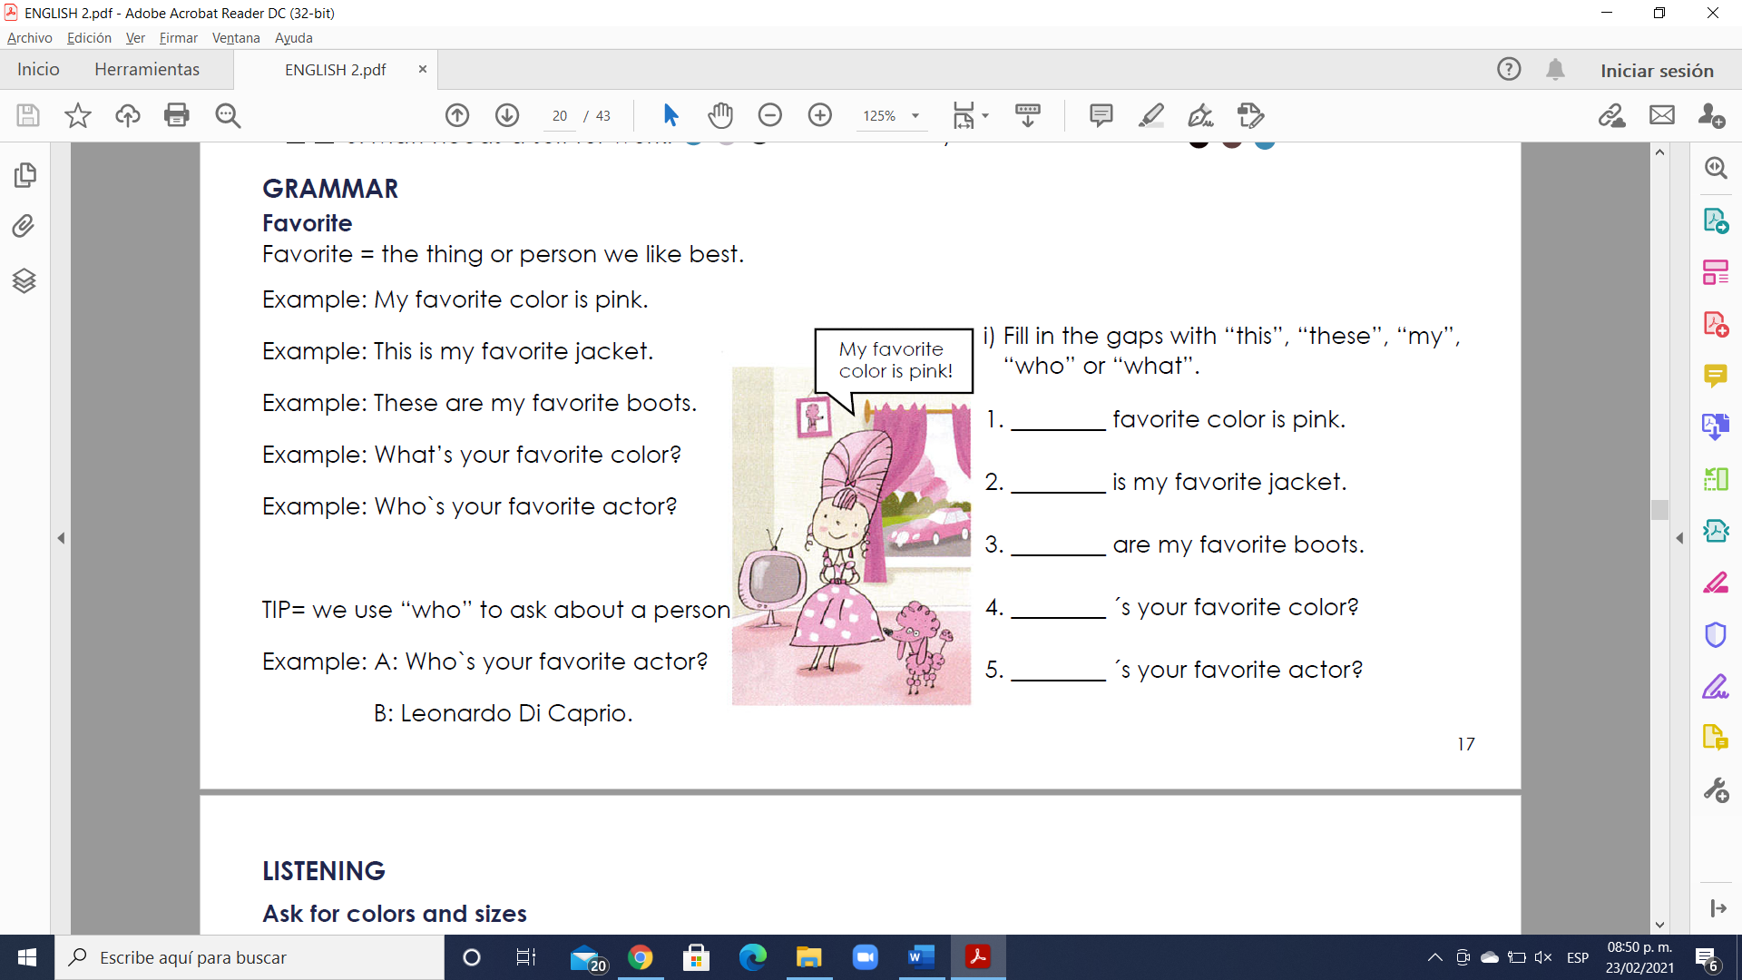
answer
answer
answer
answer
answer

VOCABULARY- Opposite adjectives to describe clothes
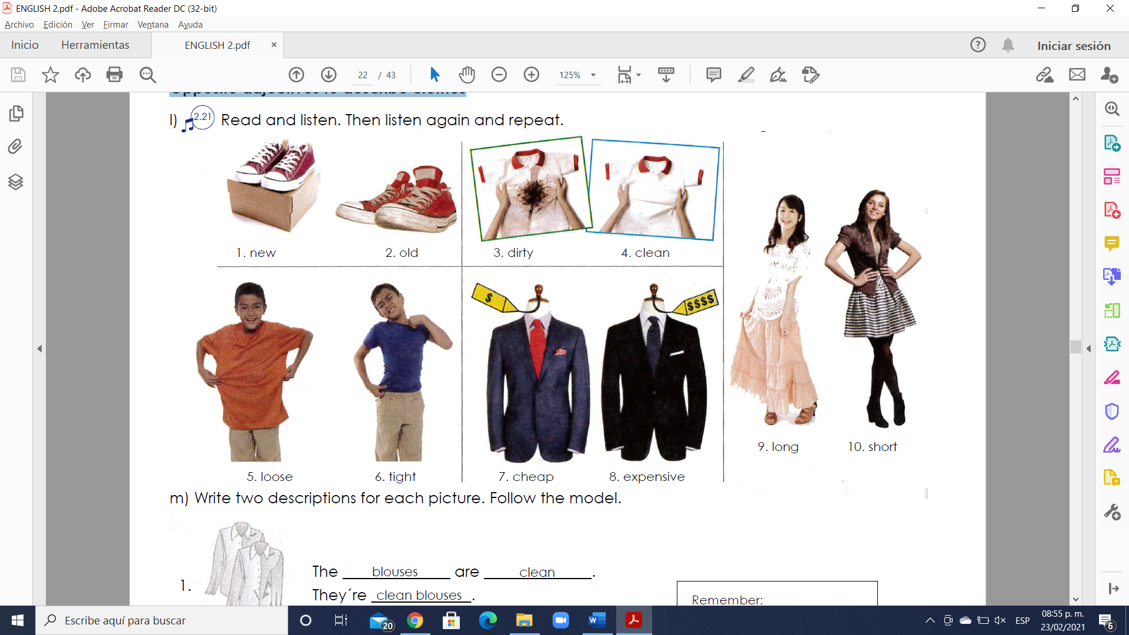

GRAMMAR - The Present Simple tense: questions with “what”, “what color”, “what size”, “why”, “which one” and “which ones”.
- Use a question word and “do” or “does” to ask information questions in the Present Simple tense.
Example: What do you need? (A blue and white tie).
Example: What does she want? (New shoes).
- Use “because” to answer questions with “why”.
Example: Why do they want that suit? (Because it’s nice).
- Use “what color” or “what size” to ask about color and size.
Example: What color do you want? (Black).
Example: What size does he need? (Extra large).
- Use “which” to ask about choice. Answer with “one” or “ones”.
Example: Which sweater do you want? (The blue one).
Example: Which shoes does he like? (The black ones).

Exercise 5. Complete the conversations in your own words.
1. A: Which skirt do you want (she / want)?
B: The skirt one.
2. A: What do you need (your friend / need)?
B: a blue and red shirt
3. A: What color shoes do you (you / like)?
B: brown
4. A: Why do you want (you / want) new shoes?
B: because they are pretty
5. A: Which shirts do you like (you / like)?
B: The black shirt
6. A: What size shoes do you need ( you / need)?
B médium

