**Unit Activity #1 – U2**

*Nombre del Alumno: Leo Geovani García García*

*Nombre del tema: Unit I1*

*Parcial: Second*

*Nombre de la Materia: English II*

*Nombre del profesor: Juan Manuel Jaime Díaz*

*Nombre de la Licenciatura:*

*Cuatrimestre: Second*

*Lugar y Fecha de elaboración*

Comitán de Domínguez Chiapas a 15 de abril de 2024.

**DESCRIBE CITIES**

**VOCABULARY**

**Exercise 1.** Match the adjectives to pictures a-h. (Escribe la letra de la figura que concuerda con la palabra)

(D ) - good.

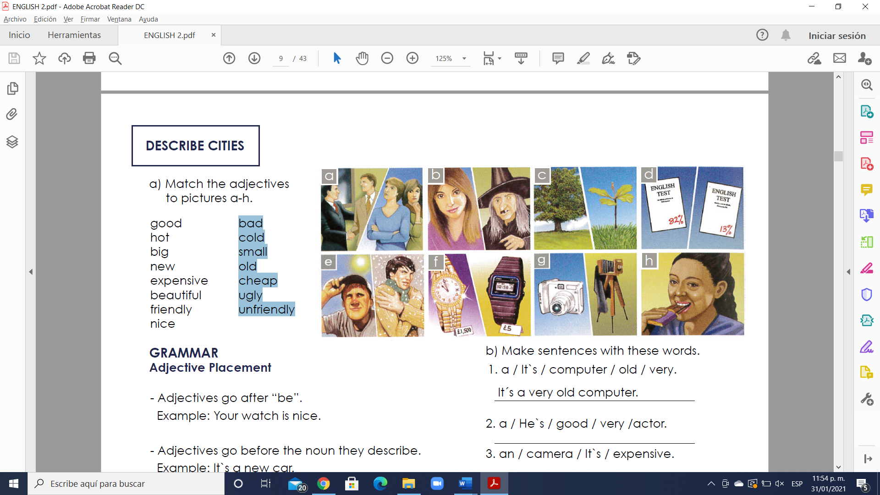(E) - hot.

(C ) - big

(G ) - new

(F ) - expensive

(B ) - beautiful

( A. ) - friendly

(H. ) nice

(D. ) bad

( E. ) Cold

(C ) - small

(G ) - old

(F )) - cheap

(B. ) - ugly

(A ) - unfriendly

**GRAMMAR**

**Adjective Placement**

- Adjectives go after “be”.

Example: Your watch is nice.

- Adjectives go before the noun they describe.

Example: It`s a new car.

- Adjectives are not plural with plural nouns.

They´re good friends.

Example: They´re good friends.

NOT ~~They´re goods friends.~~

**Exercise 2.** Make sentences with these words. (Realiza las oraciones ordenando las palabras)

1. a / It`s / computer / old / very.

A: It´s a very old computer.

2. a / He`s / good / very /actor.

A: He ‘s very good actor

3. an / camera / It`s / expensive.

A: It’s an camera expensive

4. very / nice / friends / are / His.

A: His very nice are friends

5. good / musician / a / She`s.

A: She ‘s a good músician

6. is / very / house / beautiful / Her.

A: ver house is very beautiful

7. a / It`s / night / cold / very.

A: It ‘s a nigth very cold

8. friendly / children / Your / very / are.

A: Your are children very friéndly

**GRAMMAR - Present Simple ( I, you, we, they)**

- We use the Present Simple when something is generally or always true.

Example: People need food.

- We use the Present Simple for a situation that we think is more or less permanent.

Example: She works in a bank.

- We use the Present Simple for habits or things that we do regularly. We often use adverbs of frequency, such as “often”, “always”, “sometimes”.

Example: I always play tennis on Tuesday.

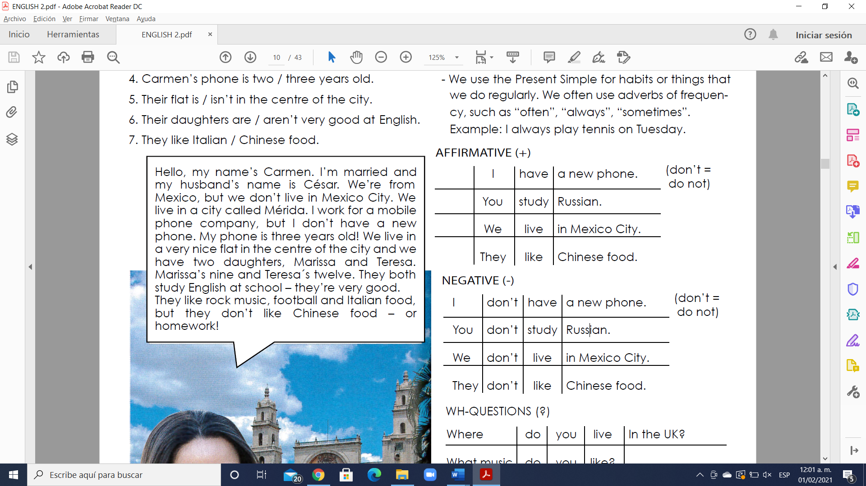 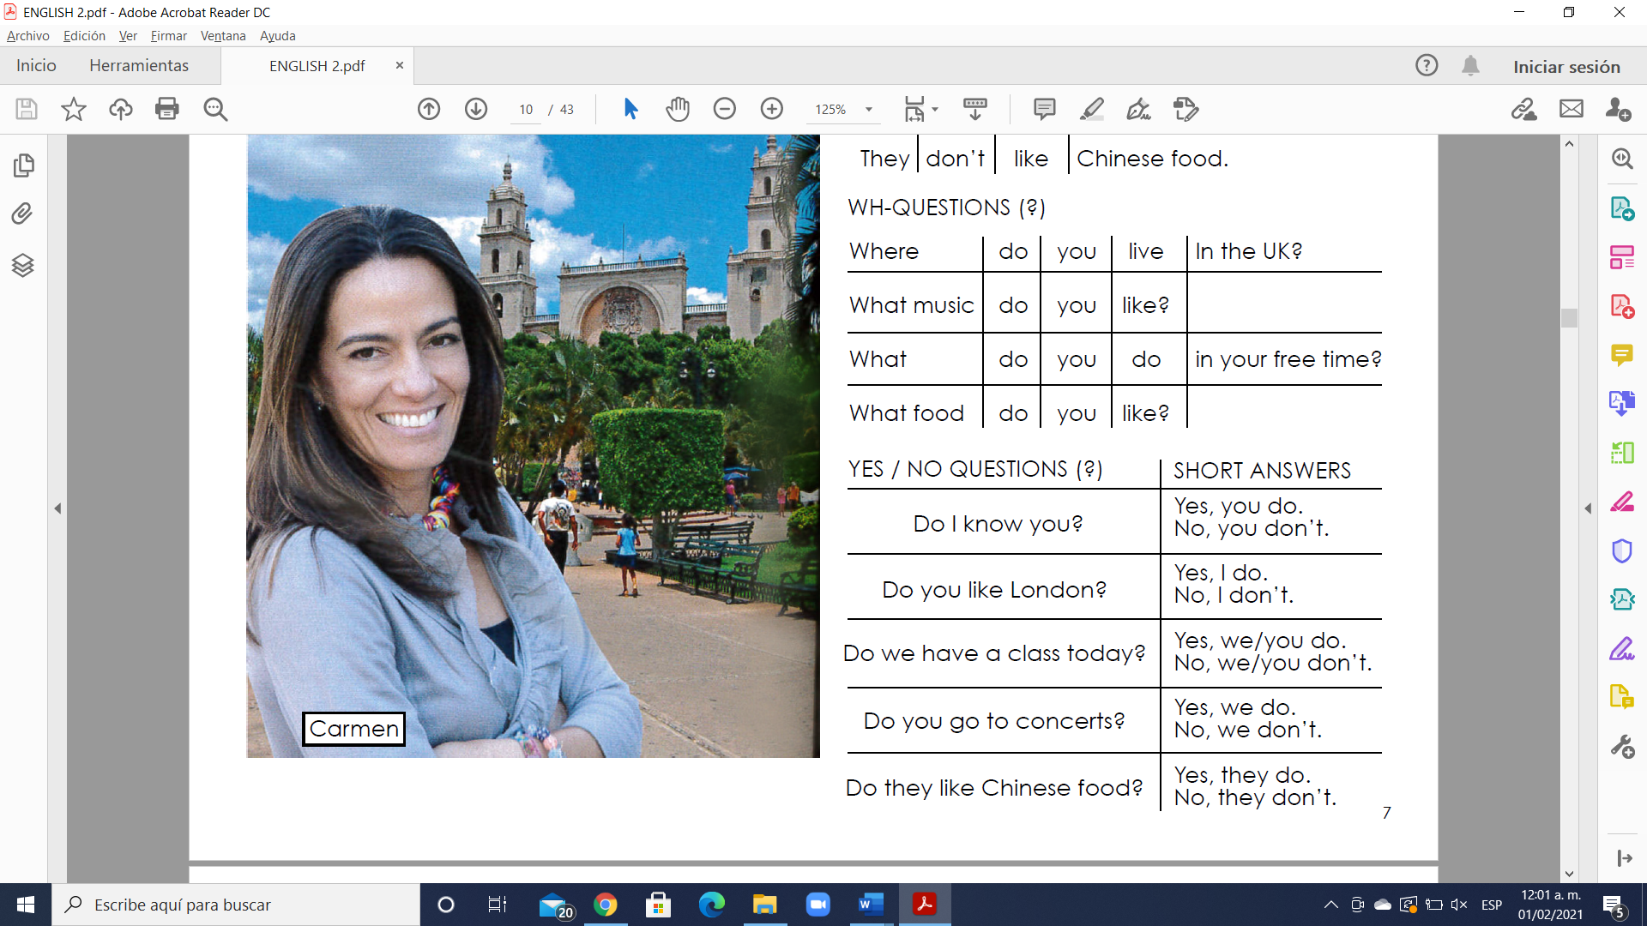

**Simple present**

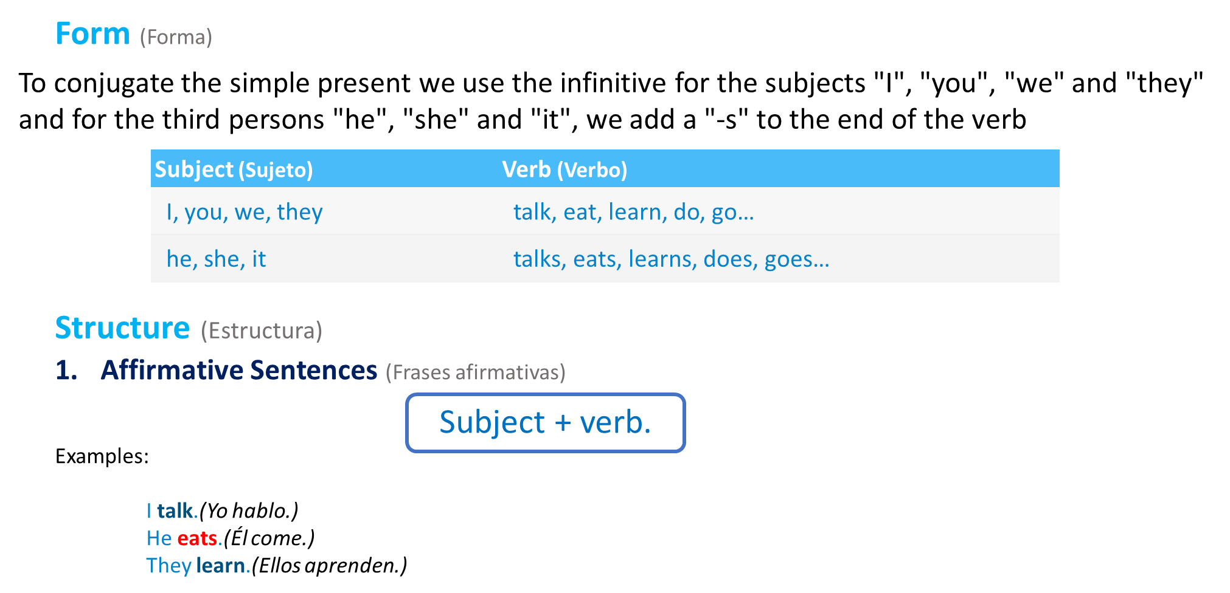

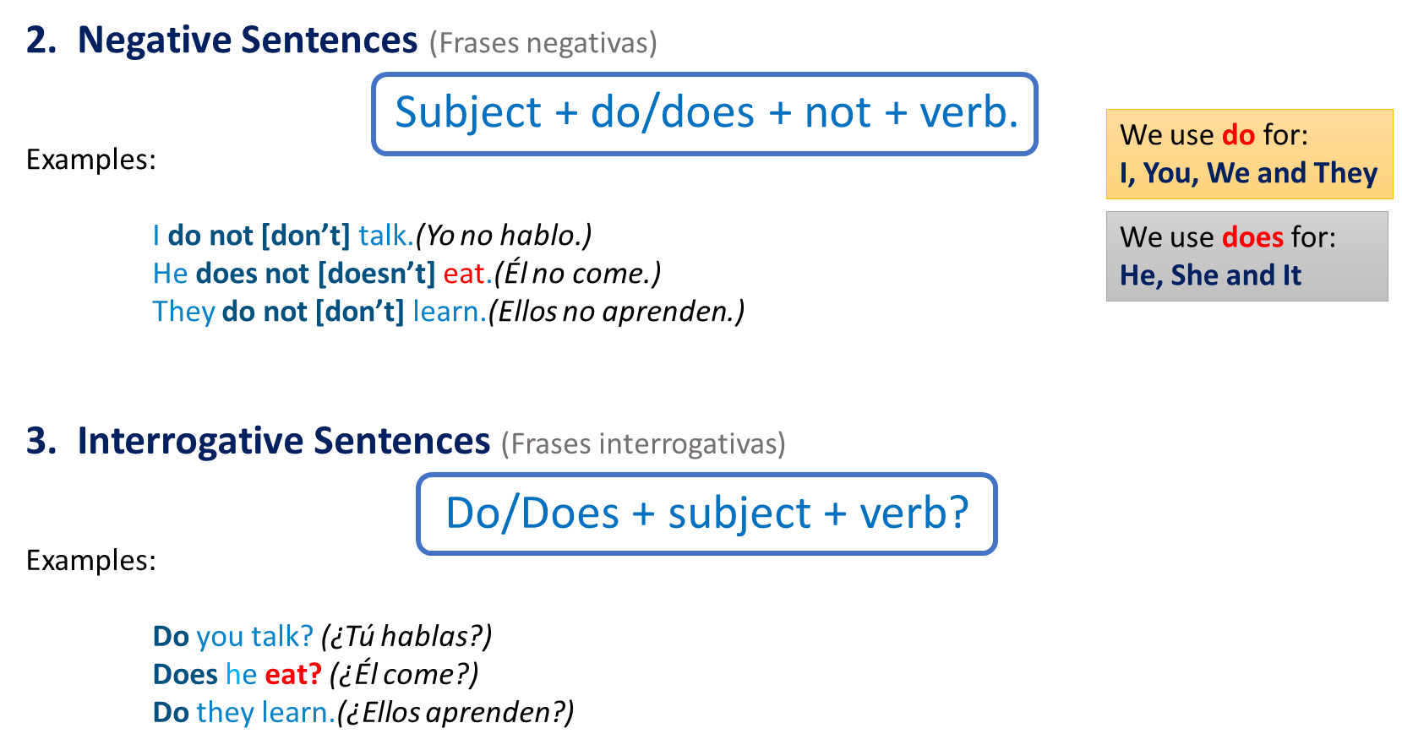

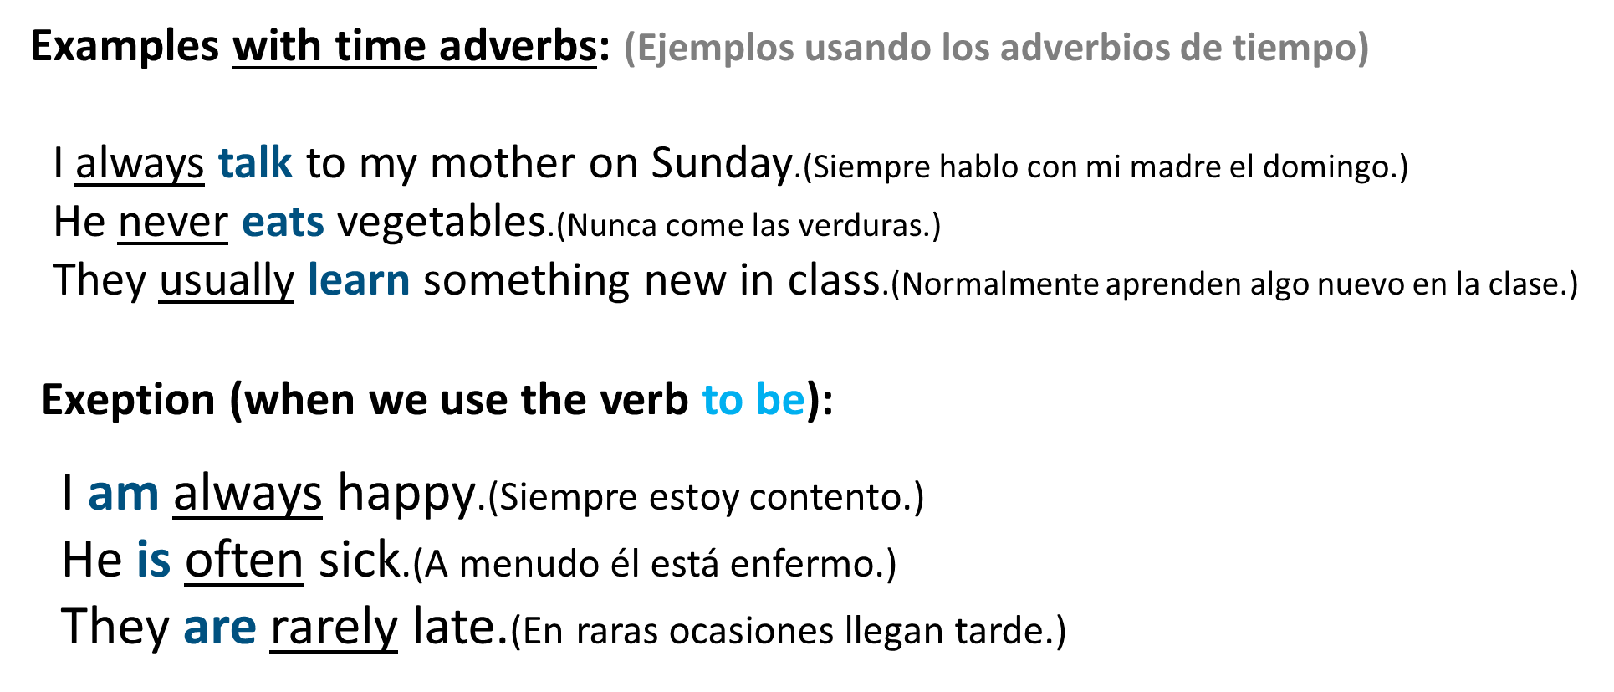

**Exercise 3.** Change the sentences to negative and question. (Cambia la oración afirmativa a oraciones negativas y preguntas)

1. I live in the center of the city.

N. I don´t live in the center of the city

Q. Do you live in the center of the city?

2. I work in an office.

N. I don’t Work in an (Office)

Q. Do you work in an (Office) ?

3. Robert likes Italian food.

N. He Doesn ‘t likes italian food

Q. Does she likes italian food ?

4. Anna likes rock music.

N. She doesn’t likes rock Music

Q. Does she likes rock músic

5. They have a new computer.

N. They don’t have a new computer

Q. Do they have a new computer ?

6. You have a sister.

N. You don’t have a sister

Q. Do you have a sister ?

7. We study English.

N. We don’t study english

Q. Do we study english

8. She lives in a small house.

N. She doesn ‘t lives in a small House

Q. Does she lives in a small house ?

9. He works for an American company.

N. He doesn’t Works for an american company

Q. Does he works for an América company ?

**MY HOME TOWN**

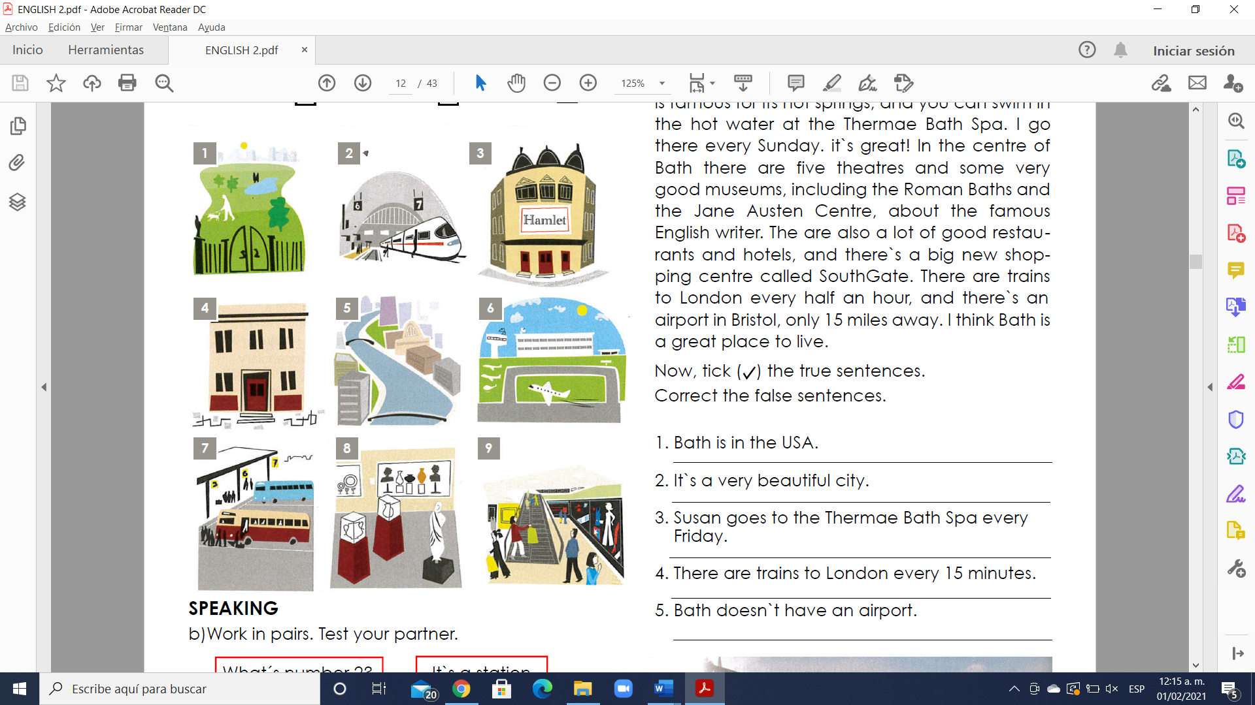**Exercise 4.** Match the adjectives to pictures 1-9. (Escribe la letra de la figura que concuerda con la palabra)

(4 ) - a building.

(8) - a museum.

(3 ) - a theatre

(9. ) - a shopping center

(1. ) a park

( 5. ) - a river

( 2. ) - a station

( 7. ) - a bus station

(6 ) - an airport

**GRAMMAR - A, some, a lot of,**

Los cuantificadores indican la cantidad de un nombre. Son repuestas a la pregunta “¿Cuántos?”. Al igual que los artículos, los cuantificadores definen a un nombre y siempre están situados delante del nombre. Algunos se pueden usar sólo con nombres contables, otros, sólo con nombres incontables y otros, con ambos.

**A or an**

El significado de “a” o “an” es el mismo y se utilizan para indicar algo o alguien en singular. Nunca los utilizaremos para referirnos a más de una cosa.

“A” o “an” corresponden a los siguientes artículos en español: un, una.

1. “A” se utiliza con nombres que comienzan por consonante.

Ejemplos:

a book(un libro)

a pen(un bolígrafo)

a chair(una silla)

a girl(una chica)

2. “An” se usa con nombres que comienzan por vocal.

Ejemplos:

an animal(un animal)

an ice cream(un helado)

an example(un ejemplo)

an orange(una naranja)

an umbrella(un paraguas)

**Some**

Significado: Algunos, unos

Uso: Se utiliza tanto para los nombres o sustantivos incontables como para los nombres o sustantivos contables en plural. Se usa en frases afirmativas e interrogativas (para afirmar algo); se sustituye “any” en frases negativas o interrogativas. Significa una cantidad indefinida, pero limitada.

Ejemplos:

Frase afirmativa/nombre contable:

She has some apples.(Tiene algunas manzanas.)

Frase afirmativa/nombre incontable:

There is some milk in the kitchen.(Hay algo de leche en la cocina.)

Frase interrogativa/nombre contable:

Can I have some cookies?(¿Puedo tomar unas galletas?)

Frase interrogativa/nombre incontable:

Would you like some coffee?(¿Quieres café?)

**A lot of/Lots of**

Significado: Mucho

Uso: Expresan idea de gran cantidad. Se puede usar con nombres o sustantivos contables e incontables. A diferencia de “many” y “much”, no las usamos en frases interrogativas. En general, “lots of” es más informal.

Ejemplos:

Nombre contable:

He has a lot of books.(Tiene muchos libros.)

Nombre contable:

He does not have a lot of books.(No tiene muchos libros.)

Nombre incontable:

I have lots of money.(Tengo mucho dinero.)

Nombre incontable:

I do not have a lot of money.(No tengo mucho dinero.)

**GRAMMAR - There is / There are: positive**

Utilizamos “there + be” (hay) para hablar sobre la existencia de algo. “There + be” se puede expresar en todos los tiempos verbales, pero a diferencia del español, en inglés conjugamos este verbo si el nombre que va después está en plural o en singular y si es contable o incontable.

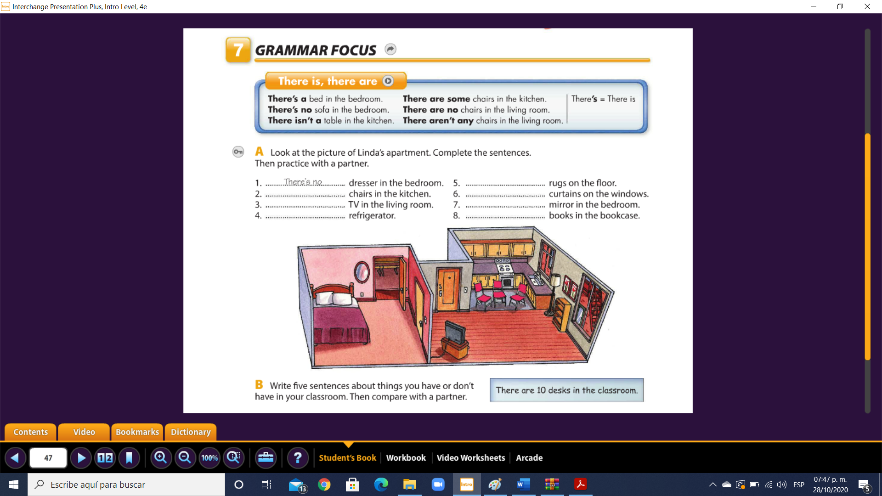

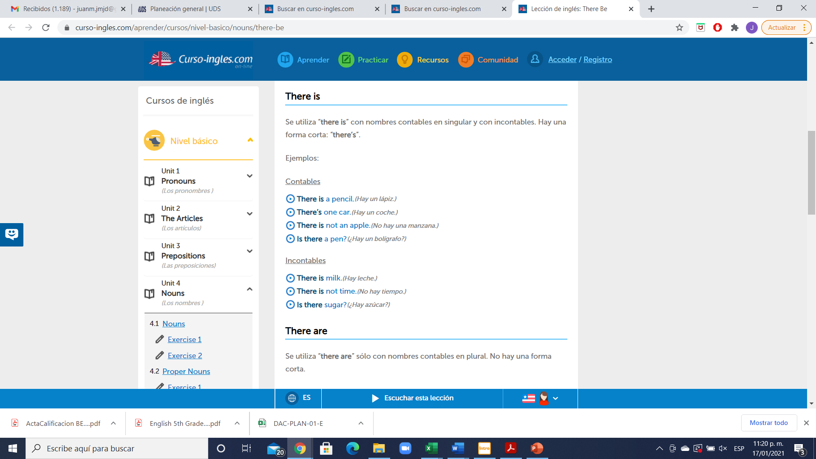

Examples:

- There is a big new shopping center.

- There is an airport in Bristol.

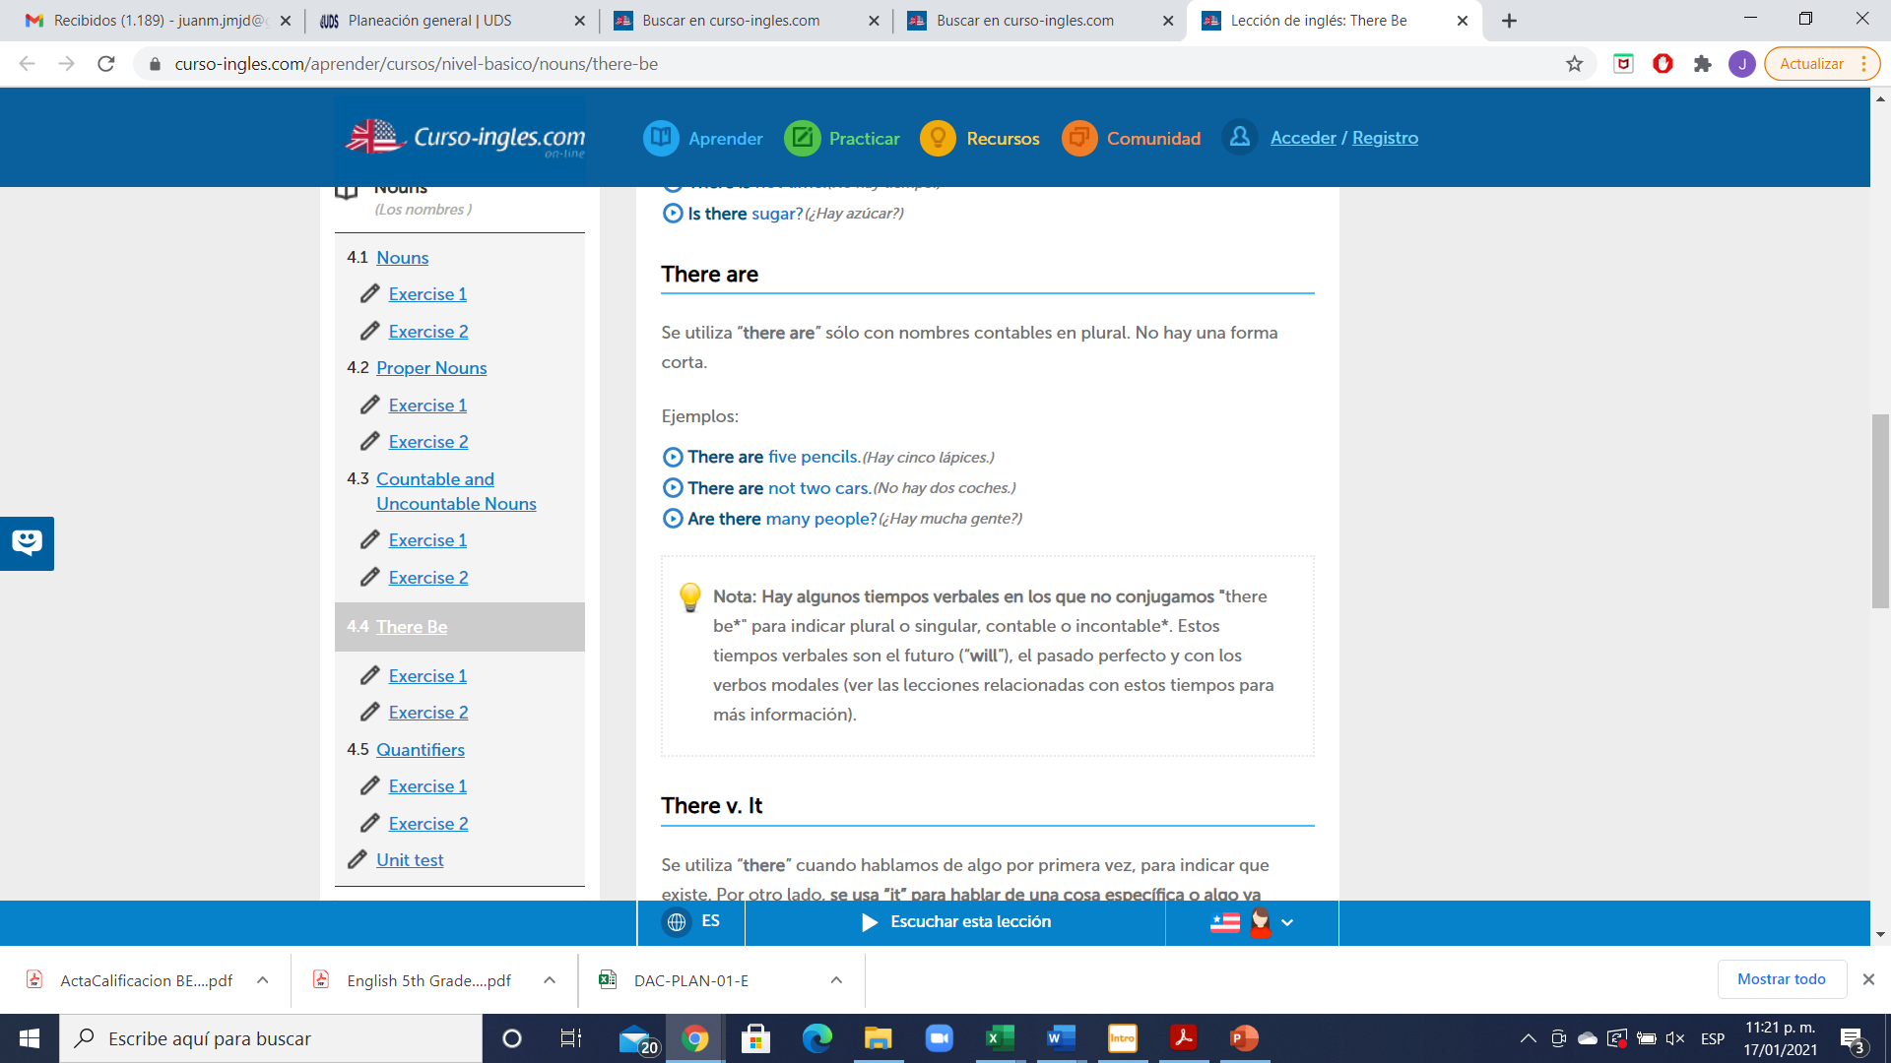

Examples:

- There are five theatres. - There are some very nice parks.

- There are a lot of old buildings.

**Exercise 5.** Look at these sentences about Bath. Fill in the gaps with “is” or “are”. Llena correctamente los espacios con “is” or “are”.

1. There is a beautiful river.

2. There are two cinemas.

3. There. Is a bus station.

4. There are some hot springs.

5. There is a nice café near the station.

6. There are two five-star hotels.

7. There is a famous restaurant called Sally Lunn’s.

8. There are a lot of trains to London every day.

**Exercise 6.** Choose the correct word. (Escoge entre las dos palabras para realizar una oración correcta, colócala en color rojo)

1. There’s **a / some** station.

2. There are **a / three** parks.

3. There are **a / some** good museums.

4. There’s **a / some** bus station.

5. There are **some / a** beautiful buildings.

6. There’s **a / an** old theatre.

7. There are **an / a lot of** very good restaurants.

8. There’s **an / some** airport.

9. There are **some / a** nice hotels.

10. There’s **a / a lot of** river.