**Unit Activity #1 – U1**

*Nombre del Alumno: Jennifer Xicoténcatl Méndez*

*Nombre del tema: Unit 1*

*Parcial: Firts*

*Nombre de la Materia: English IV*

*Nombre del profesor: Juan Manuel Jaime Díaz*

*Nombre de la Licenciatura:*

*semestre: Fourth*

*Lugar y Fecha de elaboración*

Comitán de Domínguez Chiapas a 04 de marzo de 2024.

**APPEARANCE AND HEALTH - Vocabulary**

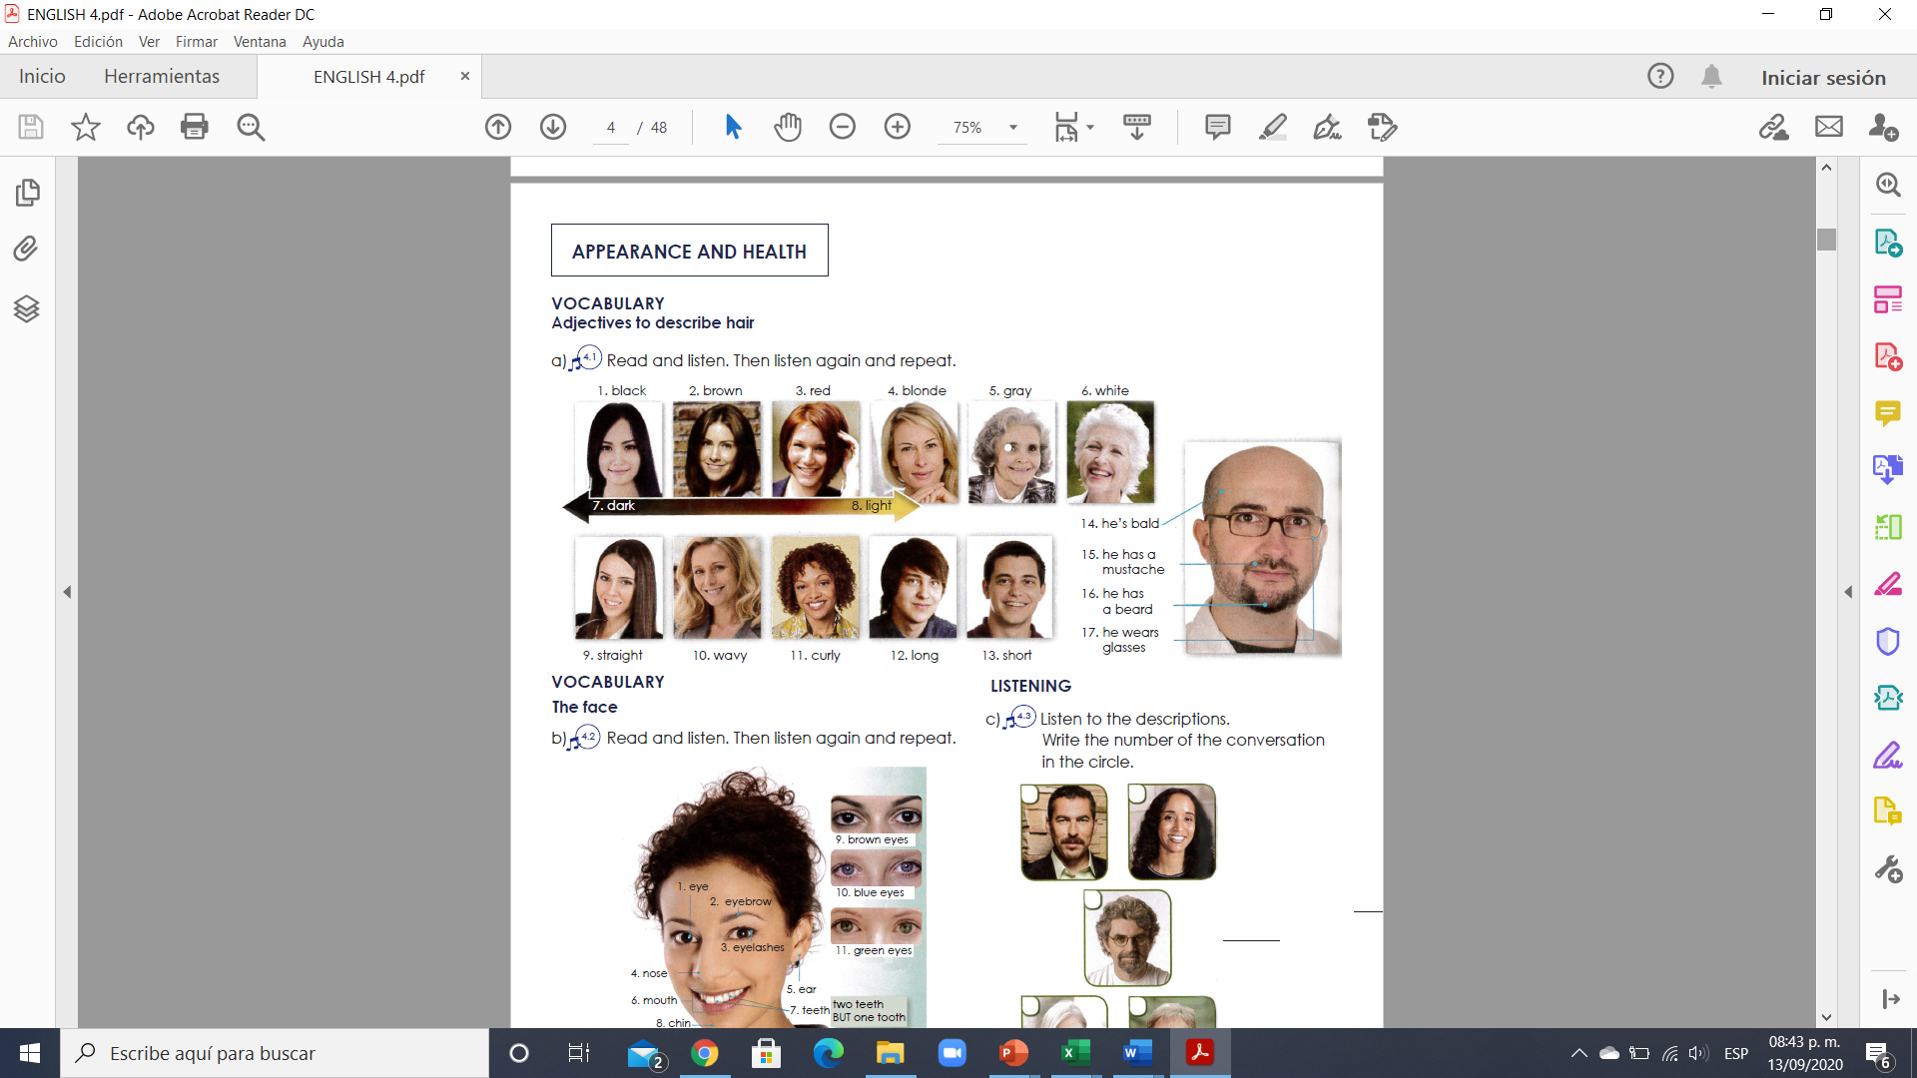

**Exercise 1.** Translate to spanish the vocabulary above. Traduce al español el vocabulario de arriba.

1. negro 10. Ondulado

2.cafe 11. Chino o rizado

3.rojo 12. Largo

4.rubio 13. Corto

5.gris 14. El es calvo

6.blanco 15. El tiene un bigote

7. no hay nada 16. El tiene una barba

8.no hay 17. El esta usando lentes

9.lacio

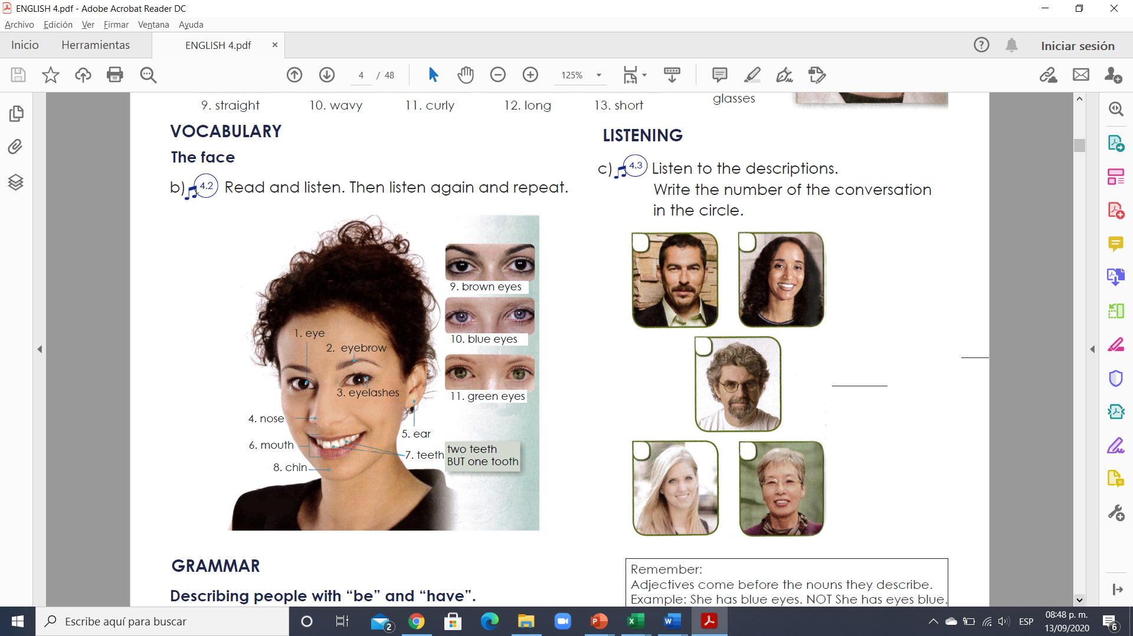

1. ojos 7. Dientes

2. cejas 8.barbilla

3. pestañas 9. Ojos marones

4. nariz 10. Ojos azules

5. oreja 11.ojos verdes

6. boca

**Exercise 2.** Translate to spanish the vocabulary above. Traduce al español el vocabulario de arriba.

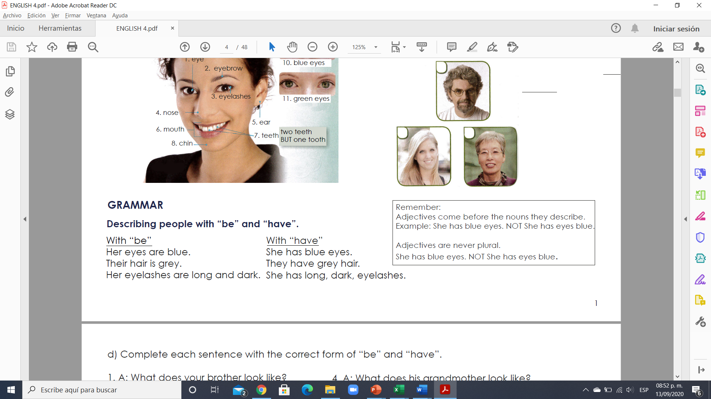

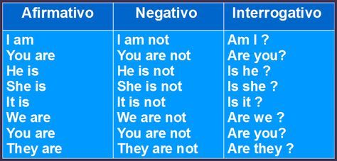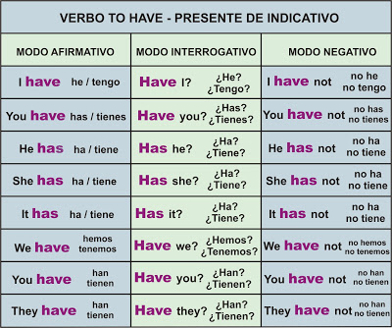

**VERBO TO BE**

**Exercise 3.** Complete each sentence with the correct form of “be” and “have”.

1. A: What does your brother look like?

B: Well, he ___has _________ a mustache and wavy hair.

And he wears glasses.

2. A: What does your mother look like?

B: Her hair ____has__________ curly and black.

3. A: What does her father look like?

B: He _____has ____________ a short, gray beard.

4. A: What does his grandmother look like?

B: She _______has _________ curly, gray hair and beautiful eyes.

5. A: What does his sister look like?

B: His sister? Her hair _____have__________ long and pretty!

6. A: What do your brothers look like?

B: They ______have ______________ straight, black hair, and they wear glasses.

**Exercise 4.** Write a sentence with “be” and a sentence with “have”.

**Example:**

**1. Kate / hair/ long / straight**

(using “be”) a. Kate’s hair is long and straight

(using “have”) b. Kate has long straight hair

**2. George / short/ black hair**

(using “be”) a.

(using “have”) b.

**3. Harry/ long / curly/ hair**

(using “be”) a.

(using “have”) b.

**4. Mary/ eyes/ blue**

(using “be”) a.

(using “have”) b.

**5. Amy/ pretty/ eyes**

(using “be”) a.

(using “have”) b.

**VOCABULARY**

**Parts of the body**

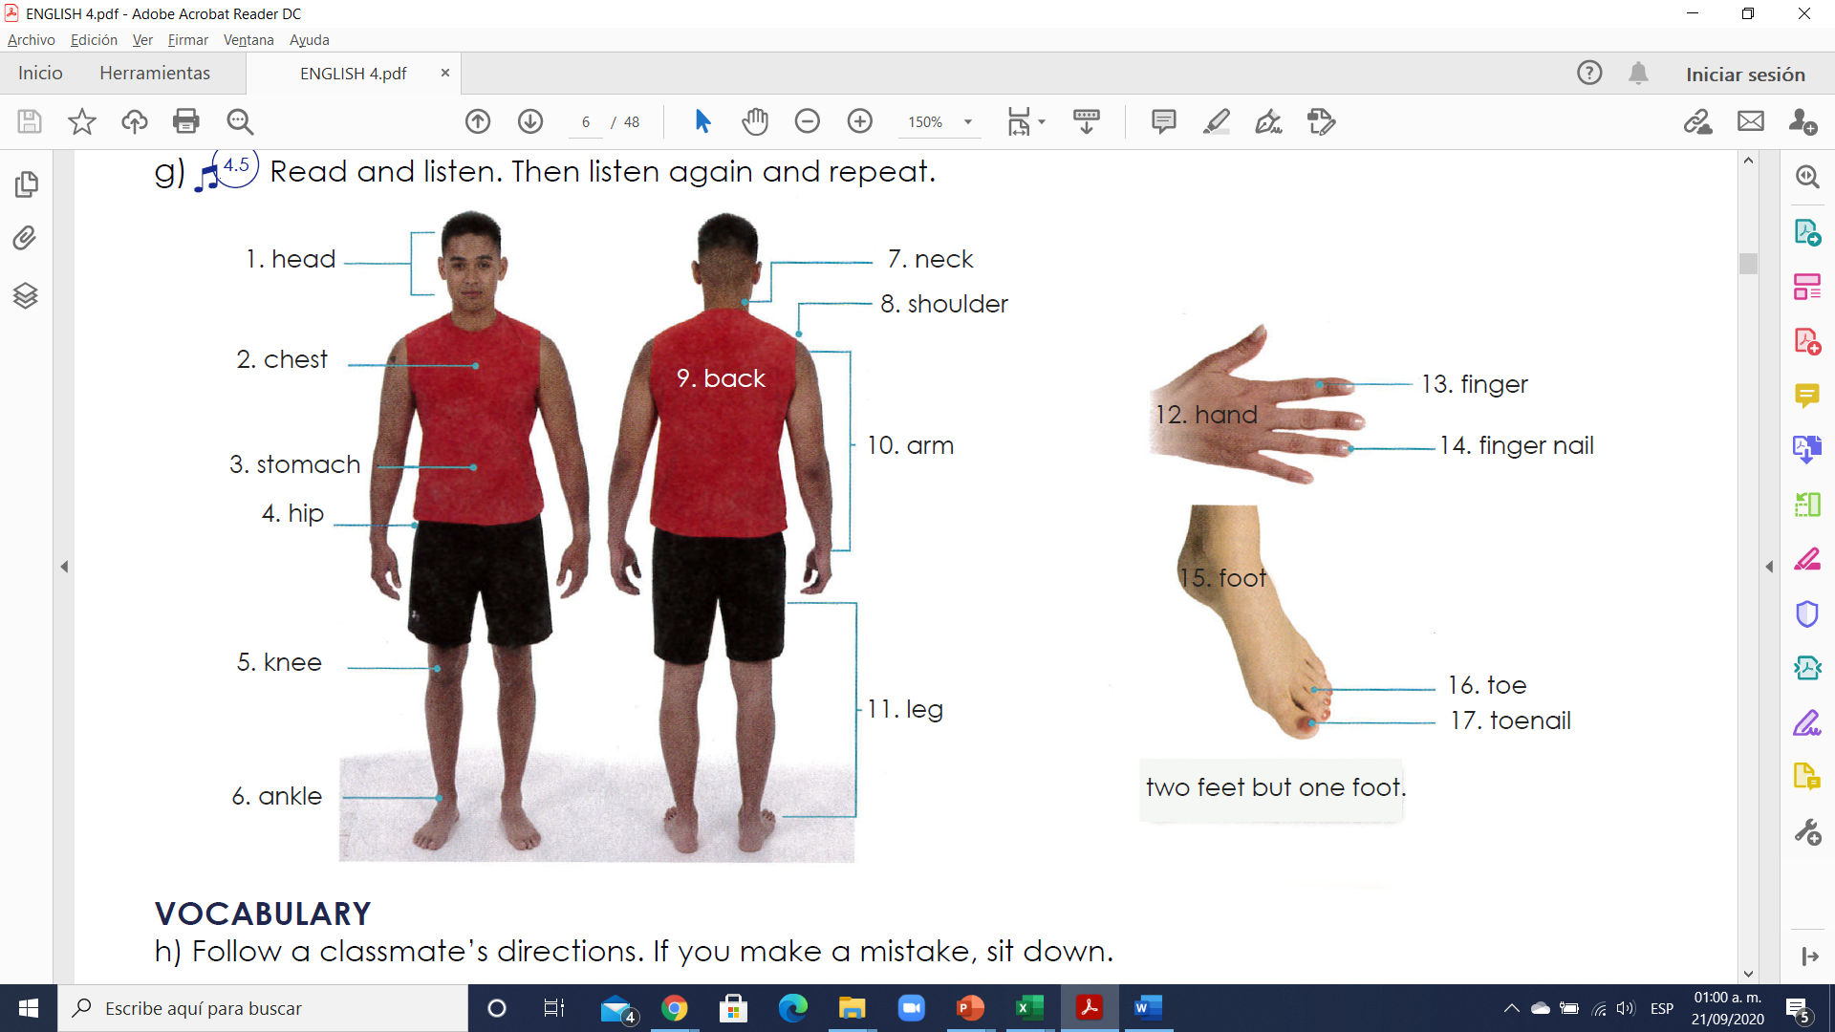

**Exercise 1.** Translate to Spanish the vocabulary above. Traduce al español el vocabulario de arriba.

1. cabeza 10. Brazos

2. pecho 11. Piernas

3. estomago 12. Manos

4. cadera 13. Dedo

5. rodillas 14. Uña del dedo

6. tobillos 15. Pie

7. cuello 16. Dedo del pie

8. hombros 17. Uña del pie

9. espalda

**VOCABULARY -Ailments (Enfermedades/Dolores)**

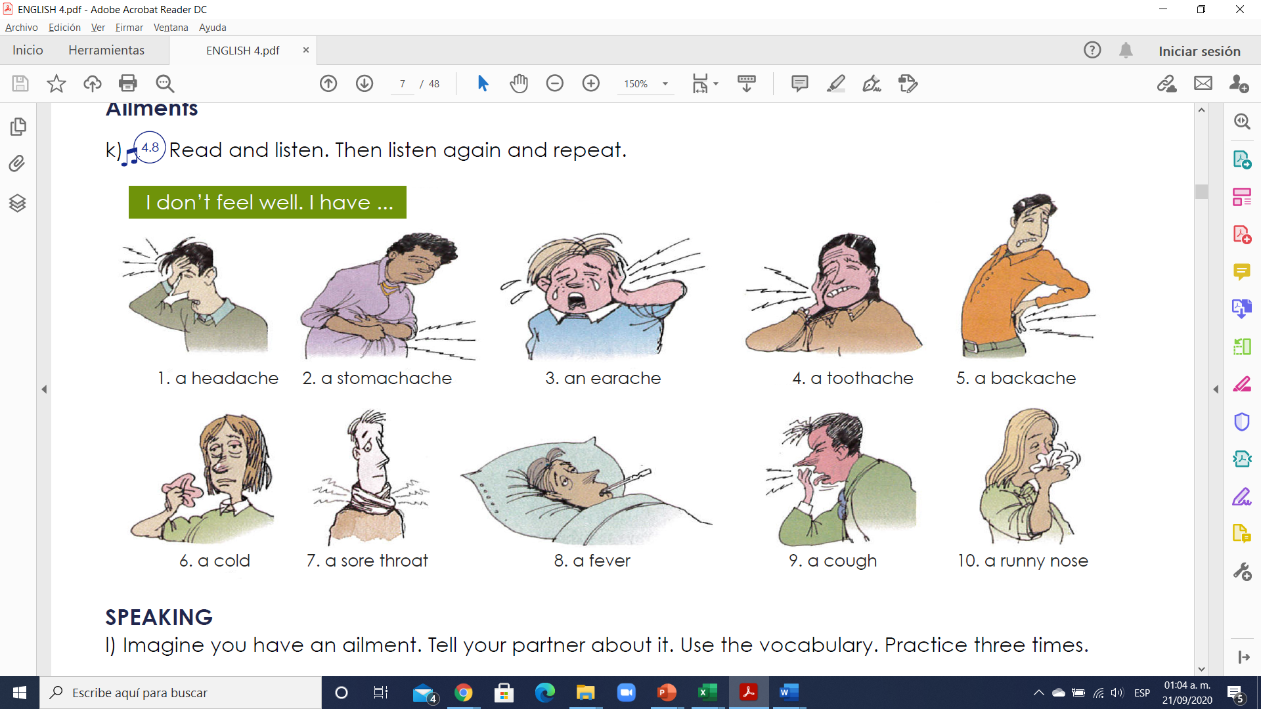

**Exercise 2.** Translate to Spanish the vocabulary above. Traduce al español el vocabulario de arriba.

1. dolor de cabeza 6. Resfriado

2. dolor de estomago 7. Dolor de garganta

3. dolor de oído 8. Fiebre

4. dolor de diente 9. A cough

5. dolor de espalda 10. Escurrimiento nasal

**VOCABULARY - Remedies**

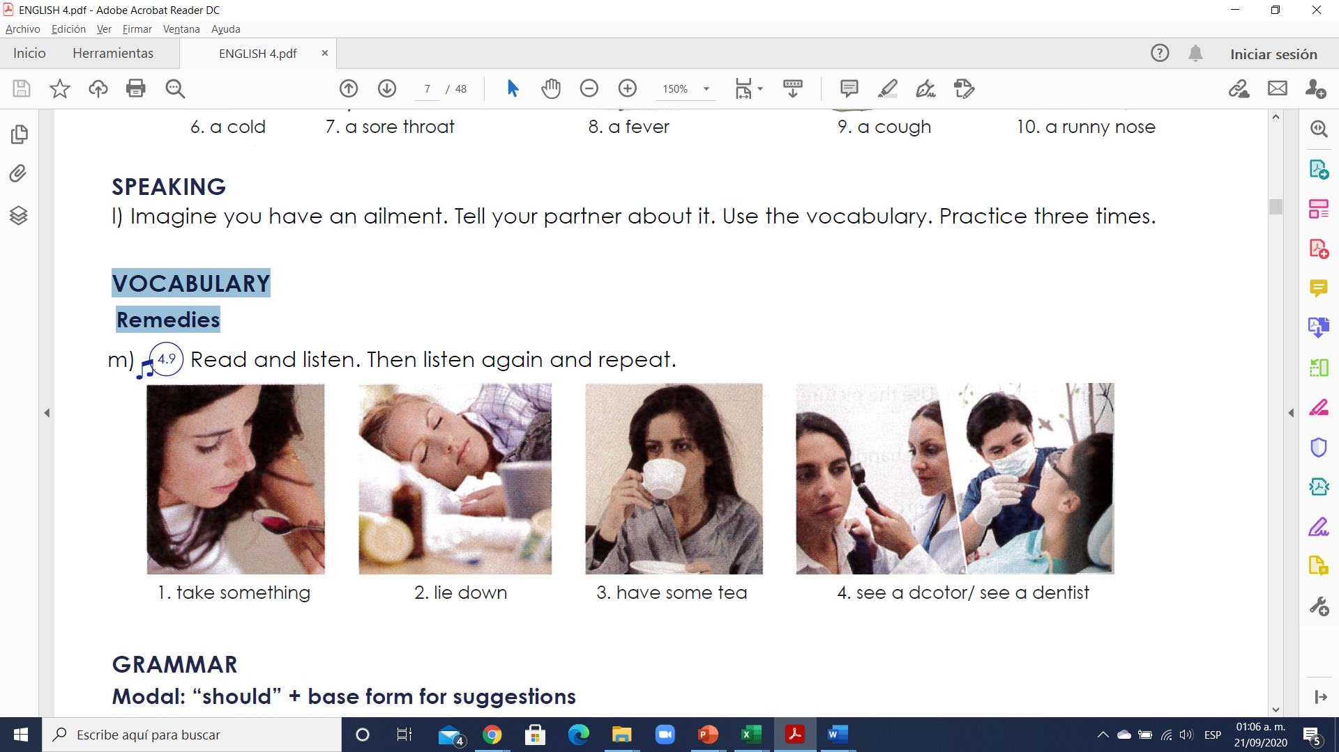

1.Toma algo.

2. Recuéstate.

3. Toma un té.

4. Ve un doctor / ve un dentista.

**Exercise 3. Escribe 8 oraciones usando el vocabulario de arriba**

Example: I have a cold; I should see a doctor.

1. she has a headache, take a something

2. I have a fever, lie dawn

3. he has a cold, have a some tea

4. I have store, take some tea

5. I have a roatache, see a doctor

6. he has a fever, lie down

7. she has a cough, take something

8. I have meucles, lie down

**GRAMMAR - Modal: “should” + base form for suggestions**

Should: deber

Shouldn’t: no deber

Should not: no deber

**Usos**

1. **Dar consejos** (**give advice**); ejemplo:

-I think you should go to the doctor. (Creo que debes ir al médico)

-You shouldn’t drink alcohol. (No deberías beber alcohol)

2. **Mostrar obligación** o deber (obligation or duty) para decir qué el lo correcto

–You should wear a helmet when riding a motorcycle. (Usted debe usar un casco cuando conduzca una motocicleta)

-You shouldn’t smoke in here. (No deberías fumar aquí)

3. **Mostrar probabilidad o expectativa** (probability or expectation)

-They should be here soon. (Deberían esta aquí pronto)

-I believe 200 dollars should be enough for the trip. (Creo que 200 dólares deberían ser suficientes para el viaje)

**Estructura**

**a) Affirmative:** después de SHOULD el verbo no debe tener TO, sólo la forma base.

He should call an ambulance right now. (El debería llamar una ambulancia ahora mismo)

**b) Negative:** la forma sin es contracción es **SHOULD NOT** y con contracción es **SHOULDN’T**; ambas formas son correctas.

-They shouldn’t cheat on the Spanish exam. (Ellos no deben hacer trampa en el examen de español)

-That soccer player should not dive all the time; it´s not fair play. (Ese jugador de futbol no debería fingir/echarse a la piscina todo el tiempo; no es juego limpio)

**c) Interrogative:** debemos usar SHOULD antes del SUJETO.

–Should I take a summer course at college? (¿Debo tomar un curso de verano en la universidad?)

-Yes, you should. (Sí) -No, you shouldn’t. (No)

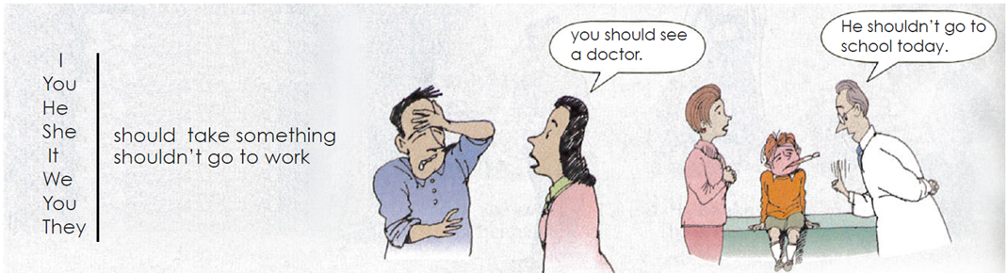

**Exercise 4.** Complete each sentence with **“should o shouldn´t”** and a verb form the box.

1. It’s your birthday. You should go out for dinner!

2. I’m sorry you have a toothache. You _____should _______________ **(see)** a dentist.

3. There’s a movie on TV tonight. We _____should _______________ **(watch)** it.

4. You have a cold? You ___should”t_________________ **(not exercise)** today.

5. We have tomatoes, potatoes, and onions. We ______should______________ **(make)** tomato potato soup for dinner tonight!

6. Pam’s taking a shower right now. You ______ should _______________ **(call)** back later.

7. Martin has a headache. He _____ should”t _______________ **(not play)** soccer tonight.

8. It’s time for bed. You _______ should ______________ **(get)** undressed.