**Unit Activity #1 – U1**

*Nombre del Alumno: Karla Julissa Morales Moreno*

*Nombre del tema: Unit 1*

*Parcial: Firts*

*Nombre de la Materia: English II*

*Nombre del profesor: Juan Manuel Jaime Díaz*

*Nombre de la Licenciatura: Enfermería*

*Cuatrimestre: Second*

*Lugar y Fecha de elaboración*

Comitán de Domínguez Chiapas a 15 de enero de 2024.

**DOES IT HAVE A VIEW?**

**Exercise 1.** Write the parts of the house (Escribe las partes de la casa)

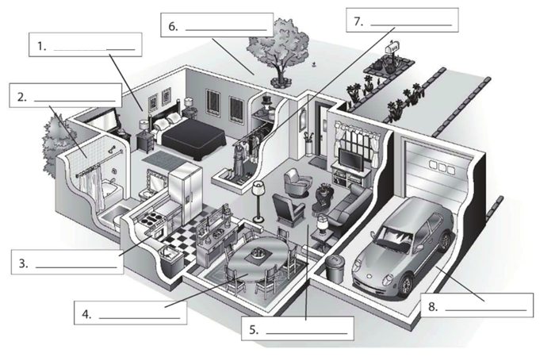

**Living room**

**Dining room**

**Garage**

**Kitchen**

**Bathroon**

**Closet**

**Yard**

**bedroom**

**Exercise 2.** Complete the conversation. Use the sentences in the box (Completa la conversación usa las oraciones de la caja)

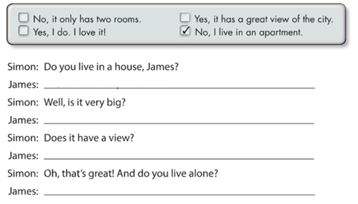

**Yes,it has a great view of the city**

**Yes, I do,I love it**

**No,It only has two rooms**

**No, I live in an apartment**

**Exercise 3.** Complete the conversation with the correct words in parenthese (Completa la conversación con las palabras correctas en parentesis)

**Live**

**Do**

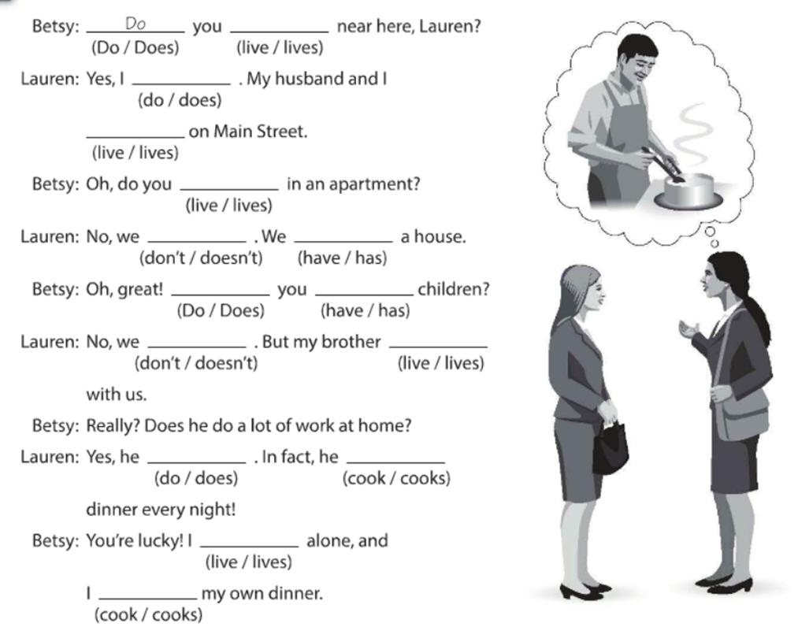

**Cooks**

**Cook**

**Lives**

**Live**

**Does**

**Don’t**

**Have**

**Do**

**Don’t**

**Have**

**Live**

**Live**

**Do**

**Exercise 4.** Answer these questions with your personal information Use short answers (Completa estas preguntas con tu información personal, usa respuestas cortas)

**Yes, I do or No, I don´t**

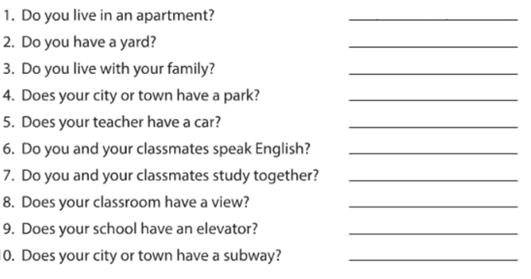

**Yes,It does**

**Yes,we do**

**Yes ,we do**

**No,It doesn’t**

**No,It doesn’t**

**Yes,he does**

**Yes,I do**

**Yes,I do**

**Yes ,I do**

**Exercise 5.** Answer these questions about the pictures. (Responde las preguntas de acuerdo a la imagen)

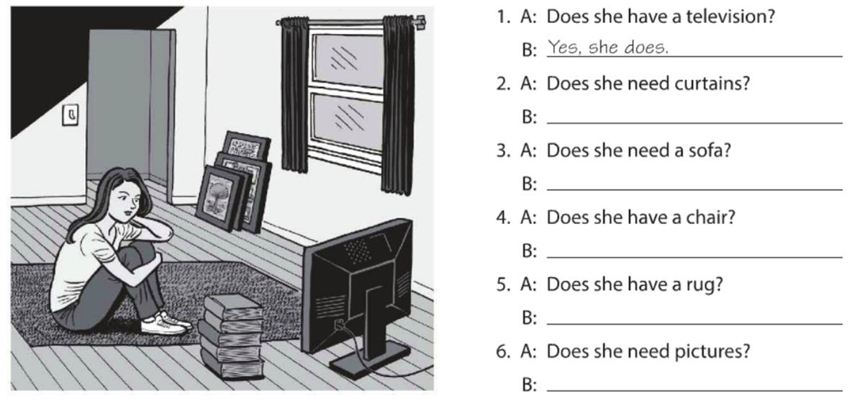

**Yes, she does**

**Yes, she does**

**No,she doesn’t**

**Yes, she does**

**No,she doesn’t**

**Yes, she does**

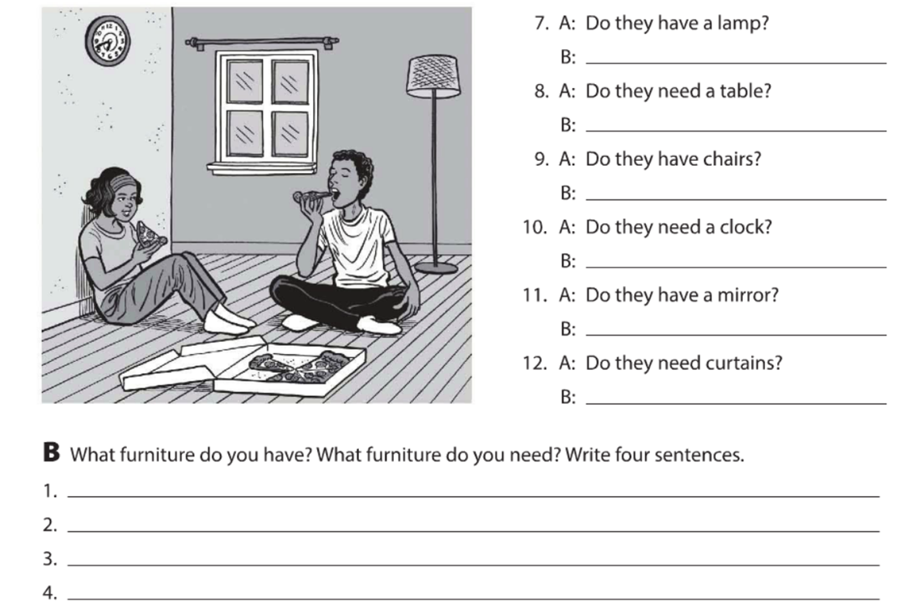

**I need lamps**

**Yes,they do**

**No,they don’t**

**No,they don’t**

**Yes,they do**

**Yes,they do**

**Yes,they do**

**I need desk**

**I have a picture**

**I have a TV.**

**Exercise 6.** Complete the description with “ ´s, are or aren´t ”. (Completa la descripción con “ ´s, are or aren´t ”)

**‘s**

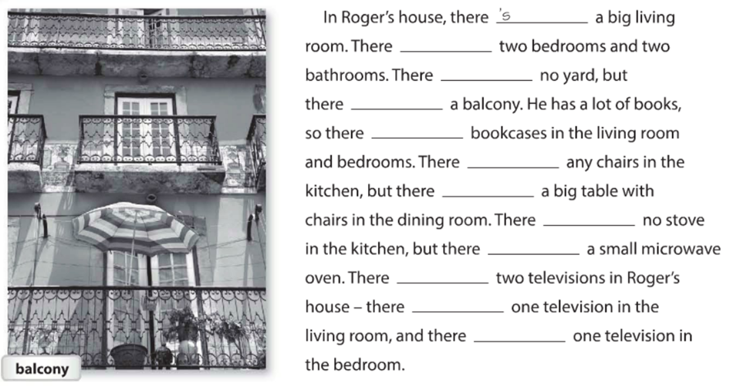

**Are**

**Are**

**Are**

**‘s**

**Are**

**Are**

**Aren’t**

**‘s**

**‘s**

**Are**

**Are**

**Exercise 7.** Answer these questions with information about your home. Use the phases in the box. (Responde las preguntas con información acerca de tu casa, usa la información de la caja).

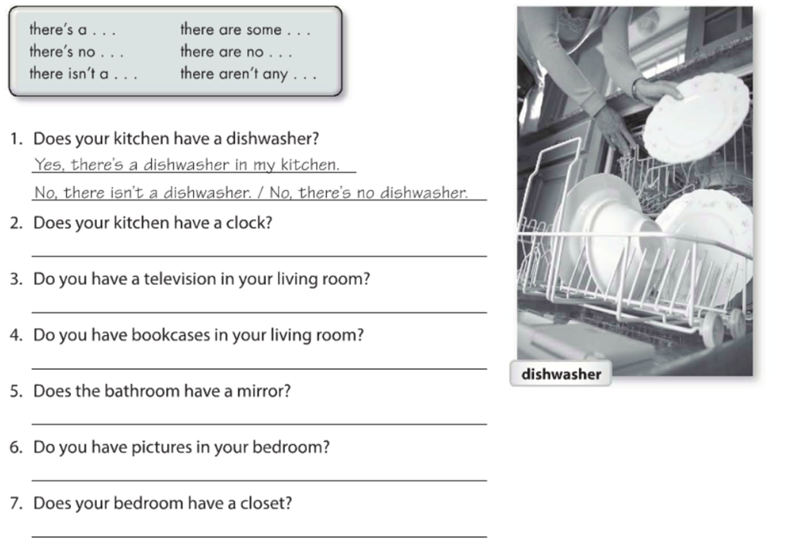

**Yes ,there’s a closet**

**No,there’s no**

**Yes,there’s a mirror**

**There’s no a bookcases**

**There’s a tv**

**There’s no clock**

**Exercise 8.** Write sentences about the house. Use “**there”** and the words in parentheses. (Escribe acerca de la casa, usa **“there”** y las palabras en parentesis).

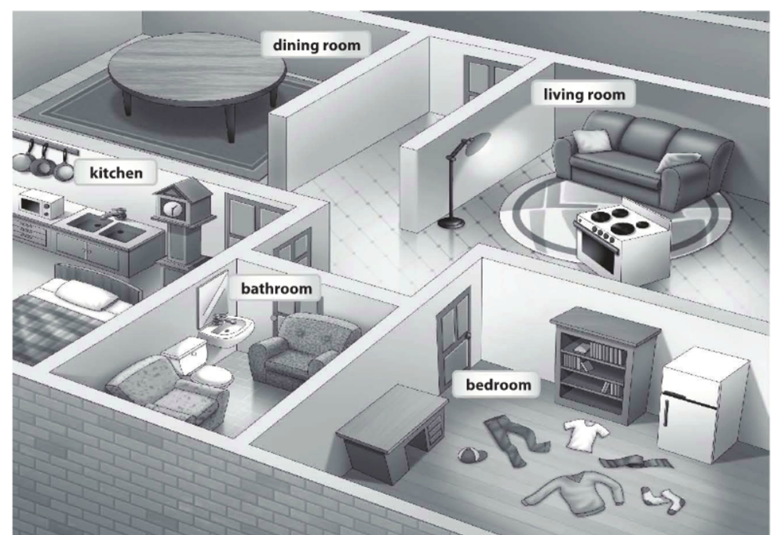

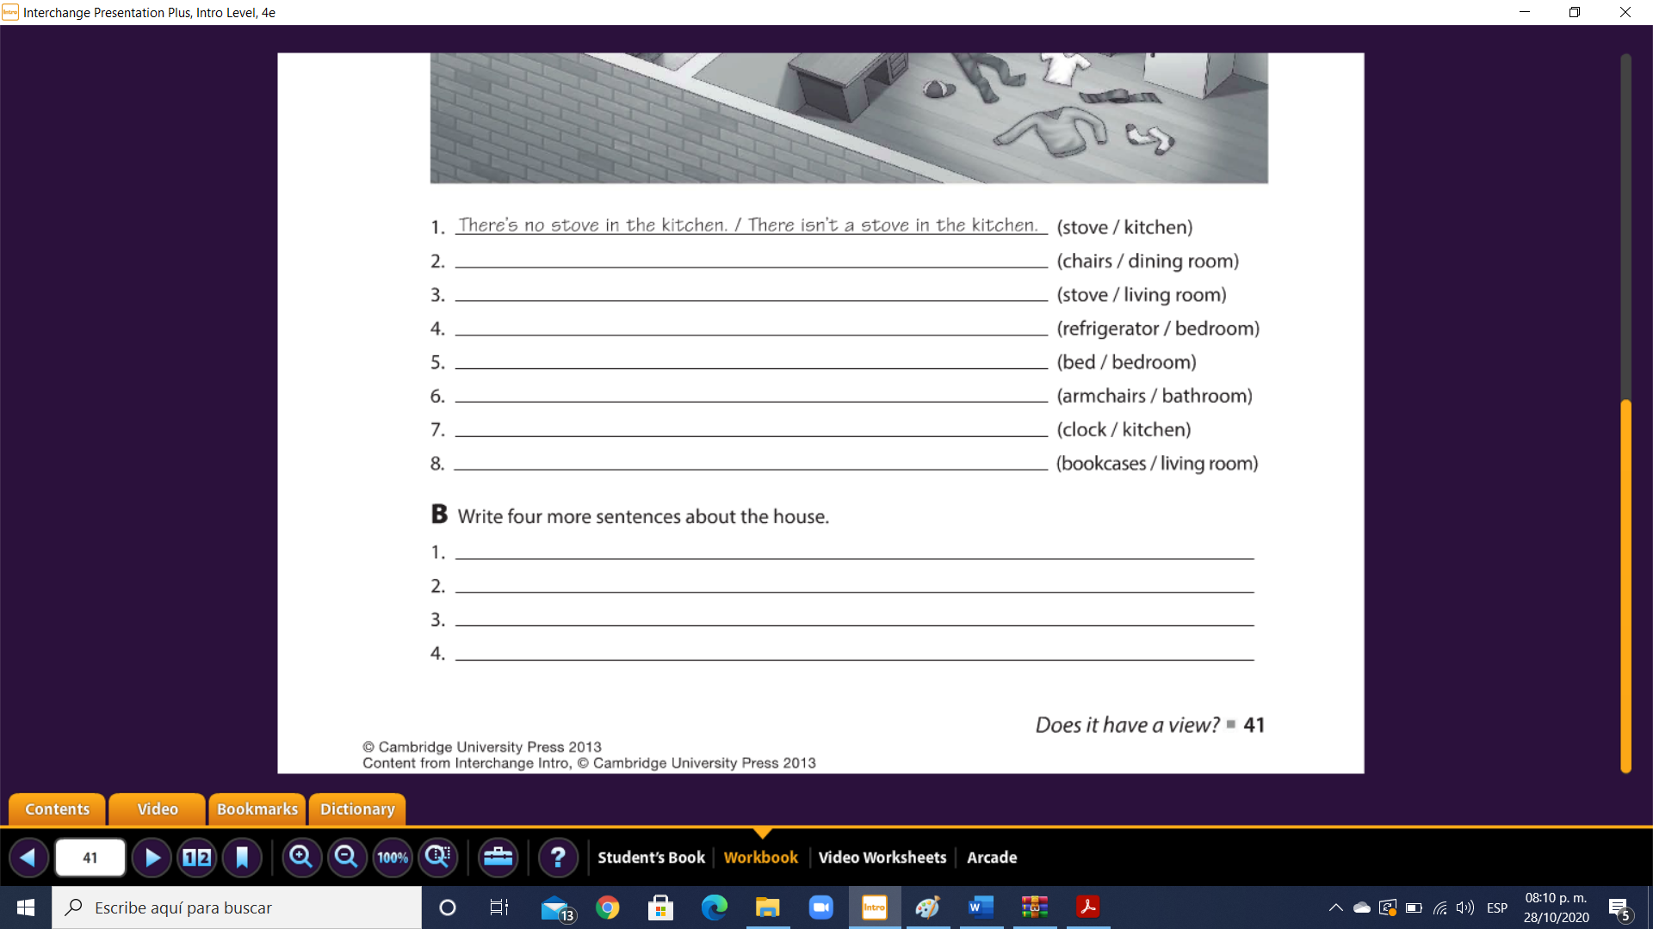

**There are cars in the garage**

**There’s no cat un the yard**

**There are beds in the house**

**There are dogs in my house**

**There’s no bookcases in the living room**

**There Is a clock in the kitchen**

**There Is a armchairs in the bathroom**

**There’s no bed in the bedroom**

**There Is a refrigerator in the bedroom**

**There Is a stove un the living room**

**There’s no chairs in ther dining room**

**Exercise 9.** Chose the correct responses. (Escoge las respuestas correctas).

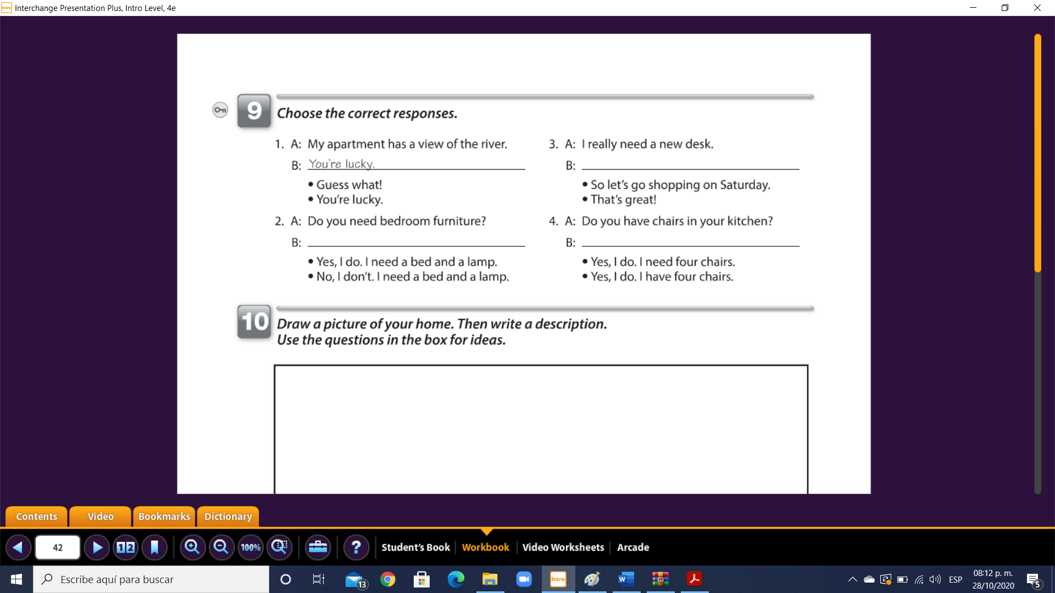

**Yes, I do. I hace four chairs**

**So let’s go shopping on saturday**

**No,I don’t. I need a bed AND a lamp**

**Exercise 10.** Reading comprehension (Lectura de comprensión).

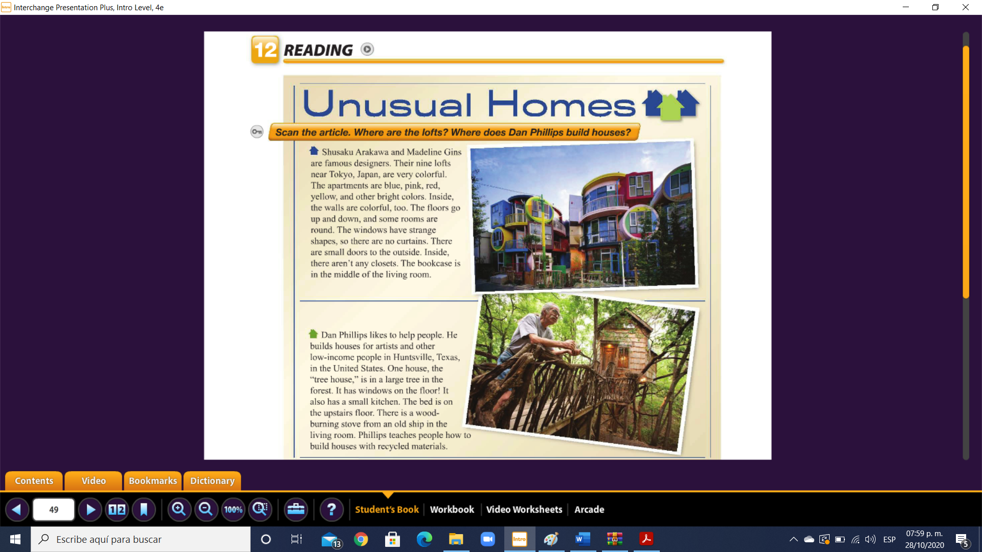

Complete the chart. (Completa la tabla).

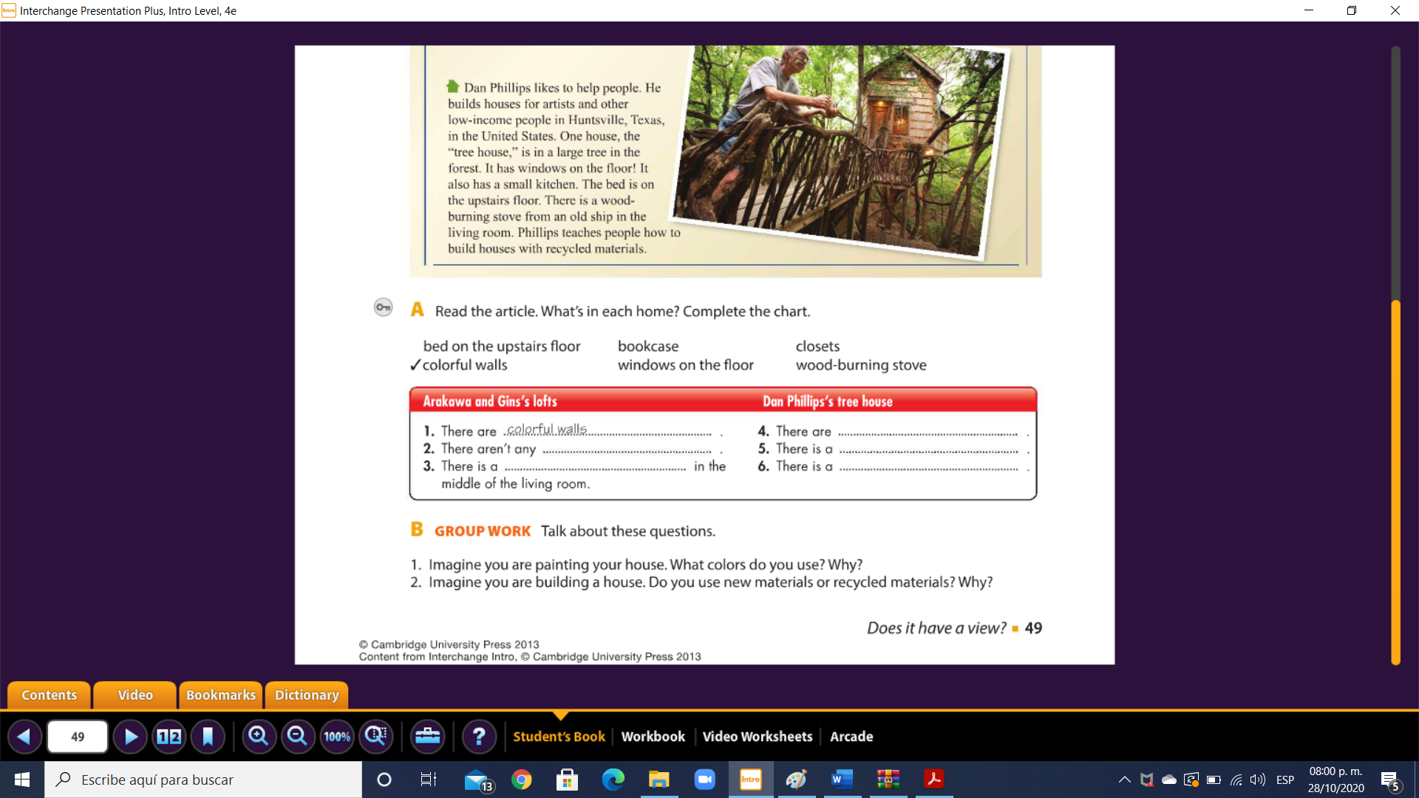

**Wooe- burning stove**

**Bed on the upstairs floor**

**Closets**

**Bookcase**

**Windows on te floor**