**Unit Activity #1 – U1**

*Nombre del Alumno: Valeria Montserrat Ramírez Ocampo*

*Nombre del tema: Unit 1*

*Parcial: Firts*

*Nombre de la Materia: English II*

*Nombre del profesor: Juan Manuel Jaime Díaz*

*Nombre de la Licenciatura: Licenciatura en enfermeria*

*Cuatrimestre: Second*

*Lugar y Fecha de elaboración*

Comitán de Domínguez Chiapas a 15 de enero de 2024.

**DOES IT HAVE A VIEW?**

**Exercise 1.** Write the parts of the house (Escribe las partes de la casa)

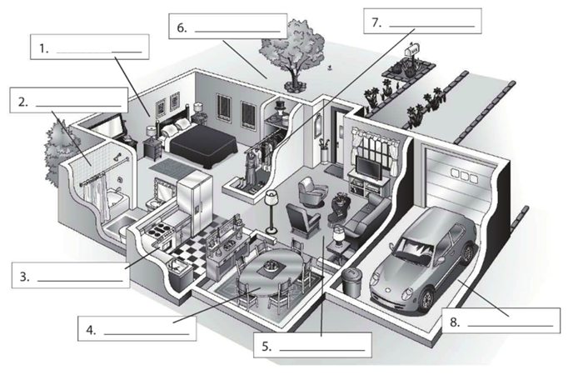

**Living room**

**Dining room**

**garage**

**kitchen**

**bqdroom**

**closet**

**rard**

**bedroom**

**Exercise 2.** Complete the conversation. Use the sentences in the box (Completa la conversación usa las oraciones de la caja)

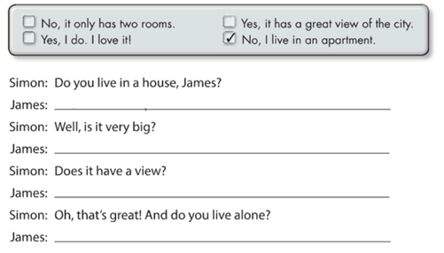

**Yes, it has a great view of the city**

**No, it only has two rooms**

**Yes, I do. I love it!**

**No, I live in an apartment**

**Exercise 3.** Complete the conversation with the correct words in parenthese (Completa la conversación con las palabras correctas en parentesis)

**live**

**Do**

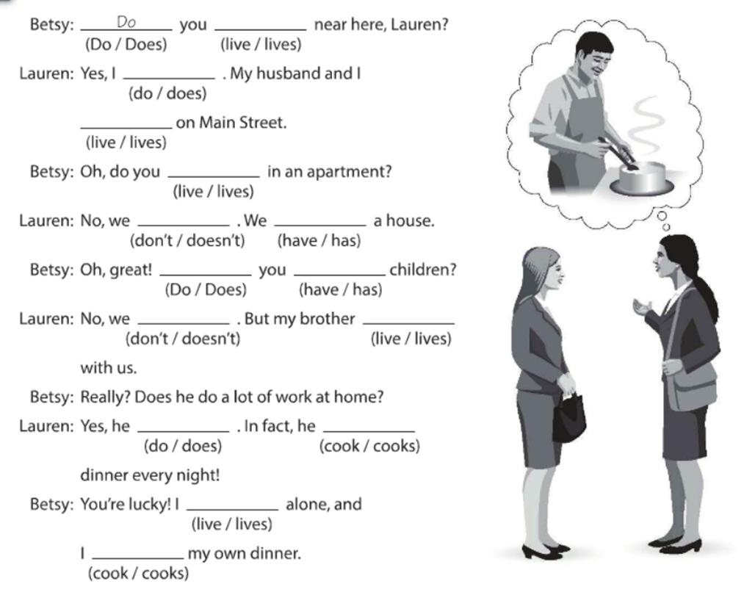

**Doesn´t**

**Doesn´t**

**cook**

**live**

**cook**

**does**

**lives**

**have**

**do**

**has**

**live**

**does**

**do**

**Exercise 4.** Answer these questions with your personal information Use short answers (Completa estas preguntas con tu información personal, usa respuestas cortas)

**Yes, I do or No, I don´t**

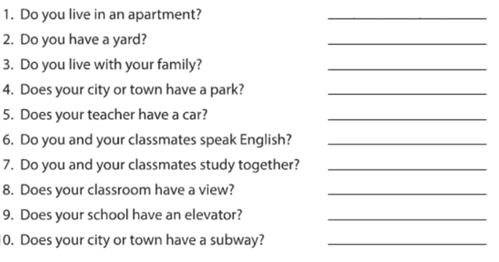

**Yes, it dosen´t**

**Yes, it dosen´t**

**Yes, it do**

**Yes, we do**

**Yes, we do**

**Yes, he does**

**Yes, it do**

**Yes, I do**

**No, I don´t**

**Exercise 5.** Answer these questions about the pictures. (Responde las preguntas de acuerdo a la imagen)

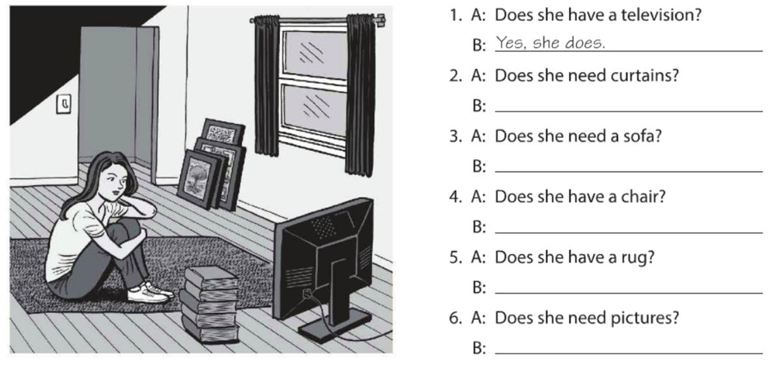

**No, she doesn´t**

**Yes, she does**

**no, she doesn´t**

**Yes, she does**

**No, she doesn´t**

**Yes, she does**

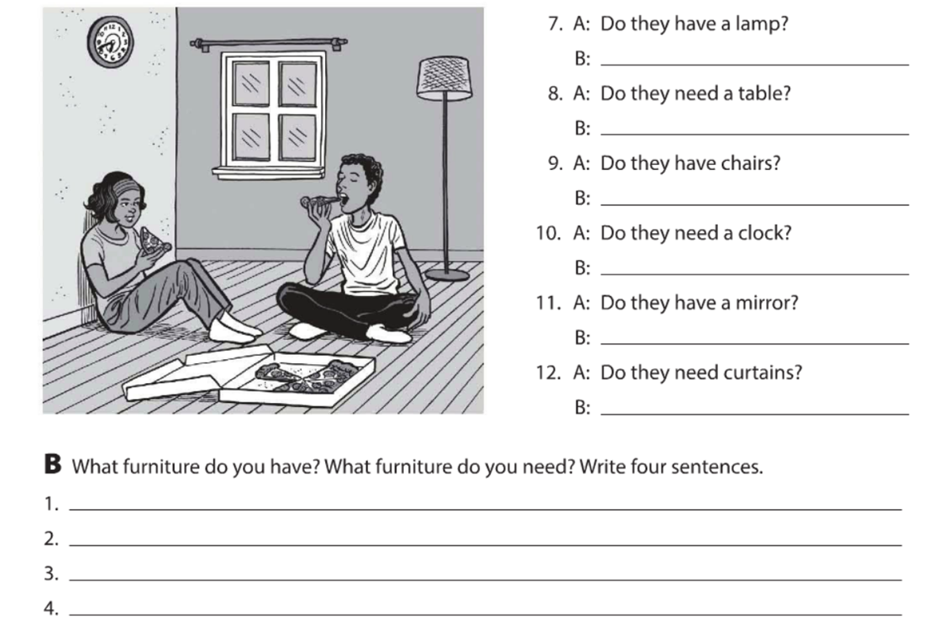

**I need pictures**

**I have a bed**

**I need a rug**

**I have a table**

**Yes, they do**

**No, they don´t**

**No , they don´t**

**No, they don´t**

**Yes, they do**

**Yes. They do**

**Exercise 6.** Complete the description with “ ´s, are or aren´t ”. (Completa la descripción con “ ´s, are or aren´t ”)

**‘s**

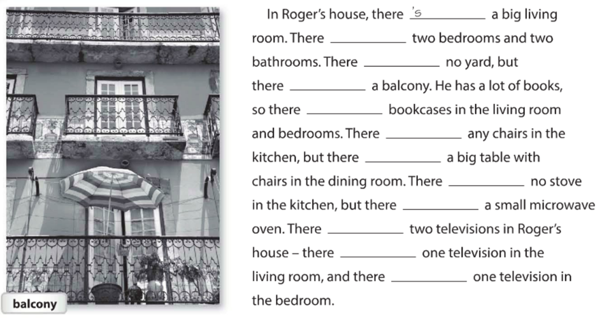

**t**

**t**

**s**

**t**

**t**

**t**

**s**

**s**

**t**

**t**

**s**

**Exercise 7.** Answer these questions with information about your home. Use the phases in the box. (Responde las preguntas con información acerca de tu casa, usa la información de la caja).

z

**Yes, there´s a closet**

**No, there aren´t any bookcases**

**No, there aren´t pictures**

**Yes, there´s a mirror**

**Yes, there´s a television**

**Yes, there´t a clok**

**Exercise 8.** Write sentences about the house. Use “**there”** and the words in parentheses. (Escribe acerca de la casa, usa **“there”** y las palabras en parentesis).

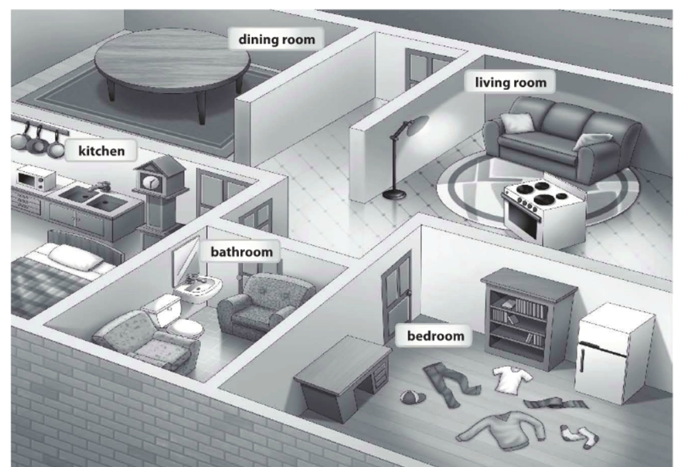

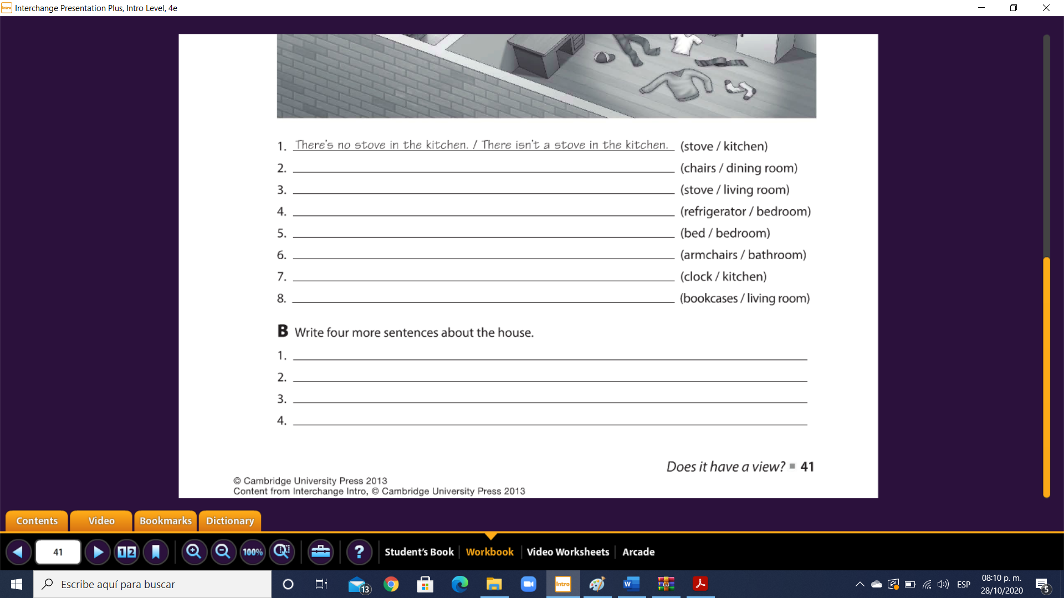

**There´s microwave oven in the kitchen**

**There are any curtains in the bedroom**

**There´s table in the dining room**

**There´s bed in the kitchen**

**There aren´t any bookscases in the living room**

**There are armchairs in the bathroom**

**There isn´t a bed in the bedroom**

**There´s clok in the kitchen**

**There´s refrigerator in the bedroom**

**There´s stove in the living room**

**There aren´t any chairs in the dining room**

**Exercise 9.** Chose the correct responses. (Escoge las respuestas correctas).

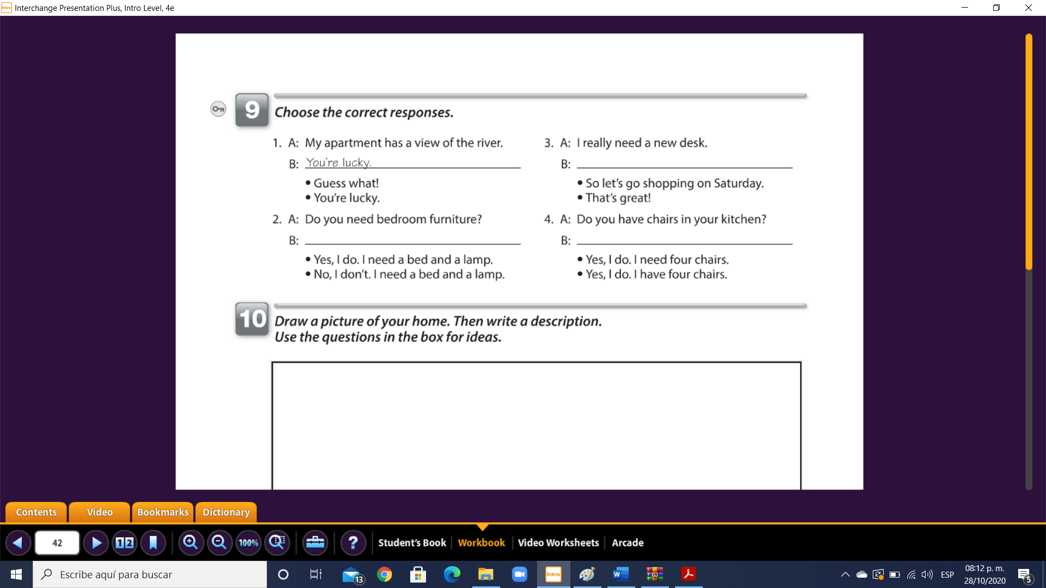

**No, I don´t . I need a bed and a lamp**

**Yes, I do. I have four chairs**

**So let´s go shopping on saturday**

**Exercise 10.** Reading comprehension (Lectura de comprensión).

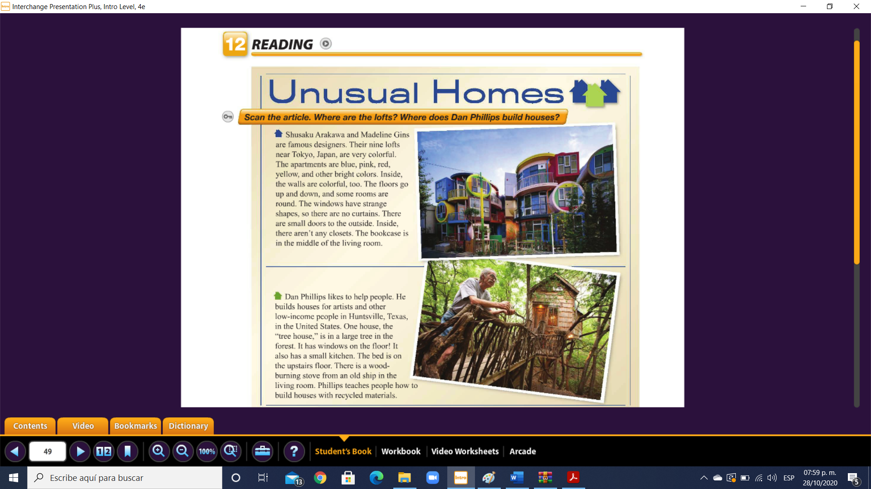

Complete the chart. (Completa la tabla).

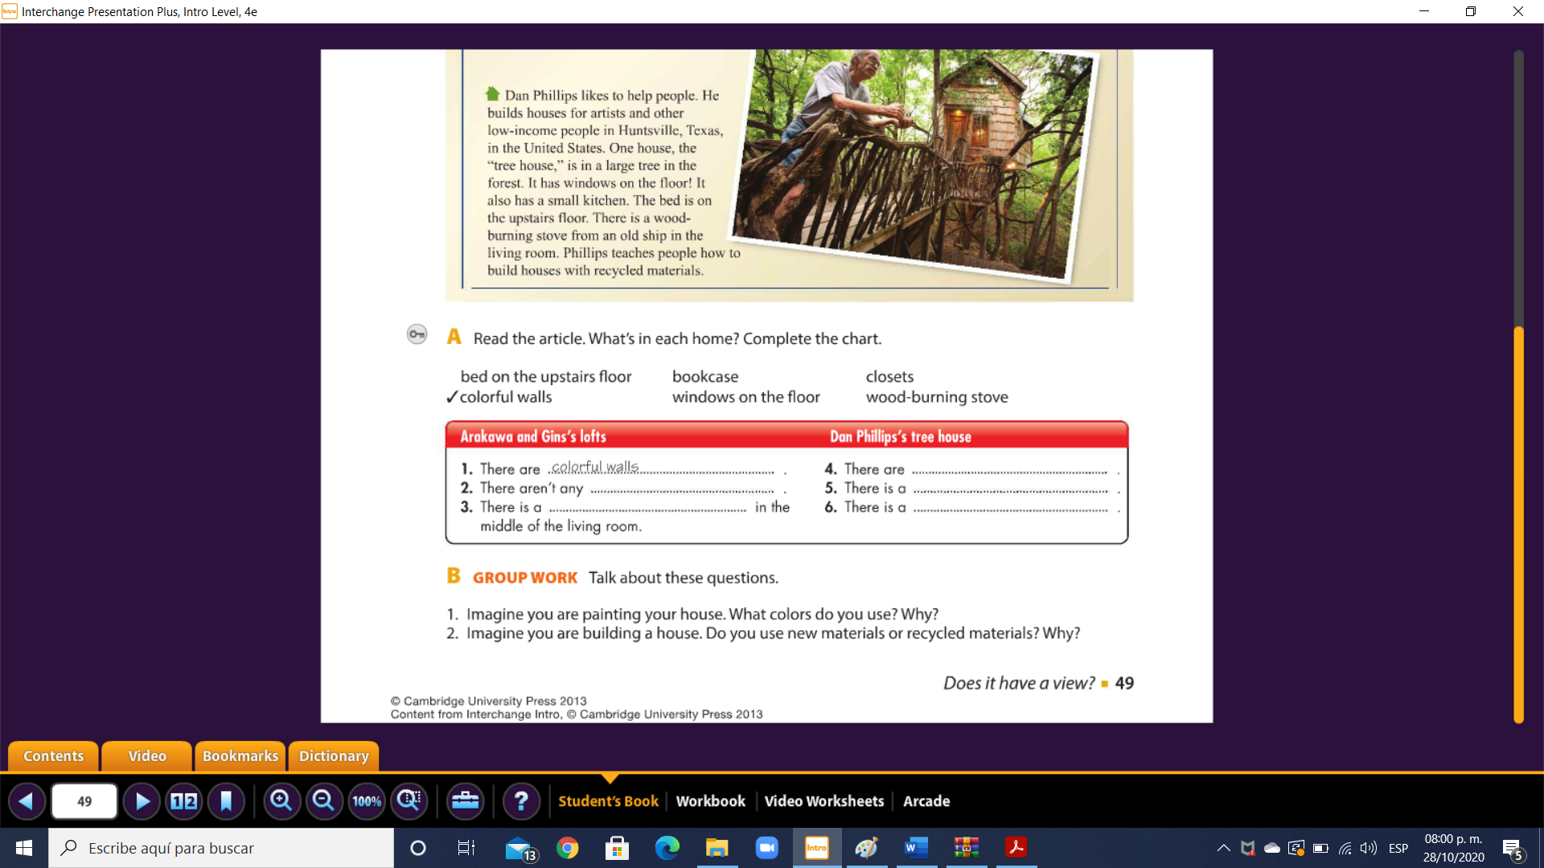

**Wood- burning stove**

**Windows on the floor**

**bookcase**

**Bed on the upstairs floor**

**closets**