

Nombre de la alumna: Claudia Sofia Chávez Laparra

Nombre de la materia: Ingles II

Cuatrimestre: II

Nombre de la licenciatura: Nutrición.

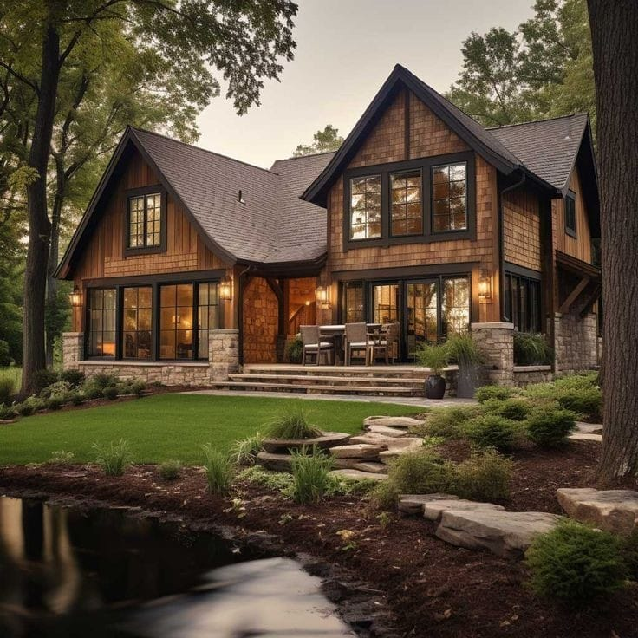**THE HOUSE OF MY DREAMS**.

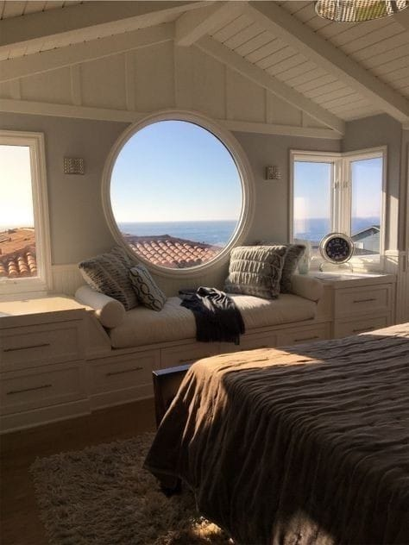For me, Ireally like the rustic and the fact of living in a field with a few animals. But Ialso like modern desings. So I would like to have a house that combines the two desings. I like big house that have big Windows and neutral colors on the outside like Brown, gray or black.

My house will have a front yard and a garaje in the back and there is two floors.

In the kitchen there are ligth colors such as White or besh. There is a breakfast room and the coupboard will be on the Wall and made of Wood.

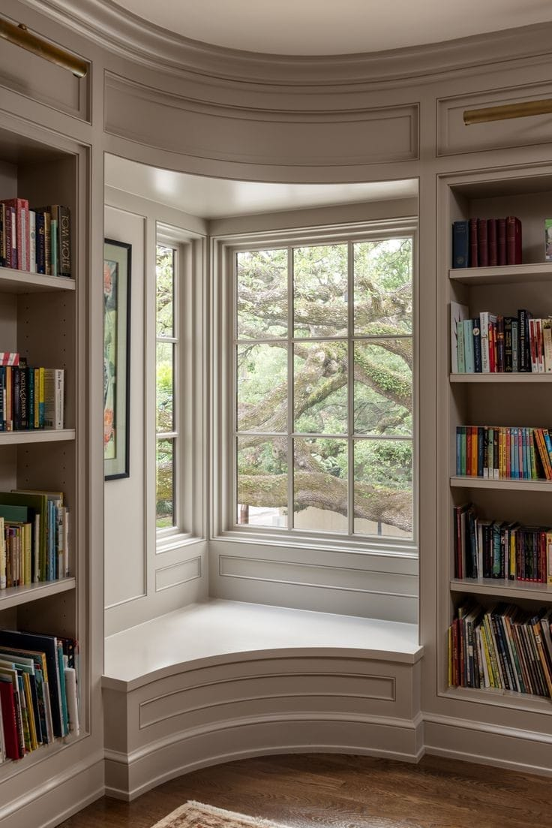In the bedroom there is a window with a view of the sky. There is a large bed and rigth there will have a closet and there is a bathroom.

The living room will be large and there are carpets with large, comfortable armchairs. There is a personal space where there are many books because I like to read.