

**Nombre de alumno: Daniel Antonio Ortiz Albores.**

**Nombre del profesor: Rafael Iván Guillen Alcalá .**

**Nombre del trabajo: Explicar la casa de mis sueños.**

**Materia: Ingles 2.**

**Grado: 2°**

**Grupo: A**

Comitán de Domínguez Chiapas a 21 de enero del 2024

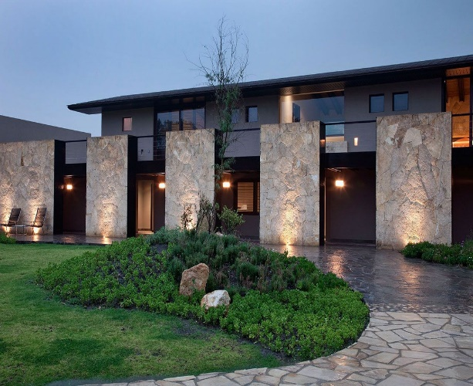House of my dream

My dream is to have this house with three apartments, inside the apartment there is a closet, and one of the rooms has a bathroom, there is mirror a room for visitors, a bathroom for visitors, a dining room with a cedar table and chairs, a room video game there is computer , a livin room in front of the house to cook roast beef, with several black windows, brown armchairs, with white curtains, paintings of sunset landscapes, behind the house a garage for a two-car entrance, in The second floor has the entire front part made of glass, the sides made of wooden finish, with lamps in the corners, next to the living room a garden with roses, tulips, orchids, there is frige