

**Nombre de alumno: Luis Ángel López Méndez.**

**Nombre del profesor: Rafael Iván Guillen Alcalá .**

**Nombre del trabajo: Explicar la casa de mis sueños.**

**Materia: Ingles 2.**

**Grado: 2°**

**Grupo: A**

Comitán de Domínguez Chiapas a 21 de enero del 2024

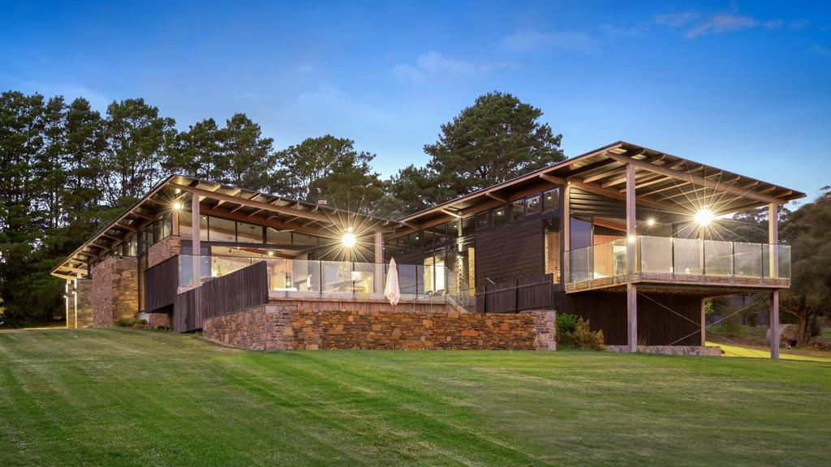I would like this type of house with three rooms, there is a room with two black windows, there are lamps with clear bulbs, there are paintings, there are also mirrors, a closet, there is another room with brown windows, there are mirrors and a closet, there is a dining room with windows large sun-shaped ones, there are also brown armchairs, there are paintings of beautiful landscapes, there is a garden with beautiful sunflower flowers, with a view of the landscape, there is a dining room with a glass table, there is a black stove and chairs black, there are blue curtains, there is a garage behind the house.