NOMBRE DE ALUMNA

NATASHA RASHEL VAZQUEZ HERNÁNDEZ

ASIGNATURA

INGLES

GRADO

NATASHA RASHEL VAZQUEZ HERNANDEZ

UDS

MI UNIVERSIDAD

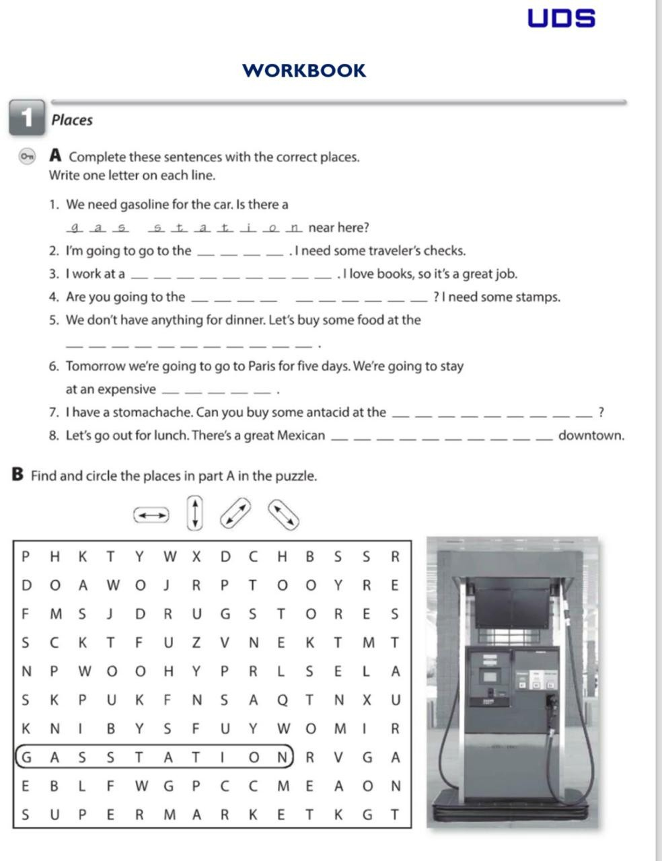

bank

Book store

Past oficce

Droos store

restaurant

hotel

Super market

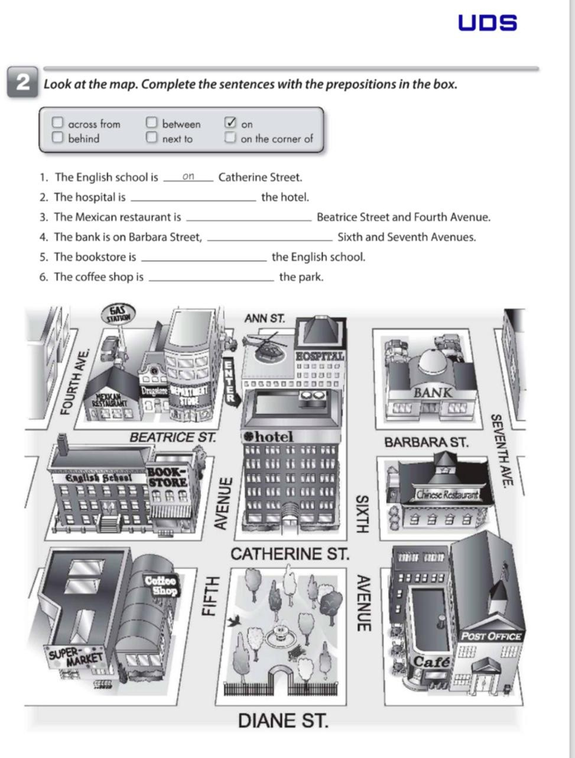

Between-on

On- next to

On the corner of

Next to

In front

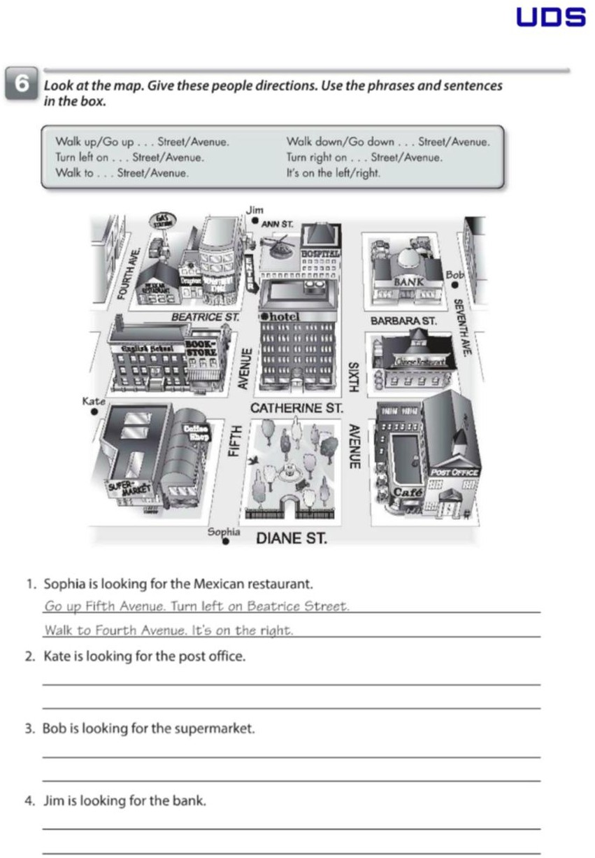

No, don´t it´ s on the right

No, don´ t go down go up

Main streel

no, don´t right turn left on