**HOJA DE PRESENTACION**

ANA NOHEMI LÓPEZ HERNÁNDEZ

López Jiménez Enrique Arturo

English 2

First Quarter

Rehearsal

April 06 /2024, Tapachula Chiapas

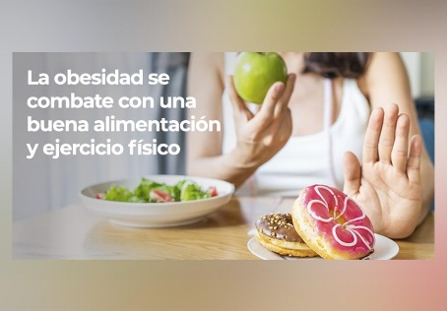

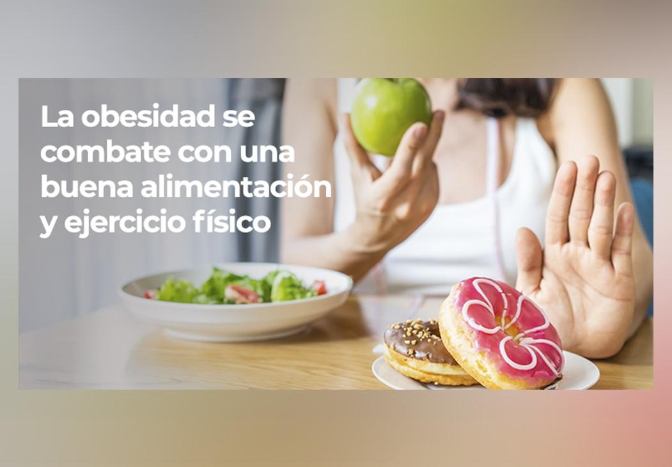

**To combat obesity it is necessary to follow a routine of healthy care throughout life.**

**01 -Learn to eat well and cook with pleasure**

**02-Say goodbye to a sedentary lifestyle and hello to active life**

**03- Sleep well and everything be necessary**

**04- Exclude alcohol from your life** **to combat obesity**

**05-Visit to the specialist**

**OBESE**

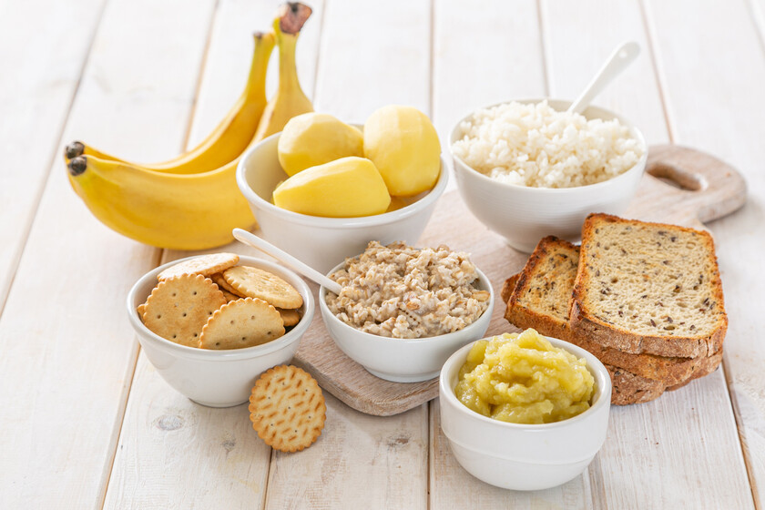

### **Do not contain irritants, spicy or excessive seasonings. Be moderate in fat use simple techniques food preparation (ooking, roasting, grilling, boiling, etc. Avoid fried foods very salty.**

**SOFT**

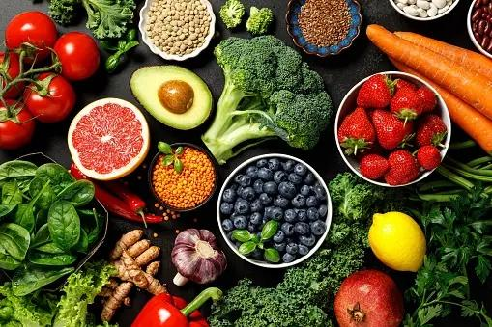

**In this type of diet you can get protein from chickpeas, beans, lentils, beans, green beans, beans, red beans, pints, soybeans and its derivatives.**

**VEGETARIAN**

**DIABETIC**

**"A kind of**

**diet: diabetic, vegetarian, soft, obese" (describir**

**Fruits and vegetables should be ½ of the plate, 1 serving of hours a day must be raw and other cooked ¼ of the plate should be food protein: meats lean, fish. Eggs and legumes ¼ of the plate should be carbohydrates carbon. Better integral and euitando cookies, pastries and others rich in sugars take 3 pieces of fruit a day, one of them citrus.**

### **¼ of the plate should be food protein: meats lean, fish. Eggs and legumes**

**¼ of the plate should be carbohydrates carbon. Better Integral and euitando cookies, pastries and others rich in sugars**

