**Super note**

***Student´s name:*** *Alondra Paola Ovando Rodríguez*

***Topic:*** *My house has*

***Partial:*** *1*

***Subject:*** *English II*

***Teacher´s name:*** *Alejandra Vidal Escandón*

***Degree:*** *2nd**Module*

***Quarter:*** *2nd grade*

*Pichucalco, Chiapas; February 29th, 2024.*

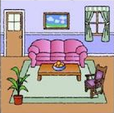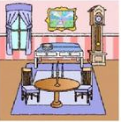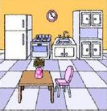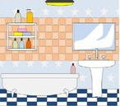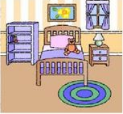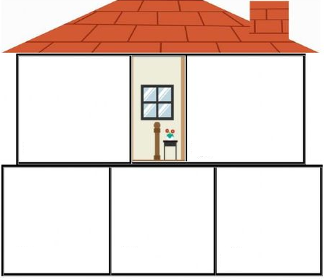

**STOVE**

**DISHWASHER**

**CUPBOARD**

**FRIDGE**

**VASE**

**AROMATIC CANDLE**

**TV**

**CLOCK**

**FURNITURE**

**TABLE**

**FLOWER POT**

**CENTER TABLE**

**PORTRAIT**

**CHAIR**

**COUCH**

**KITCHEN**

**DINING ROOM**

**HALL**

**SHAMPOO**

**SPONGE**

**SINK**

**MIRROR**

**BATHTUB**

**BATHROOM**

**TOY PLAYER**

**LAMP**

**RUG**

**TEDDY**

**CAMA**

**BEDROOM**

**My House Has**