

Nombre Del Alumno: Yazuri Guadalupe Álvarez García

Nombre Del Tema: Sistemas Y Componentes

Nombre De La Materia: Inglés

Nombre del Maestro: Ignacio Javier S. Sossa

Licenciatura: Enfermería

Cuatrimestre: 2°

Elaboración: Pichucalco Chiapas ; Sábado 10 de enero del 2024

**SKELETAL SYSTEM**

The skeleton is a dynamic estructure, made up of bones. Each bone is an organ since is made up of various tissues: bone, cartilaginous, dense connective, epithelial, others, that generate blodd, adipose and nervous.

**Functions of the skeletal system**

1. Support: bones are the support of soft tissues, and the fulcrum of most skeletal muscles.
2. Protection: the bones protector the internal organs, for example the skull protects the brain, rib cage todo heart and lungs.
3. Movements: in conjunction with the muscles
4. Mineral homeostasis: Bone tissue stores calcium and phosphorus to give resistance todo the bones, and also releases them into the blood to keep their concentration in balance.
5. Production: of blood cells: in the red bone marrow ( specialized connective tissue) hemopoiesis occurs to produce red blood cells, white blood cells, and platelets.
6. Triglyceride storage: red bone marrow is gradually replaced in adults by yellow bone marrow, which contains adipocytes.

**Bone structure**

Bones are classifed into various types according to their shape. A long bone ( such as the femur or humerus) consists of the following parts:

1. **Diaphysis**: it is the body or main cylindrical portion of the bone.
2. **Epiphysis**: are the proximal and distal ends of the bone
3. **Metaphysis**: it is the site of union of the diaphysis with the epiphysis; Its thickness decreases with age.
4. **Articulo cartilage**: It is a thin layer of hyaline cartilage that covers the part of the epiphysis of a bone that articulates with another bone.
5. **Periosteum:** It is a resistant layer of dense connective tissue that surrounds the bone surface that does not have articular cartilage. It protects the bone, participantes in the repair of fractures, collaborates in the nutrition of the bone.
6. **Medullary cavity:** it is the internal space of the diaphysis that contains the bone marrow fat yellow.
7. **Endosteum:** it is the layer that lines the medullary cavity, and contains bone-forming cells.

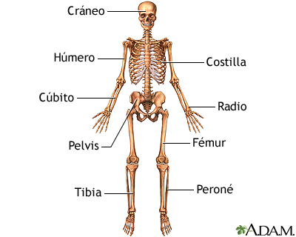

**NERVOUS SYSTEM**

The nervous system has two main parts:

•The central nervous system is made up of the brain and espinal córdoba.

•The peripheral nervous system is made up of all the nerves that branch from the spinal cord and extend to all parts of the body.

The nervous system transmits signals between the brain and the rest of the body, including internal organs.

In this way, nervous system activity controls the ability todo move, breathe, see,think, and more.

The Basic unit of the nervous system is a cell nerve, or neuron. The human brain contains about of 100 billion neurons.

The nervous system also includes non-neuronal cells, called glial cells. Glial cells, perform many important functions that keep the nervous system functioning properly for example, the glial:

• They help support and keep neurons in place.

•They protect neurons.

• They create insulation called myelin, which helps move nerve impulses.

• They repair neurons and help restore neuronal function.

• They trim dead neurons.

• They regulate neurotransmitters.

**¿ What controls the nervous system?**

The nervous system controls the many complicated interconnected functions of the body and mind. Motor, cognitive, sensory, and autonomic functions are all coordinated and directed by the brain and nerves.

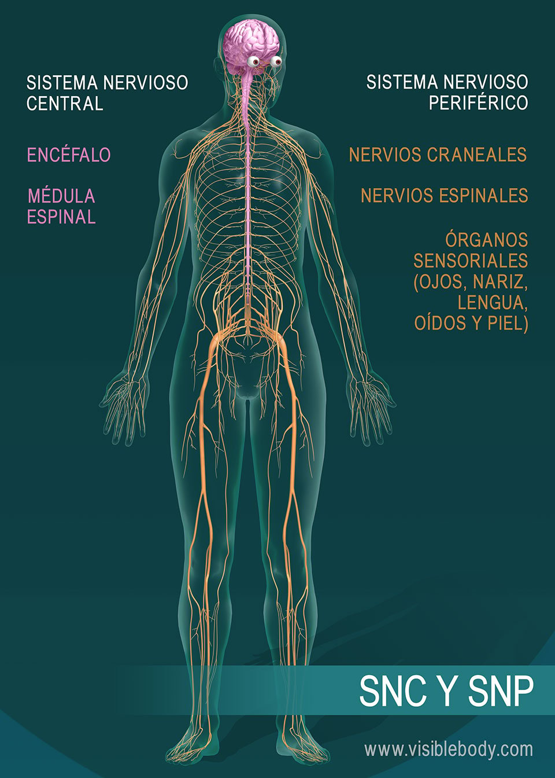

**CARDIOVASCULAR SYSTEM**

**What is the cardiovascular system and what is its function?**

The cardiovascular system is made up of the heart and blood vessels: a network of veins, arteries and capillaries that supply oxygen from the lungs to tissues throughout the body through blood thanks to the pumping of the heart. Another fiction of the cardiovascular system is also to transport carbon dioxide, a waste product, from throughout the body to the heart and lungs to finally eliminate the carbon dioxide through breathing.

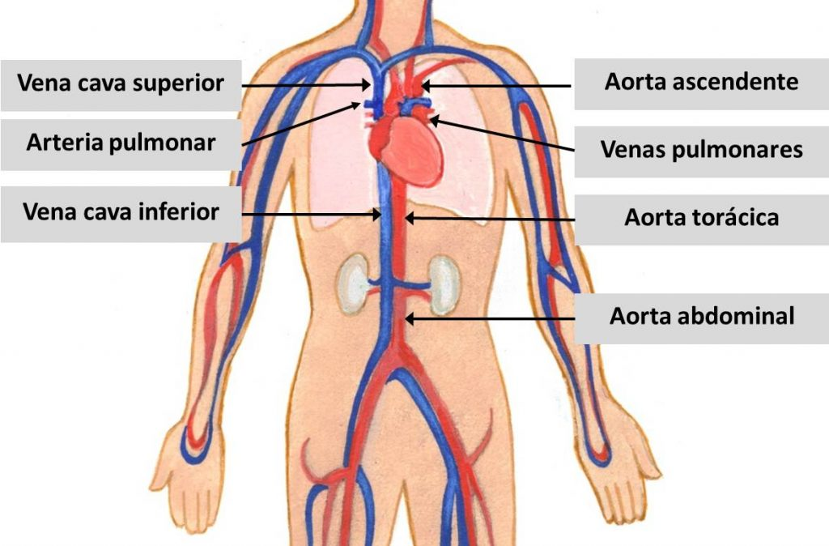

**HOW IS THE CARDIOVASCULAR SYSTEM FORMED?**

The cardiovascular system is made up of:

•The heart-is the muscular pump that provides the energy todo move blood through the blood vessels

•Blood vessels-are the arteries, veins and capillaries ( small blood vessels) that make up the system of elastic tubes in our body through which blood circulates

•Blood-is the liquid content or tissue that circulates through the vessels. The main components of blood are oxygen and nutrients, which are transported to the tissues in addition todo waste that the body no longer needs and which is also transported through the vascular system.

**How is the cardiovascular system divide?**

From an anatomical point of view, the circulatory system is divided into a major or systemic circuit and a minor or pulmonar circuit; both originate in the heart and consist of blood vessels that lead to the entire body and the lungs , respectively.

**RESPIRATORY SYSTEM**

**Set of organs that participate in respiration; includes the nose, throat, larynx, trachea,bronchi,and lungs. Also called respiratory tract.**

The respiratory system is made up of the airways and the lungs. Through the airways, air circulates towards the lungs and it is in these organs where gas exchange takes place.

In the airways we differentiate the upper airway, which goes from the nose and mouth to the vocal cords. And the lower airway, formed by the trachea, the bronchi and their branches inside of the lungs, the bronchioles.

The trachea is the tube that goes from the larynx to the main bronchi. These, in turn, penetrate the inferior of each lung and divide into smaller branches ( bronchioles). Finally, as they enter the lungs, they end up in bags or sacs called alveoli.

In the walls of the trachea and the thickest bronchi there are severa layers that from the outside in are the cartilage, which gives it structure and consistency, a muscular layer and an innermost covering, which is the mucosa.

**Función**

The basic function of the respiratory system is breathing.

It consists of bringing oxygen from the air to the blood anda eliminating carbon dioxide (CO²) from the air. This gas exchange occurs inside the lungs.

Air enters through the nose and/or mouth and is conducted through the respiratory tract to the alveoli, where gas exchange occurs. Thus, oxygen passes into the blood and is ported to all cells. In turn, the anhydride they only thing (CO²) produced in cells is carried to the lungs for elimination.

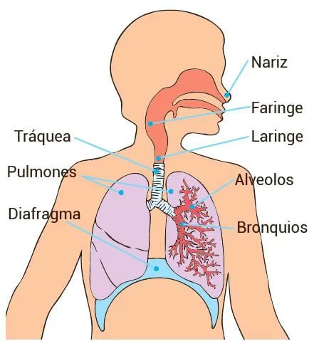

**DIGESTIVE SYSTEM**

The digestive system is made-up of the gastrointestinal tract, also called the digestive tract, and the liver, páncreas, and gallblader. The tract.

Gastrointestinal is a series of hollow organs joined together in a long, twisted tube that runs from the mouth to the anus.

The hollow organs that make up the gastrointestinal tract are the mouth, esphagus, stomach, small intestine, large intestine, and anus. The liver, páncreas and gallblader are the solid organs of the digestive system.

The small intestine has three parts. The first part is called the duodenum. The jejunum is in the middle and the ileum is at the end.

The large instestine includes the appendix, cecum, colon, and rectum. The cecum is the first part of the large intestine. The colon is next. The rectum is the end of the large intestine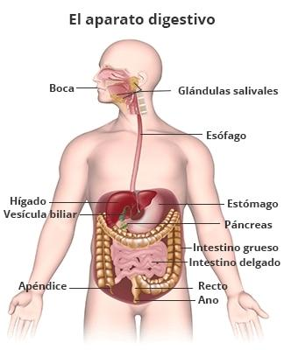

**THE PARTS OF THE DIGESTIVE SYSTEM ARE THE**

Mouth, pharynx ( throat), esophagus, stomach, small intestine, large intestine, rectum, and anus

**HOW DOES THE DIGESTIVE SYSTEM WORK?**

Each part of the digestive system helps transport food and liquids through the gastrointestinal tract, chemically break down foods and liquids into smaller pats or both.

**MUSCULAR SYSTEM**

The muscular system is a set of miscles that can be controlled voluntarily by a living organism.

In most texts it is considered that the muscular system is made up of voluntary muscles. The rest of the muscles, wich include smooth muscle and cardiac muscle, which include smooth muscle and cardiac muscle, are integrated into other systems because they have very different functions.

For example, the cardiac muscle is included within the cardiovascular system and the muscles oficial the bronchial wall within the respiratory system.

The articles that should be consulted for the description of all muscles, both voluntary and involuntary, are :

Muscle and muscle tissue. Its main function is to achieve mobility, an action that tales place when electrice stimuli from the nervous system cause contraction of muscle fibers.

Auntomatically contracting muscles such as heart muscle or smooth muscle are not usually considered part of the muscular system.

