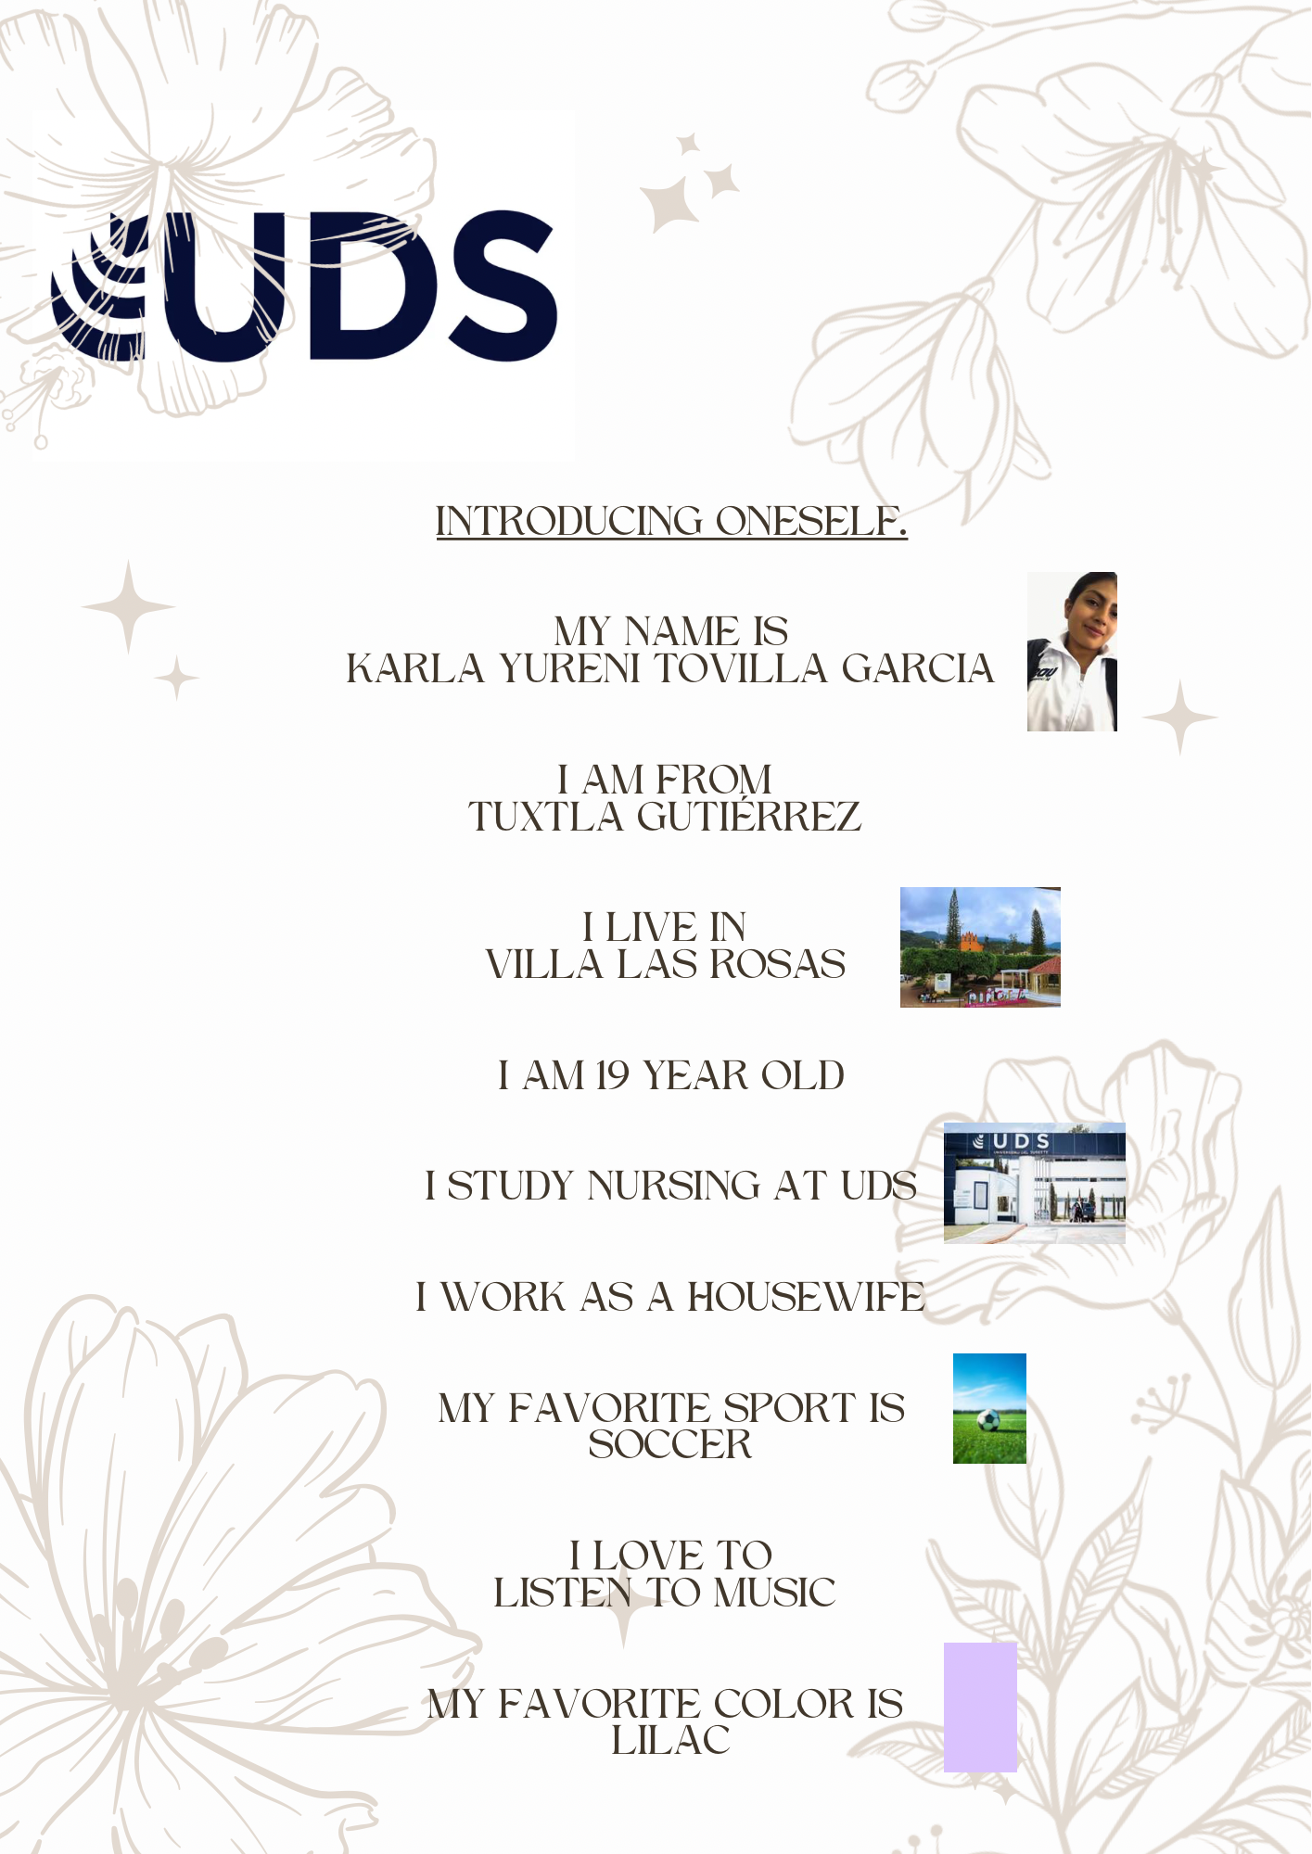

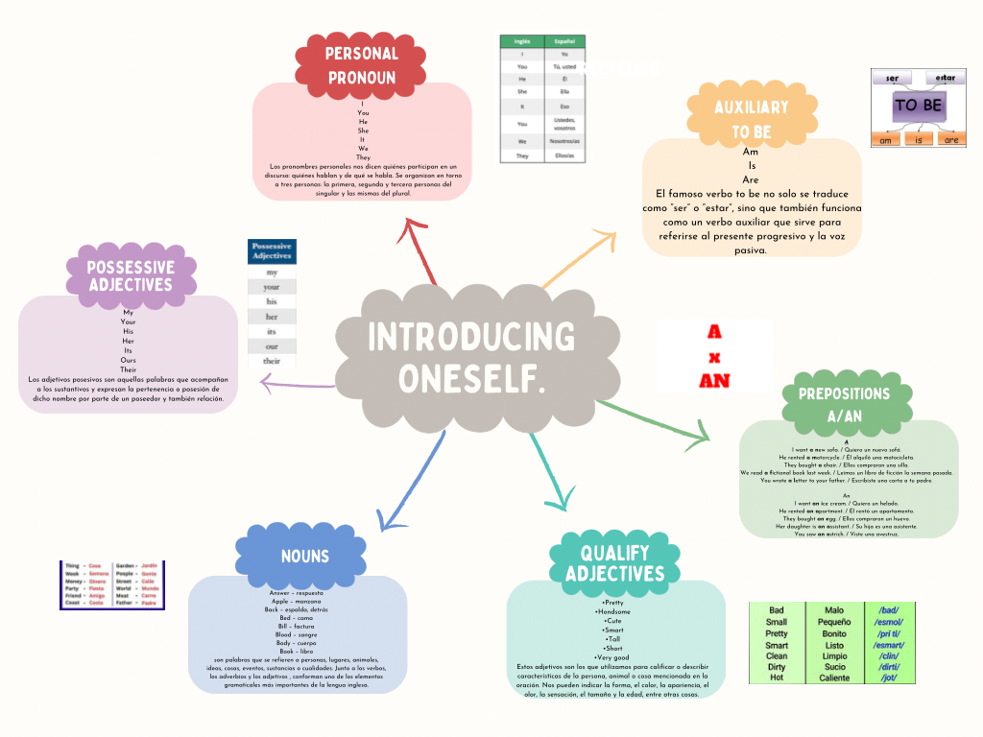

<https://www.canva.com/design/DAF0L6WT5WE/6BcFnFSShgOBvTrb2bvCJQ/edit?utm_content=DAF0L6WT5WE&utm_campaign=designshare&utm_medium=link2&utm_source=sharebutton>