

***NOMBRE DEL ALUMNO***

***KARLA YURENI TOVILLA GARCIA***

***NOMBRE DEL PROFESOR***

***ALDO IRECTA NÁJERA***

***MATERIA***

***COMPUTACION***

***TEMA***

***QUE ES INFORMÁTICA Y LAS COMPUTADORAS***

***FECHA DE ENTREGA***

***14/11/2023***

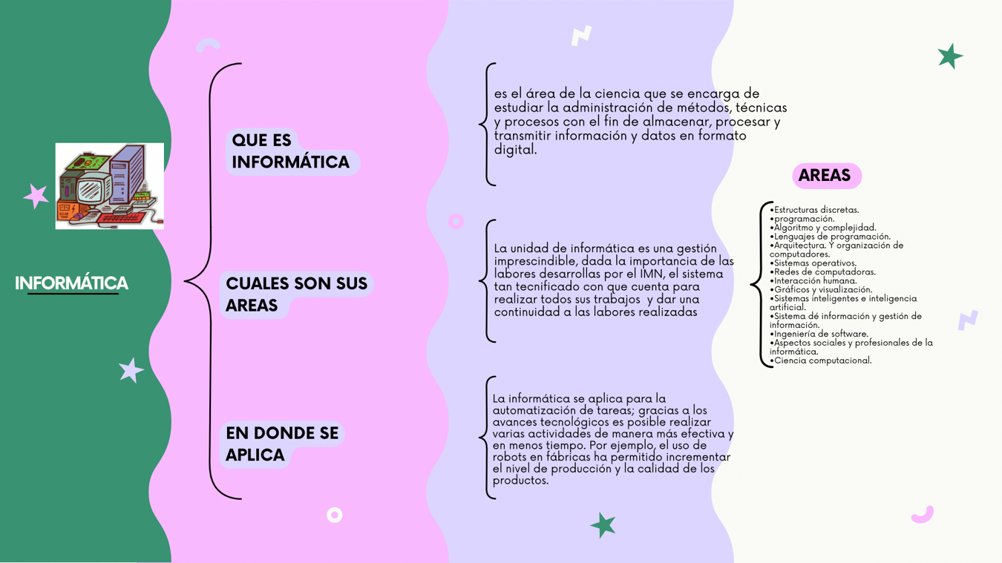

[***https://www.canva.com/design/DAF0EPywDQU/-qG0AIeqPvL1J6xp7LaCsA/edit?utm_content=DAF0EPywDQU&utm_campaign=designshare&utm_medium=link2&utm_source=sharebutton***](https://www.canva.com/design/DAF0EPywDQU/-qG0AIeqPvL1J6xp7LaCsA/edit?utm_content=DAF0EPywDQU&utm_campaign=designshare&utm_medium=link2&utm_source=sharebutton)

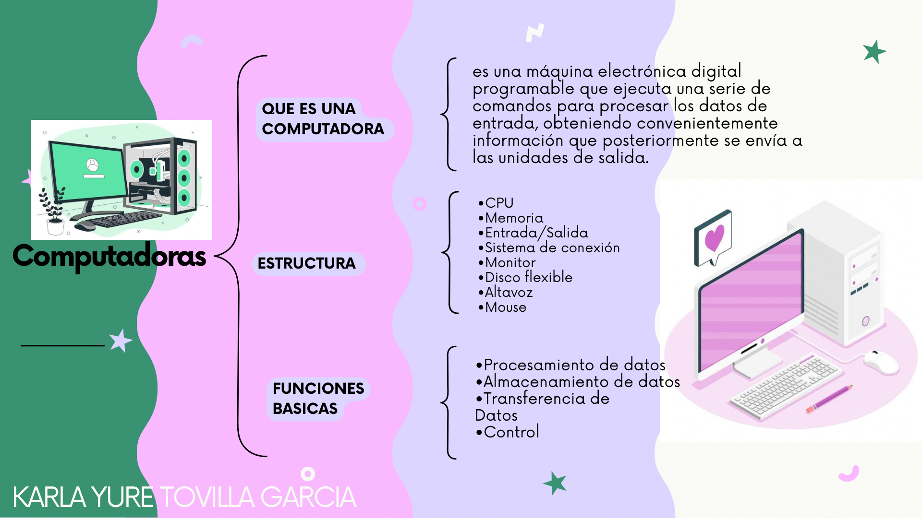

[***https://www.canva.com/design/DAF0F65KNIQ/Z6KRl4qHtyeWyQ2eVZdqCg/edit?utm_content=DAF0F65KNIQ&utm_campaign=designshare&utm_medium=link2&utm_source=sharebutton***](https://www.canva.com/design/DAF0F65KNIQ/Z6KRl4qHtyeWyQ2eVZdqCg/edit?utm_content=DAF0F65KNIQ&utm_campaign=designshare&utm_medium=link2&utm_source=sharebutton)