

**Nombre de alumno:**

**Lizbeth Elizabeth López de León**

**Nombre del profesor:**

**Rafael Iván Guillen Alcalá**

**Nombre del trabajo: describing a picture**

**Materia:**

**Ingles**

**Grado: 1**

**Grupo: A**

Comitán de Domínguez Chiapas a 29 de Enero de 2020.

my family

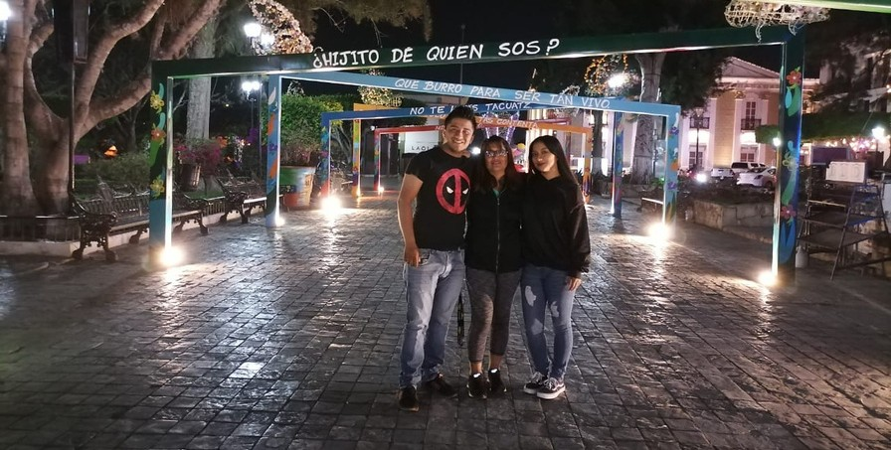

Hello, this is me and my Family in a park Full oF lights and decorated with signs

I am skinny short with a black sweatshirt and black tennis shoes and jeans and unkempt hair

In the middle is my mother, she is Mirna, she is short, she has short hair dyed copper, dressed in black tennis sports pants and a vest and glasses.

He is also obed, he is tall, chubby, he is dressed in a black t-shirt, black tennis shoes and light jeans.

# we are taking photos

* walking at night

# We are spending time as a Family.

* reading the signs.

# eating tamales and hot chocolate.