

**Nombre de alumno:**

**Lizbeth Elizabeth López de León**

**Nombre del profesor:**

**Francisco Ivan Guillen Alcala**

**Nombre del trabajo: Travel around the world Materia: Ingles**

**Grado: 1**

**Grupo: A**

Comitán de Domínguez Chiapas a 29 de Enero de 2020.

CHIAPAS

Chiapas is famous for it's great culture and nature environment

## Why you must to visit chiapas?

Chiapas is a state in southeastern Mexico, offering a wide variety of cultural and natural experiences for travelers.

## Where is located?

It is located southeast of Mexico; It borders to the north with the state of Tabasco, to the west with Veracruz and Oaxaca, to the south with the Pacific Ocean and to the east with the Republic of Guatemala. To the north 17°59', to the south 14°32' north latitude; east 90°22', west 94°14' west longitude.

When is the best time of the year to visit cascadas de agua azul?

The months from October to March are

recommended to avoid any rain

Tuxtla G

Must

Gobernador

San Cristóbal

Who is the current governor of Chiapas?

The governor of Chiapas is Rutilio Escandón Cadenas

What is your favorite city of Chiapas?

Tuxtla Gutiérrez and san Cristobal

## Which climate is better for you?

cold, cloudy, rainy weather

# important indigenous culture

* Maya •Tzotzil •Tojolabal

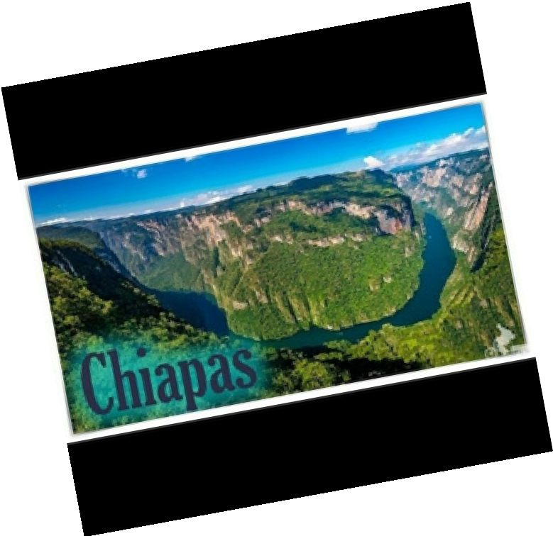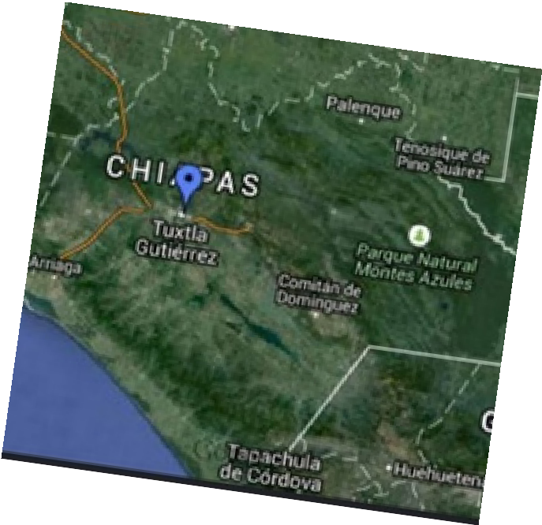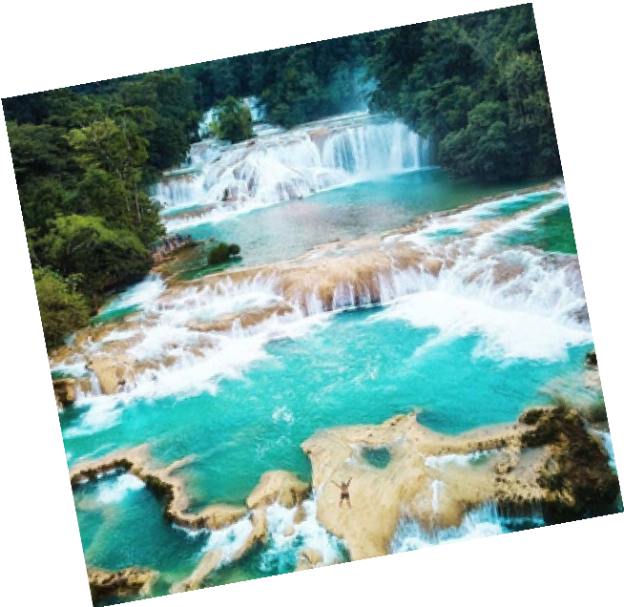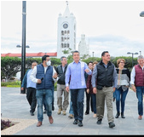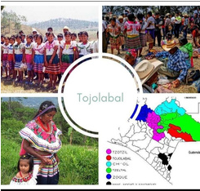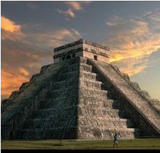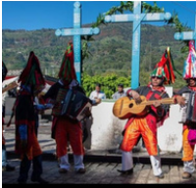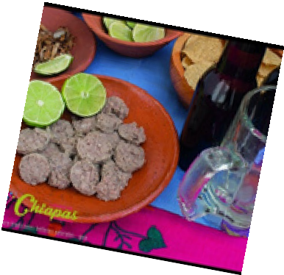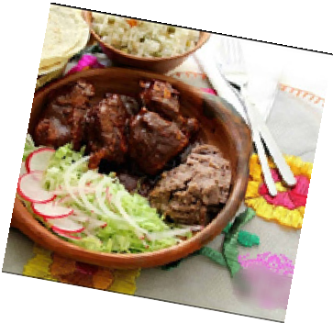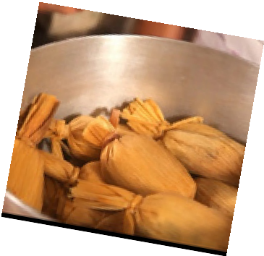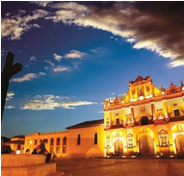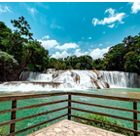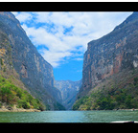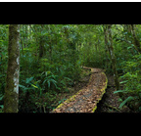

Must important cities?

* San Cristóbal
* Comitan
* Tuxtla
* Palenque

## Most popular food in chiapas?

* Tamales
* Cochito horneado
* Butifarras

## Must important turistic place?

* + Chiapas de corzo • Selva Lacandona
  + San Cristóbal • Agua azul
  + Comitan • Montebello
  + El chiflon • Cañon del sumidero
  + Palenque