

**Nombre de alumno: Isabela Guillen Borbolla**

**Nombre del profesor: Juan Manuel Jaime Diaz**



**Nombre del trabajo: Unit Activity #1 U1 – 5BEN**

**Materia: Ingles**

**Grado: 5to semestre**

**Grupo: Enfermeria**

Comitán de Domínguez Chiapas a 06 de septiembre de 2023.

**STAYING IN SHAPE - Vocabulary**

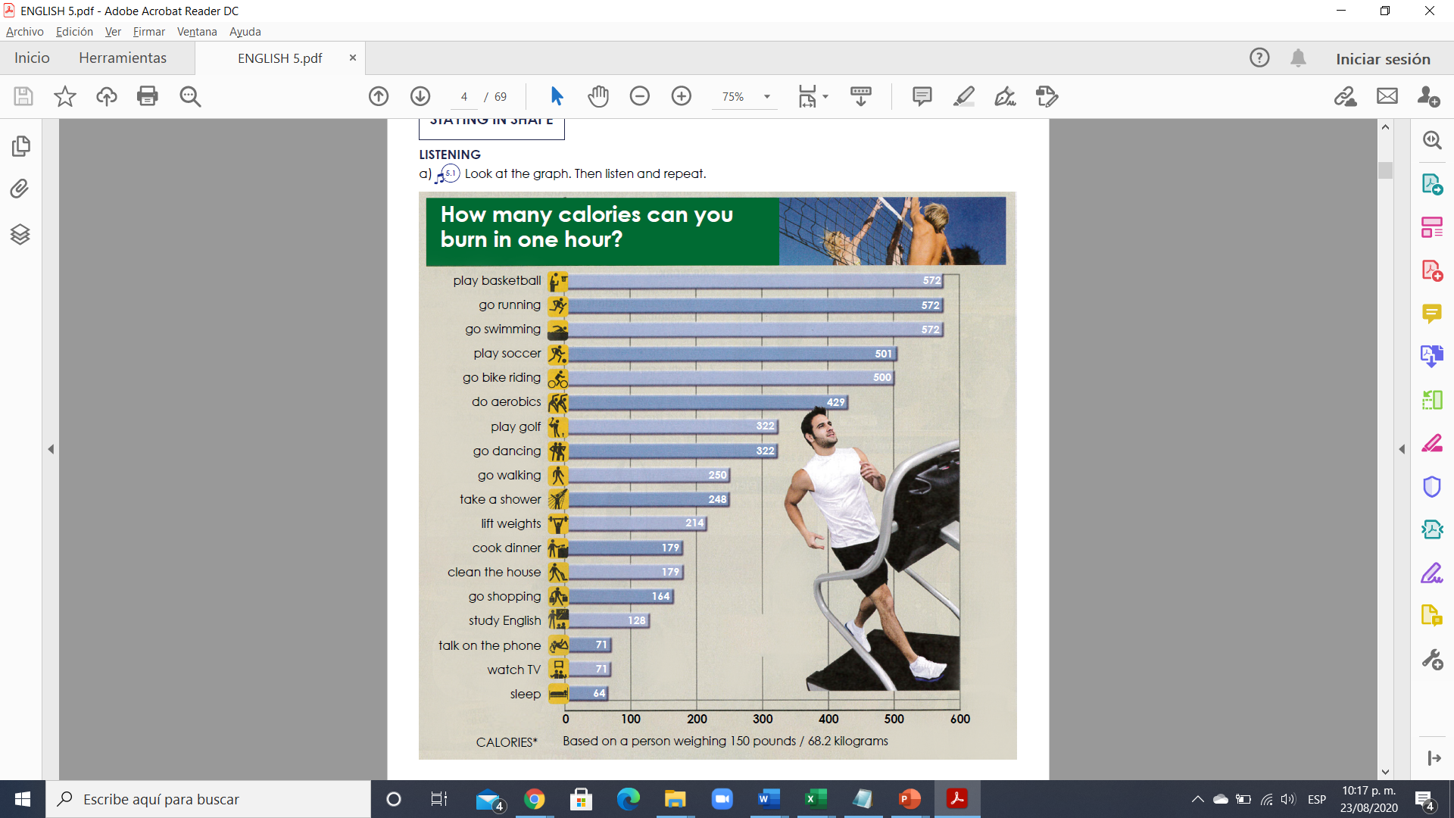

**Exercise 1.** Translate the next vocabulary – Traduce el siguiente vocabulario

play basketball – jugar basketball go shopping – ir de compras

go running – s ir a correr study English – estudiar ingles

go swimming - ir a nadar watch TV – ver la tele

play soccer – jugar futbol sleep – dormir

go bike riding – montar Bicicleta

do aerobics – hacer aerobics

play golf - jugar golf

go dancing – salir a bailar

go walking – salir a caminar

take a shower – tomar una ducha

lift weights – levantar pesas

cook dinner – cocinar la cena

clean the house – limpiar la casa

talk on the phone – hablar por telefono

**Exercise 2.** Using the vocabulary above and list the activities you do...(usando el vocabulario de arriba enlista las actividades que realizas por día, por fin de semana, una vez a la semana, casi nunca, nunca)

|  |  |  |  |  |
| --- | --- | --- | --- | --- |
| **Every day** | **Every weekend** | **Once a week** | **Almost never** | **Never** |
| 1. Cook dinner  2. Go bike riding  3. Take a shower  4. Study English  5. Sleep | 1. Go dancing  2. Go walking  3. Watch TV  4. Talk on the phone | 1. Go shopping  2. Clean the house  3.  4.  5. | 1. Go swimming  2. Go running  3.  4.  5. | 1. Lift weights  2. Play soccer  3. Play golf  4. Do aerobics  5. Play basketball |

**Grammar**

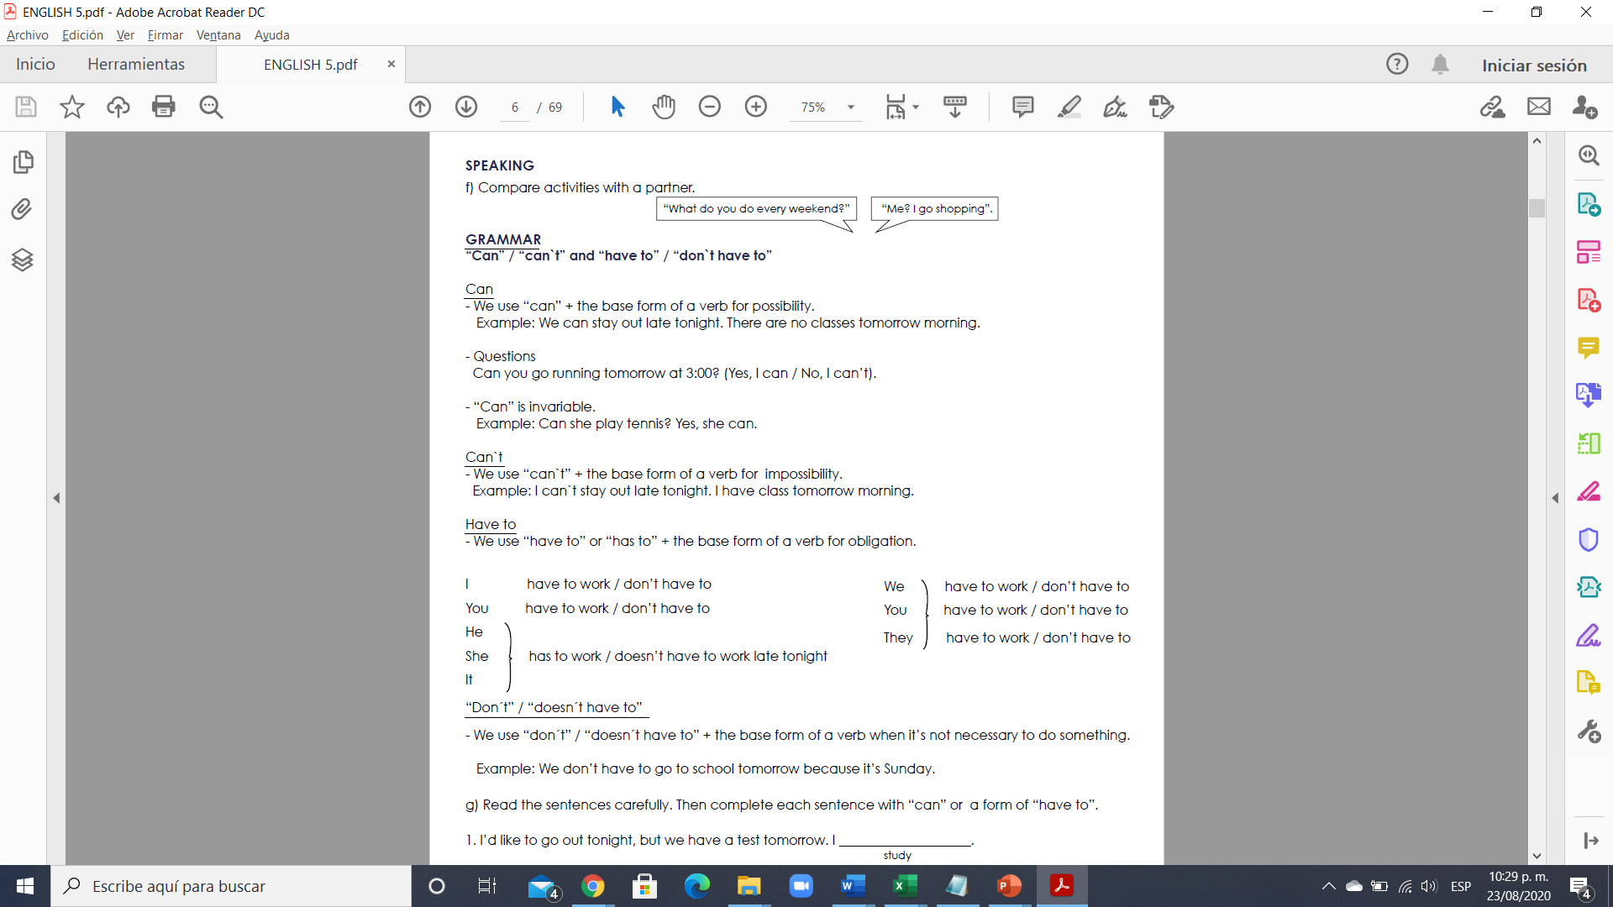

**Exercise 3.** Read the sentences carefully. Then complete each sentence with “can” or a form of “have to”.

1. I’d like to go out tonight, but we have a test tomorrow. I __have to study_____.

study

2. Audrey ________can´t meet ___us for lunch today. She __has to help__________ her boss write a report.

not / meet help

3. Good news! I ______don´t have to work_____ late tonight. We ___can go running____ together at 6:00.

not / work go running

4. My sister _____can´t go shopping_______ at the mall today. She _____has to go_______ to the doctor.

not / go shopping go

5. Henry ______is going ______________ to Toronto next week, so he ____can´t play_________ golf with us.

go not / play

6. Sorry, I _____can´t go_______________ to aerobics class tonight. I ___have to meet_______ with my boss.

not / go meet

**Exercise 4.** Write four questions using “can” and four questions using a form of “have to”. (with answer)

Example: Can you have a Zoom meeting tomorrow at 3:00? (Yes, I can / No, I can’t).

Do you have to work until 6:00pm? (Yes, I have to work / No, don’t have to work).

Questions with can:

1. Can you play the guitar?

2. Can you clean your room?

3. Can you go out with us tomorrow?

4. Can you come to my room?

Questions with have to:

1. Do you have to go to the dentist?

2. Dou you have to play at the meet?

3. Does she have to leave now?

4. Does he now how to behave?

**VOCABULARY - Places for sport and exercise**

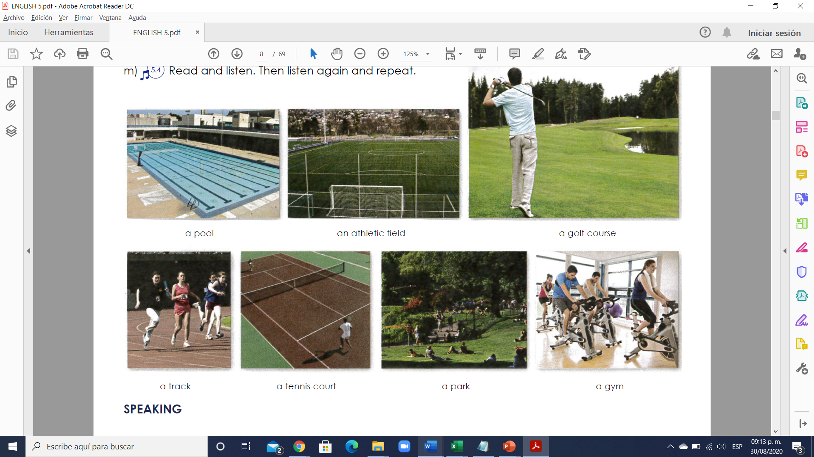

**Exercise 1.** Translate the next vocabulary – Traduce el siguiente vocabulario al español

a pool – una alberca

an athletic field – un campo Atletico

a golf course – un campo de golf

a track – una pista

a tennis court – una cancha de tenis

a park – un parque

a gym – un gimnasio

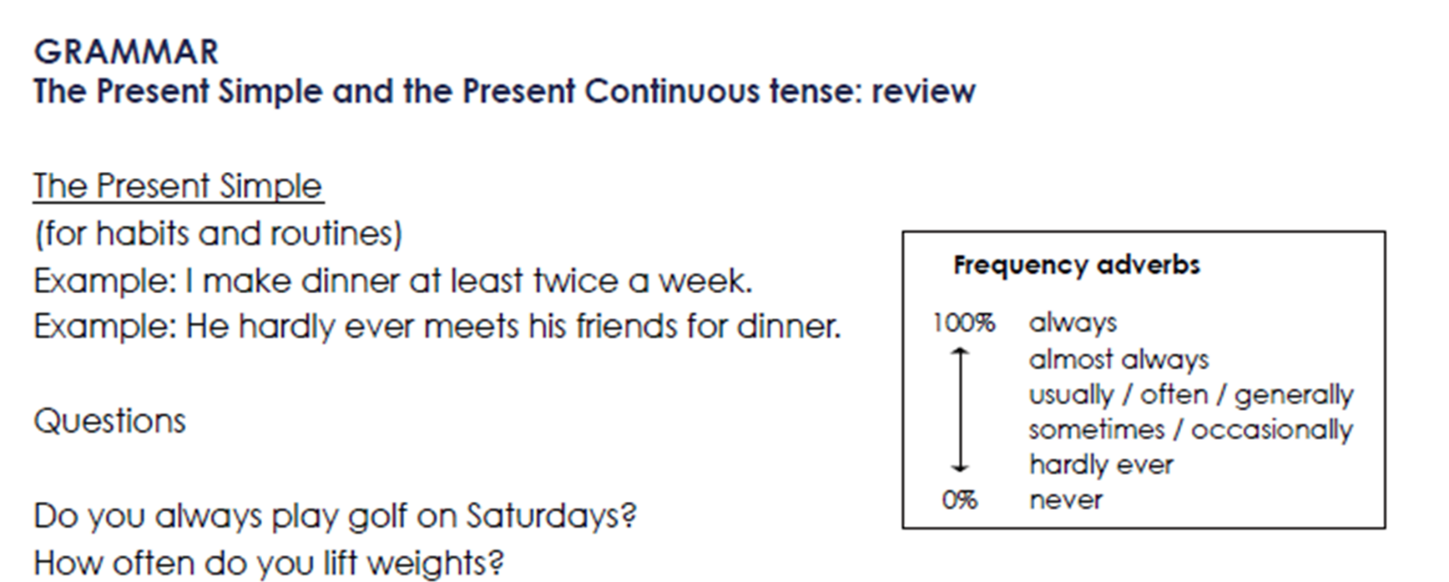

**Simple present**

**Grammatical rules**

* We use simple present for habits and routines.
* We use simple present with time adverbs.

|  |  |
| --- | --- |
| **Time adverbs** | **Meaning** |
| Always | Siempre |
| Every day | Todos los dias |
| Usually | Usualmente |
| Often | A menudo |
| Sometimes | A veces |
| Rarely | Raramente |
| Hardly ever | Casi nunca |
| Never | Nunca |

**Simple present**

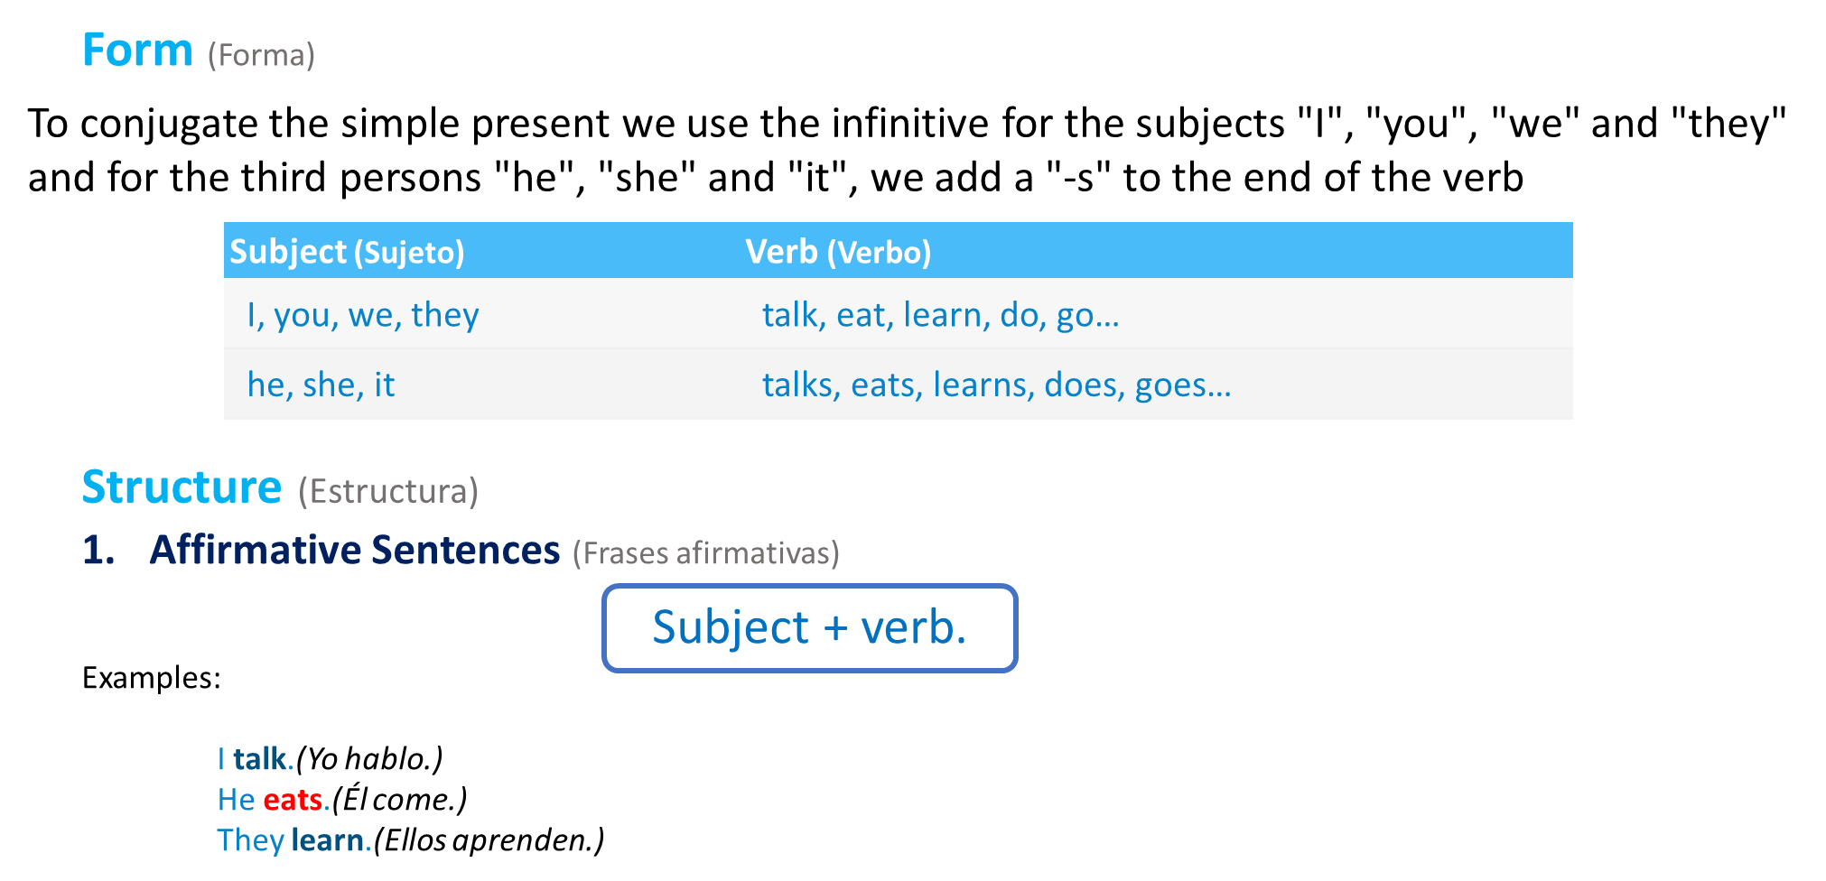

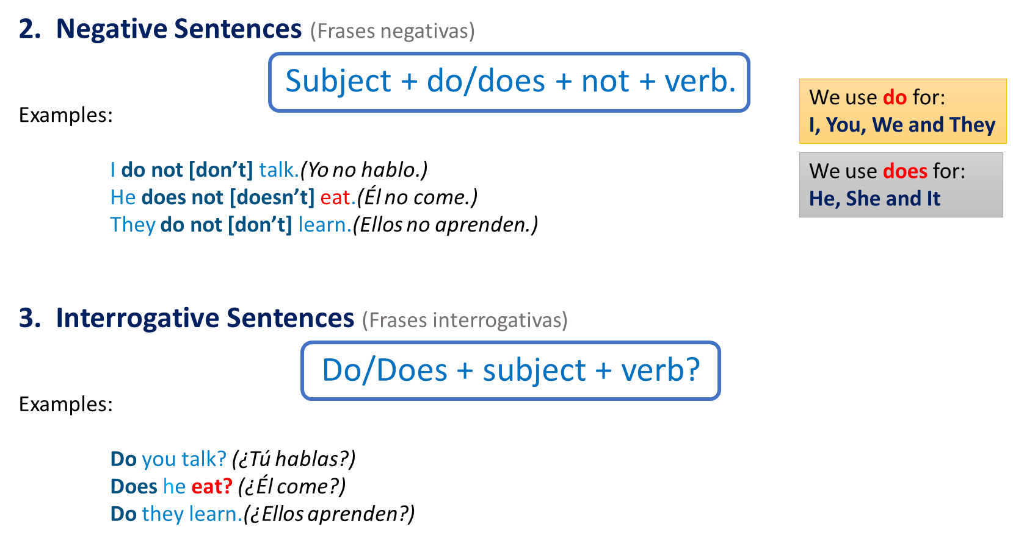

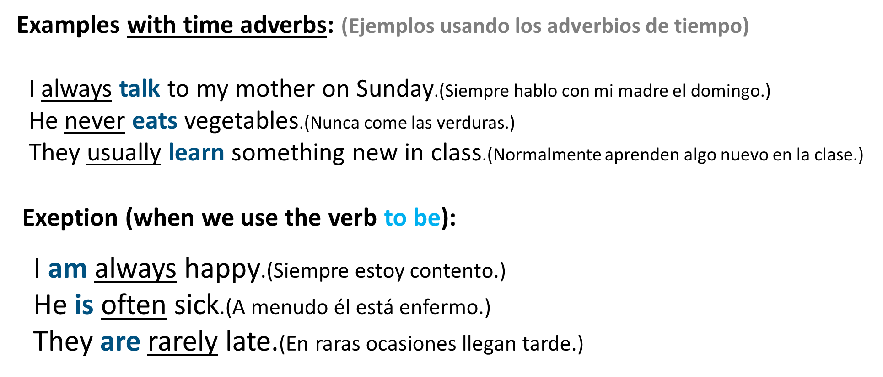

**Exercise 2.** Write 12 sentences using the present simple and time adverbs (Escribe 12 oraciones en presente simple usando los adverbios de tiempo)

3 Affirmative sentences (tres oraciones afirmativas)

1. I never work late

2. She always plays soccer

3. He almost never does art

4. You always study hard

3 Negative sentences

5. He doesn’t play well very often

6. They don’t know French yet

7. We rarely don’t enjoy that

8. You can´t go

3 Interrogative sentences

9. Does she play?

10. Does he run?

11. Do you know?

12. Do we go now?

**Present Continuous**

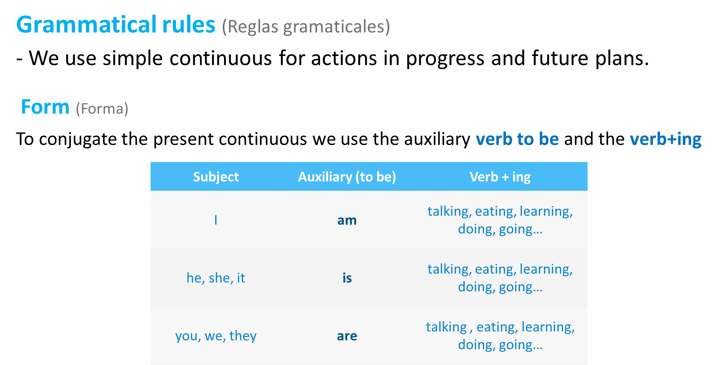

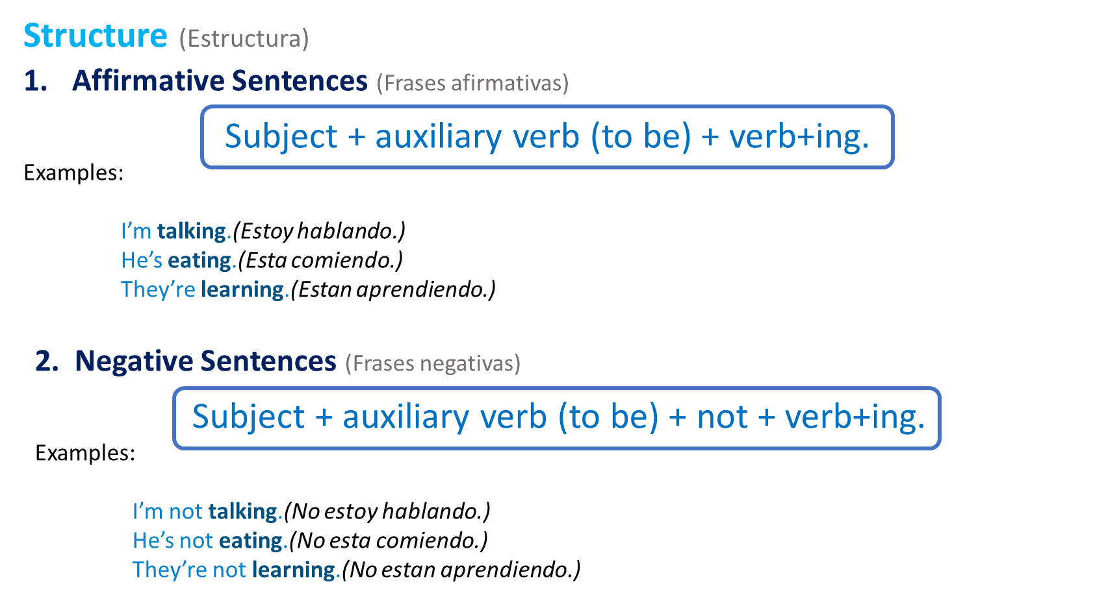

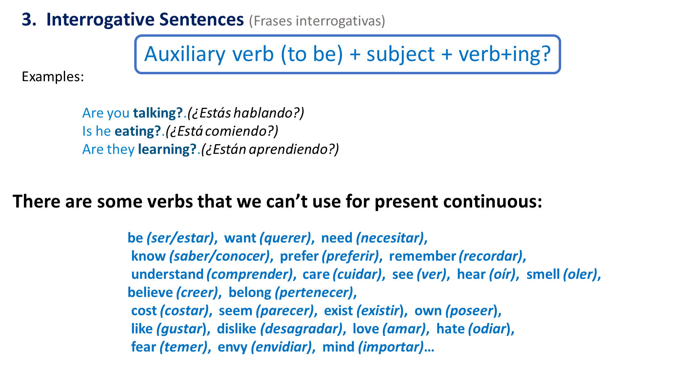

**Exercise 3.** Write 12 sentences using simple continuous (Escribe 12 oraciones en presente continuo)

3 Affirmative sentences (tres oraciones afirmativas)

1. He is going

2. I am understanding

3. She is playing

4. He is falling for her

3 Negative sentences

5. We can´t be seeing this

6. They don’t like playing

7. We don’t

8. He doesn’t hate walking

3 Interrogative sentences

9. Do you want to go running?

10. Does she mind helping?

11. Do we need to go swimming?

12. Do the know we are coming?

**Exercise 4.** Complete the sentences. Use the Present Simple or the Present Continuous tense. (Completa las oraciones usando presente simple o presente continuo con las palabras en el paréntesis)

1. Brian can’t answer the phone right now. __He is studying _________ ***(he / study)***.

2. How often ___ does she go ____ ***(she / go)*** walking?

3. __Can we play____ ***(we / play)*** tennis this weekend?

4. ___He lifts _____ ***(he / lift)*** weights three times a week.

5. __They are making ________ ***(they / make)*** lunch. Can they call you back?

6. How often ___do you___________ ***(you/ clean)*** the house?

7. ___I do_________ ***(I / do)*** aerobics every day.

8. ______She is going ____ ***(she / go)*** shopping tonight.

**Exercise 5.** Complete the table with the missing sentences use the Present Simple. (Completa la siguiente table con las oraciones faltantes usando presente simple)

|  |  |  |
| --- | --- | --- |
| Affirmative | Negative | Questions |
| I work everyday | I don´t work every day | Do I work everyday? |
| I go swimming with my brother | I don’t go swimming with my brother | Do I go swimming with my brother? |
| You have to study | You don´t have to study | Do you have to study? |
| He studies English | He doesn’t study English | Does he study English? |
| She does her homework | She doesn’t do her homework | Does she have to do her homework? |
| It has to be done | It doesn´t need to be done | Does it need to be done? |
| We run in the park | We don’t run in the park | Do we run in the park? |
| They eat their lunch | They don’t eat their lunch | Do they eat their lunch? |
| You want a chocolate cake | You don’t want a chocolate cake | Dou you want a chocolate cake? |

**Exercise 6.** Complete the table with the missing sentences use the Present Continuous. (Completa la siguiente table con las oraciones faltantes usando el presente continuo)

|  |  |  |
| --- | --- | --- |
| Affirmative | Negative | Questions |
| I am working at UDS | I am not working at UDS | Am I working at UDS? |
| I am running in the park | I am not running in the park | Am I running in the park? |
| You are studying now | You are not studying now | Are you studying now? |
| He is studying English | He is not studying English | Is he studying English? |
| She is doing her homework | She is not doing her homework | Is she doing her homework? |
| It is going well | It is not working well | Is it going well? |
| We are playing soccer in the park | We are not playing soccer in the park | Are we playing soccer at the park? |
| They are eating their lunch | They are not eating their lunch | Are they eating their lunch? |
| You are cooking a chocolate cake | Your are not cooking a chocolate cake | Are you cooking a chocolate cake? |

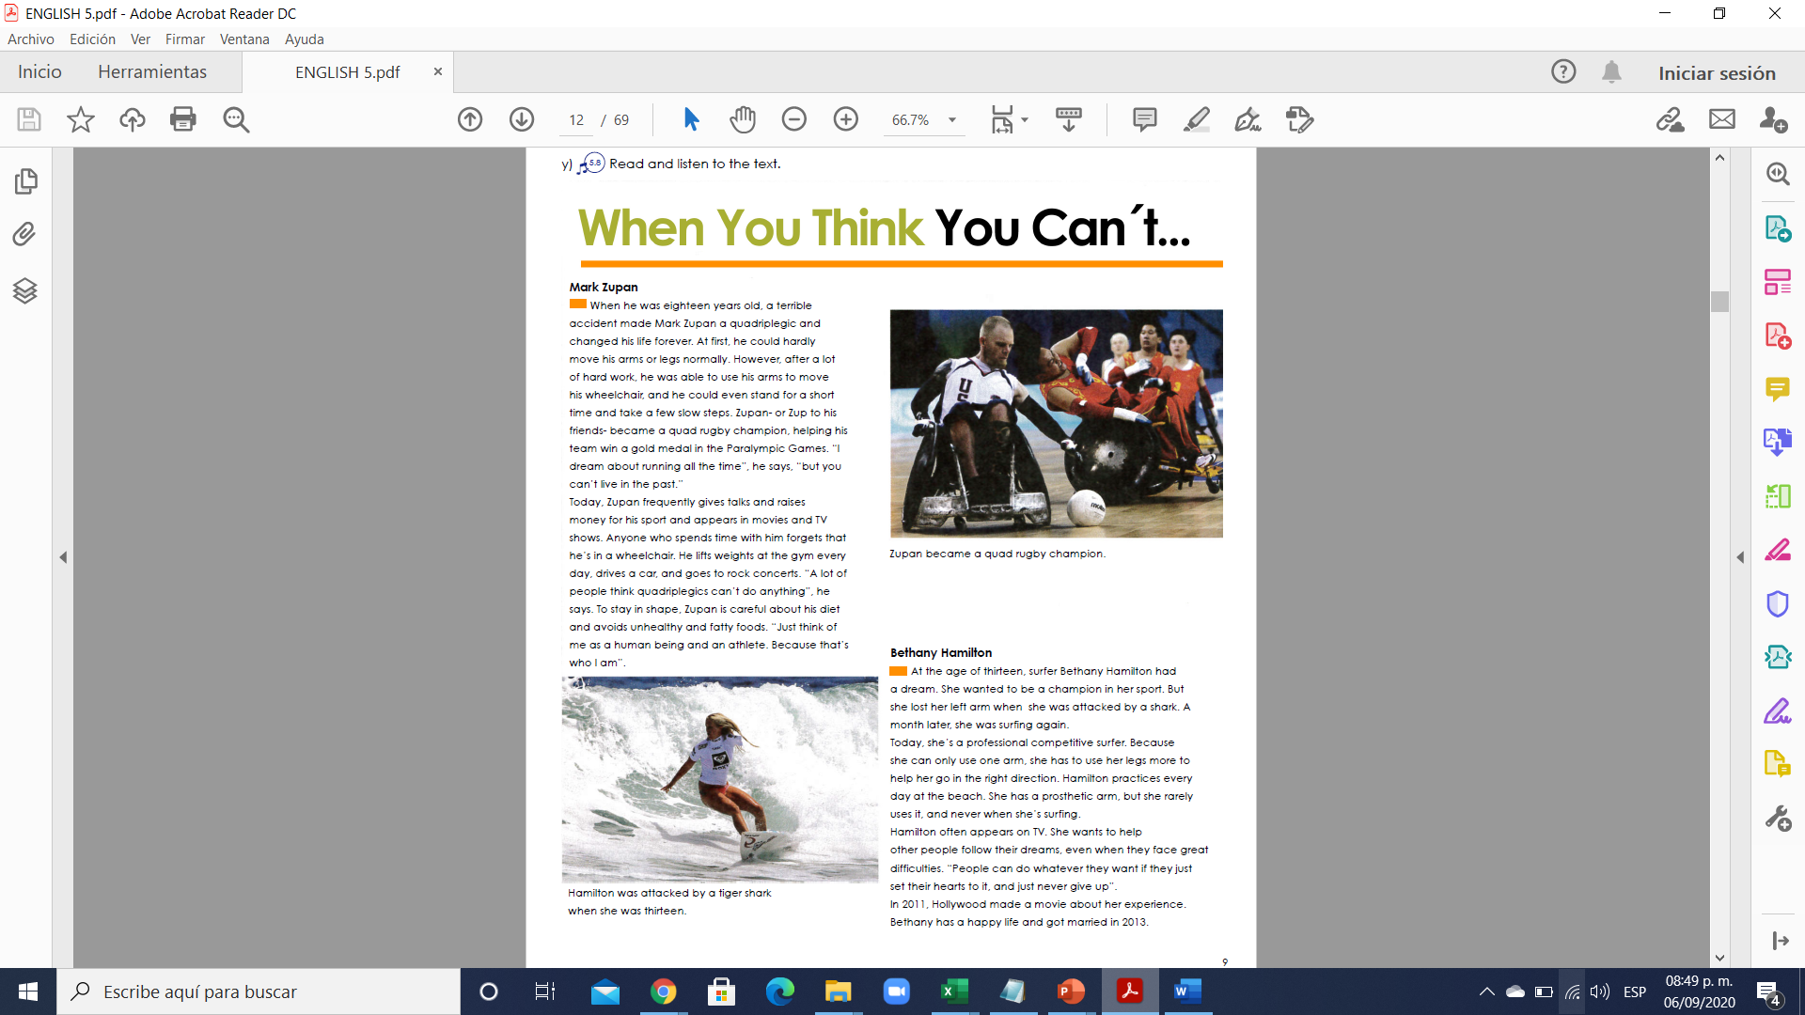

**Exercise 7.** Read the text above and answer the next exercises. (Lee el texto de arriba y contesta el siguiente ejercicio).

**Complete the paragraph about Marc Zupan. Use “can”, “can’t” or “has to”.**

Zupan __has to ___ spend most of his time in a wheelchair, but he __can ___ stand up

and take a few steps for a short time. He _ can´t __ go walking or running, but he

__can ___ play quad rugby. He __has to ___ be careful about his diet so he doesn’t get out of shape. He doesn’t have complete use of his hands, but he _can __ lift weights.

He __can´t __ drive a car using his feet, but he __can __ use his hands. A lot of people

think quadriplegics _can´t __ do anything, but Zupan proves that they __can _.

**Complete the paragraph about Bethany Hamilton using the Present Simple or the Present Continuous.**

When she surfs, Hamilton ___uses ____ ***(use)*** her legs to help her go in the right direction.

She __has _____ ***(have)*** a prosthetic arm, but she hardly ever ______wears ___ ***(wear)*** it.

She ___competes ______ ***(compete)*** regularly with the world’s top professional women surfers.

In the photo, she is competing against other surfers with two arms.

She ____wears _____ ***(wear)*** a t-shirt and _____stands ___ ***(stand)*** on her surfboard. Hamilton

____wants ______ ***(want)*** to help other people with difficult experiences follow their dreams.