**Unit Activity #1 – U4**

*Nombre del Alumno: Elisema jacqueline cruz cruz*

*Nombre del tema: Unit IV*

*Parcial: Fourth*

*Nombre de la Materia: English I*

*Nombre del profesor: Juan Manuel Jaime Díaz*

*Nombre de la carrera: técnico en enfermería general*

*Cuatrimestre: 1st*

*Lugar y Fecha de elaboración*

Comitán de Domínguez Chiapas a 04 de diciembre de 2023.

**TOPIC 4**

**Exercise 1.** Write the name of the numbers.

1 -one 11 -eleven 30 - thirty

2 -two 12 - twelve 40 -fourty

3 -three 13 - thirteen 50 - fifty

4 -four 14 - fourteen 60 -sixty

5 –five 15 - fifteen 70 - seventy

6 –six 16 - sixteen 80 - eighty

7 – seven 17 -seventeen 90 - ninety

8 – eight 18 - eighteen 100 -one hundred

9 – nine 19 - nineteen 135 -one hundred thirty five

10 –ten 20 -twenty 192 – one hundred ninety two

**Exercise 2.**  Complete with “am”, “is”, or, “are”.

1. My surname is López.

2. We are from Madrid.

3. I am Anna.

4. Antonio and Juan are in room 7.

5. He is the English teacher.

6. You are in Class 3.

7. She is a student.

**Exercise 3.** Complete the questions with “who”, “what”, “where” or “how”.

1. What`s your favorite sport?

2. Where`s Roberta from?

3. What`s your favorite teacher?

4. Where_are you?

5. What time is it?

6. what grade are you in?

7. What`s your last name?

8. What old is Mark?

**Exercise 4.** Translate to English:

1. Grandfather. Abuelo
2. Grandmother. Abuela
3. Grandson. Nieto
4. Granddaughter. Nieta
5. Father. Padre
6. Mother. Madre
7. Wife. Esposa
8. Husband. Marido
9. Son. Hijo
10. Daughter. Hija
11. Sister. Hermana
12. Brother. Hermano
13. Aunt tia
14. Uncle. Tio
15. Niece. Sobrina
16. Nephew. Sobrino

**Exercise 5.** Complete the questions. Use “how old is” or “how old are”.

1.how old are your sisters?

2. How old are Matt`s parents?

3.How old is your grandfather?

4.how old is Helen`s husband?

5. How old are her children?

6. How old is his son?

**Exercise 6.** Circle the correct word or words to complete each sentence.

1. Mr. Thomas is ( my / I) boss.

2. Is Mrs. Cory (you / your) teacher.

3. Is (she / her) Dr. Kim?

4. Are (they / their) Connie and Sam?

5. Are (your / you) Barry`s friend?

6. He`s (my / I) colleague.

7. Mr. Benson is (Alec / Alec`s) neighbor.

8. Jake is (Ms. Rose / Ms. Rose`s) student.

9. (He`s / His) an architect.

10 (Kyle / Kyle`s) and Ray`s classmate is Gail.

**Exercise 7.** Read about some famous actors and their families and friends.

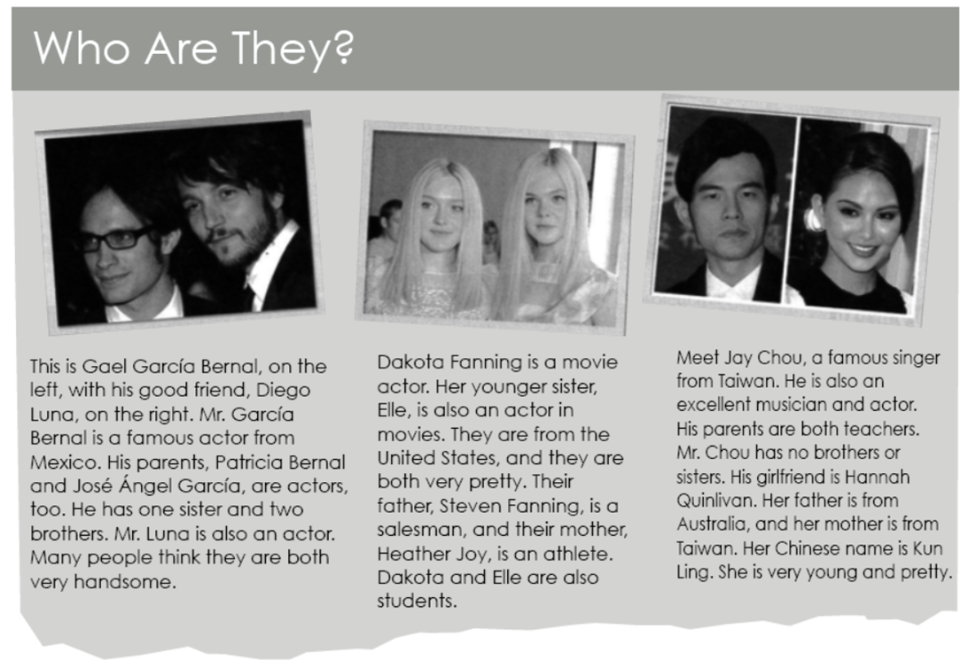

Now, complete the sentences.

1. Gael García Bernal is Diego Luna`s friends

2. Patricia Bernal, José Ángel García, and Diego

Luna are all actors

3. Heather Joy is Steven FanniÁnge lwife.

4. Elle Fanning is Heather Joy`s daughter

5. Mr. Chou`s Girl friend is good-looking.

6. Jay Chou`s parents have one son.

**Exercise 8.** Complete each sentence with “have” or “has”. Then choose the correct response. Circle the letter.

1. Matthew has two sisters.

a. How old is she? b. How old are they?

2. Mark and Jamie have a daughter.

a. How old is her? b. How old is she?

3. I have a brother and sister.

a. How old is your brother? b. How old is my sister?

4. We have a son.

a What`s your name? b. What`s his name?

**Exercise 9.** Unscramble the words. Write sentences.

1. brother / tall / is / My / very

2. handsome / He / too / very / is

3. your / Are / pretty / sisters / ?

4. Is / daughter / young / Her

5. cute / so / is / she