**Unit Activity #1 – U3**

*Nombre del Alumno: Dulce Violeta González Morales*

*Nombre del tema: Unit III*

*Parcial: Third*

*Nombre de la Materia: English III*

*Nombre del profesor: Juan Manuel Jaime Díaz*

*Nombre de la carrera:*

*Cuatrimestre: 1st*

*Lugar y Fecha de elaboración*

Comitán de Domínguez Chiapas

**TOPIC 3: WHERE ARE THEY?**

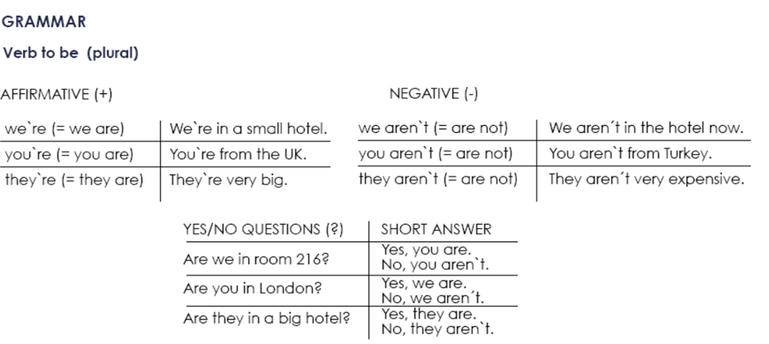

**Exercise 1.** Write the contractions: I`m, we`re, aren`t, etc.

1. We aren`t from Italy, __we're______ from Spain.

2. __It's_____ a new hotel, but it____isn't__ very nice.

3. __He's_____ a doctor and he ___isn't__ married.

1. 4. You ___aren't___ Australian, ___Youre ___ American.

5. ___He's_____ a manager and ___he isn’t___ a musician.

**Exercise 2.** Complete each statement with a singular or plural form of “be”.

1. I____am__ a writer.

2. She ___is_ not a pilot.

3. We ____are_ doctors.

4. They ____are_ not scientists.

5. We ___are_ managers.

6. He _____is _ a singer.

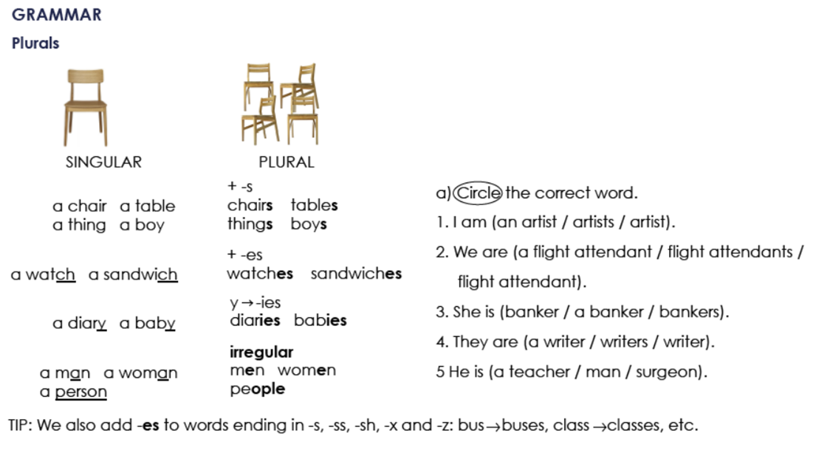

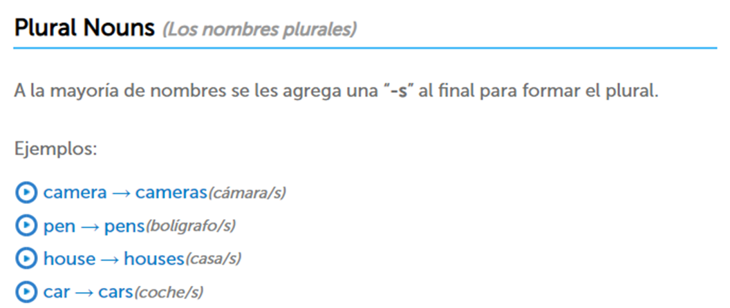

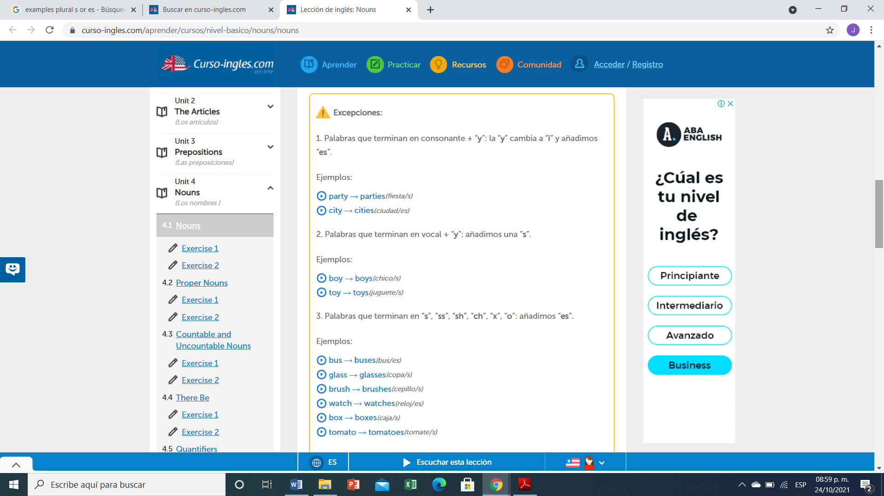

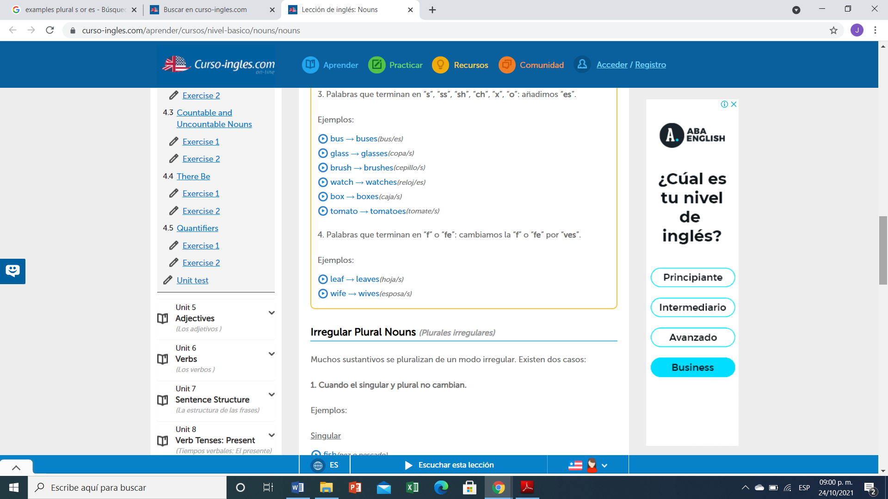

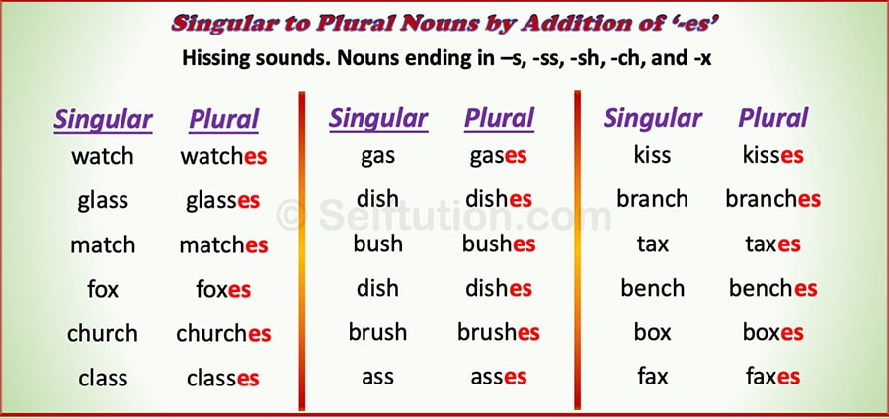

**Exercise 3.** Write the plural of:

1. Babies
2. Cakes
3. Churches
4. Glasses
5. Wite
6. Fishes
7. Months
8. Children
9. Wish
10. Women
11. Cities
12. Men
13. Boxes
14. Feet
15. Mice
16. Leaves
17. Sheep
18. 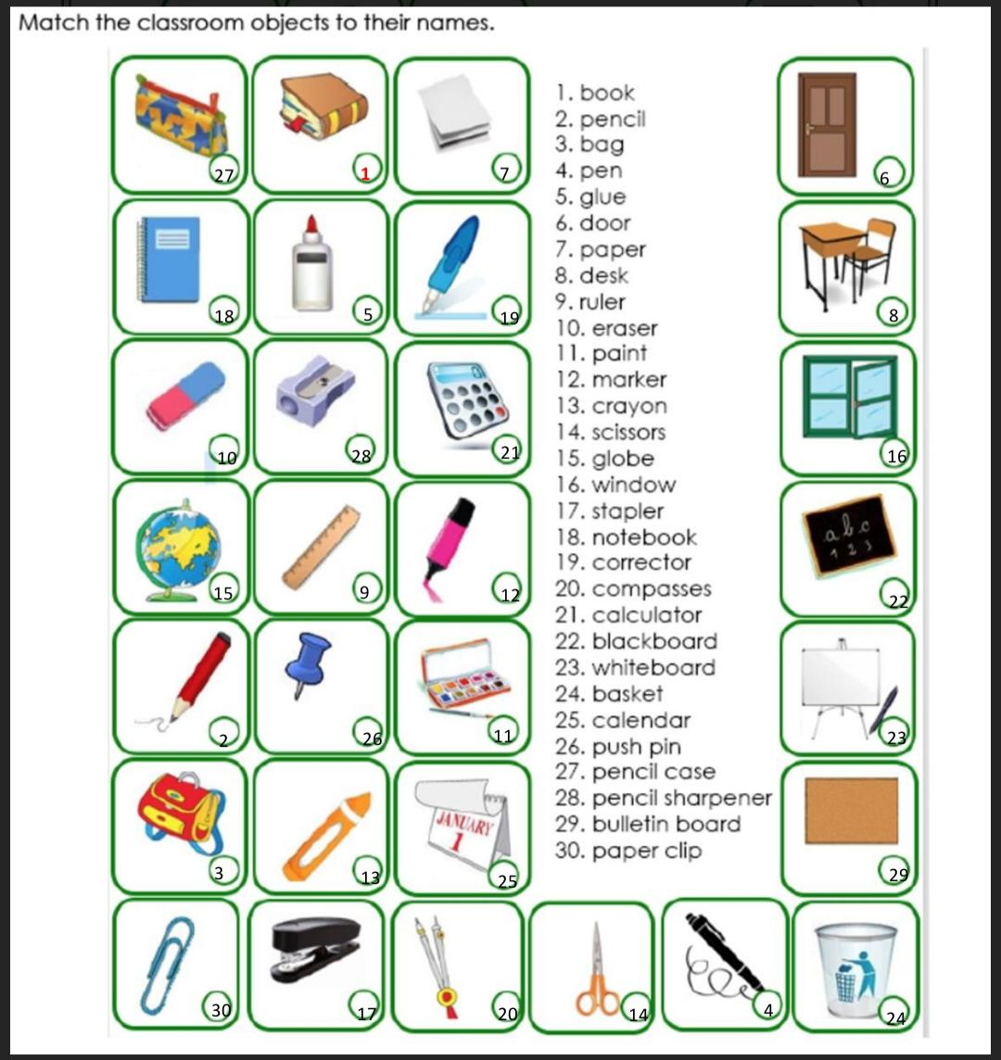Tomatoes

**1**

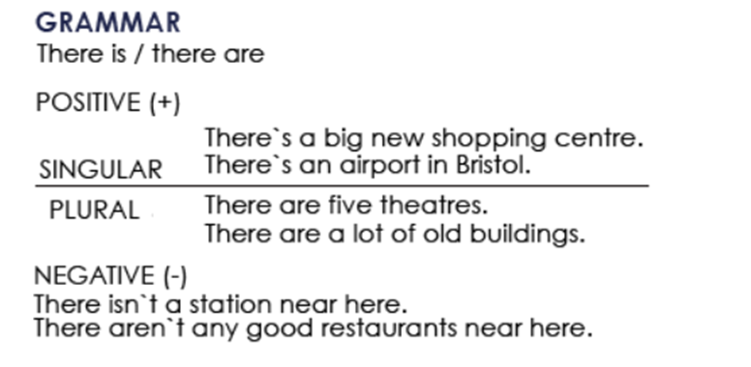

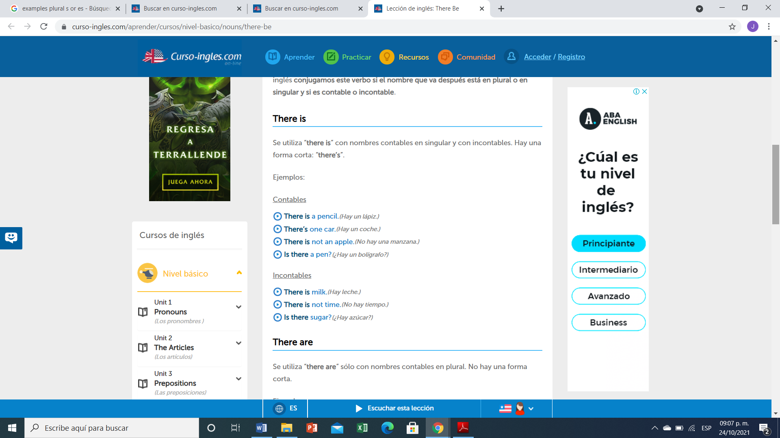

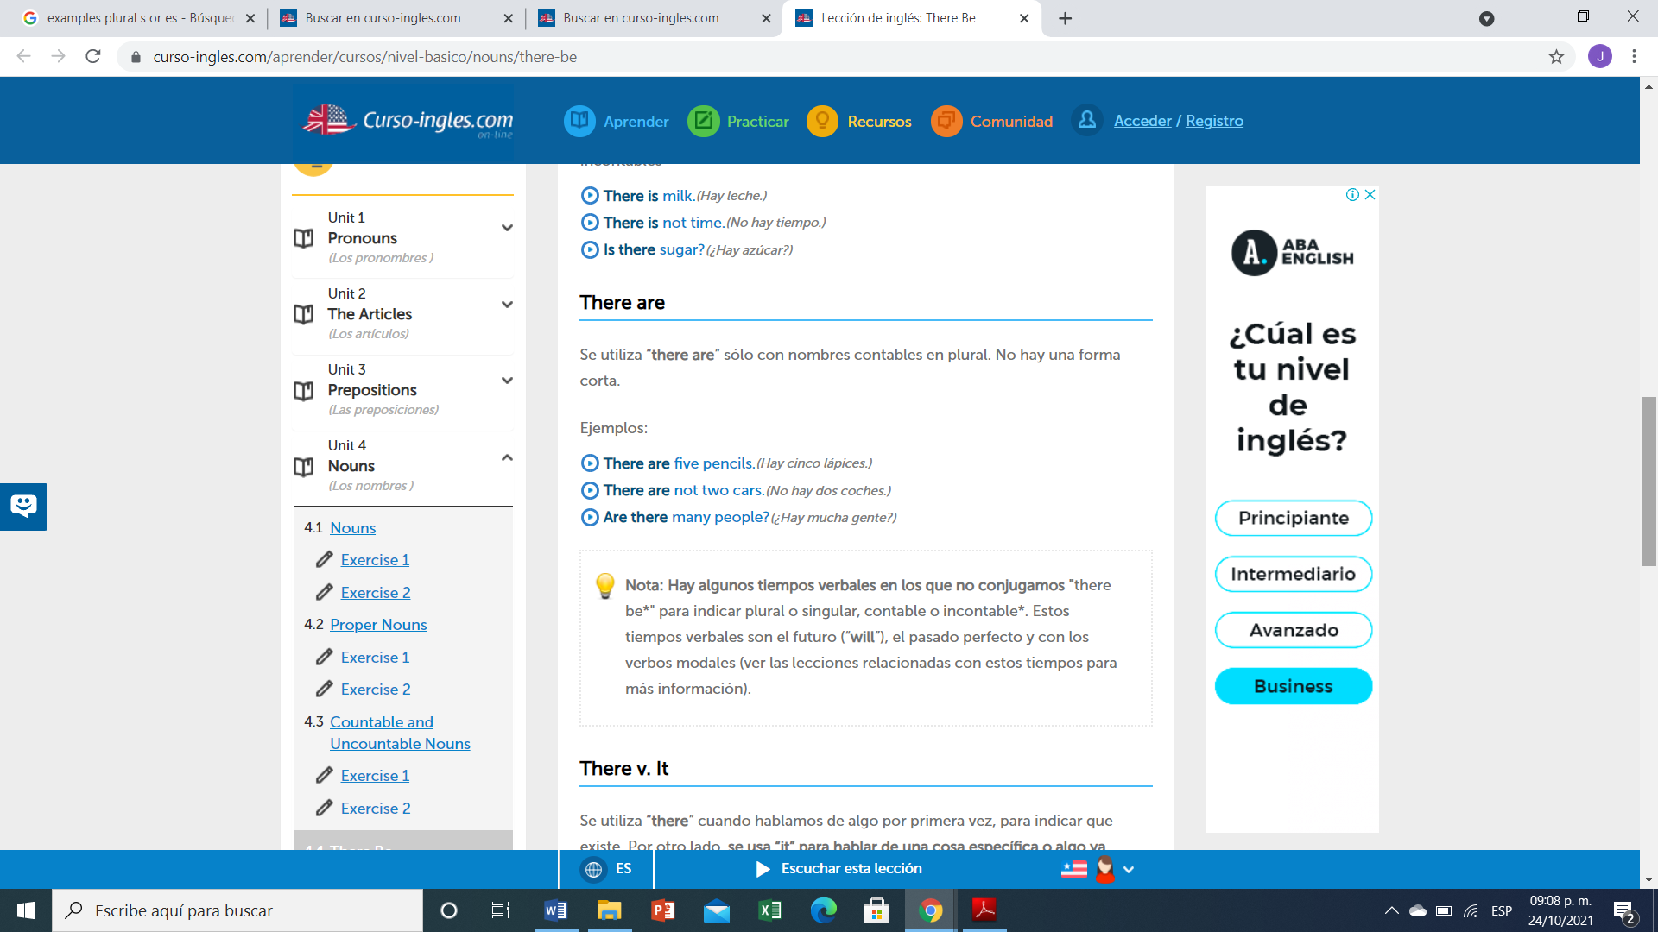

**Ejercicio #4 -** Completa las siguientes frases con la forma correcta de "there is or There are".

1. ____There are_______ 5 apples in the bowl.
2. _____Is there ______ any water?
3. _____There isn’t______ (not) any sugar in the coffee.
4. _______There isn’t____ (not) any tomatoes in the salad.
5. _________ There is __ some wine in the glass.
6. ______Is there_____ any money in your wallet?
7. There is ___________ a problem with this phone.
8. _Are there___ any vegetables in this recipe?

**Ejercicio #5 -** Escribe las palabras en el orden correcto.

many / aren’t / this / pages / there / in

R: there aren’t many pages in this book

any / eggs / there / the / in / are / fridge / ?

R: Are there any .eggs in the fringe?

is / nearby / restaurant / nice / there / a

R: There is restaurant nearby nice

dining / are / chairs / in / room / there / three / the

R: there are three chairs in the dining room

hospital / there / this / isn't / a / in / town

R: there isn’t a town in this hospital

here / is / bank / there / a / near / ?

R:is there a bonk near here?

**TOPIC 4: PERSONAL INFORMATION**

**Exercise 1.** Contesta las siguientes preguntas.

1. What`s your first name?

A: My name is Dulce

2. What`s your surname or last name?

A: ny surneme is González

3. What`s your nationality?

A: I,m mexican

4. What`s your address?

A: my address is calzada del panteón

5. What`s your mobile number?

A: My mobile number is 963 186 94 10

6. What`s your mail address?.

A: my mil address is [dpro63008@gmail.com](mailto:dpro63008@gmail.com)

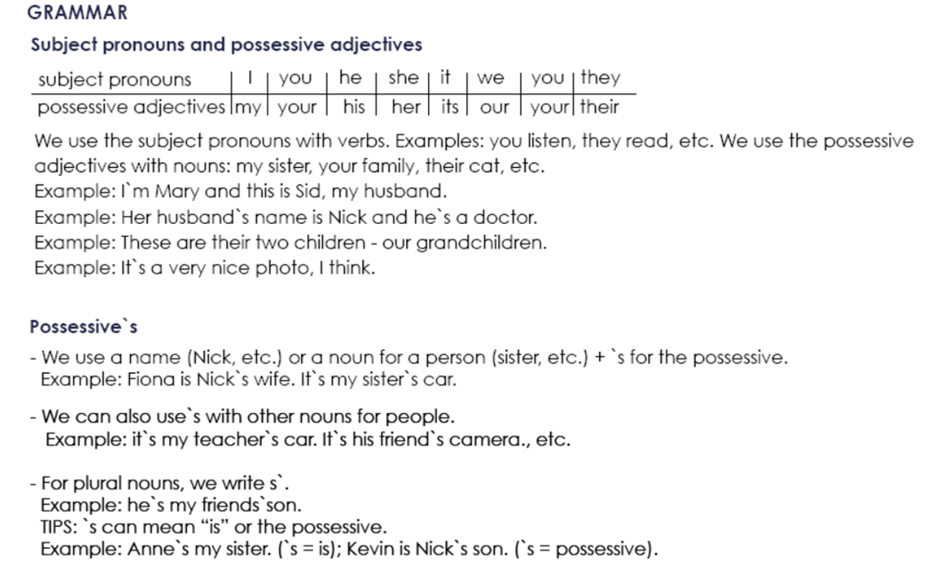

**Possessive Adjectives - Adjetivos Posesivos**

Se utilizan para indicar a quién pertenece el sujeto u objeto de la oración. Van seguidos de un sustantivo (o una cláusula nominal).

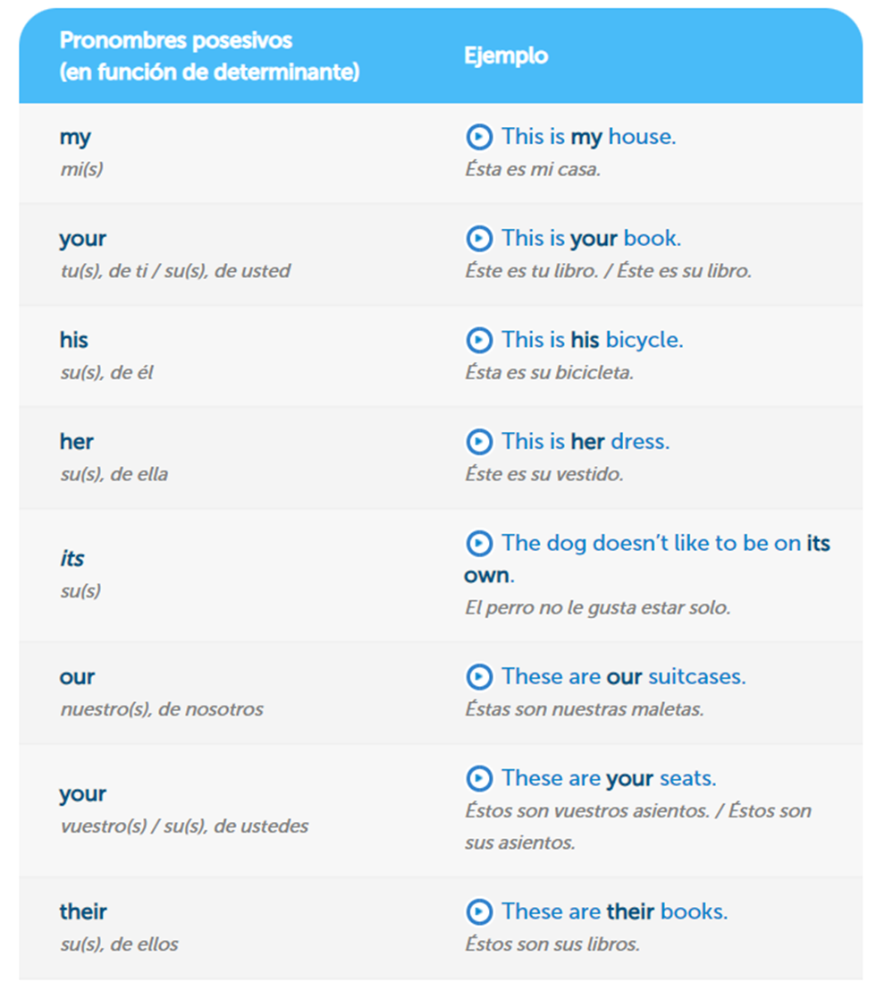

**Exercise 2.** Complete the sentences with a possessive adjective.

Example: My name´s Stephen.

1. Angela, please turn off ________her___ mobile phone.

2. The students are from Italy.______their_____ names are Susanna and Carlo.

3. London is famous for _______its____ red buses.

4. She`s French, but her mother is English.

5. We`re in Class 3._our_____ teacher is Bob.

6. _______his name____ name is Ian. He`s from Scotland.

7. I`m Mike._________my__ family are from Dublin.

**Exercise 3.** Write the questions.

Example: you how are ?: How are you?

1. his what`s name ? : What's his name?___________

2. German mother is her ? : ___Is her mother german?_________________

3. from your are where parents ? : __where are your parents from?__________

4. surname Simpson is your ? : _is simpson yur surname ____________

5. spell do how your name you ? : __how do you spellyour name ___________

**Exercise 4.** Traduce el siguiente vocabulario.

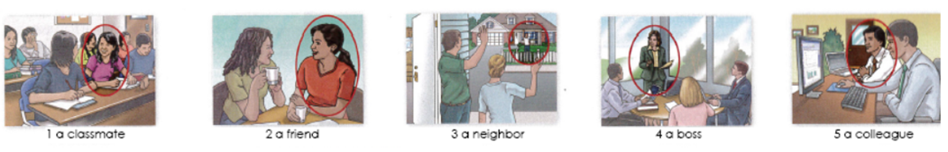

1. Comp@ñera de clase

2. Amiga

3. Vecin@

4. Jef@

5. Colega de trabajo

**Exercise 5.** Circle the correct word or words to complete each sentence.

1. Mr. Thomas is ( my / I) boss.

2. Is Mrs. Cory (you / your) teacher.

3. Is (she / her) Dr. Kim? 4. Are (they / their) Connie and Sam?

5. Are (*your* / you) Barry`s friend?

6. Hes (my / I) colleague. 7. Mr. Benson is (Alec / Alec`s) neighbor.

8. Jake is (Ms. Rose / Ms. Rose`s) student.

9. (He`s / His) an architect.

10 (Kyle / Kyle`s) and Ray`s classmate is Gail.