**Unit Activity #1 – U4**

*Nombre del Alumno: Dulce Violeta González Morales*

*Nombre del tema: Unit IV*

*Parcial: Fourth*

*Nombre de la Materia: English I*

*Nombre del profesor: Juan Manuel Jaime Díaz*

*Nombre de la carrera:*

*Cuatrimestre: 1st*

*Lugar y Fecha de elaboración*

Comitán de Domínguez Chiapas a 14 de diciembre de 2023.

**TOPIC 4**

**Exercise 1.** Write the name of the numbers.

1 One 11 -Eleven 30 - Thirty

2 - Two 12 – Twelve 40 - Forty

3 – Three 13 - Thirteen 50 - FiFty

4 - Four 14 -Fourteen 60 - Sixty

5 – Five 15 -Fifteen 70 - Seventy

6 – Six 16 -Sixteen 80 – Eighty

7 – Seven 17 - Seventeen 90 - Ninety

8 –Eight 18 – Eighteen 100 - One hundred

9 – Nine 19 - Nineteen 135 -One hundred and thirty-five

10 – Ten 20 -Twenty 192 -One hundred and ninety two

**Exercise 2.**  Complete with “am”, “is”, or, “are”.

1. My surname __is_____ López.

2. We ___are___ from Madrid.

3. I ____am___ Anna.

4. Antonio and Juan _are_______ in room 7.

5. He ___is____ the English teacher.

6. You _____are_ in Class 3.

7. She ____is__ a student.

**Exercise 3.** Complete the questions with “who”, “what”, “where” or “how”.

1. ___Who`s your favorite sport?

2. _Where`s Roberta from?

3. Who`s your favorite teacher?

4. ____Who___are you?

5. __What time is it?

6. ____Where___grade are you in?

7. _Wha_`s your last name?

8. _What old is Mark?

**Exercise 4.** Translate to English:

1. Grandfather-Abuelo
2. Grandmother-Abuela
3. Grandson-Nieto
4. Granddaughter-Nieta
5. Father-Padre
6. Mother-Madre
7. Wife-Esposa
8. Husband-Esposo
9. Son -Hijo
10. Daughter-Hija
11. Sister-Hermana
12. Brother-Hermano
13. Aunt-Tia
14. Uncle-Tio
15. Niece-Sobrino
16. Nephew-Sobrina

**Exercise 5.** Complete the questions. Use “how old is” or “how old are”.

1._How old are__ your sisters?

2. How old are_____ Matt`s parents?

3. How old is_______________ your grandfather?

4.__How old is_____________ Helen`s husband?

5. ___How old are____________ her children?

6. How ald is ___________ his son?

**Exercise 6.** Circle the correct word or words to complete each sentence.

1. Mr. Thomas is ( my / I) boss.

2. Is Mrs. Cory (you / your) teacher.

3. Is (she / her) Dr. Kim?

4. Are (they / their) Connie and Sam?

5. Are (your / you) Barry`s friend?

6. He`s (my / I) colleague.

7. Mr. Benson is (Alec / Alec`s) neighbor.

8. Jake is (Ms. Rose / Ms. Rose`s) student.

9. (He`s / His) an architect.

10 (Kyle / Kyle`s) and Ray`s classmate is Gail.

**Exercise 7.** Read about some famous actors and their families and friends.

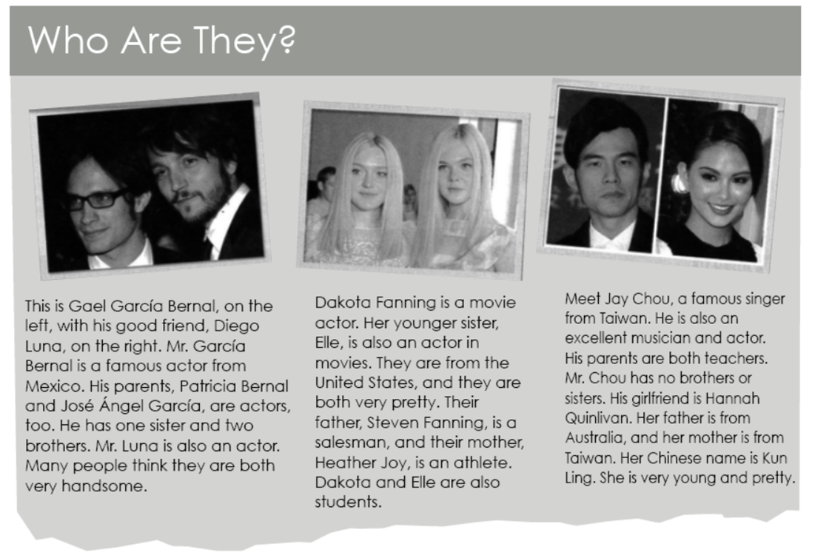

Now, complete the sentences.

1. Gael García Bernal is Diego Luna`s ___friend’s______.

2. Patricia Bernal, José Ángel García, and Diego

Luna are all ____actors______________.

3. Heather Joy is Steven Fanning`s _____wife_______.

4. Elle Fanning is Heather Joy`s__daughter____.

5. Mr. Chou`s ______firl friend__________ is good-looking.

6. Jay Chou`s parents have one ____son______.

**Exercise 8.** Complete each sentence with “have” or “has”. Then choose the correct response. Circle the letter.

1. Matthew _____has_______ two sisters.

a. How old is she? b. How old are they?

2. Mark and Jamie ___have_______ a daughter.

a. How old is her? b. How old is she?

3. I _____have_____ a brother and sister.

a. How old is your brother? b. How old is my sister?

4. We______have__ a son.

a What`s your name? b. What`s his name?

**Exercise 9.** Unscramble the words. Write sentences.

1. brother / tall / is / My / very

2. handsome / He / too / very / is

3. your / Are / pretty / sisters / ?

4. Is / daughter / young / Her

5. cute / so / is / she

1.My brother is very tall

2. He is very handsome too

3. Your are sisters pretty

4. Her is daughter young

5. She is so cute