

Unit Activity #1 – U3

*Nombre del Alumno: Mauricio Alexander Fernández Colín*

*Nombre del tema: Unit III*

*Parcial: Third*

*Nombre de la Materia: English III*

*Nombre del profesor: Juan Manuel Jaime Díaz Nombre de la carrera: BEN bachillerato en enfermería Semestre: 1st*

Comitán de Domínguez Chiapas a 06 de noviembre de 2023.

# TOPIC 3: WHERE ARE THEY?

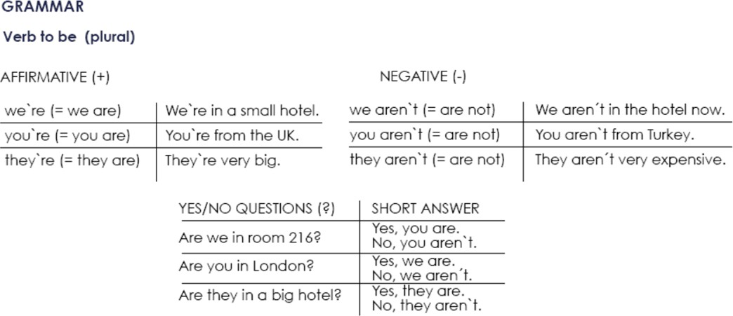

**Exercise 1.** Write the contractions: I`m, we`re, aren`t, etc.

1. We aren`t from Italy, we´re from Spain.
2. _it’s a new hotel, but it_ isn´t very nice.
3. _he´s a doctor and he _isn´t married.
4. You _aren´t Australian, _you´re American.
5. _she´s a manager and _she isn´t a musician.

**Exercise 2.** Complete each statement with a singular or plural form of “be”.

1. I am a writer.
2. She _is not a pilot.
3. We are doctors.
4. They are not scientists.
5. We _are managers.
6. He _is a singer.

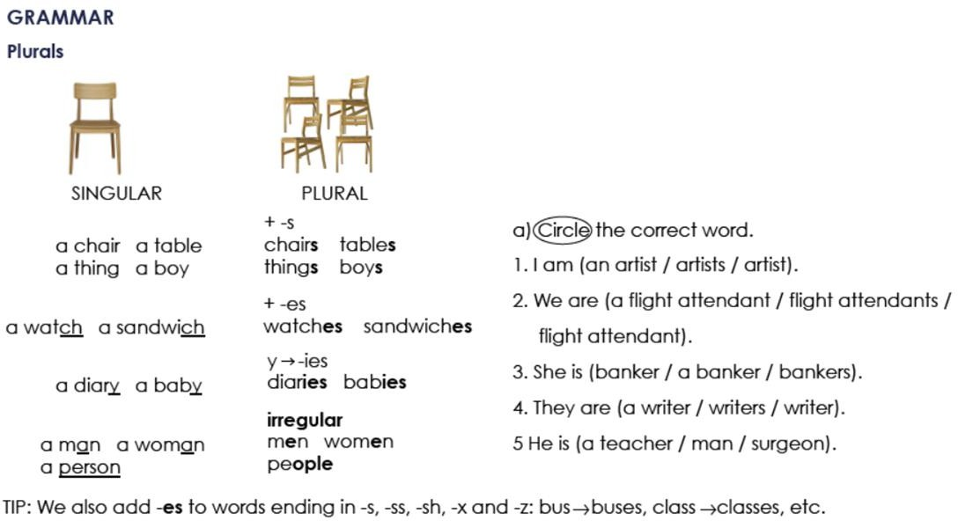

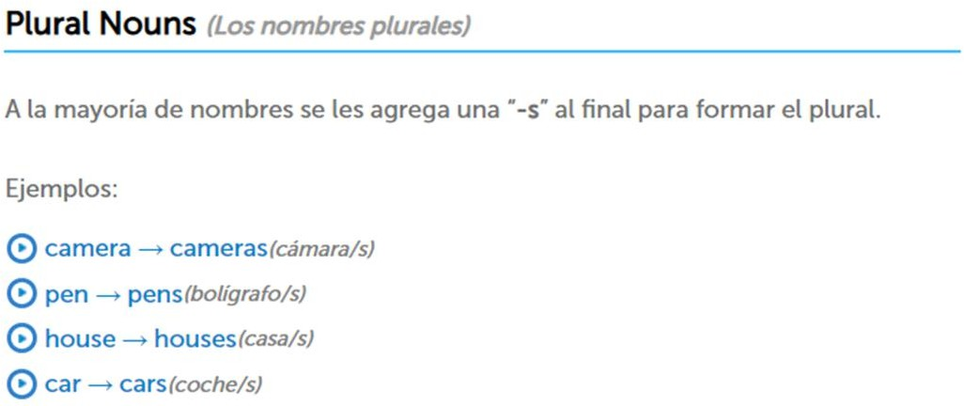

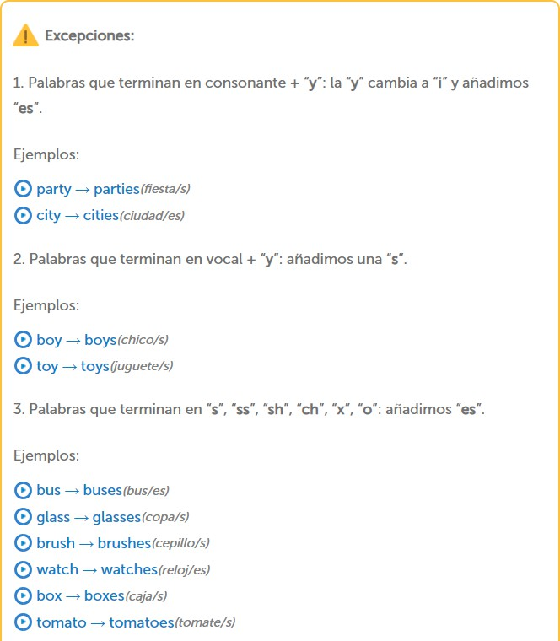

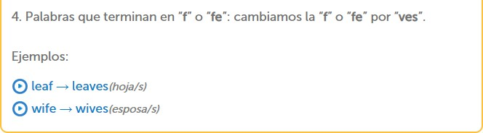

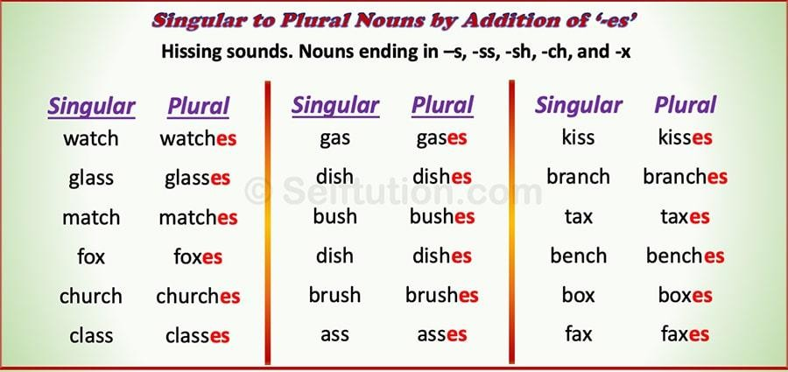

**Exercise 3.** Write the plural of:

1. Baby-babies
2. Cake-cakes
3. Church-churches
4. Glass-glasses
5. Wife-wives
6. Fish-fishes
7. Month-months
8. Child-children
9. Wish-wishes
10. Woman-women
11. City-cities
12. Man-men
13. Box-boxes
14. Foot-foots
15. Mouse-mice
16. Leaf-leaves
17. Sheep-sheep
18. Tomato-tomatoes

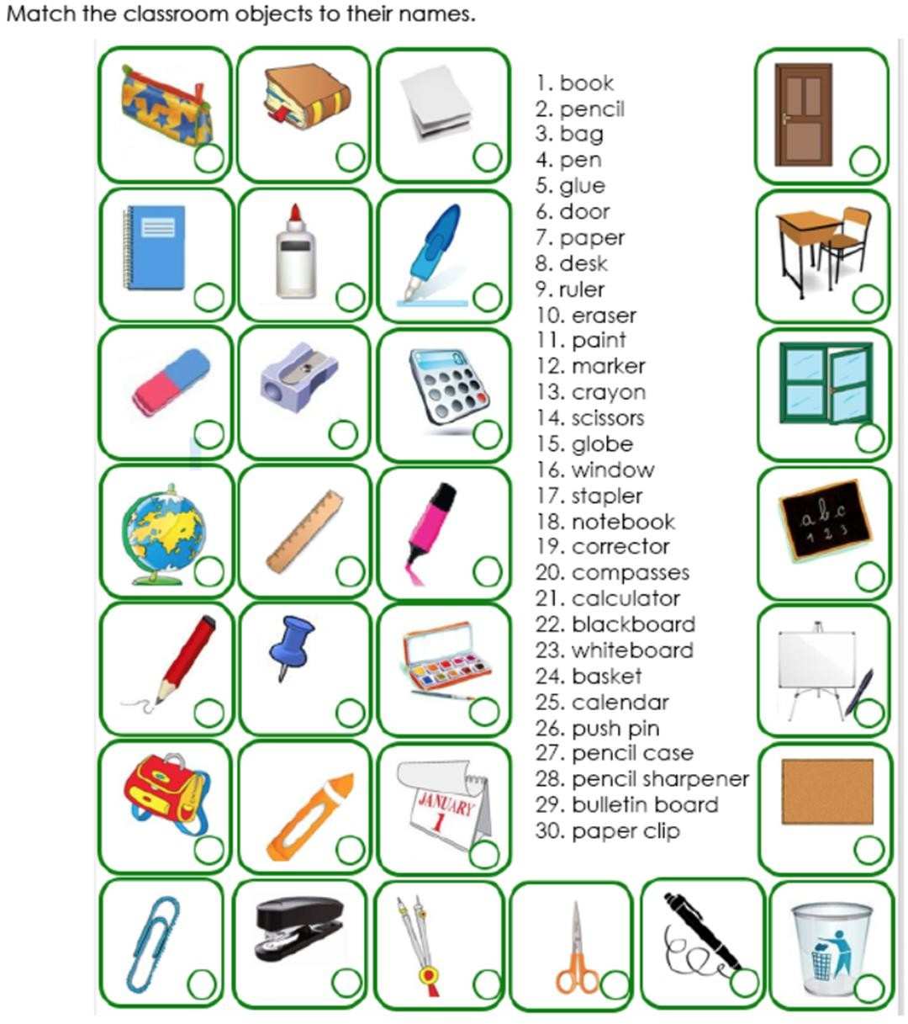**1**

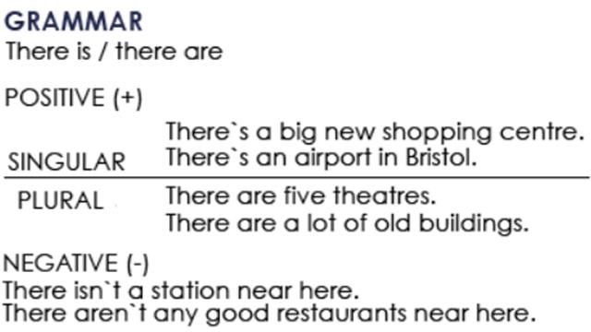

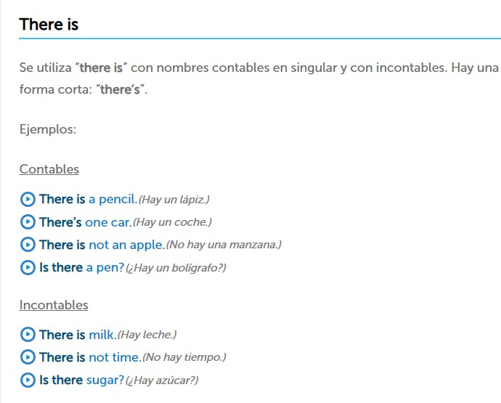

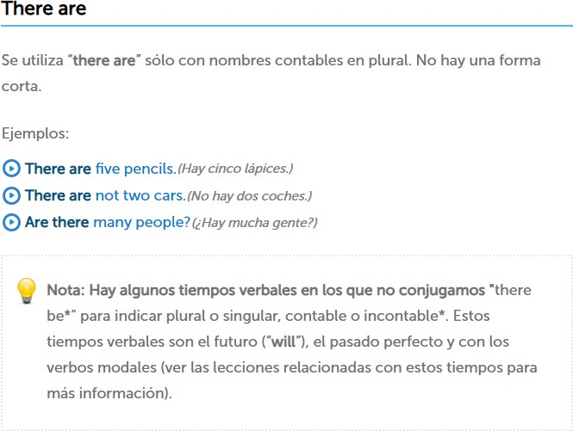

**Ejercicio #4 -** Completa las siguientes frases con la forma correcta de "there is or There are".

1. there are 5 apples in the bowl.
2. is there any water?
3. there isn´t (not) any sugar in the coffee.
4. there aren´t (not) any tomatoes in the salad.
5. _there is some wine in the glass.
6. is there any money in your wallet?
7. there is a problem with this phone.
8. _are there any vegetables in this recipe?

**Ejercicio #5 -** Escribe las palabras en el orden correcto.

many / aren’t / this / pages / there / in R: in there pages aren´t this many

any / eggs / there / the / in / are / fridge / ? R: there are the eggs in any fridge?

is / nearby / restaurant / nice / there / a R: there are is a nerby nice restaurant

dining / are / chairs / in / room / there / three / the R: there are three chairs in the dinig room

hospital / there / this / isn't / a / in / town R: there isn´t a hospital in this town

here / is / bank / there / a / near / ? R: here is there a near bank ?

# TOPIC 4: PERSONAL INFORMATION

**Exercise 1.** Contesta las siguientes preguntas.

1. What`s your first name? A:my name is karol
2. What`s your surname or last name? A:my surname is Hernández
3. What`s your nationality? A:i´m Mexican
4. What`s your address? A:my address is chichima
5. What`s your mobile number? A:my mobile number is 963 144 2167
6. What`s your mail address?.

A:my mail address is [kkarolsoliss@gmail.com](mailto:kkarolsoliss@gmail.com)

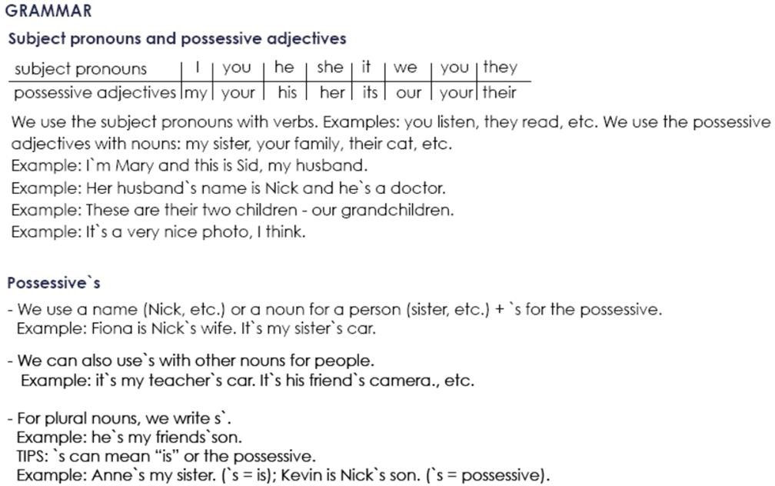

## Possessive Adjectives - Adjetivos Posesivos

Se utilizan para indicar a quién pertenece el sujeto u objeto de la oración. Van seguidos de un sustantivo (o una cláusula nominal).

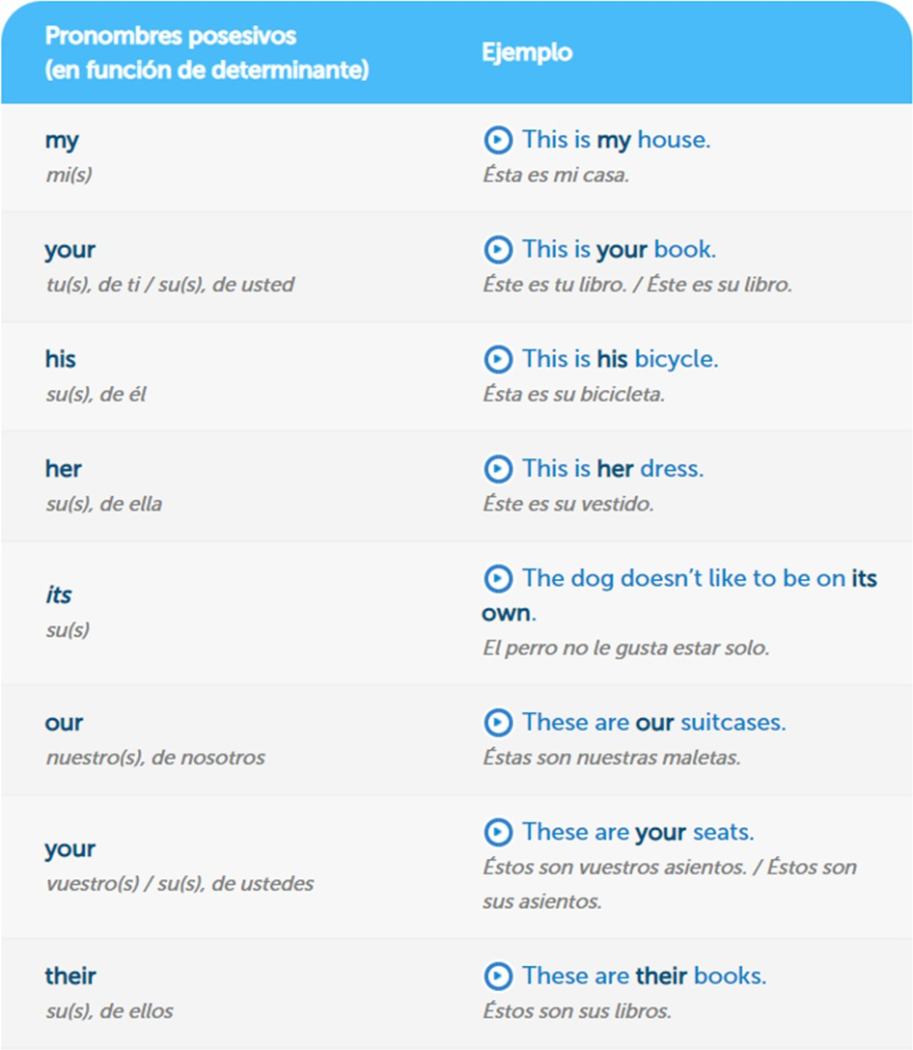

**Exercise 2.** Complete the sentences with a possessive adjective. Example: My name´s Stephen.

1. Angela, please turn off _her mobile phone.
2. The students are from Italy. their names are Susanna and Carlo.
3. London is famous for its red buses.
4. She`s French, but her mother is English.
5. We`re in Class 3. our teacher is Bob.
6. _his name is Ian. He`s from Scotland.
7. I`m Mike. my family are from Dublin.

**Exercise 3.** Write the questions.

Example: you how are ?: How are you?

1. his what`s name ? : what´s his name?
2. German mother is her ? : _is her mother german?
3. from your are where parents ? : _where are your parents from?
4. surname Simpson is your ? : is simpson your surname?
5. spell do how your name you ? : how do you spell your name?

**Exercise 4.** Traduce el siguiente vocabulario.

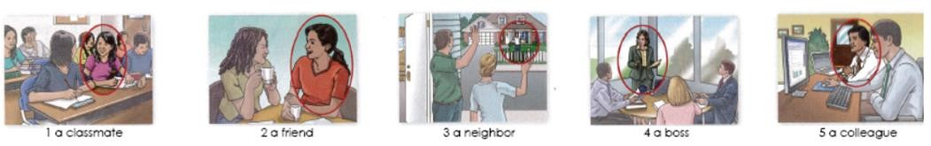

1. Un compañero de clase
2. Un amigo
3. Un vecino
4. Un jefe o jefa
5. Un colega

**Exercise 5.** Circle the correct word or words to complete each sentence.

1. Mr. Thomas is ( my / I) boss.
2. Is Mrs. Cory (you / your) teacher.
3. Is (she / her) Dr. Kim?
4. Are (they / their) Connie and Sam?
5. Are (your / you) Barry`s friend?
6. He`s (my / I) colleague.
7. Mr. Benson is (Alec / Alec`s) neighbor.
8. Jake is (Ms. Rose / Ms. Rose`s) student.
9. (He`s / His) an architect.

10 (Kyle / Kyle`s) and Ray`s classmate is Gail.