

**Nombre de alumno: Litzy Fernanda Domínguez León**

**Nombre del profesor: Juan Manuel Jaime Diaz**



**Nombre del trabajo: Unit Activity #1 - U1 4BEN**

**Materia: INGLES IV**

**Grado: 2**

**Grupo: A**

Comitán de Domínguez Chiapas a 17 de marzo de 2023.

**APPEARANCE AND HEALTH - Vocabulary**

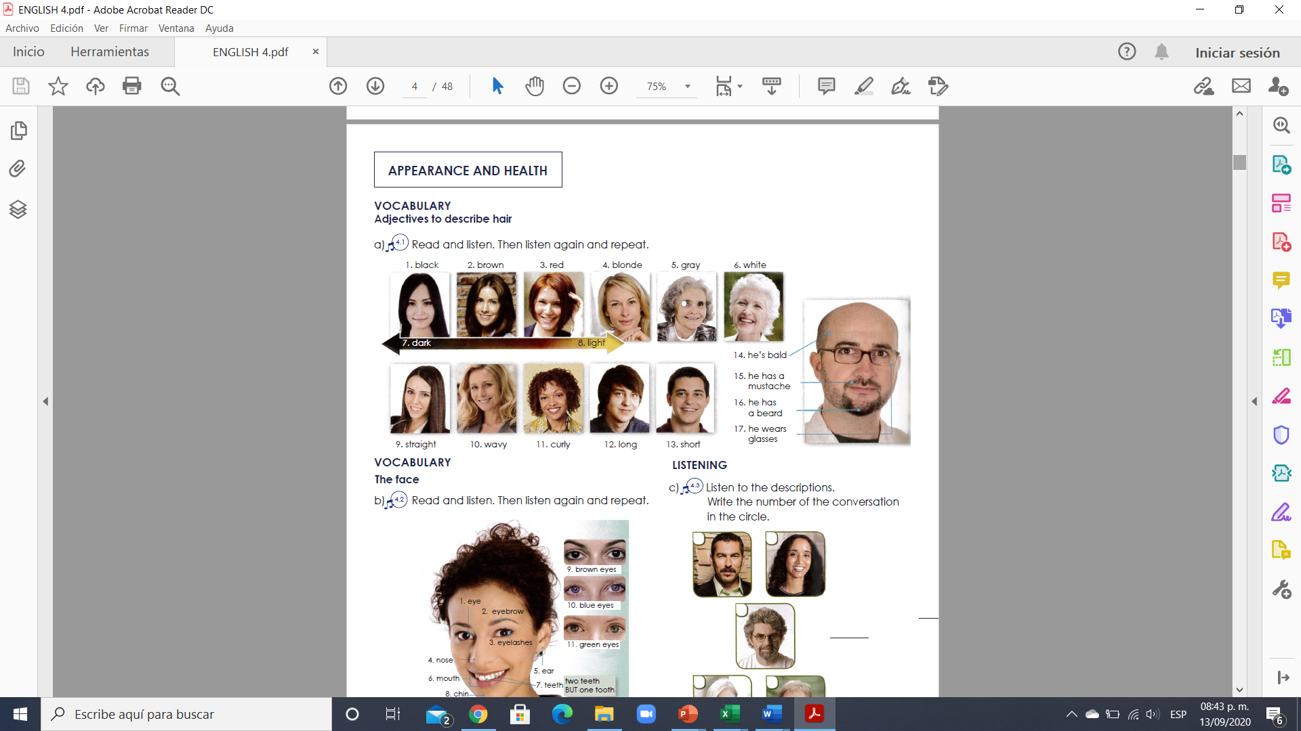

**Exercise 1.** Translate to spanish the vocabulary above. Traduce al español el vocabulario de arriba.

1. NEGRO 10. ONDULADO

2. CAFE 11. RIZADO

3. ROJO 12. LARGO

4. RUBIO 13. CORTO

5. GRIS 14. ES EL CALVO

6. BLANCO 15. ES TIENE BIGOTE

7. OSCURO 16. EL TIENE BARBA

8. CLARO 17. EL USA LENTES

9. LACIO

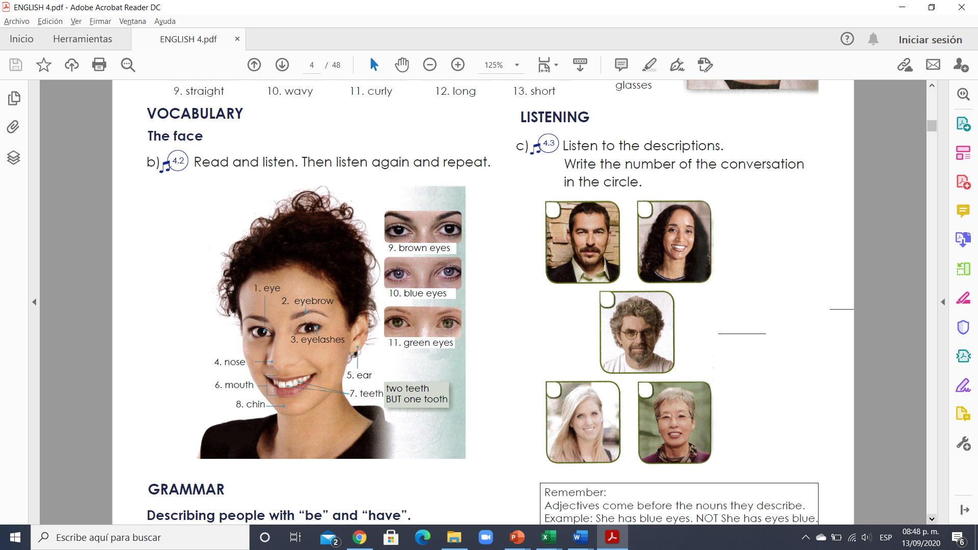

**Exercise 2.** Translate to spanish the vocabulary above. Traduce al español el vocabulario de arriba.

1. OJOS 7. DIENTES

2. CEJAS 8. BARBILLA

3. PESTAÑAS 9. OJOS CAFES

4. NARIZ 10. OJOS AZULES

5. OREJA 11. OJOS VERDES

6. BOCA

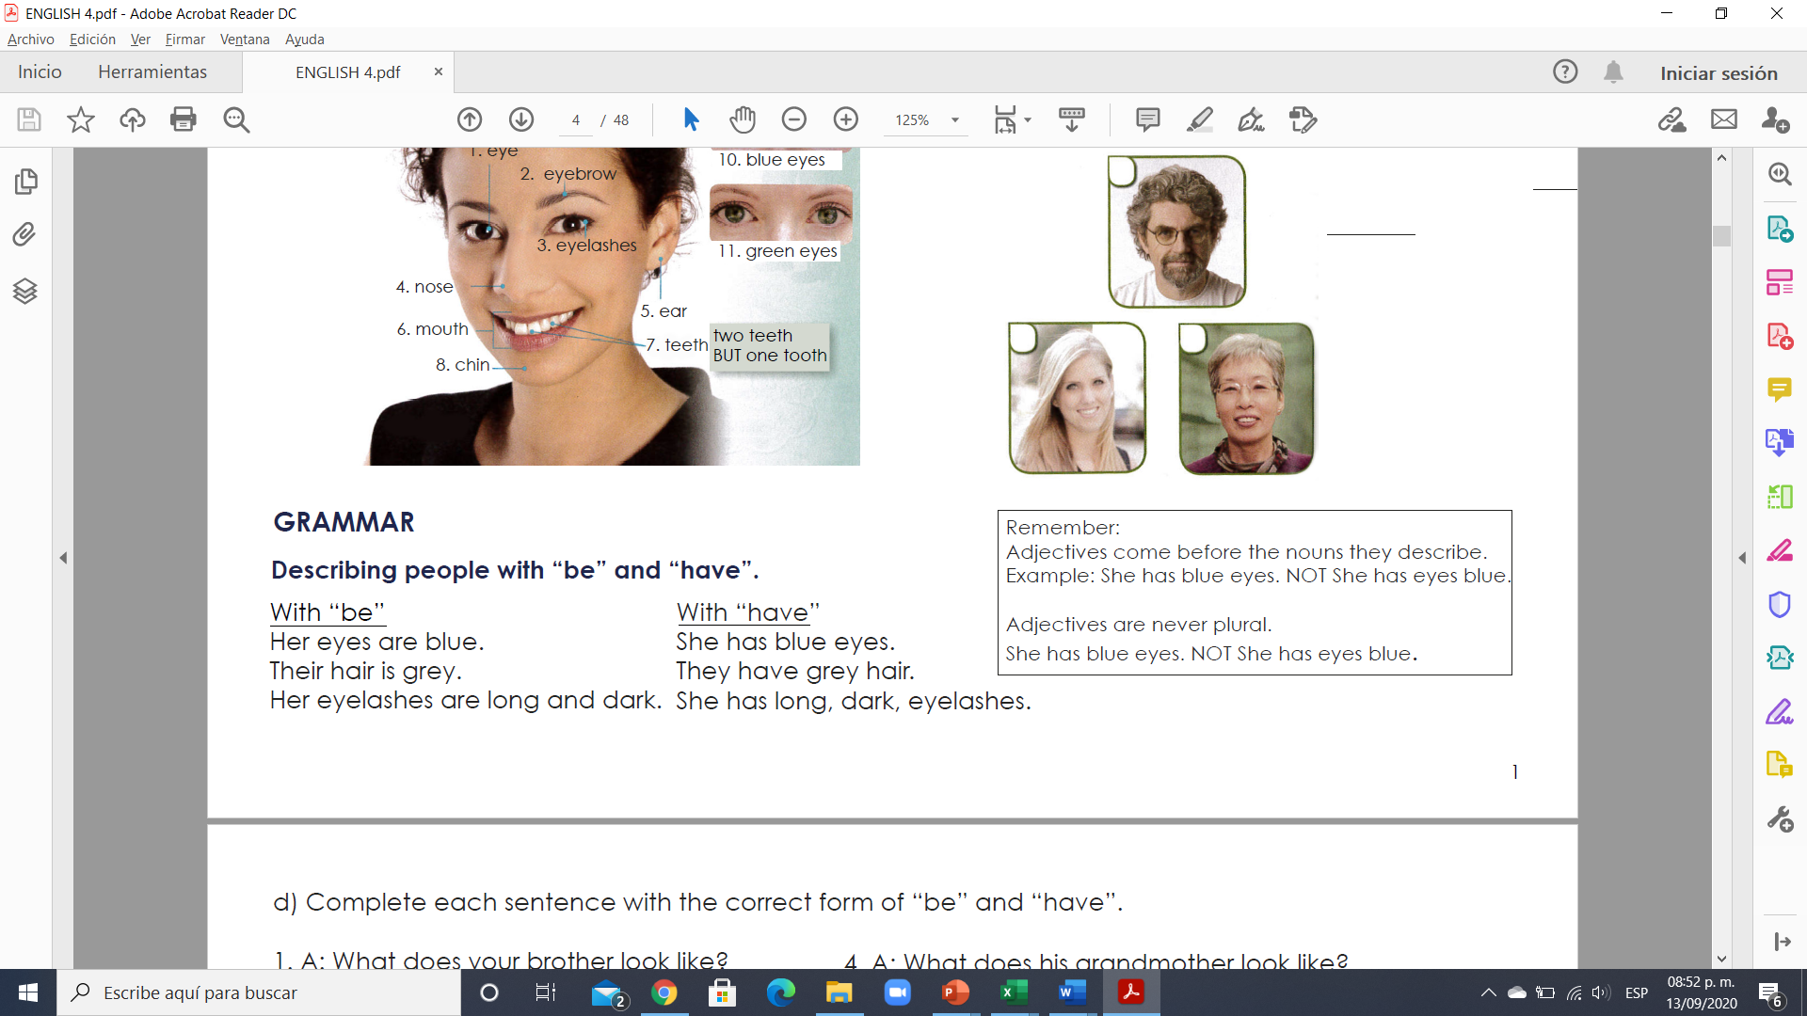

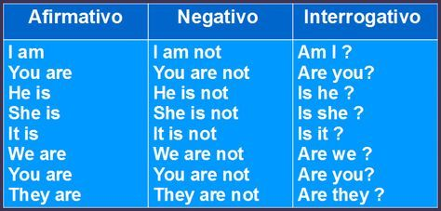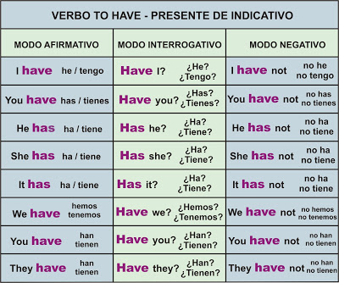

**VERBO TO BE**

**Exercise 3.** Complete each sentence with the correct form of “be” and “have”.

1. A: What does your brother look like?

B: Well, he _____have____ a mustache and wavy hair.

And he wears glasses.

2. A: What does your mother look like?

B: Her hair _____have____ curly and black.

3. A: What does her father look like?

B: He ___be___ a short, gray beard.

4. A: What does his grandmother look like?

B: She ___have___ curly, gray hair and beautiful eyes.

5. A: What does his sister look like?

B: His sister? Her hair ______have____ long and pretty!

6. A: What do your brothers look like?

B: They _____be _____ straight, black hair, and they wear glasses.

**Exercise 4.** Write a sentence with “be” and a sentence with “have”.

**Example:**

**1. Kate / hair/ long / straight**

(using “be”) a. Kate’s hair is long and straight

(using “have”) b. Kate has long straight hair

**2. George / short/ black hair**

(using “be”) a. George must be short bleached hair

(using “have”) b. George have short black hair

**3. Harry/ long / curly/ hair**

(using “be”) a. harry hair must be long and curly

(using “have”) b. harry have long curly hair

**4. Mary/ eyes/ blue**

(using “be”) a. mary a de be of blue eyes

(using “have”) b. Mary have blue eyes

**5. Amy/ pretty/ eyes**

(using “be”) a. Amy eyes must be very pretty

(using “have”) b. Amy have pretty eyes

**VOCABULARY**

**Parts of the body**

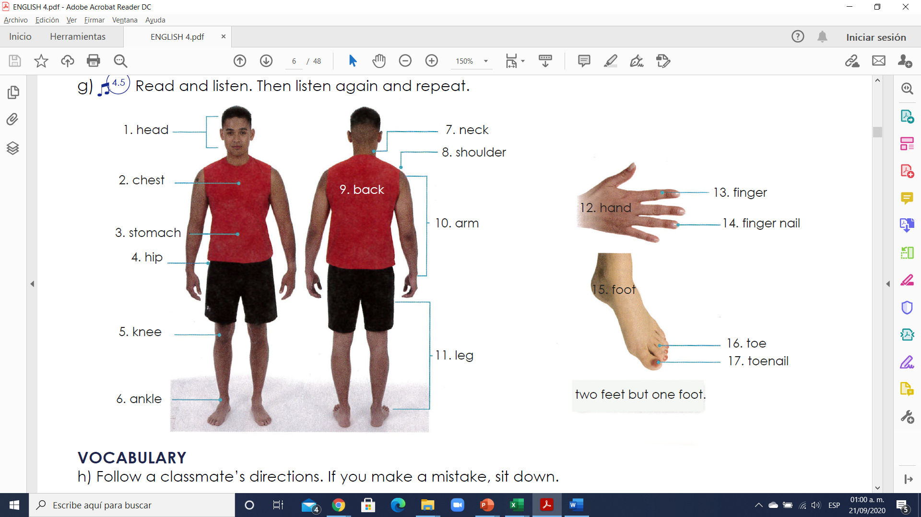

**Exercise 1.** Translate to Spanish the vocabulary above. Traduce al español el vocabulario de arriba.

1. CABEZA 10. BRAZO

2. PECHO 11. PEIERNAS

3. ESTOMAGO 12. MANO

4. CADERA 13. DEDOS

5. RODILLAS 14. UÑA DE LOS DEDOS

6. TOBILOS 15. PIE

7. CUELLO 16. DEDO

8. HOMBRO 17. UÑA DE LOS DEDOS

9. ESPALDA

**VOCABULARY -Ailments (Enfermedades/Dolores)**

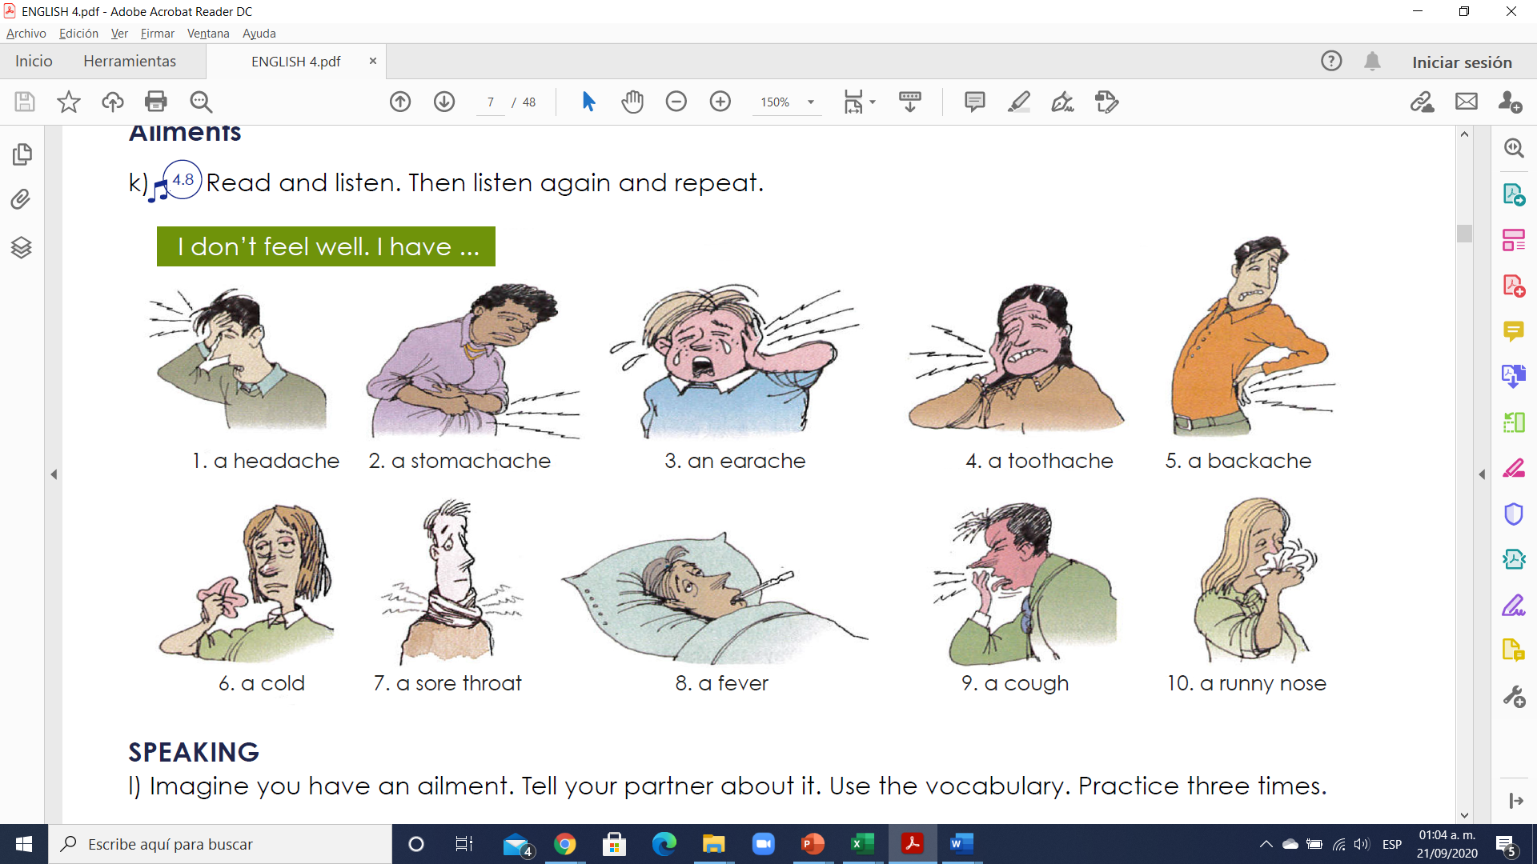

**Exercise 2.** Translate to Spanish the vocabulary above. Traduce al español el vocabulario de arriba.

1. DOLOR DE CABEZA 6. RESFRIADO

2. DOLOR DE ESTOMAGO 7. DOLOR DE GARGANTA

3. DOLOR DE OIDO 8. FIEBRE

4. DOLOR DE DIENTES 9. TOS

5. DOLOR DE ESPLADA 10. ESCURRIMIENTO NASAL

**VOCABULARY - Remedies**

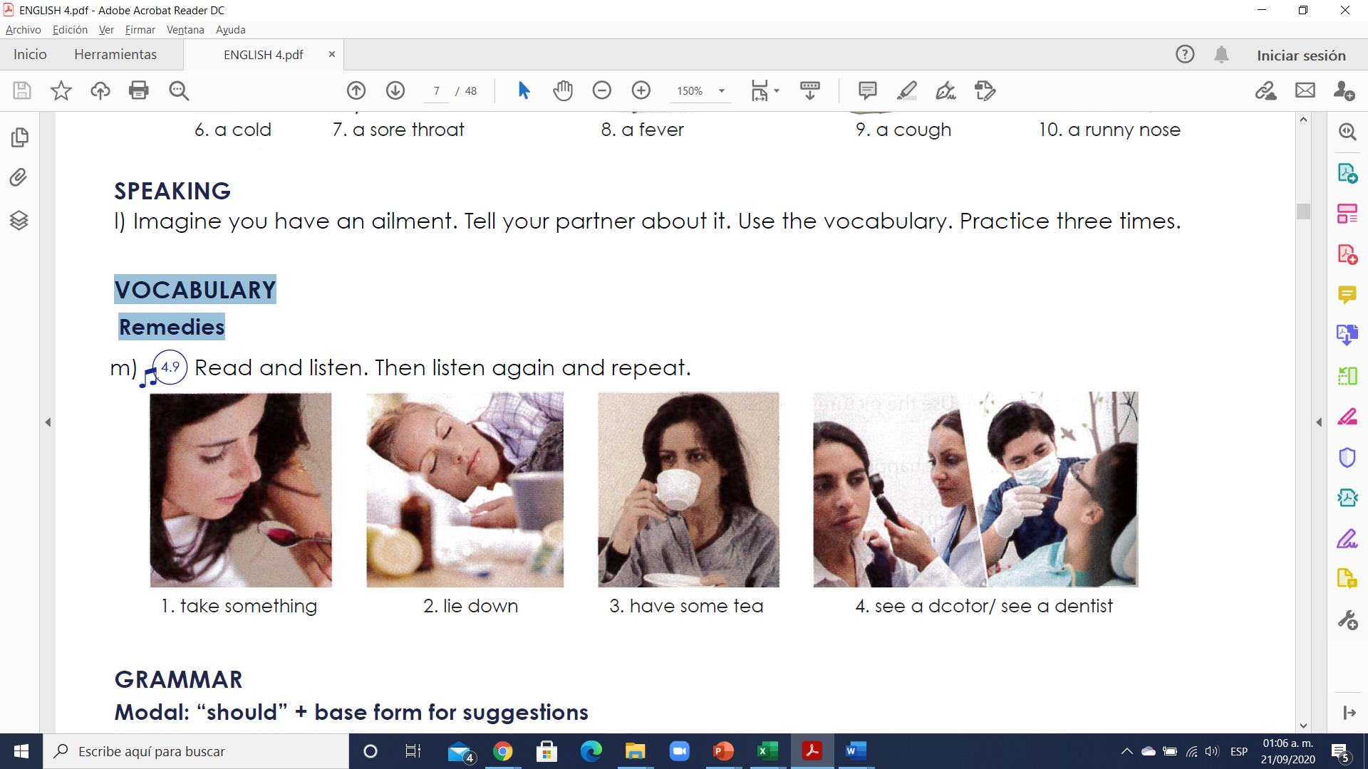

1.Toma algo.

2. Recuéstate.

3. Toma un té.

4. Ve un doctor / ve un dentista.

**Exercise 3. Escribe 8 oraciones usando el vocabulario de arriba**

EXAMPLE: I HAVE A COLD; I SHOULD SEE A DOCTOR.

1. MARIO AND CARLOS HAVE A STOMACHACHE

2. FERNANDA HAS A COLIC, SHE SHOULD LIE DOWN

3. DANIELA HAS A BACKACHE, SHE SHOULD GO TO THE QUIROPRAC

4. EMMANUEL SHOULDN’T GO SHOPPING

5. CAMILA HAS A TOOTHACHE SHE SHOULDN’T EAT

6. JORGE SHOULDN’T GO TO THE PARK, HE HAS A COLD

7. DANIELA BROKE HER LEG, SHE SHOULDN’T BE WALKING

8. ANTONIO HAS A COLD. HE SHOULD GO TO THE DOCTOR

**GRAMMAR - Modal: “should” + base form for suggestions**

Should: deberia

Shouldn’t: no deberia

Should not: no deberia

**Usos**

1. **Dar consejos** (**give advice**); ejemplo:

-I think you should go to the doctor. (Creo que debes ir al médico)

-You shouldn’t drink alcohol. (No deberías beber alcohol)

2. **Mostrar obligación** o deber (obligation or duty) para decir qué el lo correcto

–You should wear a helmet when riding a motorcycle. (Usted debe usar un casco cuando conduzca una motocicleta)

-You shouldn’t smoke in here. (No deberías fumar aquí)

3. **Mostrar probabilidad o expectativa** (probability or expectation)

-They should be here soon. (Deberían esta aquí pronto)

-I believe 200 dollars should be enough for the trip. (Creo que 200 dólares deberían ser suficientes para el viaje)

**Estructura**

**a) Affirmative:** después de SHOULD el verbo no debe tener TO, sólo la forma base.

He should call an ambulance right now. (El debería llamar una ambulancia ahora mismo)

**b) Negative:** la forma sin es contracción es **SHOULD NOT** y con contracción es **SHOULDN’T**; ambas formas son correctas.

-They shouldn’t cheat on the Spanish exam. (Ellos no deben hacer trampa en el examen de español)

-That soccer player should not dive all the time; it´s not fair play. (Ese jugador de futbol no debería fingir/echarse a la piscina todo el tiempo; no es juego limpio)

**c) Interrogative:** debemos usar SHOULD antes del SUJETO.

–Should I take a summer course at college? (¿Debo tomar un curso de verano en la universidad?)

-Yes, you should. (Sí) -No, you shouldn’t. (No)

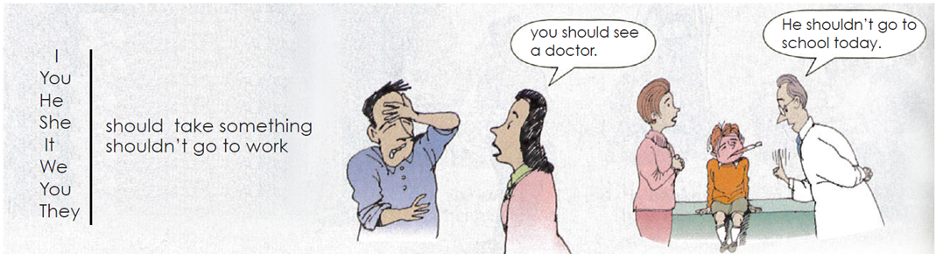

**Exercise 4.** Complete each sentence with **“should o shouldn´t”** and a verb form the box.

1. It’s your birthday. You should go out for dinner!

2. I’m sorry you have a toothache. You SHOULD **(see)** a dentist.

3. There’s a movie on TV tonight. We SHOULD **(watch)** it.

4. You have a cold? You SHOULDN´T **(not exercise)** today.

5. We have tomatoes, potatoes, and onions. We SHOULD **(make)** tomato potato soup for dinner tonight!

6. Pam’s taking a shower right now. You SHOULD **(call)** back later.

7. Martin has a headache. He SHOULDN´T **(not play)** soccer tonight.

8. It’s time for bed. You SHOULD **(get)** undressed.