

**Nombre de alumno: Litzy Fernanda Domínguez León**

**Nombre del profesor: Juan Manuel Jaime Díaz**



**Nombre del trabajo:**

**Unit**

**Activity**

**#1**

**-**

**U**

**2**

**4**

**BEN**

**Materia:**

**INGLES IV**

**Grado: 4**

**Grupo: A**

Comitán de Domínguez Chiapas a 17 de abril de 2023.

**VOCABULARY**

# Abilities

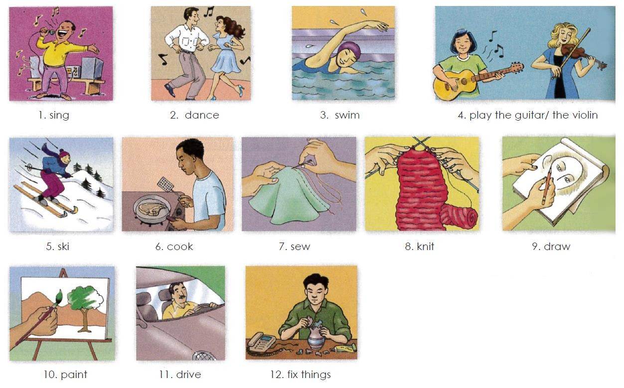

**Exercise 1.** Translate to Spanish the vocabulary above. Traduce al español el vocabulario de arriba.

1. Cantar 7. Costurar

2.bailar 8. Bordar

1. Nadar 9. Dibujar
2. Tocar guitarra/ tocar violín 10. Pintar

5.squiar 11. Manejar

6.cocinar 12. Reparar cosas

# Grammar - Adverbs “well” and “badly”

Use **“badly”** if your sentence is active. You should determine if your sentence involves how an action is/was performed. This means it is active and requires an adverb, such as "badly."

For instance, in the sentence “I feel badly since my fingers were burned,” the word “feel” is used actively as an action. Instead of describing an emotional state, the sentence now describes a person’s ability to touch. Therefore, the adverb “badly” is used.

**Badly** es un adverbio, lo que significa que describe los verbos o las acciones además de otros adjetivos y adverbios. Por ejemplo, cuando alguien “habla mal”, cuando alguien “cocina mal”, cuando alguien “conduce mal” etc, usamos badly. Es decir, Badly cataloga lo mal que se realiza algo.

Ejs: Su novia canta bastante mal. His girlfriend sings pretty badly.

Él juega muy mal al fútbol. He plays football very badly*.

Él está mal vestido He’s badly dressed.

Use **“well”** if your sentence is active. Once you understand that the meaning of your sentence is active in nature, use the adverb “well” to further your explanation of how an action is/was performed.

For instance, in the sentence “I feel well now that my fingers have healed,” the word “feel” is used actively as an action. Instead of describing an emotional state, the sentence now describes a person’s ability to touch (or to “do” something well—which is an action). Therefore, the adverb “well” is used.

Un adverbio nos dice de que manera se hace la acción. Cuando **WELL** se usa como adverbio significa que la acción se hace bien, de manera adecuada, con claridad, etc.

I could not hear the teacher well. - No pude escuchar el profesor con claridad.

Things are going well. - Las cosas van bien.

He did his job well. - El hizo su trabajo bien/adecuadamente.

**Exercise 2.** Escribe 3 oraciones usando well y 3 oraciones usando badly usa el vocabulario de arriba

**Well**

1. **ANTONIO AND JORGE DRIVES THE MOTORCYCLE VERY WELL**
2. **LEXA SWINS WEY WELL**

## 3. HE DANCES VERY WEELL

**Badly**

1. **LEXA COOKS VERY BADLY**
2. **JORGE PAINTS WER BADLY**
3. **MICELLI DRIVES VERY BADLY**

# Grammar - “Can” and “can´t” for ability

We use “can” or “can’t” + the base form of a verb to talk about ability.

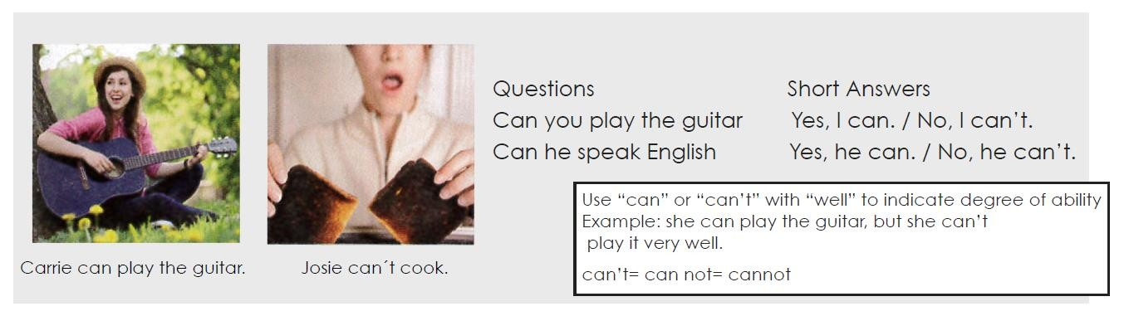

**Exercise 3.** Complete each conversation with “can” or “can’t” and the base form of a verb.

1. **A: CAN you PLAY the guitar?**

**B: Yes, I CAN. But I don´t play well.**

1. **A: CAN Gwen SWINS well?**

**B: Yes, she CAN. She swims very well.**

1. **A: CAN your brother COOK?**

**B: My brother? No. He CAN cook at all.**

1. **A: CAN Gloria SPEAK English well.**

**B: No, she CAN´T. She needs this class.**

1. **A: CAN your mother KINT?**

**B: Yes. She knits very well.**

1. **A: CAN your sisters SKING?**

**B: Yes. They go skiing every weekend.**

**Exercise 4.** Answer the questions with true information. Use short answers with “can” or “can’t”.

1. Can you play the piano? **I CAN PLAY, I DO IT WELL**
2. Can you ski**? I CAN´T IT DOESN´T WORK OUT FOR ME**
3. Can your parents sing well? **THEY CAN, THEY DO IT VERRY WELL**
4. Can your friend speak English? **SHE CAN, SHE DOES IT WELL**
5. Can you draw? **I CAN´T DO IT**
6. Can your father fix things? **HE CAN, HE DOES IT WELL**

# Grammar - Too + adjective

“Too” makes an adjective stronger. It usually gives it a negative meaning.

Example: I’m too busy. I can’t talk right now.

Example: I’m too tired. Let’s not go to the movies.

Example: It’s too late. I should go to bed.

**Exercise 5**.

**1. I don’t want these shoes. They’re TO EXPENSIVE.**

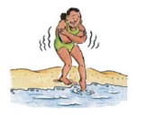 **2. It’s TOO COLD today. She can´t go swimming.**

** 3. I’m TO FIRED I can’t read right now.**

** 4. He doesn’t want that shirt. It’s TOO SMALL**

** 5. I can´t talk right now. I’m TO BUSY**

** 6. It’s TOO LATE for a movie. We should go to bed.**

**Exercise 6.** Complete each sentence. Use “too” and an adjective.

**1. I need a new dress. This dress is too old.**

**2.This skirt is TOO LARGE I want a short skirt.**

1. **His shirt is TOO LARGE. He needs size small.**
2. **I don’t want that suit. It’s TOO EXPENSIVE.**
3. **He needs size medium. This shirt is TOO SMALL**