

**Nombre de alumno: Marely Concepción Jiménez Gordillo**

**Nombre del profesor: Juan Manuel Jaime**

**Nombre del trabajo: Unit Activity #1 – U2 2BEN**

**Materia: English**

**Grado: 2° semestre**

**Grupo: BEN01EMM0122-A**

Comitán de Domínguez Chiapas a 17 de abril de 2023.

**DESCRIBE CITIES**

**VOCABULARY**

**Exercise 1.** Match the adjectives to pictures a-h. (Escribe la letra de la figura que concuerda con la palabra)

( d ) - good.

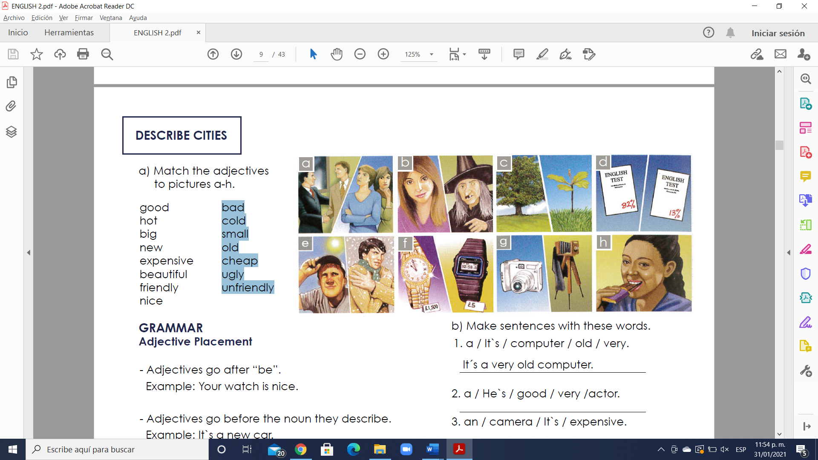( **e** ) - hot.

( c ) - big

( g ) - new

( f ) - expensive

( b ) - beautiful

( a ) - friendly

( h ) - nice

( d ) - bad

( e ) - cold

( c ) - small

( g ) - old

( f ) - cheap

( b ) - ugly

( a ) - unfriendly

**GRAMMAR**

**Adjective Placement**

- Adjectives go after “be”.

Example: Your watch is nice.

- Adjectives go before the noun they describe.

Example: It`s a new car.

- Adjectives are not plural with plural nouns.

They´re good friends.

Example: They´re good friends.

NOT ~~They´re goods friends.~~

**Exercise 2.** Make sentences with these words. (Realiza las oraciones ordenando las palabras)

1. a / It`s / computer / old / very.

A: It´s a very old computer.

2. a / He`s / good / very /actor.

A: He’s a very good actor

3. an / camera / It`s / expensive.

A: It’s an expensive camera

4. very / nice / friends / are / His.

A: His friends are very nice

5. good / musician / a / She`s.

A: She’s a good musician

6. is / very / house / beautiful / Her.

A: Her house is very beautiful

7. a / It`s / night / cold / very.

A: It’s a very cold night

8. friendly / children / Your / very / are.

A: Your children are very friendly

**GRAMMAR - Present Simple ( I, you, we, they)**

- We use the Present Simple when something is generally or always true.

Example: People need food.

- We use the Present Simple for a situation that we think is more or less permanent.

Example: She works in a bank.

- We use the Present Simple for habits or things that we do regularly. We often use adverbs of frequency, such as “often”, “always”, “sometimes”.

Example: I always play tennis on Tuesday.

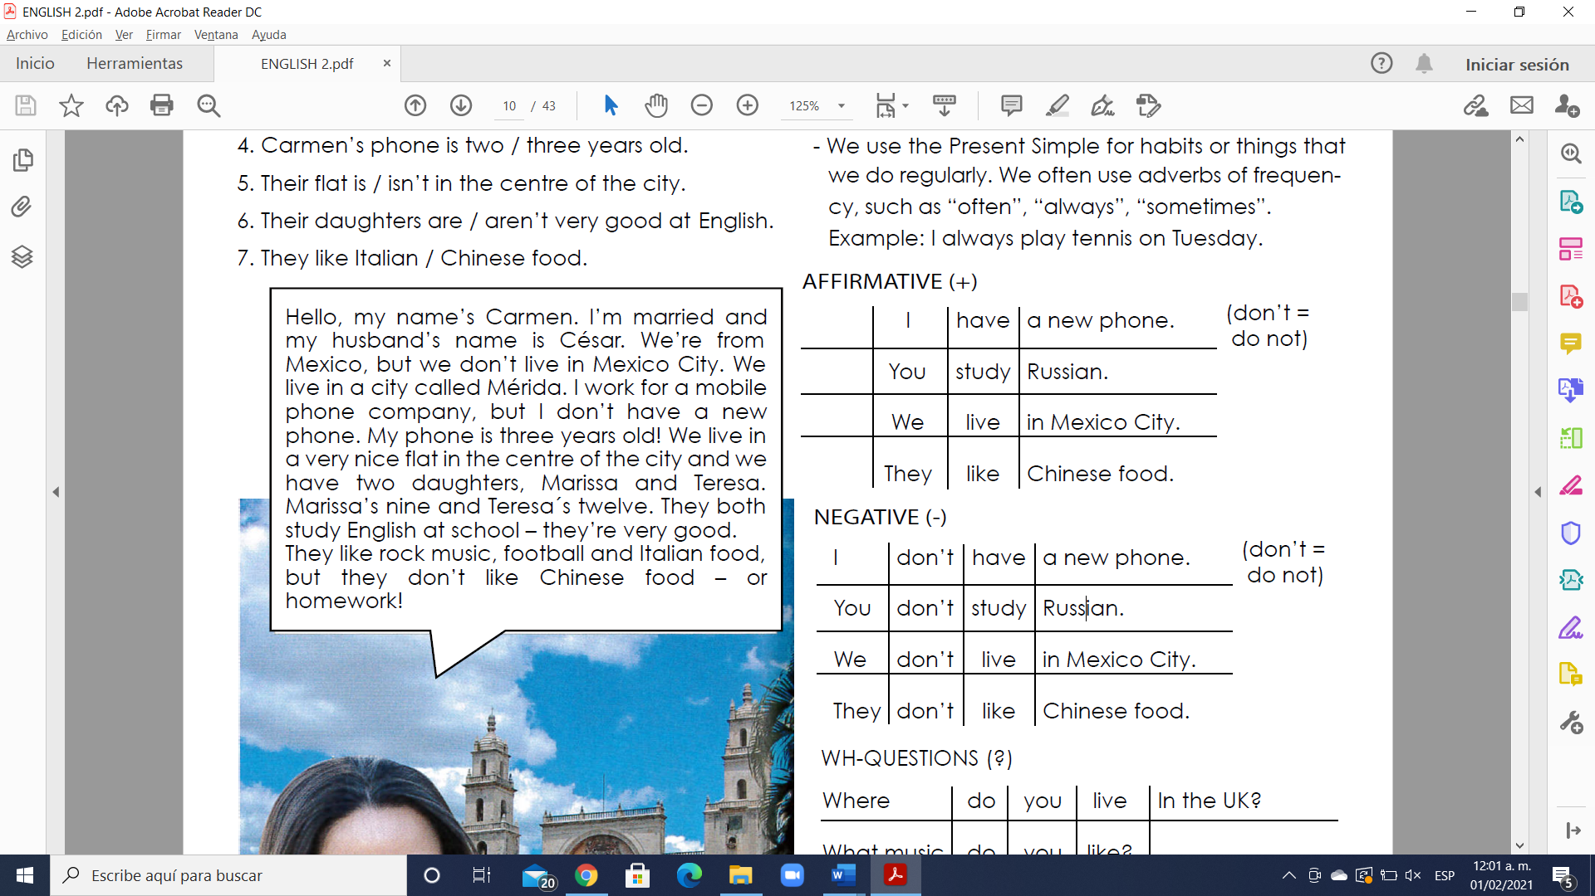 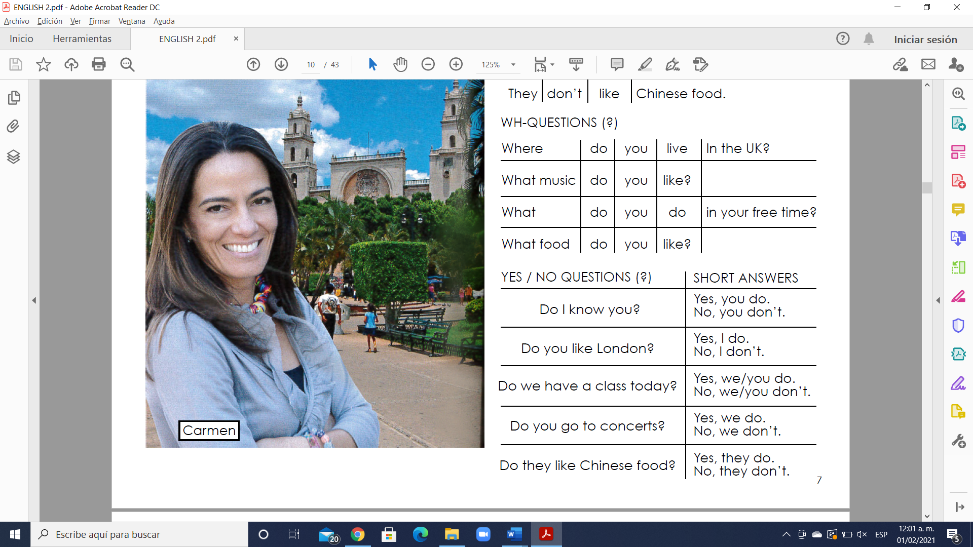

**Simple present**

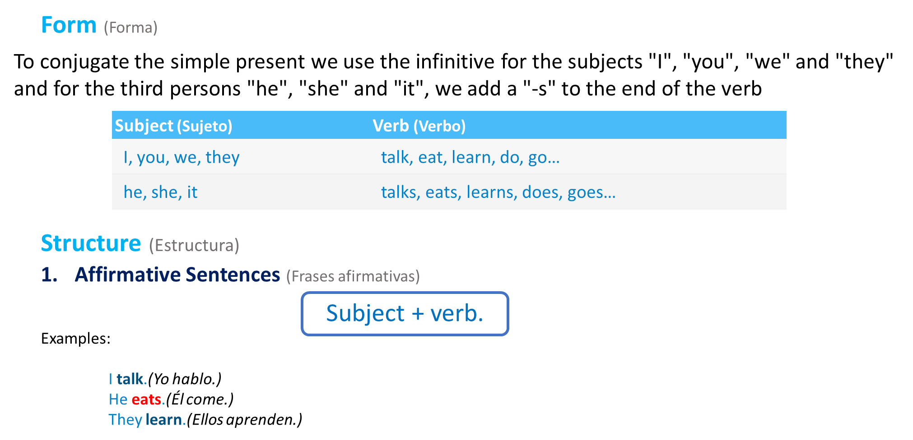

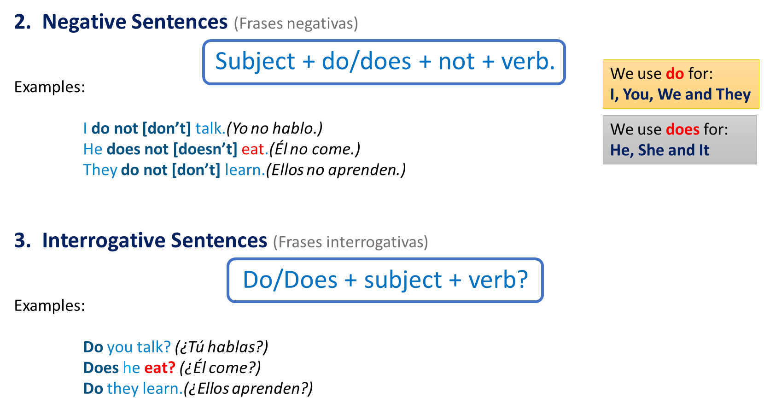

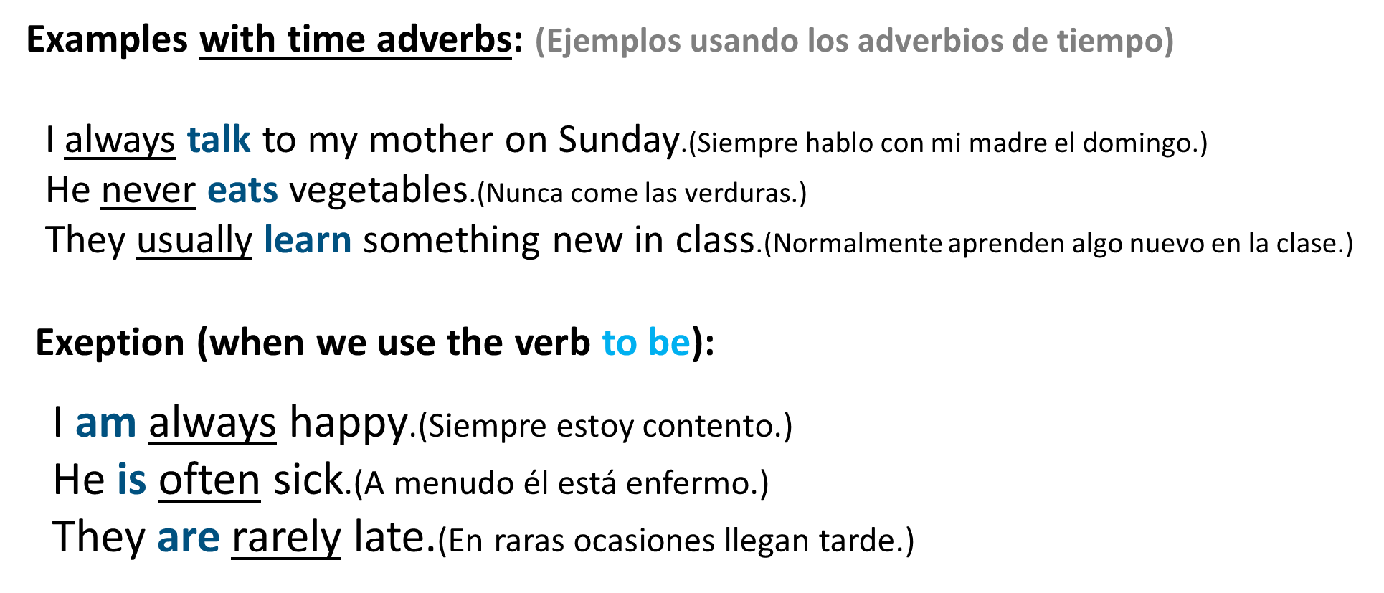

**Exercise 3.** Change the sentences to negative and question. (Cambia la oración afirmativa a oraciones negativas y preguntas)

1. I live in the center of the city.

N. I don´t live in the center of the city

Q. Do you live in the center of the city?

2. I work in an office.

N. I don’t work in a office

Q. Do you work in a office?

3. Robert likes Italian food.

N. Robert doesn’t likes Italian food

Q. Do Robert likes Italian food?

4. Anna likes rock music.

N. Anna doesn’t likes rock music

Q. Do Anna likes rock music?

5. They have a new computer.

N. They don’t hace a new computer

Q. Do they have a new computer?

6. You have a sister.

N. You don’t have a sister

Q. Do you have a sister?

7. We study English.

N. We don’t study English

Q. Do we study English?

8. She lives in a small house.

N. She doesn’t in a small house

Q. Do she live in a small house?

9. He works for an American company.

N. He doesn’t works for an American company

Q. Do he works for an American company?

**MY HOME TOWN**

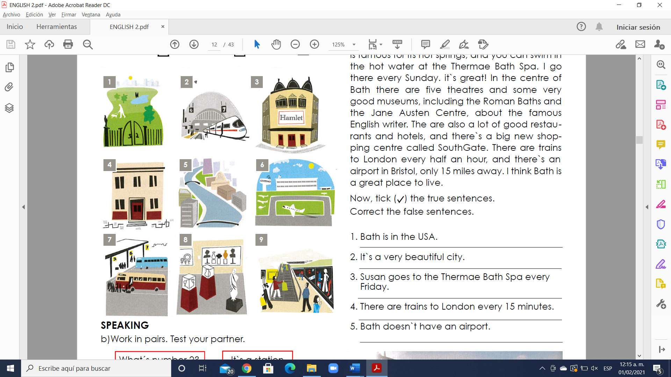**Exercise 4.** Match the adjectives to pictures 1-9. (Escribe la letra de la figura que concuerda con la palabra)

( 4 ) - a building.

( **8** ) - a museum.

( 3 ) - a theatre

( 9 ) - a shopping center

( 1 ) - a park

( 5 ) - a river

( 2 ) - a station

( 7 ) - a bus station

( 6 ) - an airport

**GRAMMAR - A, some, a lot of,**

Los cuantificadores indican la cantidad de un nombre. Son repuestas a la pregunta “¿Cuántos?”. Al igual que los artículos, los cuantificadores definen a un nombre y siempre están situados delante del nombre. Algunos se pueden usar sólo con nombres contables, otros, sólo con nombres incontables y otros, con ambos.

**A or an**

El significado de “a” o “an” es el mismo y se utilizan para indicar algo o alguien en singular. Nunca los utilizaremos para referirnos a más de una cosa.

“A” o “an” corresponden a los siguientes artículos en español: un, una.

1. “A” se utiliza con nombres que comienzan por consonante.

Ejemplos:

a book(un libro)

a pen(un bolígrafo)

a chair(una silla)

a girl(una chica)

2. “An” se usa con nombres que comienzan por vocal.

Ejemplos:

an animal(un animal)

an ice cream(un helado)

an example(un ejemplo)

an orange(una naranja)

an umbrella(un paraguas)

**Some**

Significado: Algunos, unos

Uso: Se utiliza tanto para los nombres o sustantivos incontables como para los nombres o sustantivos contables en plural. Se usa en frases afirmativas e interrogativas (para afirmar algo); se sustituye “any” en frases negativas o interrogativas. Significa una cantidad indefinida, pero limitada.

Ejemplos:

Frase afirmativa/nombre contable:

She has some apples.(Tiene algunas manzanas.)

Frase afirmativa/nombre incontable:

There is some milk in the kitchen.(Hay algo de leche en la cocina.)

Frase interrogativa/nombre contable:

Can I have some cookies?(¿Puedo tomar unas galletas?)

Frase interrogativa/nombre incontable:

Would you like some coffee?(¿Quieres café?)

**A lot of/Lots of**

Significado: Mucho

Uso: Expresan idea de gran cantidad. Se puede usar con nombres o sustantivos contables e incontables. A diferencia de “many” y “much”, no las usamos en frases interrogativas. En general, “lots of” es más informal.

Ejemplos:

Nombre contable:

He has a lot of books.(Tiene muchos libros.)

Nombre contable:

He does not have a lot of books.(No tiene muchos libros.)

Nombre incontable:

I have lots of money.(Tengo mucho dinero.)

Nombre incontable:

I do not have a lot of money.(No tengo mucho dinero.)

**GRAMMAR - There is / There are: positive**

Utilizamos “there + be” (hay) para hablar sobre la existencia de algo. “There + be” se puede expresar en todos los tiempos verbales, pero a diferencia del español, en inglés conjugamos este verbo si el nombre que va después está en plural o en singular y si es contable o incontable.

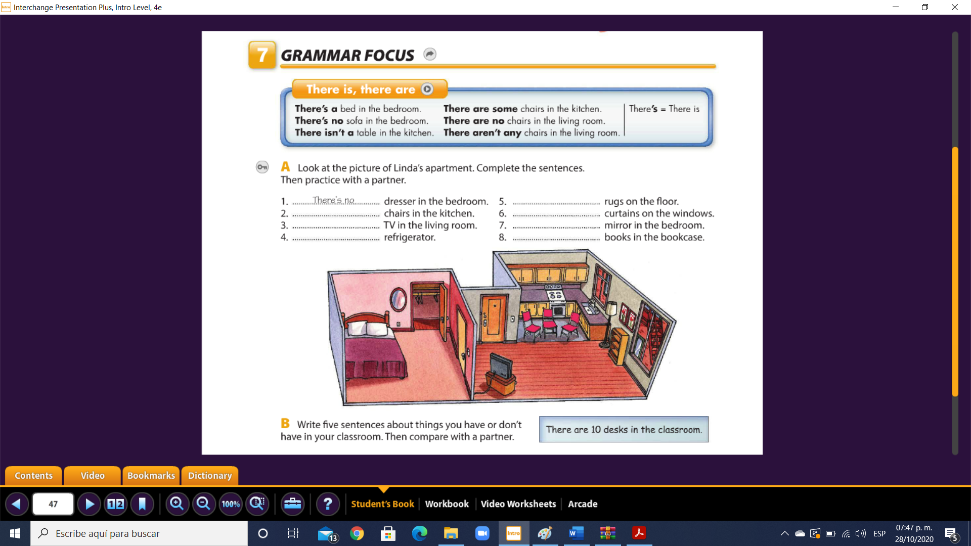

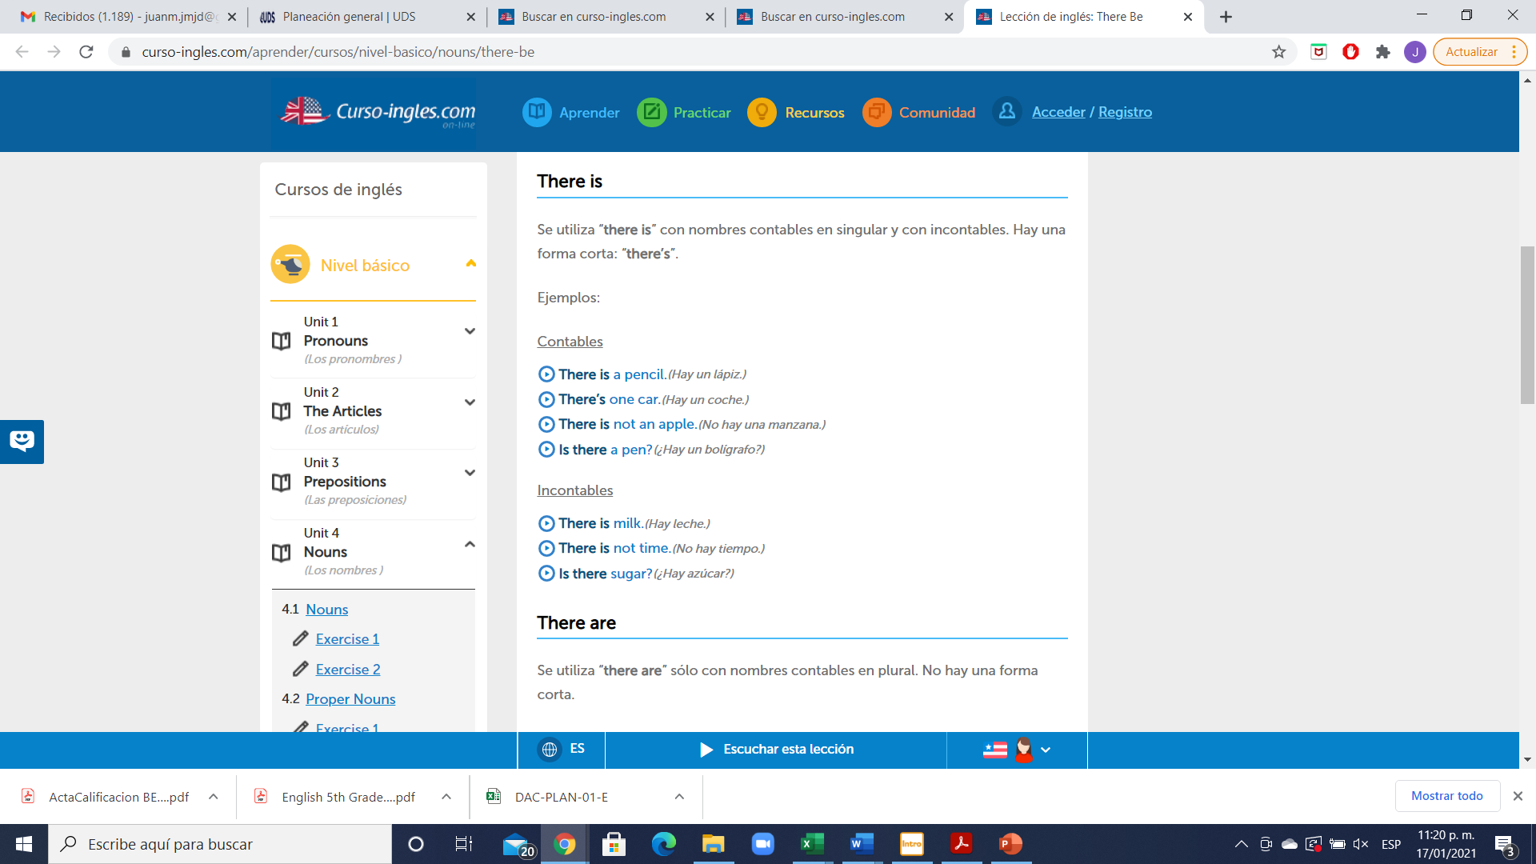

Examples:

- There is a big new shopping center.

- There is an airport in Bristol.

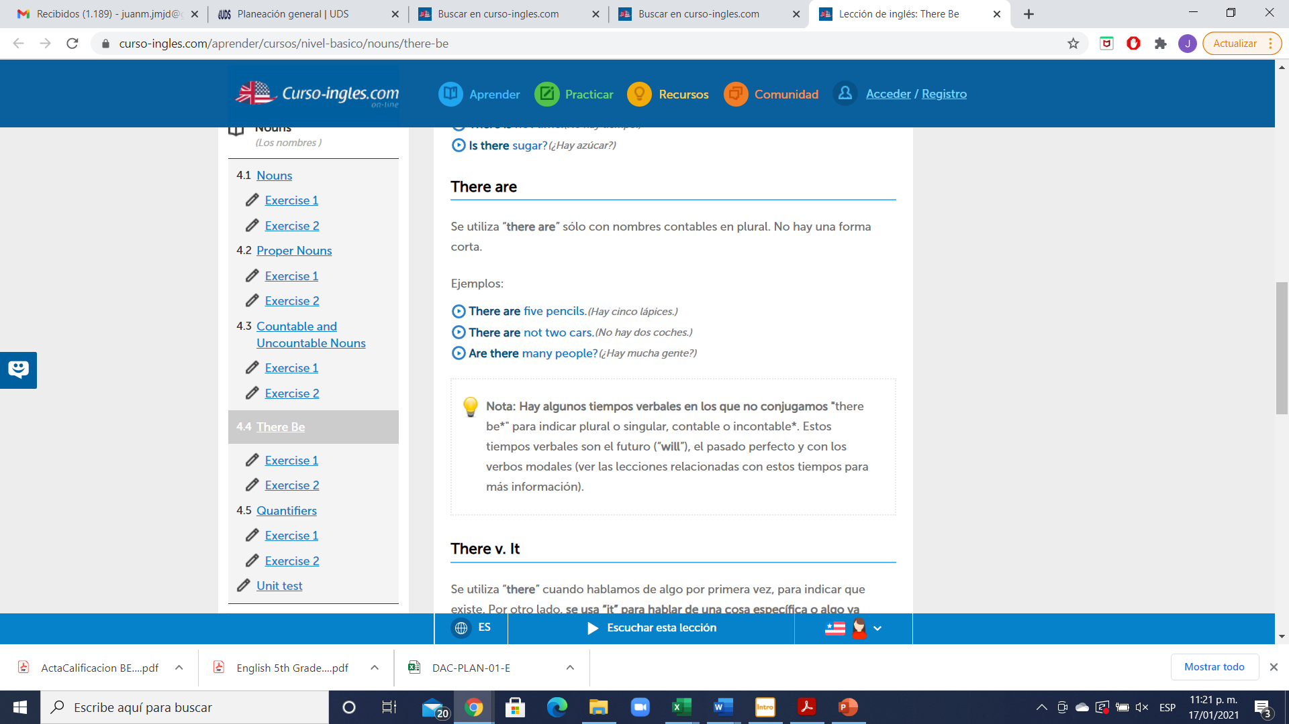

Examples:

- There are five theatres. - There are some very nice parks.

- There are a lot of old buildings.

**Exercise 5.** Look at these sentences about Bath. Fill in the gaps with “is” or “are”. Llena correctamente los espacios con “is” or “are”.

1. There is a beautiful river.

2. There are two cinemas.

3. There is a bus station.

4. There are some hot springs.

5. There is a nice café near the station.

6. There are two five-star hotels.

7. There is a famous restaurant called Sally Lunn’s.

8. There is a lot of trains to London every day.

**Exercise 6.** Choose the correct word. (Escoge entre las dos palabras para realizar una oración correcta, colócala en color rojo)

1. There’s **a / some** station.

2. There are **a / three**  parks.

3. There are **a / some** good museums.

4. There’s **a / some** bus station.

5. There are **some / a** beautiful buildings.

6. There’s **a / an** old theatre.

7. There are **an / a lot of** very good restaurants.

8. There’s **an / some** airport.

9. There are **some / a** nice hotels.

10. There’s **a / a lot of**  river.