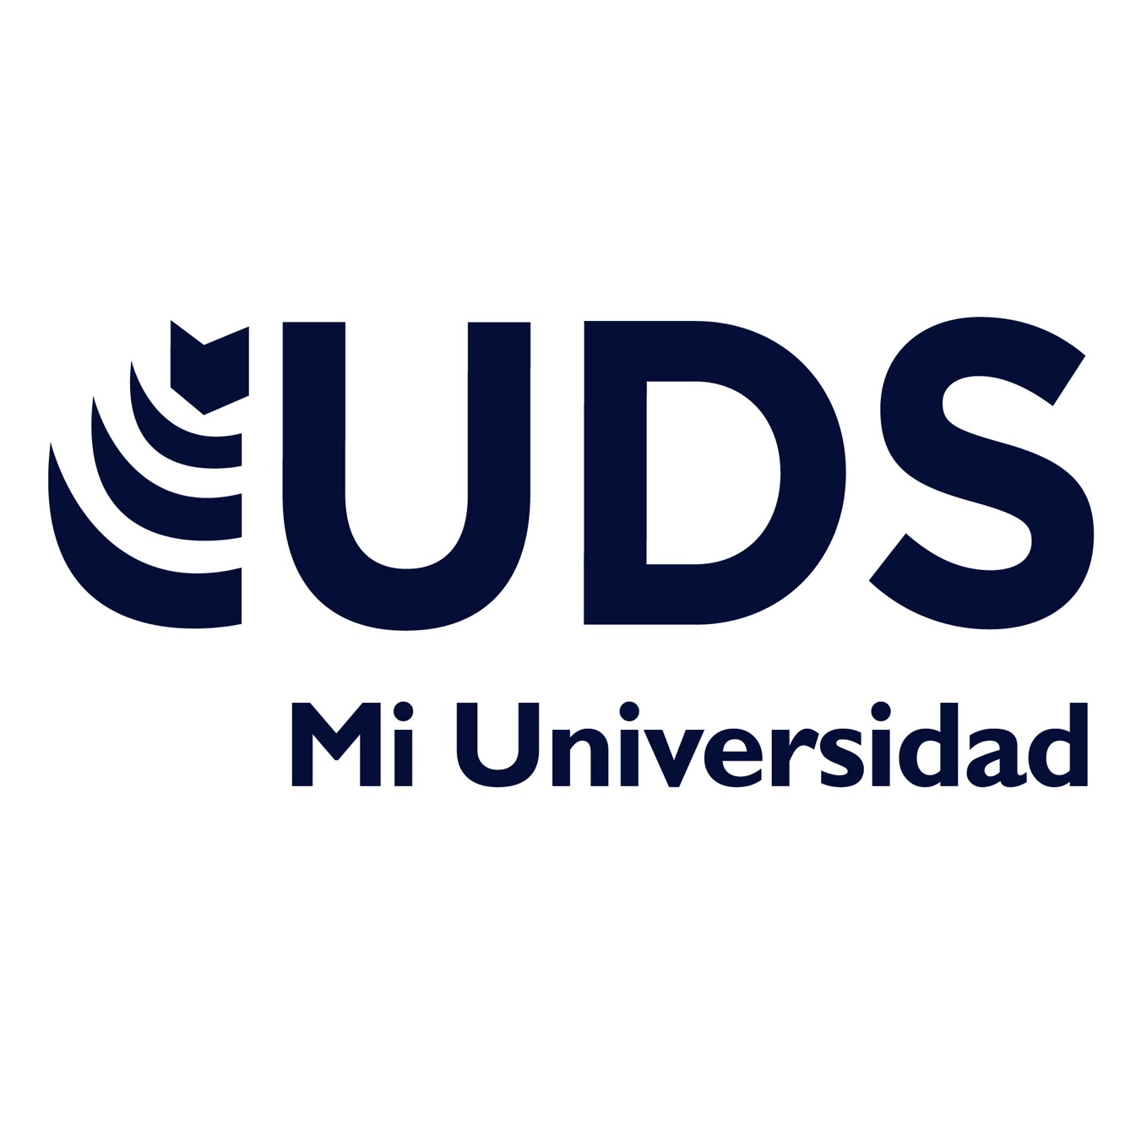

SIMPLE PAST
Nombre del Alumno: Iván Alejandro Esponda López
Nombre del tema: Simple past
Primer parcial
Nombre de la materia : Inglés
Nombre del profesor: Andrea Berenice Segura
Nombre de la licenciatura: licenciatura en derecho
Segundo cuatrimestre

In my vacations, I’m just went to my work because we don´t have a real vacations in december, because there´s a loto f work to do, so the most parto f those days, I went to work, then I came to my home top lay some videogames, one of those days, I was playing a Call Of Duty torney, with two of my best Friends on pc, and we won, we made a very Good job in that torney, so we just decided to keep pushing and get better for the next time, in the last night I went to my favorite uncle´s house, we ate tamales and pizza, to celebrate a new year, My uncle tried to talk me about how much dangerous it´s the coca cola to our body, but I did know what to answer, so I just said that i´ll tried, so my new year purpose is to stop drinking coca cola anymore, I sure I´m gonna make it.

