

ALUMNO: ANTONIO DE JESUS VILLATORO CAMACHO

NOMBRE DEL TEMA: HOUSE DESCRIPTION

PARCIAL: PRIMER MODULO

NOMBRE DE LA MATERIA: INGLES II

NOMBRE DEL PROFESOR: LILIANA RUBI GUTIERREZ PENAGOS

CARRERA: LICENCIATURA EN CONTADURIA PÚBLICA Y FINANZAS

CUATRIMESTRE: 2DO CUATRIMESTRE

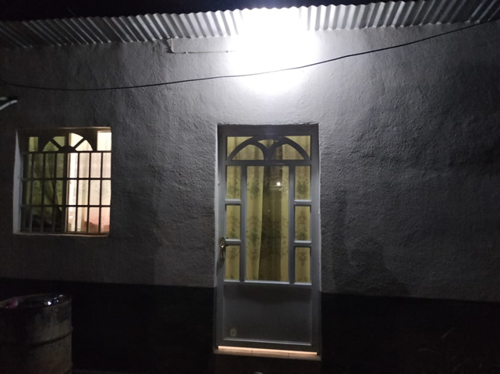

HOUSE DESCRIPTION

***This is a room that my grandparents rent, it is the closest I stay, in this room there are two double beds, they also have a wardrobe, a TV, air conditioning and a garbage can, in what is the bathroom section it has a mop, broom, bucket and dustpan, my grandmother also lends the tenants pillows, sheets, blankets and towels. The room has all the services, water, electricity, internet, cable vision, on the outside it also has a cistern, and a pump to raise water to the water tank, it has parking for one car.***