The veterinarian diagnoses, controls and eradicates diseases in productive animal species, through the development of veterinary public health programs.

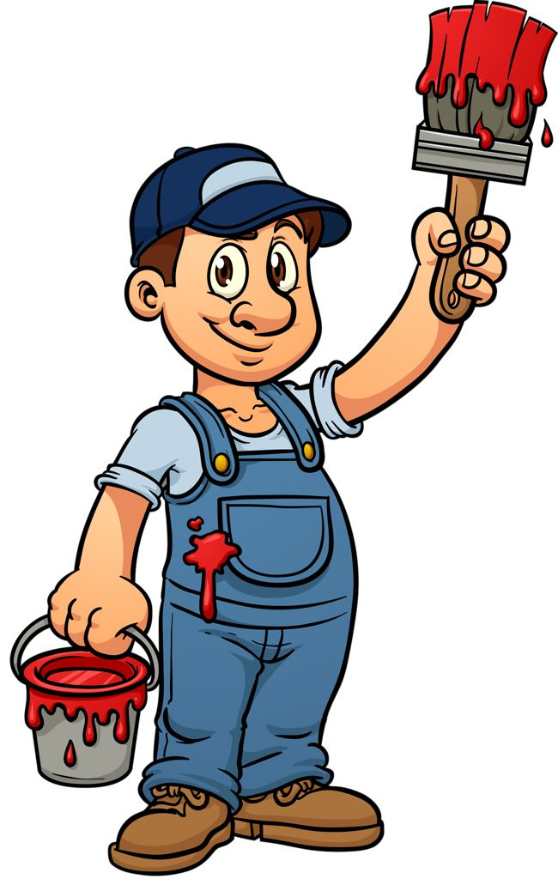

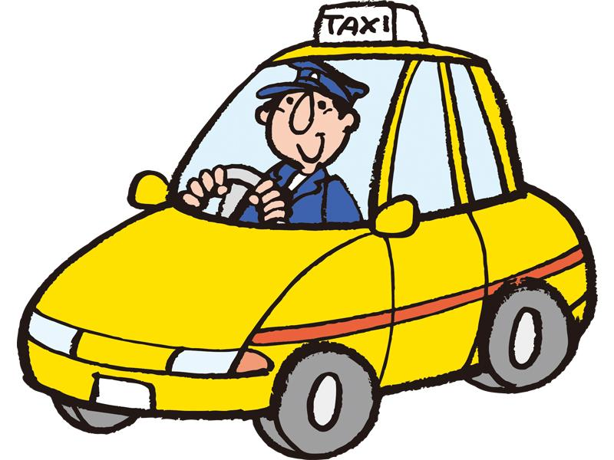

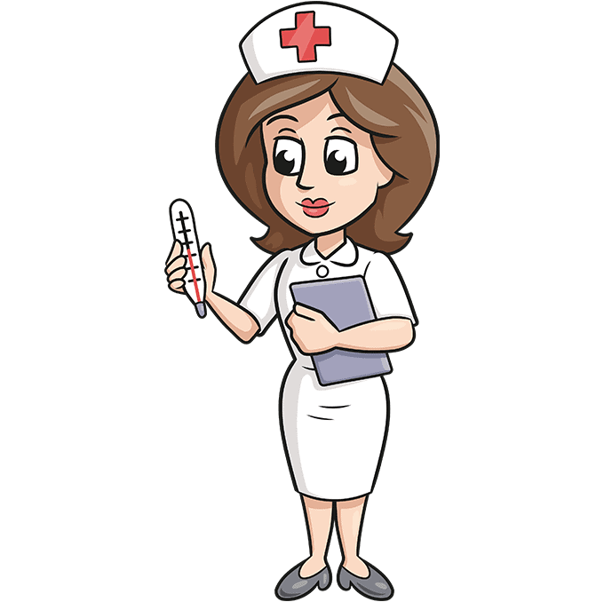

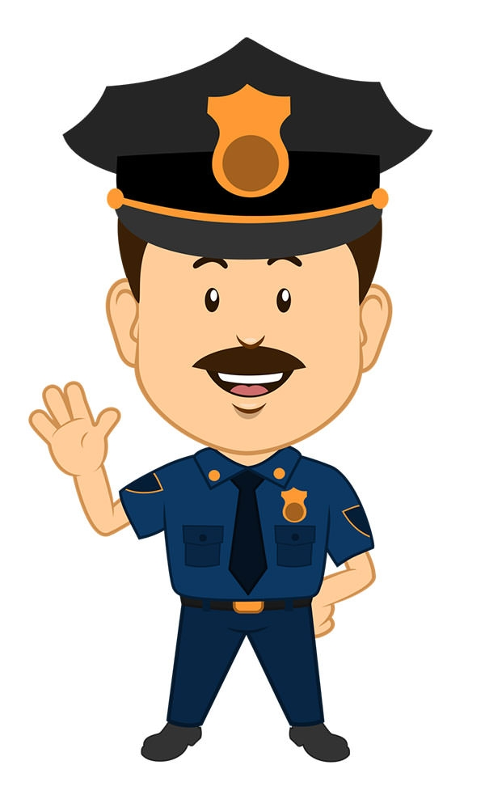

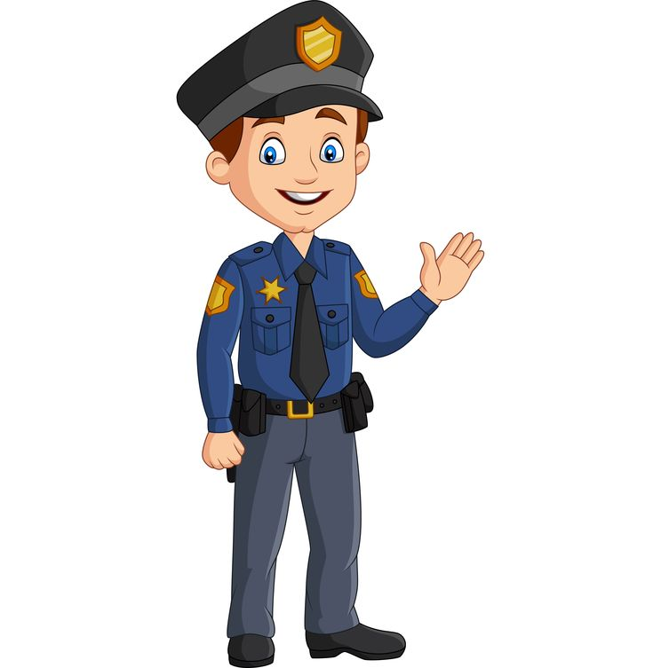

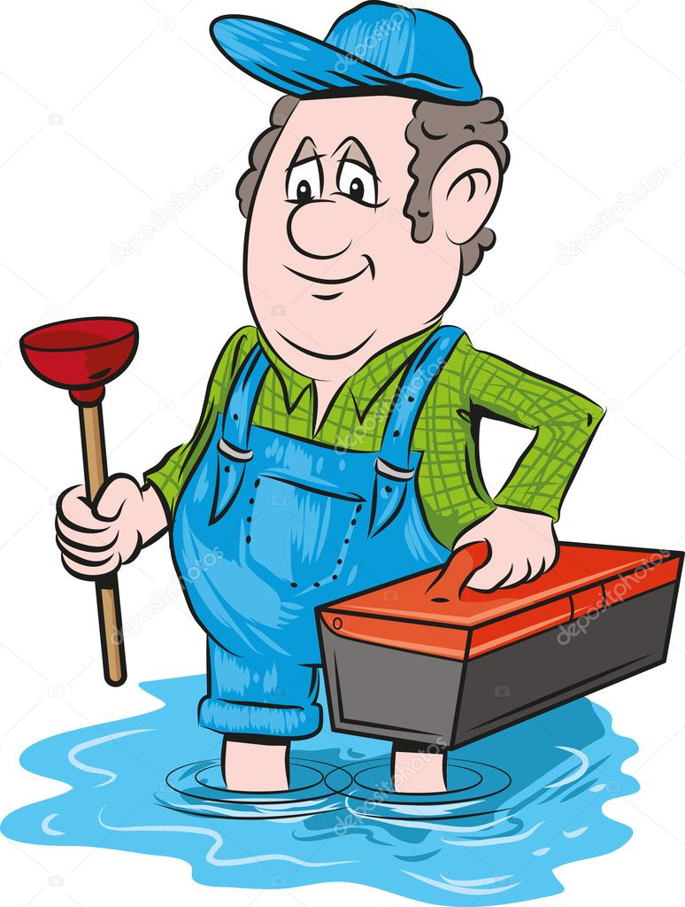

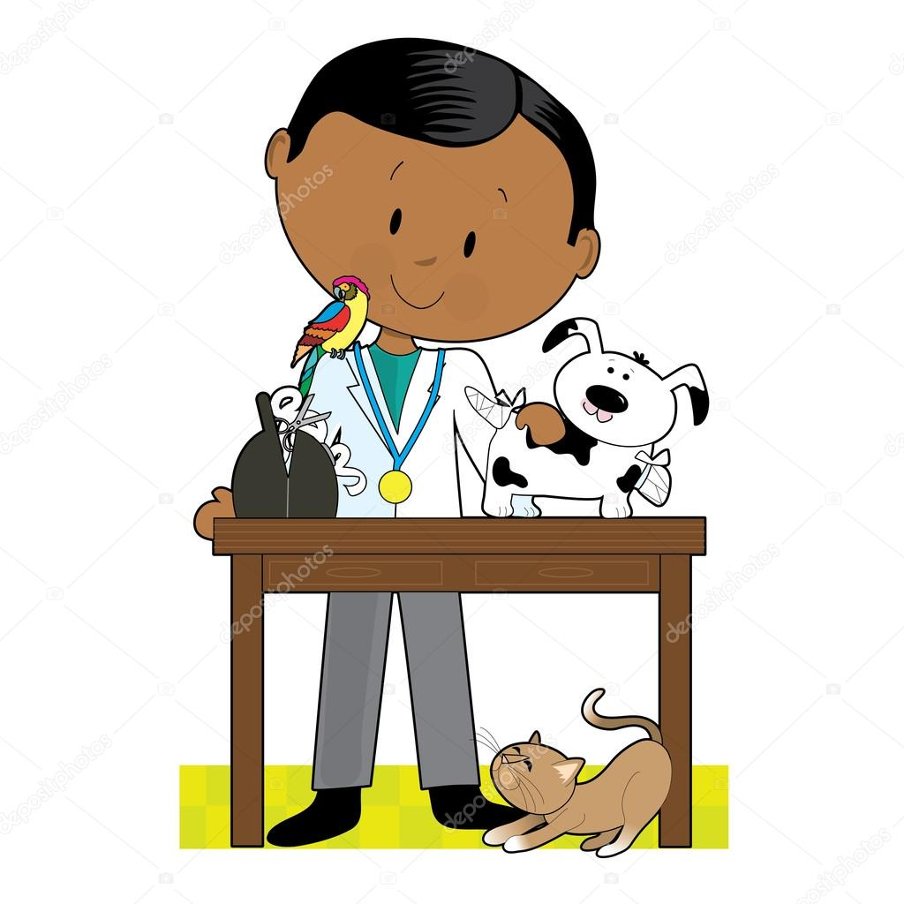



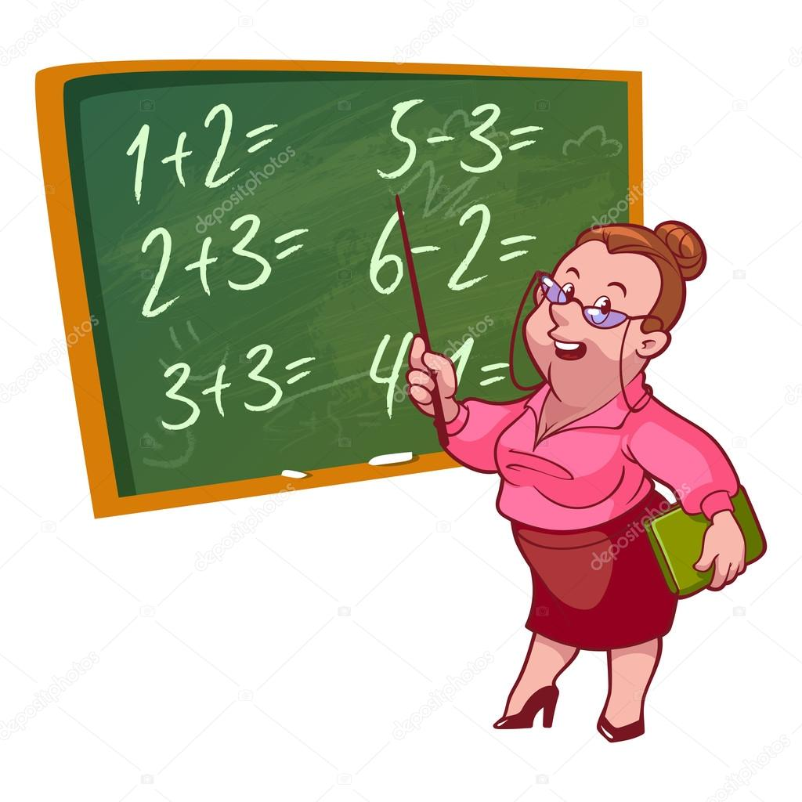

the teacher controls the class, prepares the subject, the evaluation and accompanies the student in his learning process.

TEACHER

a plumber Repairs and maintains the pipes and accessories of drainage, water supply and drainage systems

PLUMBER

NURSE

Before making decisions, a nurse first makes a circuit of medical examinations and reviews the patient's medical records

VET

what a dogtor does Diagnose and treat diseases, injuries and other health disorders.

DOCTOR

a security guard is dedicated to inspecting shopping malls buildings to prevent theft and incidents within the area

a police officer serves to patrol and maintain order in the areas and protect people and their property

taxi drivers pick up people to be able to take them to another destination charging them a fee

a painter Carries out the preparation of the paint and the painting process with the corresponding materials and tools

TAXI DRIVER

PAINTER

SEGURITY GUARD

POLICE

OFFICER

JOBS

WHAT DO YOU FOR A LIVING­­­­?