

**Nombre de alumno: Diego Eduardo Cruz Aguilar**

**Nombre del profesor: Juan manuel Jaime Diaz**

 **Grado: 2**



**Nombre del trabajo:**

**Unit Activity #1**

**–**

**U3 2BRH**

**Materia:**

**ingles**

Grupo: A R.H

Comitán de Domínguez Chiapas a 06 de marzo de 2023.

**TOURIST INFORMATION - CLOTHES**

**VOCABULARY**

**Exercise 1.** Match the adjectives to pictures a-h. (Escribe la letra de la figura que concuerda con la palabra)

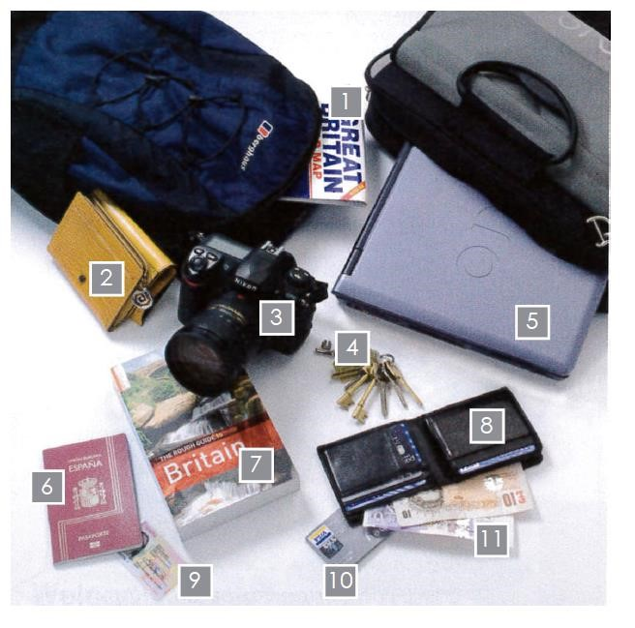( 2 ) - a wallet ( **4** ) - keys.

( 11 ) - money

( 9 ) - an ID card

( 7 ) - a map

( 5 ) - a laptop

( ) - a purse

( 10) - a credit card

( 6 ) - a passport

( 7 ) - a guide book

( 3 ) - a camera

## Vocabulary - Clothes

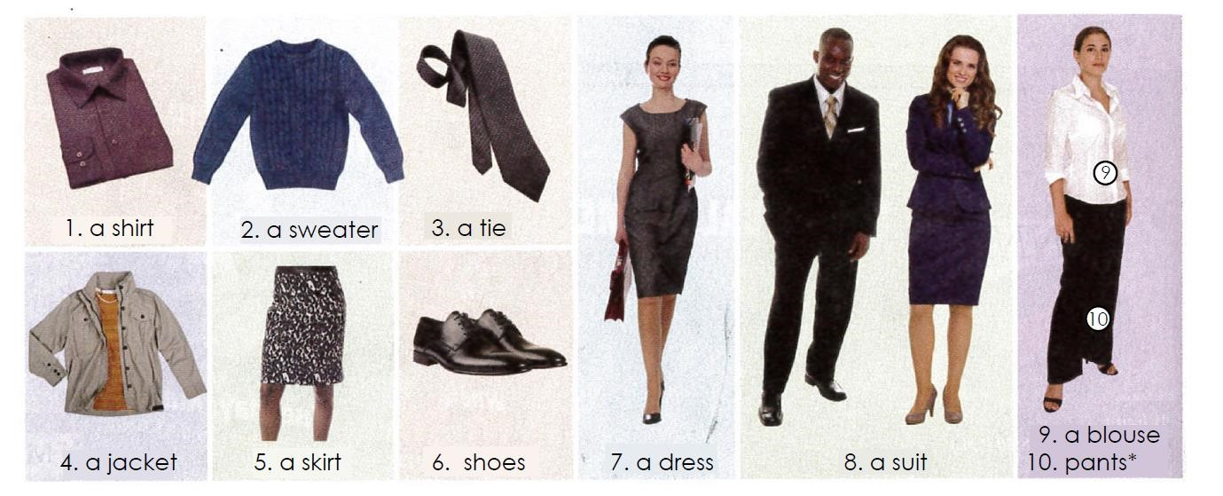

**GRAMMAR -** Demonstrative adjectives: “this”, “that”, “these”, “those”.

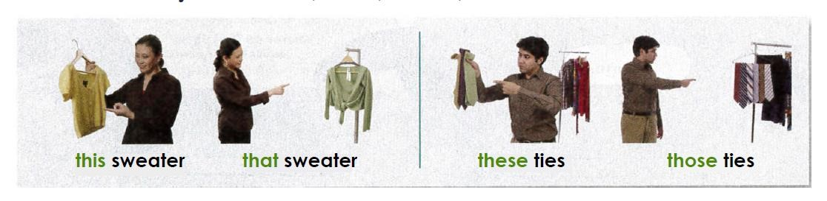

Es importante comenzar señalando que los pronombres pueden estar en singular o plural y que pueden hacer referencia a la distancia.

**This (este/a/o)**

**That (ese/a/o, aquél, aquello/a)**

### These (estos/as)

**Those (esos/as, aquellos/as)** Ejemplos:

**Singular and this (singular y aquí):**

I like this car.(Me gusta este coche.) **Singular and there (singular y allí):**

I like that car.(Me gusta ese coche.)

**Plural and here (plural y aquí):**

I like these cars.(Me gustan estos coches.)

**Plural and there (plural y allí):**

I like those cars.(Me gustan aquellos coches.)

Los pronombres demostrativos pueden ir acompañados de un nombre como vemos en los ejemplos anteriores, o pueden ir solos como en los siguientes ejemplos:

This is a good book.(Éste es un buen libro.)

What is that?(¿Qué es eso?)

Other Uses of Demonstrative Pronouns (Otros usos de los demostrativos)

1. Podemos utilizarlos “this” para presentarnos por teléfono.

Hello. This is Alicia.(Hola. Soy Alicia.)

1. Para preguntar quién hay al otro lado de la línea telefónica o en un lugar oscuro, usamos “that”.

Peter, is that you?(¿Eres tú, Peter?)

1. También usamos “this” cuando presentamos personas.

Lucy, this is my friend Jill.(Lucy, ésta es mi amiga Jill.)

4.“That” también lo podemos utilizar para referirnos a algo del pasado. That pizza was delicious.(Aquella pizza estaba riquísima.)

**Exercise 2.** Look at the pictures. “Write “this”, “that”, “these”, or “those” and the name of the clothes.

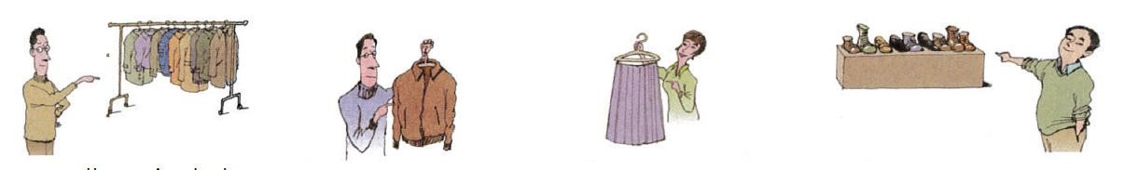

1. Those jackets 2. __this jacket ___________ 3.______this skirt_______ 4.____Those shoes______________

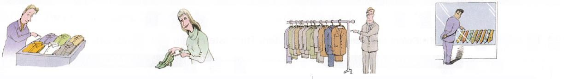

5. _____these shirts_________ 6. __these high heels___________ 7._____thoes suits________ 8.________those ties__________

**Exercise 3.** Escribe 8 oraciones usando “this”, “that”, “these”, and “those”.

1. These shoes look lovely

1. This shirt doesn’t fit me

3.These pants are pretty nice

4.these bouquet of flowers would look nice at our dinner table

5.Those shoes are pretty

6.That skirt would look nice on you

7.This math problem is hard

8. these stores are pricey

**GRAMMAR - The Present Simple tense: affirmative statements with “like”, “want”, “need” and “have”.**

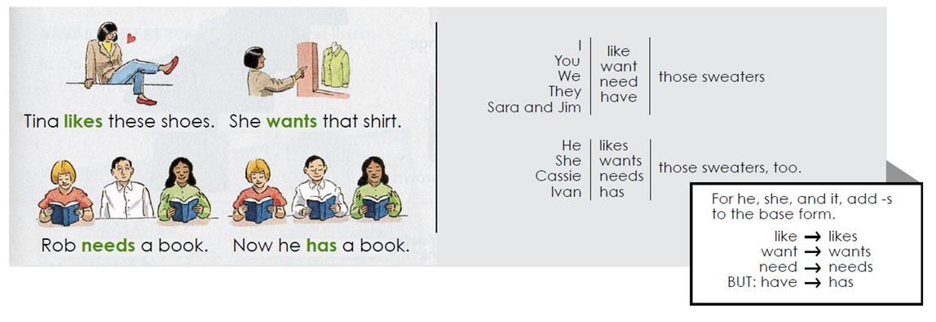

**Exercise 3.** Complete each statement with the correct form of the verb.

1. I ____like____________ (like/likes) your tie.
2. My friends ______want__________ (want/ wants) this suit.
3. Janet _______needs_________ (need / needs) this skirt.
4. Peter _________has________ (have / has) that jacket.
5. We _______like_________ (like / likes) our dresses.
6. Sue and Tara ___want_____________ (want/ wants) those suits.

## VOCABULARY – Colors and Sizes

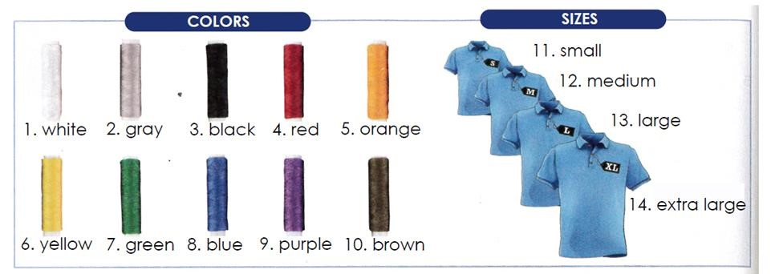

**Exercise 4.** Complete the sentences with the correct form of the verb. Use contractions.

1. A: _____Do________ (Do/Does) your children _____have________ (have) sweaters for school?

B: My daughter _____does________ (do/does), but my son _________doesn’t____(don´t/doesn´t).

1. A: ____Does_________ (Do/Does) your husband ___have__________ (need) a black tie?

B: No, he __doesn’t___________ (don´t/doesn´t). He ________has____ (have) two black ties.

3: A: I ______need_______ (need) a blue suit for work. ___Do __________ (Do/Does) you ___have__________ (need) one too?

B: Yes, I ____do_________(do/does).

1. A: _____Do________ (Do/Does) you ____have_________ (like) that green shirt?

B: Actually, no, I_________don’t____(don´t/doesn´t).

1. A: We __don’t___________ (not like) the clothes in this store.

B: Really? that`s too bad. We ____do_________(do/does).

1. A: ________Do_____ (Do/Does) you ______have_______ (have)this black jacket in size 34?

B: No, I’m sorry. We ________don’t_____(don´t/doesn´t).

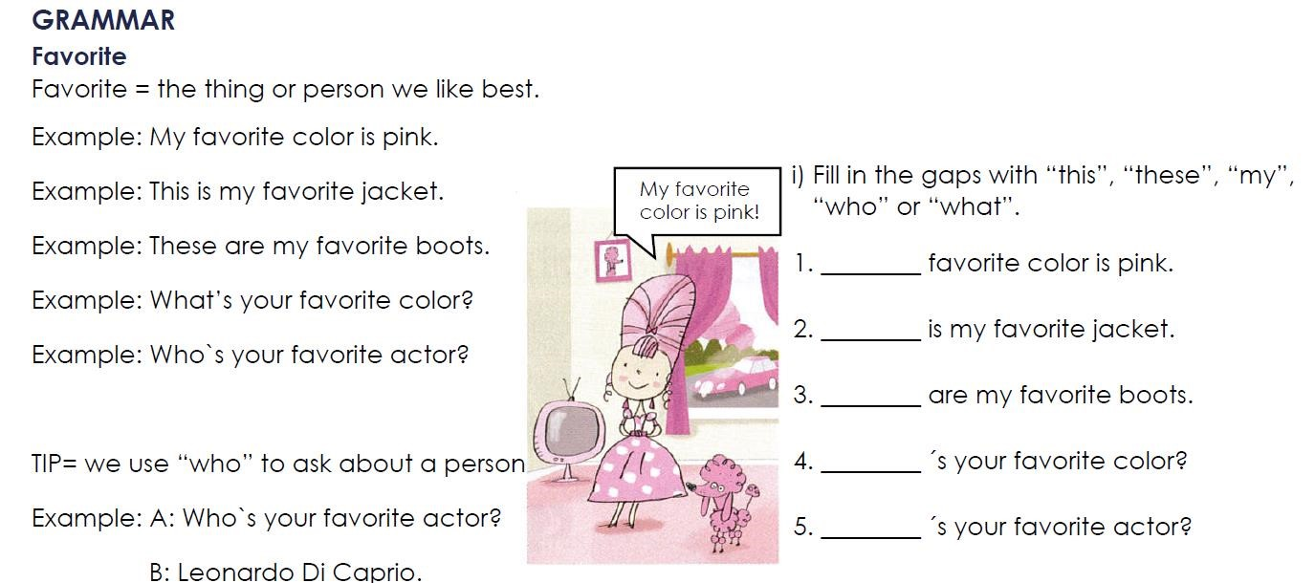

answer

answer

ans

wer

answer

answer

## VOCABULARY- Opposite adjectives to describe clothes

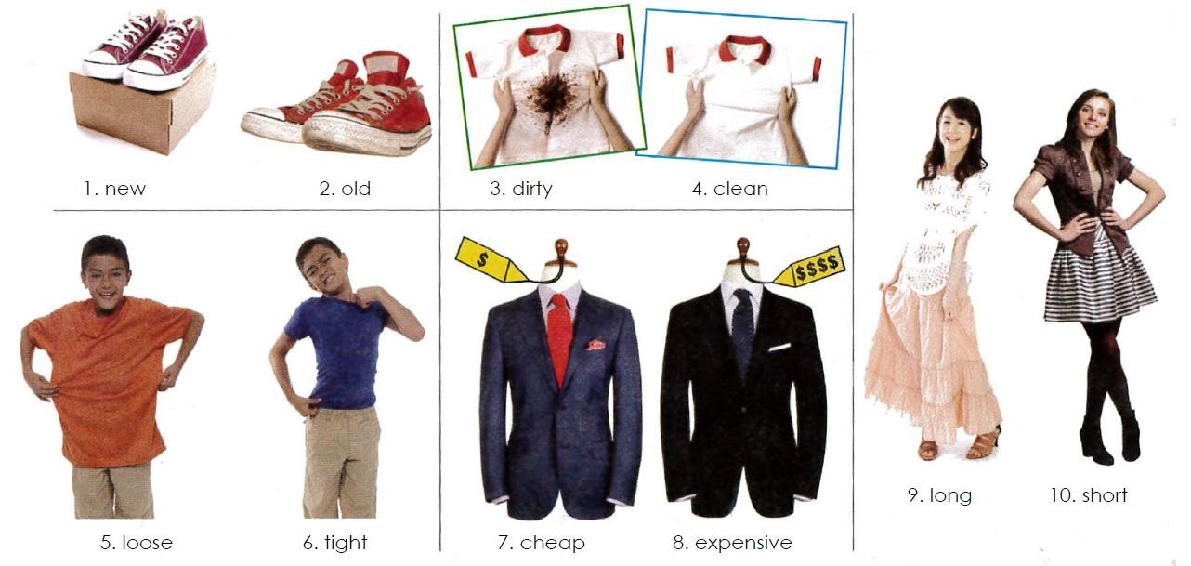

**GRAMMAR - The Present Simple tense: questions with “what”, “what color”, “what size”, “why”, “which one” and “which ones”.**

* Use a question word and “do” or “does” to ask information questions in the Present Simple tense.

Example: What do you need? (A blue and white tie).

Example: What does she want? (New shoes).

* Use “because” to answer questions with “why”.

Example: Why do they want that suit? (Because it’s nice).

* Use “what color” or “what size” to ask about color and size.

Example: What color do you want? (Black).

Example: What size does he need? (Extra large).

* Use “which” to ask about choice. Answer with “one” or “ones”.

Example: Which sweater do you want? (The blue one).

Example: Which shoes does he like? (The black ones).

**Exercise 5.** Complete the conversations in your own words.

1. A: Which skirt _______does she want?________________ (she / want)?

B: The _________pink_________________one.

1. A: What ___________does your friend need___________ (your friend / need)?

B: __________she needs more socks___________________.

1. A: What color shoes _do you like______________________ (you / like)?

B: ________________i like black colored ones________________________.

1. A: Why ___________do you need____________ (you / want) new shoes?

B: __________Because, my old shoes are old and ripped ____________________________.

1. A: Which shirts ___do you like___________________ (you / like)?

B: The ________crop top ones__________________.

1. A: What size shoes _____do you need__________________(you / need)?

B: __________size 23_____________________.